Introduction
Biodiversity Response Planning (BRP) is a long-term area-based planning approach to biodiversity conservation in Victoria. It is designed to strengthen alignment, engagement and participation between government, Traditional Owners, non-government agencies and the community.
DELWP Regional staff have been working with stakeholders on actions to conserve biodiversity in specific landscapes, informed by the best available science and local knowledge.
These Fact Sheets capture a point in time, reflecting data and knowledge available in 2020. They provide information for many (but not all) landscapes across Victoria, containing general information on the key values and threats in each area, as well as the priority cost-effective actions that provide the best protection of biodiversity. Fact Sheets are intended to provide useful biodiversity information for the community, non-government and government organisations during project planning and development.
Further information and the full list of Fact Sheets is available on the Department’s Environment website.

Landscape description
Carlisle Heathy Woodland focus landscape is 17,989ha in size with 69% native vegetation cover remaining. Public land makes up 67% of the area.
Current ecological modelling shows the Carlisle Heathy Woodland focus landscape occurs completely within the Otway Plain Bioregion, bounded by the Warrnambool Plain and Otway Ranges Bioregions to its north-west and south-east respectively. The landscape has around 600ha of threatened Ecological Vegetation Classes (EVC) and is largely dominated by abundant Heathy Woodland and Wet Heathland EVCs. Areas of Riparian Scrub/Swampy Riparian Woodland Complex and Riparian Forest EVC divide the landscape. Shrubby Foothill Forest moves into the landscape from the southern boundaries with areas of Wet Sands Thicket found in patches, while Lowland Forest bounds the west. Small sections of Damp Sands Herb-rich Woodland can also be found. The Victorian Biodiversity Atlas has records of 9 federally protected species, 24 state protected species and 57 rare or threatened species on the Victorian Advisory List occurring within the landscape.
The Eastern Maar Aboriginal Corporation are Traditional Custodians of this focus landscape, with current stakeholders including Barwon Water, Birdlife Australia, Central Otway Landcare Network, Colac Otway Shire Council, Conservation Ecology Centre, Corangamite Catchment Management Authority, Greening Australia, Parks Victoria, Regional Roads Victoria, and Trust for Nature.

Cultural importance
In Meerreengeeye Ngakeepoorryeeyt¹, the Carlisle Heathy Woodland focus landscape occurs in the Heathlands Country. It acknowledges the landscape as an important place where there are many cultural values, with further investigations required. Heathy woodlands are acknowledged as some of the most diverse communities within Australia, where several threatened species can be found, particularly small mammals such as the Eastern Pygmy Possum, Long-nosed Potoroo, Southern Brown Bandicoot, White-footed Dunnart, and Swamp Antechinus².

Stakeholder interest
There are numerous valuable ecological assets present in this focus landscape, including those identified by Traditional Owners, partners and community.

0BEcological Values identified by Traditional Owners, partners and community within this focus landscape
Great Otway National Park | Otway Forest Park
Heathlands | Gellibrand River
Carlisle River | Diverse small mammal assemblages

Habitat Distribution Models identify 7 species with more than 5% of their modelled Victorian range in this focus landscape | Threatened terrestrial species within this focus landscape requiring specific actions other than those identified in Strategic Management Prospects (SMP)
7 plants, notably:  - Bog Clubmoss (Rare) | Bog Clubmoss

Strategic Management Prospects
Strategic Management Prospects (SMP) models biodiversity values such as species habitat distribution, landscape-scale threats and highlights the most cost-effectiveness action for specific locations. For a further in depth look into SMP for this landscape please refer to NatureKit.

Which landscape-scale actions are most cost-effective in this landscape?
The coloured areas in the map below indicate where the identified landscape-scale actions are most cost-effective and will maximise biodiversity benefit across Victoria for multiple species.
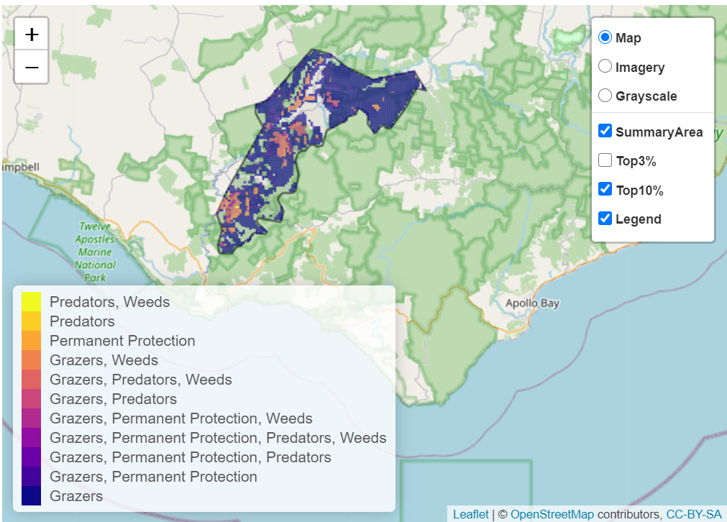
The main SMP priority actions within this focus landscape which rank among the top 10% for cost-effectiveness are listed below:
Control Total Grazing Pressure 6,322ha
Control Overabundant Kangaroos 6,190ha
Control Pigs 5,649ha
Control Deer 4,525ha
Control Rabbits 3,067ha
Permanent Protection 2,047ha

Within this landscape, control of all grazing pressures, pig control and permanent protection were also identified among the top 3% for cost-effectiveness.

Additional threats and considerations
Threats and considerations (in addition to those modelled in SMP) identified by Traditional Owners, partners and community groups during the BRP process for this focus landscape were:
Threats | Ecological processes and values requiring further considerations
Climate change | Appropriate burning regimes
Stock access to riparian and wetland areas | Aquatic/riparian species and catchment influences
 | Indicator species and ecosystem engineers
 | Small mammal assemblage

References
- Eastern Maar Aboriginal Corporation, 2015. Meerreengeeye Ngakeepoorryeeyt, Eastern Maar Country Plan
- Burns, P., 2019. New Holland Mouse (Pseudomys novaehollandiae) in the Western Otways?, Conservation Ecology Centre, threatened Species Forum extract : https://www.conservationecologycentre.org/2019/08/21/otways-threatened-species-forum-2019-abstracts

