Deciding which actions best help nature
Decision-support tools to help biodiversity managers protect Victoria’s environment.
We need the best information possible, together with decision-support tools to help us navigate and solve complex problems.
Victoria has a diverse and unique range of species and ecosystems that we value and need to protect for future generations. But our biodiversity is in decline. This presents a significant management challenge that will be exacerbated by climate change. To meet this challenge, we need to revolutionise our thinking. Our management approach needs a stronger focus on providing the best opportunities for Victoria’s plants and animals to withstand or adapt to these changes. The Victorian Government’s new Biodiversity Plan, Protecting Victoria’s Environment – Biodiversity 2037, recognises the value of using strategic decision-support tools to prioritise action and focus more on earlier intervention (described in more detail in Chapter 3 of the Plan).
Decision-support tools are typically computer-based information products that inform choices at the management, operations, planning or policy level of an organisation. They are enablers, designed to inform decisions, not dictate the answer. More specific local or regional knowledge can easily be added to further inform questions and decisions.
Distribution of habitat for plants and animals (e.g. modelled relative likelihood of habitat for the Brush-tailed Phascogale)
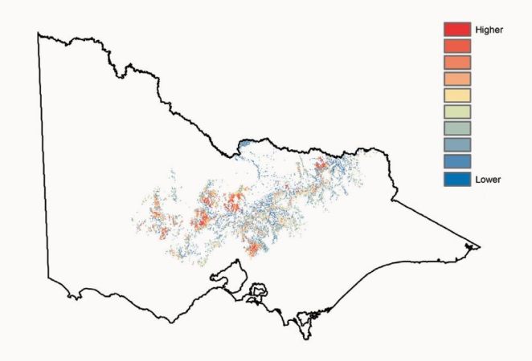
NaturePrint is a suite of decision-support tools designed to help us make choices about what actions we take, and in which places, to conserve Victoria’s biodiversity. These tools provide a view across multiple threats and species, and enable consideration of different future scenarios. NaturePrint provides the community, government, agencies and other users with commonly-shared, readily available guidance.
Extent and intensity of landscape-scale threats (e.g. modelled extent and density of rabbit warrens)
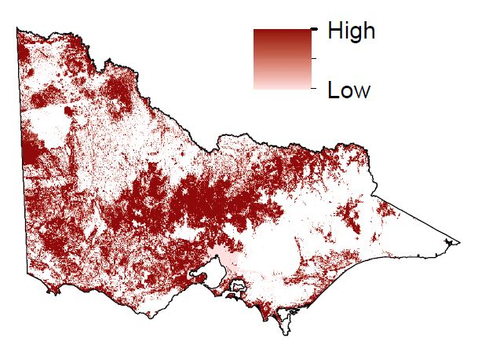

Prospects for change

Benefit
When undertaking management actions it is important to know how those actions benefit different plants and animals in different places. Information on where actions have the greatest benefit, or the greatest prospects for change for particular species, is essential to guide investment or management planning.
Benefits can be large or small, and generated quickly or slowly. Some actions (e.g. caging orchids to protect from herbivores) are only appropriate in unique situations, while other actions (e.g. fox baiting) can provide benefits for a number of species in many places. A common measure of benefit is required to enable comparisons across a wide range of species, threats and actions.
The Biodiversity Plan identifies a new measure – Change in Suitable Habitat – that will standardise the measurement of benefit and be used to assess overall progress towards the Plan’s targets.
Benefits to individual species from controlling threats (e.g. benefits to Horned Hop-bush from controlling rabbits)
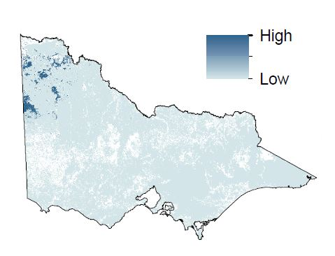
Benefits to all species from controlling threats (e.g. benefits to all species from controlling rabbits)
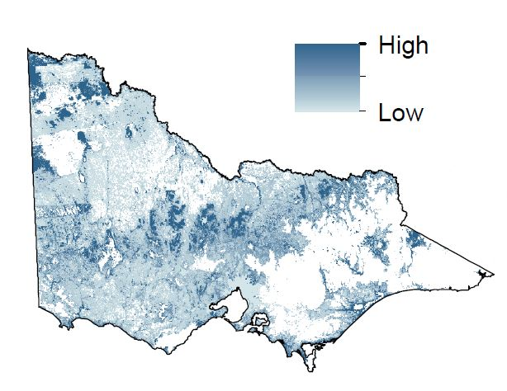

Benefit-cost ratio
Another important consideration when evaluating the importance of management actions is their cost. A key direction of the Biodiversity Plan is ensuring that the greatest benefit to biodiversity is achieved with the available resources.
NaturePrint’s approach incorporates the indicative costs of actions with their expected benefit (measured by Change in Suitable Habitat), which allows for direct comparison of the cost-effectiveness of actions, through a benefit-cost ratio.
This allows biodiversity managers and investors to compare and select the options that will provide the best outcomes for nature, and are also value for money.
Estimated benefit (measured by Change in Suitable Habitat) of each action to individual species (e.g. an area in north-east Victoria)
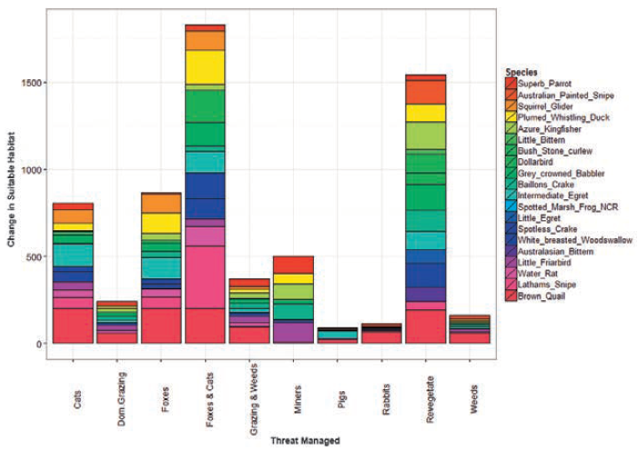

Strategic integration of prospects
NaturePrint’s decision-support tool ‘Strategic Management Prospects’ provides guidance about which actions in which places could deliver maximised biodiversity outcomes.
It does this by integrating benefit-cost information for multiple species, actions and places. This gives us a comprehensive view of conservation prospects across Victoria. It shows how investment in separate or combined actions can improve the extent and condition of biodiversity, and where strategic actions could provide the greatest Change in Suitable Habitat. It is a consistent, transparent approach that will help program managers and on-ground practitioners make decisions for biodiversity conservation.
The analysis of this huge amount of complex spatial information allows us to consider the benefits of actions for plants and animals from a range of perspectives including statewide, landscape and local scales. This new decision-support tool is a significant step forward in our strategic approach to conservation planning and investment.
Best management regime
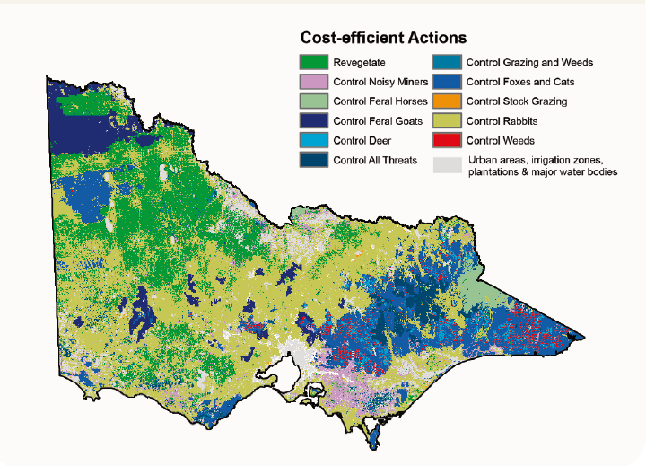
Relative spatial priority for action
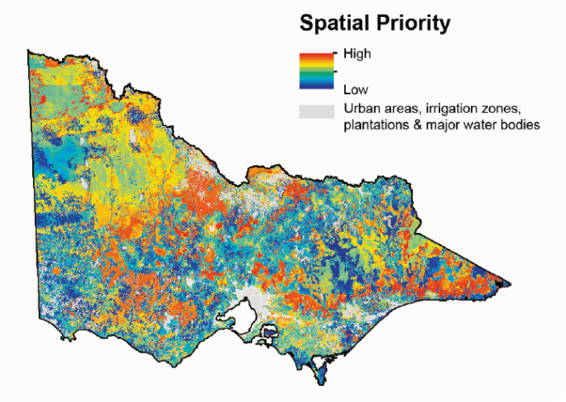
Biodiversity response planning
Biodiversity management requires a collaborative approach to share accountability and drive measurable improvement across Victoria. The Strategic Management Prospects approach is providing the basis for a set of statewide targets that will align conservation action across Victoria under the Biodiversity Plan.
Regional investment processes can use Strategic Management Prospects to identify prospects for change in their area. This approach also allows for the NaturePrint tools to be complemented by regional and local community views on what is practical and achievable in terms of conservation action.

Continuous improvement of data
We are committed to continuous improvement. These products can be tested and improved with the collection of new field data. NaturePrint can help identify areas of highest uncertainty and help target effort towards areas where the new information is of highest value.
The current version of Strategic Management Prospects has a landscape-scale, terrestrial focus. It will be progressively complemented by new information on the occurrence of species, new threat and action combinations, and updated cost information.

Strategic Biodiversity Values
Another complementary decision-support tool, Strategic Biodiversity Values, identifies the priority areas for protection based on the importance of the natural values in that location. It can be used to help inform priorities for adding to the public land reserve system, or inform where organisations such as Trust for Nature or Bush Heritage could direct their attention when purchasing and conserving land. It could also be used for prioritising areas for regulatory controls.
Strategic biodiversity values
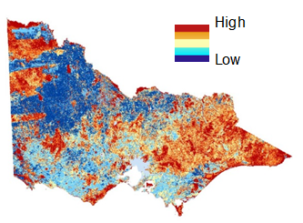

Find out more
For more information on the NaturePrint suite of tools and how to access them, visit the NaturePrint website:
environment.vic.gov.au/biodiversity/natureprint

