What is NVIM?
NVIM Quick Reference Guide
General guide

NVIM stands for Native Vegetation Information Management and is a system to access Victoria’s native vegetation information.

Accessing NVIM
NVIM is a web-based system available to the public –http://nvim.depi.vic.gov.au. The home page provides information about the system and tools available.

Search for property
- Enter a full property address or a Standard Parcel Identifier (SPI) in the Search bar (note: SPI is separated using “\”)
- Address will be displayed in information panel on the left and marked on map (Note: several options may appear – choose one and the map zooms to display the parcel)
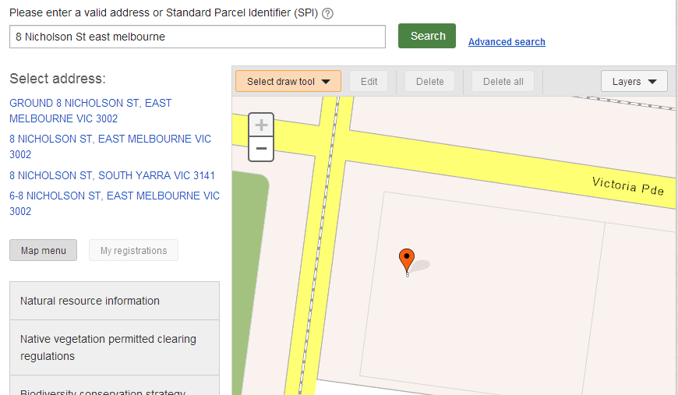

Advanced search
Advanced search is a quick way to locate an area of interest. Once selected the map zooms in (layers do not need to be active). Select what you are searching for either by using the drop down boxes provided or by typing in the box (using predictive text to search):
- Search for: – select a specific category
- By: – select a pre-determined attribute (note some may have only one attribute to choose from)
- Show: – select the specific name or number of the attribute
Note – to remove a search you will need to select the Clear button.

Select a template
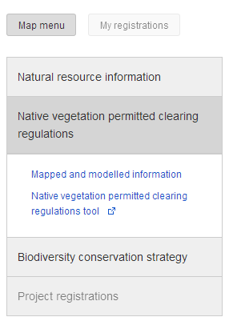
- In the left information panel select a topic that may best suit the information you are seeking (grey box)
- Choose a template from the drop down list (blue text)

Selecting layers
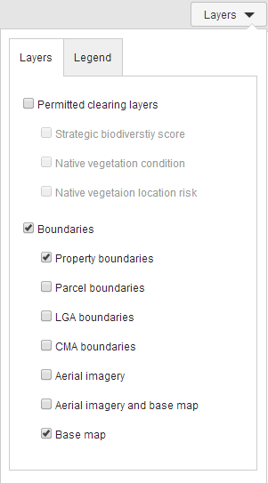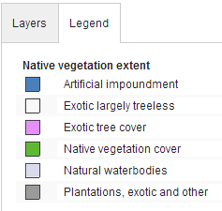
- Select the Layers tab from the menu at the top right of the map
- Switch on or off different layers to change the map
- Use the Legend tab to identify different vegetation types on the map
- Aerial imagery is available to assist in identifying native vegetation on property

Drawing tools
- Select a drawing tool from the Select draw tool drop list a the top of the map
- Drawing tools available in NVIM include:
  - Draw a polygon to mark up an area
  - Draw a line to indicate a fence line
  - Place a point to mark out a feature
  - Mark a circle to outline a 15m radius circle around a point or a scattered tree
- All areas marked up will be numbered and should be clearly identified.
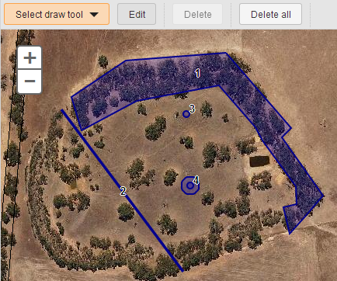

Edit drawings
Start editing your map drawings by selecting the Edit button on the top of the map. To:
- change the shape of a polygon or line − click on the shape then choose a vertices (circles on the polygon or line) and drag to new position
- move a polygon, line or point − click on the shape and hold down the mouse key and move it to new position
- finish editing − click on the Finish Editing button

Delete
NVIM Quick Reference Guide
General guide

- To delete a point on a line or polygon right click on the dark grey larger circles and click on the red circle x next to the delete popup
- To delete a single polygon, line or point − select the Edit button, then click on the shape and select the Delete button
- To delete all − select Delete all button from any mode

Points to note
- Use the scroll bar on your mouse or the map controls to zoom in & out, pan on map
- No information can be saved. To save your work we suggest doing a screen print or printing the page to a PDF.
- Some properties have multiple address listings, drawing on these properties will return multiple results in the information panel
- An address may not be found for a roadside or public land
- NVIM is not supported by Internet Explorer 8 or below. Please use Internet Explorer 9 or later, Chrome or Firefox

Other reference guides for NVIM
Other reference guides to use in conjunction with this one include for specific templates include:
- Native vegetation for permitted clearing - Mapped and modelled information
- Native vegetation for permitted clearing regulations tool
- Biodiversity in the Victorian planning provisions
- Estimate your obligations under the Biodiversity Conservation Strategy

More Information
Further information regarding the NVIM system is available on the DEPI website www.depi.vic.gov.au/nvim

