|  |
| --- |
| Victoria Unearthed |
| Part of the Victorian Government’s commitment to protecting our environment |

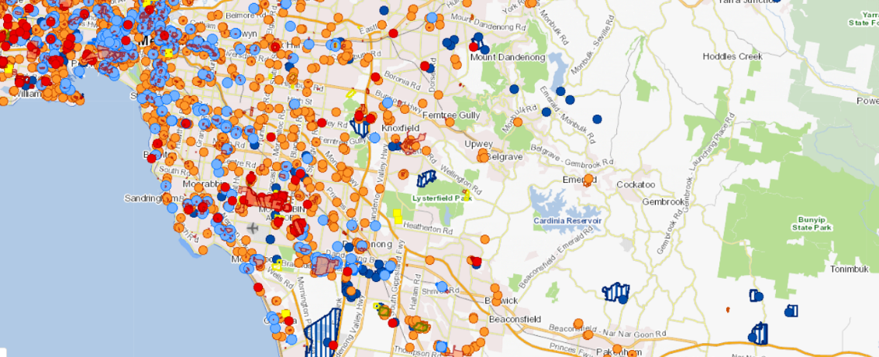

## 

## What is Victoria Unearthed?

Victoria Unearthed is an online mapping tool designed to help you find out more about land, groundwater, past business activities and potential contamination.

The information in Victoria Unearthed is already publicly available but is now easier to access in one place and is presented in a spatial format.

You can find information by searching for an address, suburb, town or other location.

Victoria Unearthed is not a definitive source of information about contamination. It is a helpful starting point for more in-depth enquiry about land and groundwater contamination that might support further investigation.

You can access Victoria Unearthed at [environment.vic.gov.au/victoria-unearthed](http://www.environment.vic.gov.au/victoria-unearthed)

## What information is in the database?

Victoria Unearthed includes information from a range of existing government sources including up-to-date data from the Environment Protection Authority (EPA) Victoria. Data available in Victoria Unearthed includes:

* **Priority Sites Register:** sites where EPA has issued a clean up notice or pollution abatement notice.
* **EPA Licenced Sites:** sites with a current EPA licence**.**
* **Environmental audits**: sites where environmental audits have been completed.

* **Groundwater Quality Restricted Use Zones:** An area, site or property where an environmental audit has been conducted and residual groundwater contamination was found.
* **Victorian Landfill Register:** locations of current and former landfill sites across Victoria.
* **Environmental Audit Overlays**: a Victorian planning scheme overlay indicating where an audit is required prior to land being used for a ‘sensitive use’.
* **Historical business listings**: Over **560,000** digitised historical business listings from the Sands and McDougall Directories (old ‘phone books’) between 1896 and 1974.

## Historical business listings

The historical business listings dataset in Victoria Unearthed comes from the Sands and McDougall directories - the 'phone books' of the 1800s and 1900s. These directories contained contact information for both businesses and residences.

These directories do not provide any information about land contamination. They provide information about business names that have operated from a site and are not necessarily evidence of business activities having occurred at that site.

Historical business information in the directories can, for example, indicate the head office of a manufacturing business rather than the address of the factory floor.

## Downloading and accessing data files

The data included in Victoria Unearthed is also available for direct download and via web services from [Spatial Datamart](http://services.land.vic.gov.au/SpatialDatamart/) and [DataVic](http://data.vic.gov.au/) at:

<http://services.land.vic.gov.au/SpatialDatamart/>

<http://data.vic.gov.au/>

## EPA Inquiry: Improving access to information

Victoria Unearthed was developed in response to Recommendation 14.1 of the [‘*Independent Inquiry into the EPA’*](https://www.environment.vic.gov.au/sustainability/environment-protection-reform) .

The Victorian Government committed to improving access to information to strengthen management of risks associated with legacy land and groundwater contamination.

In particular, the government committed to developing a public database providing consistent, easily accessible state-wide historical information to assist with identification of potentially contaminated sites.

## What else is the Victorian Government doing to protect our environment?

The *Environment Protection Amendment Act 2018* provides the foundation for a transformation of Victoria’s environment protection laws and the EPA.

The Act provides a new approach to environmental issues, focusing on preventing waste and pollution impacts rather than managing those impacts after they have occurred. It includes proposed reforms for contaminated land management, including the introduction of the general environmental duty, the 'Duty to Manage' contaminated land and the 'Duty to Notify' EPA of contamination.

The Act was passed by parliament in August 2018 and is intended to come into effect from 1 July 2020.

## Potential contamination and health

The presence of contamination does not always mean there is a risk to human health. Many factors need to be considered such as how the land is used, the nature of the contamination, whether people are exposed, how much they are exposed to and for how long.

If you think you may have been exposed to contamination and have health concerns, you may wish to seek advice from your doctor.

## Concerned about potential land or ground water contamination?

If you have any concerns that land or groundwater may be contaminated, you can:

1. Get further information via EPA and other sources, such as [State Library Victoria](https://www.slv.vic.gov.au/), historical aerial photos, local historical societies, historic land tiles, council rates records, Melbourne Metropolitan Board of Works plans and the [Victorian Heritage Database](https://vhd.heritagecouncil.vic.gov.au/)
2. Speak to an experienced environmental consultant. EPA provides detailed information on engaging environmental consultants at <https://www.epa.vic.gov.au/business-and-industry/guidelines/engaging-consultants>

## Next steps

For more information visit: [environment.vic.gov.au/victoria-unearthed](http://www.environment.vic.gov.au/victoria-unearthed)

We also welcome your feedback at [victoria.unearthed@delwp.vic.gov.au](mailto:victoria.unearthed@delwp.vic.gov.au).

|  |  |
| --- | --- |
| © The State of Victoria Department of Environment, Land, Water and Planning 2019  LogoThis work is licensed under a Creative Commons Attribution 4.0 International licence. You are free to re-use the work under that licence, on the condition that you credit the State of Victoria as author. The licence does not apply to any images, photographs or branding, including the Victorian Coat of Arms, the Victorian Government logo and the Department of Environment, Land, Water and Planning (DELWP) logo. To view a copy of this licence, visit http://creativecommons.org/licenses/by/4.0/  ISBN 978-1-76077-067-9 (print/online/MS word)  Disclaimer  This publication may be of assistance to you but the State of Victoria and its employees do not guarantee that the publication is without flaw of any kind or is wholly appropriate for your particular purposes and therefore disclaims all liability for any error, loss or other consequence which may arise from you relying on any information in this publication. | Accessibility  If you would like to receive this publication in an alternative format, please telephone the DELWP Customer Service Centre on 136186, email [customer.service@delwp.vic.gov.au](mailto:customer.service@delwp.vic.gov.au) or via the National Relay Service on 133 677 [www.relayservice.com.au](http://www.relayservice.com.au). This document is also available on the internet at [www.delwp.vic.gov.au](http://www.delwp.vic.gov.au). |