|  |
| --- |
| Feral Cats |
| Information Sheet |

Feral cat (*Felis catus*)

## What is a feral cat?

Feral cats are feral or wild populations of the cat (*Felis catus*). Feral cats are unowned and live completely independently of humans with respect to food and shelter and without veterinary care. Feral cats survive and reproduce in self-perpetuating populations in the wild.

Feral cats are different to stray cats, or unowned cats, which partly rely on humans for food and shelter (whether it is provided intentionally or not).

## How is a feral cat different to a domestic cat?

Domestic cats are owned and their care and needs are met by their owner. The government recognises that domestic cats are important companion animals for many Victorians and that responsible cat ownership brings many benefits. Ownership of domestic cats is unaffected by the feral cat declaration.

* 1. **What is the distribution of feral cats in Victoria?**

Feral cats are found in all terrestrial habitats in Victoria. It is thought that there is up to 5.6 million feral cats in Australia[1].

## What is the impact of feral cats on biodiversity?

Nationally, feral cats are the single biggest threat to Australia’s native mammals - double that of the fox (which are the next highest threat). Feral cats have already directly contributed to the extinction of 19 Australian mammals, like the desert bandicoot and broad-faced potoroo. They are implicated in another eight mammal extinctions.

In Victoria, feral cats have a significant impact on the state’s biodiversity and threatened wildlife.

Predation by feral cats is one of the most significant threats to the survival of Victoria’s at-risk native wildlife. 43 *Flora and Fauna Guarantee Act 1988* (FFG Act) listed threatened species are at increased risk of extinction as a direct result of feral cats. Predation by feral cats is listed as a potentially threatening process under the FFG Act.

It is estimated that 75 million native animals and more than one million birds are killed every day in Australia by feral cats

**What are the other impacts of feral cats?**

Feral cats have other ecological impacts on native wildlife aside from predation. The presence of feral cats in an ecosystem can lead to increased competition for food and habitat. This can lead to behaviour change in native species, putting them at increased risk from a range of threats.

Feral cats also carry and spread disease which can be transmitted to and affect other animals, including livestock and humans. One such disease is toxoplasmosis, which can cause a range of health issues, and can affect survival rates of offspring in infected livestock.

## What are the priority areas for feral cat control?

Strategic Management Prospects (SMP) is a conservation planning tool developed by the Department of Environment, Land, Water and Planning (DELWP) to help biodiversity managers prioritise effort by identifying areas and actions with the greatest benefit to biodiversity. SMP also provides a method for integrating information on expected biodiversity benefits and costs to help compare and select management options. The SMP tool has been used to identify the areas of Victoria where biodiversity would most benefit from feral cat control. Figure 1 illustrates that significant areas of Victoria, including most of the public land estate, would benefit from feral cat management.

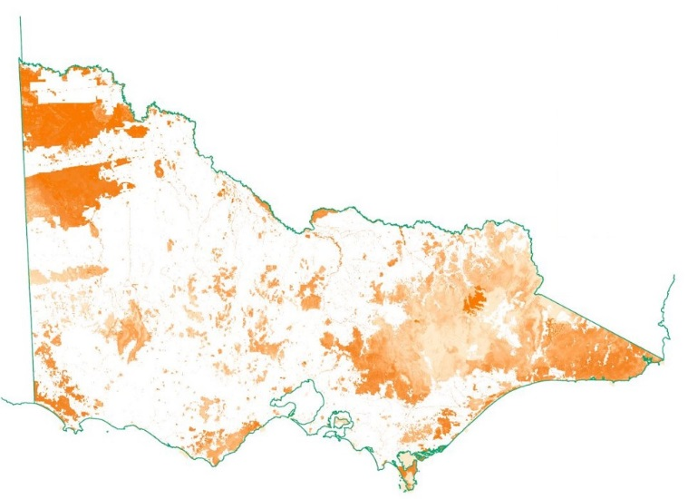Further information on SMP can be found on the [DELWP website](http://www.environment.vic.gov.au/biodiversity/natureprint).

**Figure 1**: *The relative biodiversity benefit of feral cat control on public land as identified by the Strategic Management Prospects tool (2018). Darker orange areas represent greater biodiversity benefit.*

*Credit: DELWP Strategic Management Prospects tool 2018*

## Declaration of the feral cat as an established pest animal in Victoria

The Victorian Government is committed to declaring the feral cat as an established pest animal on public land under the *Catchment and Land Protection Act 1994* to require public land managers to control feral cats on specified public land to protect biodiversity and threatened wildlife.

The feral cat declaration is part of a national commitment to the management of feral cats and is a very important milestone in the protection of Victoria’s biodiversity.

**Some critically endangered Victorian species we are protecting by managing feral cats**

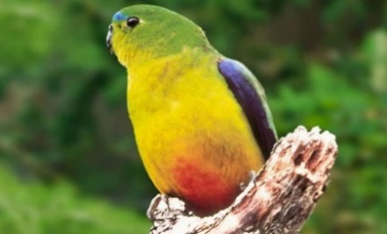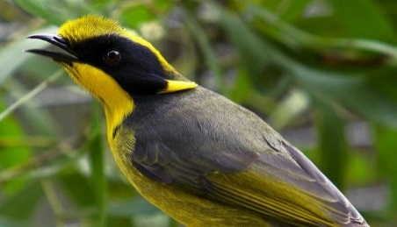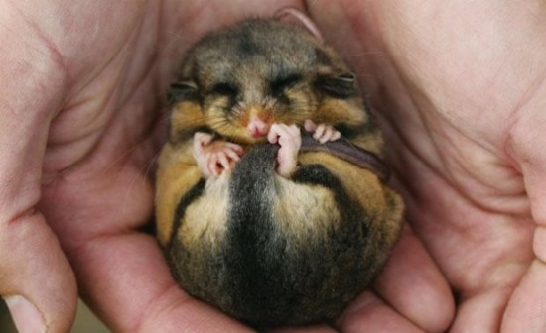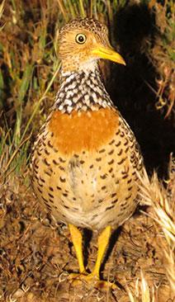

**Figure 2:** *Clockwise from top left: Mountain-pygmy Possum,* *Plains Wanderer, Helmeted Honeyeater, Orange-bellied Parrot.*

*Credit: Zoos Victoria*

## Further Information

For further information on the management of feral cats, including the declaration of the feral cat as an established pest animal in Victoria please visit the [DELWP website](https://www.environment.vic.gov.au/invasive-plants-and-animals/feral-cats).

|  |  |
| --- | --- |
| © The State of Victoria Department of Environment, Land, Water and Planning 2018  LogoThis work is licensed under a Creative Commons Attribution 4.0 International licence. You are free to re-use the work under that licence, on the condition that you credit the State of Victoria as author. The licence does not apply to any images, photographs or branding, including the Victorian Coat of Arms, the Victorian Government logo and the Department of Environment, Land, Water and Planning (DELWP) logo. To view a copy of this licence, visit http://creativecommons.org/licenses/by/4.0/  ISBN 978-1-76077-056-3 (pdf/online/MS word)  Disclaimer  This publication may be of assistance to you but the State of Victoria and its employees do not guarantee that the publication is without flaw of any kind or is wholly appropriate for your particular purposes and therefore disclaims all liability for any error, loss or other consequence which may arise from you relying on any information in this publication. | Accessibility  If you would like to receive this publication in an alternative format, please telephone the DELWP Customer Service Centre on 136186, email [customer.service@delwp.vic.gov.au](mailto:customer.service@delwp.vic.gov.au), or via the National Relay Service on 133 677 [www.relayservice.com.au](http://www.relayservice.com.au). This document is also available on the internet at [www.environment.vic.gov.au](http://www.environment.vic.gov.au) |

1. Legge, S. *et. al* (2017). Enumerating a continental-scale threat: how many feral cats are in Australia? *Biological conservation*, 206, pp.293-303.