|  |
| --- |
| VBA – Upload a Shapefile |
| How to upload a shapefile into the Victorian Biodiversity Atlas |

## This is a basic step by step guidance document to help you upload a shapefile. You can upload a shapefile to create a site boundary or to create a search area. Please note that the shapefile must be an ESRI shapefile and all relevant files associated with the shapefile must be in a zip file.

## *Tips*

*Throughout the VBA each window has a* ***?*** *in the top right hand corner – this is window-specific help that will provide further details about how to complete the fields.*

*Make sure that you have allowed pop-ups from your browser (you will need to allow these from the VBA site)*

*Also, throughout the VBA fields marked with a red dot (●) are mandatory fields and must be completed. The fields marked with a yellow dot (●) are conditional - if you complete one you must complete the others.*

1. Visit VBA (https://vba.dse.vic.gov.au/vba/) and Login using your Login Name & Password.

## Upload a shapefile to create a site boundary

1. Go to Data Entry in the top left screen, and select My Projects. Select an existing project from your list of Projects by clicking pen_pad for the relevant Project, or create a new Project (see Create a Project Help Guide). Click Create New Site.

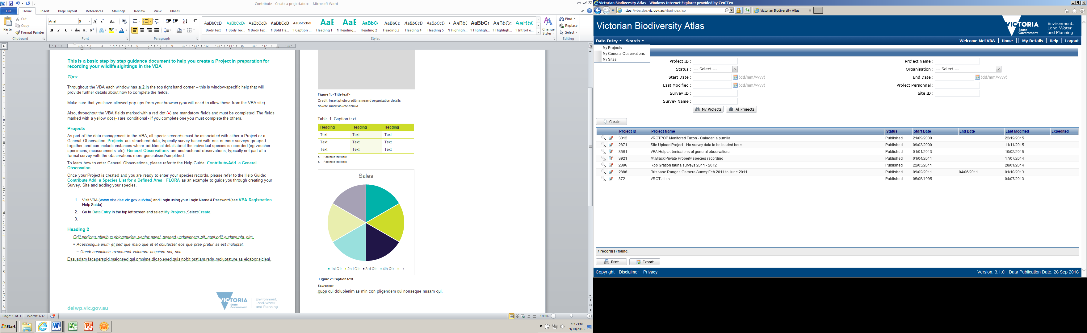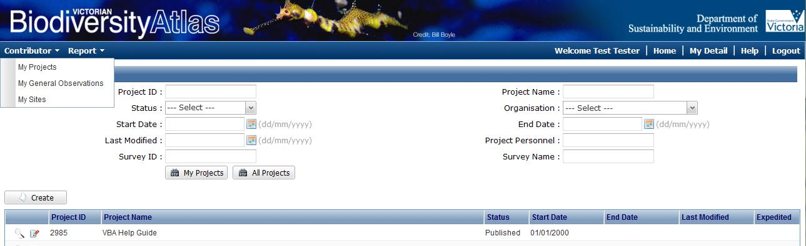

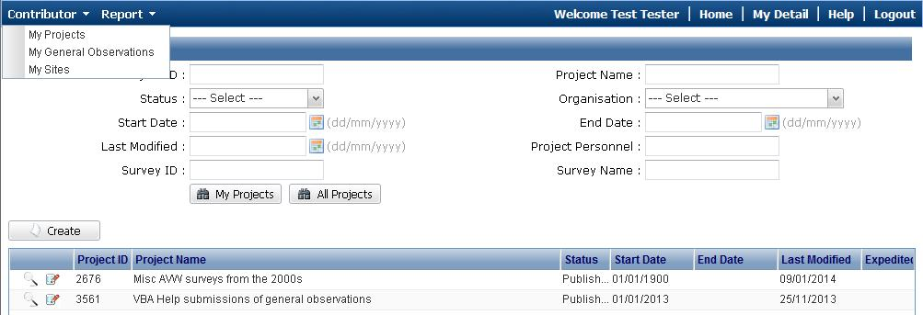

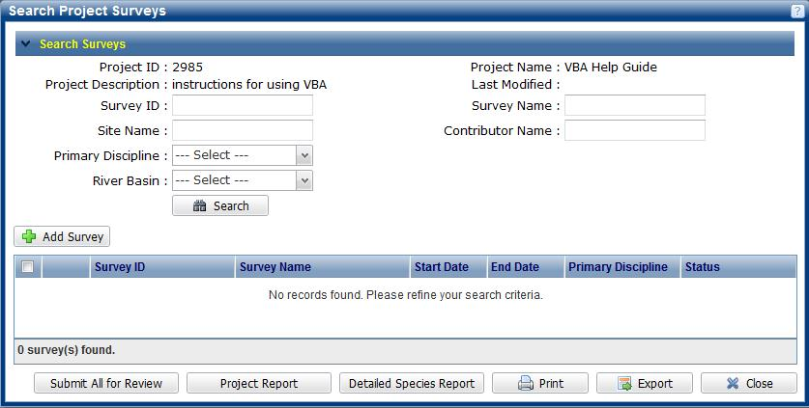

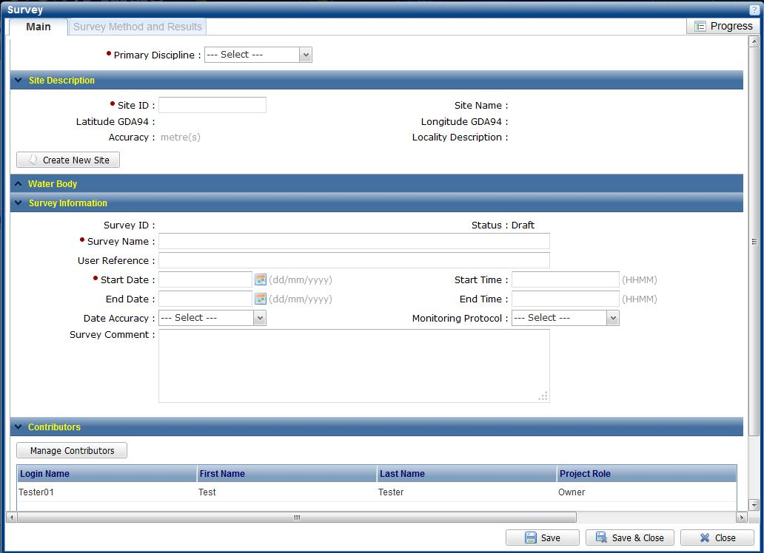

1. Complete the mandatory Site fields: site Name, Locality and Accuracy (in metres).
2. Click Upload.
3. Click Browse and navigate to your zip file containing all the relevant files for your ESRI shapefile.
4. Click Upload and your points, lines or polygons will appear on the map. Select the 1 relevant point, line or polygon to apply to this Site by clicking on it on the map – it will highlight in red when selected. Then click Use Selected.
5. This will centre in on your selected shapefile and you can now click Save. Once the Site ID has been populated Close this screen.

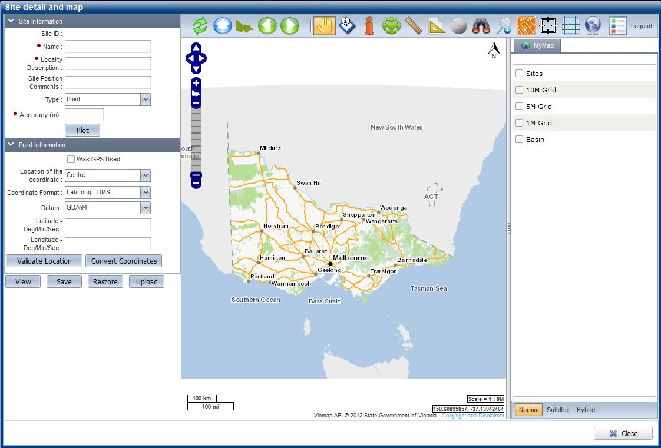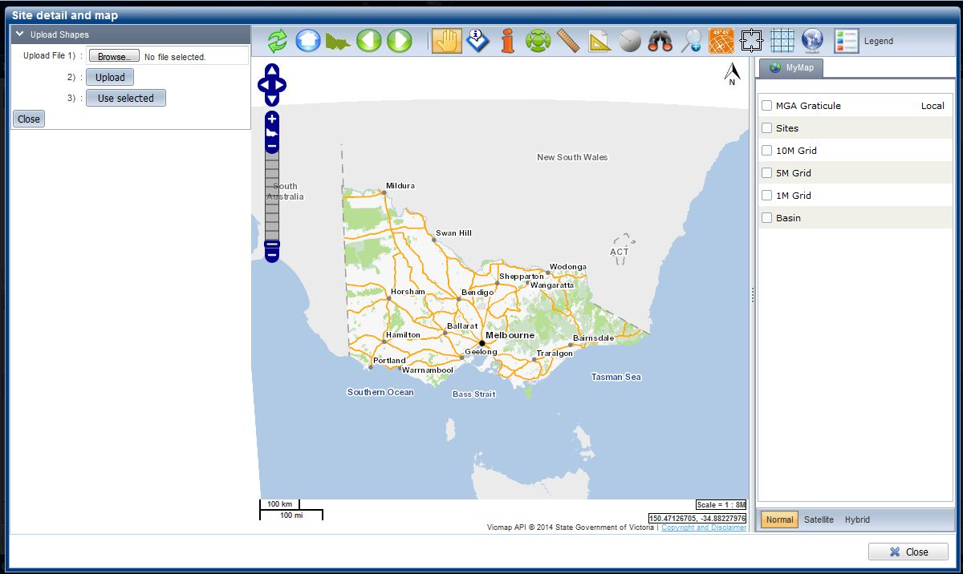

1. Continue to complete the required Survey details and save, or record the Site ID for later use or for use in your Batch Upload file

## Upload a shapefile to create a search area

1. Navigate to the Search section in the top left of the main page and then select Species and Surveys > Species Lists & Maps.
2. From the Select Area pane on the left, click on the drop-down list for Type and select Upload Shape.
3. Click Browse and navigate to your zip file containing all the relevant files for your ESRI shapefile.
4. Click Upload and your points, lines or polygons will appear on the map. Select the 1 relevant point, line or polygon to apply to this search by clicking on it on the map – it will highlight in red when selected. Then click Use Selected.
5. If you’d like to apply a buffer, enter the buffer size (in km) and click Apply Buffer. Contiue on with your search by applying any filters you’d like, select your report type and click Search.

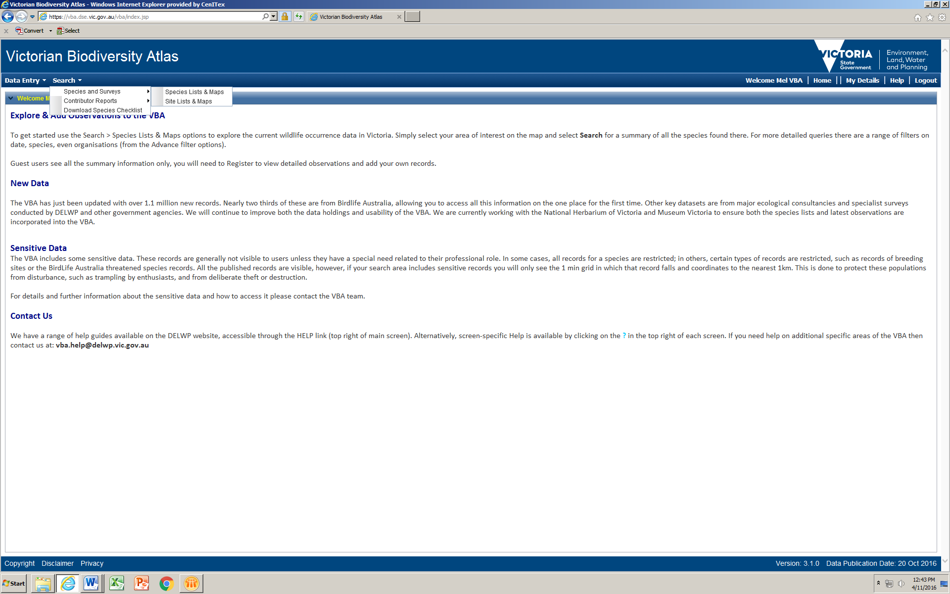

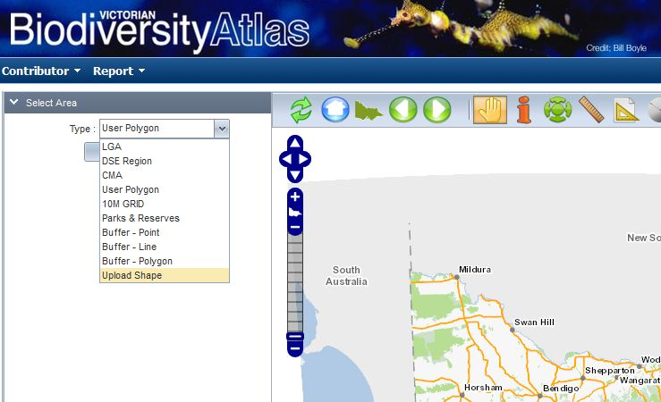

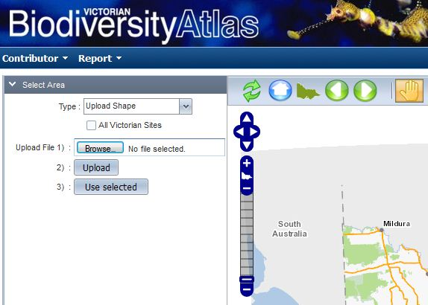

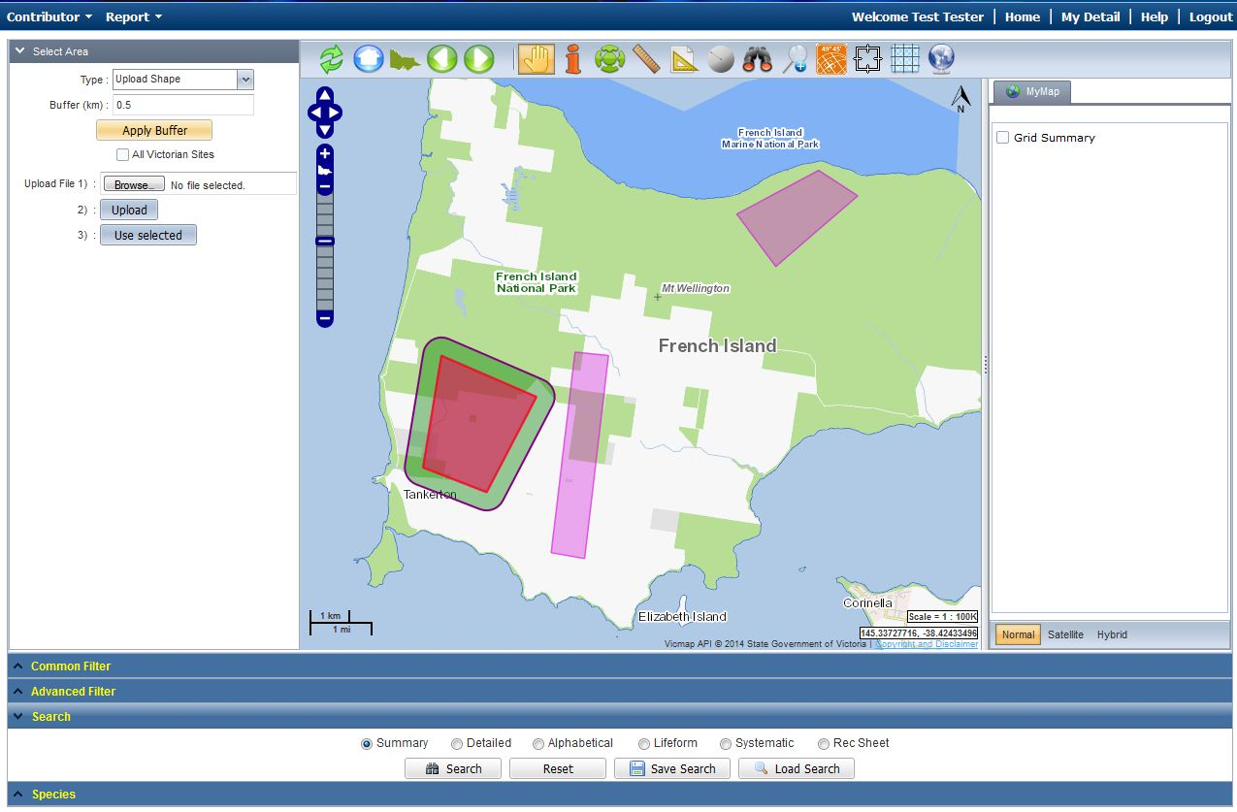

|  |  |
| --- | --- |
| © The State of Victoria Department of Environment, Land, Water and Planning 2017  LogoThis work is licensed under a Creative Commons Attribution 4.0 International licence. You are free to re-use the work under that licence, on the condition that you credit the State of Victoria as author. The licence does not apply to any images, photographs or branding, including the Victorian Coat of Arms, the Victorian Government logo and the Department of Environment, Land, Water and Planning (DELWP) logo. To view a copy of this licence, visit http://creativecommons.org/licenses/by/4.0/  Disclaimer  This publication may be of assistance to you but the State of Victoria and its employees do not guarantee that the publication is without flaw of any kind or is wholly appropriate for your particular purposes and therefore disclaims all liability for any error, loss or other consequence which may arise from you relying on any information in this publication. | Accessibility  If you would like to receive this publication in an alternative format, please telephone the DELWP Customer Service Centre on 136186, email [customer.service@delwp.vic.gov.au](mailto:customer.service@delwp.vic.gov.au) or via the National Relay Service on 133 677 [www.relayservice.com.au](http://www.relayservice.com.au). This document is also available on the internet at [www.delwp.vic.gov.au](http://www.delwp.vic.gov.au). |