2020 Net Gain Accounting Qualitative Update

The Net Gain Accounting First Approximation Report (2008) provided useful insights into the relative amounts and rates of positive and negative contributions to the native vegetation Net Gain objective.

It provided estimates of the overall rate of change in extent and quality of native vegetation on public and private land in Victoria for the year 2007. It was based on once-off modelled native vegetation extent and condition, and a range of assumptions regarding specific transactions and broad changes. As such, the estimates were subject to high variability and poorly quantified levels of uncertainty.
To access the Net Gain Accounting First Approximation Report (2008), go to: Net_Gain_Accounting_-_First_Approximation_Report.pdf (dse.vic.gov.au)
An update to the initial approximation report was produced in 2015 to reflect new data and assess the status of native vegetation at that time.
The purpose of this 2020 update is to provide an indicative scale of the contribution of a range of activities to changes in native vegetation across the state up to the year 2020 (FY 2019/20). This will be used as context to support a future update of Victoria’s native vegetation clearing regulations and the delivery of outcomes under Victoria’s biodiversity strategy.
It uses the following change categories as a basis of comparison:
- Gain activities: Government investment, general management, voluntary actions, improved security, offsets for permitted clearing and unallocated native vegetation credits
- Loss activities: Entitled uses, exemptions, controlled management regimes and insufficient threat management on crown or freehold land, and losses due to permitted clearing
- Neutral activities: wildfire, forest harvesting and regeneration
The analyses of contributions are largely based on the 2008 First Approximation Report with some minor adjustments to reflect changes in assumptions based on recent evidence (indicated in the table below). While the core elements of the analysis remained the same as those used in the earlier report this report uses updated extent and condition models.
This report contains information not included in the 2008 First Approximation Report. The impact of controlled management regimes is included as a loss where the most recent planned burn has resulted in the native vegetation being below the tolerable fire interval. While planned burning may also provide some benefits for native vegetation extent and condition, this relationship needs further investigation and is not included in this report. Controlled management decisions on public land are made in the context of many factors including community health and safety. These decisions and their trade-offs are not within the scope of this report.

Net outcome over time
 | Crown land (Habitat Hectare/ year) |  |  | Freehold land (Habitat Hectare/ year)
 | 2008 | 2015 | 2020 | 2008 | 2015 | 2020
Gains subtotal | +8,760 | +10,500 | +10,260 | +4,560 | +3,100 | +3,090
Losses subtotal | -2,860 | -8,400 | -6,540 | -14,550 | -13,400 | -13,470
Net Outcome | +5,900 | +2,100 | +3,720 | -9,990 | -10,300 | -10,380

Overall position: -6,660 HHa/ year

Summary of native vegetation gains and losses (2020)
Category | Description
For maintenance and improvement gains (where specific estimates can be made)
Government programs on crown land | Where native vegetation actions are being directly undertaken - Areas where specific actions are known in addition to baseline threat surveillance and management in 2020 e.g. weed control or rabbit control, revegetation.  Programs include: Biodiversity Response Planning, the Weeds and Pests on Public Land Program and the Bushfire Biodiversity Response and Recovery Program (BBRR).  This excludes actions that counterbalance impacts of exemptions on crown land.
Government programs on freehold land | Where native vegetation actions are being directly undertaken – Areas where specific actions are known in 2020 (includes previous investment with contracts covering 2020)  Programs include: Biodiversity Response Planning, Commonwealth programs, River Health Program and Peri-urban Weed Management Partnerships (PWMP) program. This also includes areas under Land for Wildlife, existing permanent protection (voluntary or previous investment) through Trust for Nature, Conservation Forest and Lands Act 1987 and land owned and managed by Trust for Nature.
Offsets for permitted clearing | Native vegetation actions being undertaken under agreement in 2020 as offsets for permitted clearing referred to DELWP, Melbourne Strategic Assessment and major projects where data is available. Calculated based on annualised gain.  This figure also includes areas reserved for offsets under the native vegetation regulations which have not yet been credited.
Unallocated native vegetation credits | Areas under management for native vegetation credits that have not yet been allocated as an offset. This also includes land secured under the Melbourne Strategic Assessment and not yet utilised as compensation for clearing.
For maintenance / improvement gains (where broad assumptions only are possible)
Voluntary actions on freehold land | Voluntary actions undertaken but no known link to government funding. Mainly maintenance gain from remnants of variable quality. This is based on the assumption that for each hectare of funded works (see above government investment) there is 0.26 ha of unfunded works (Duncan, Garreth, Morris & Smith 2013). Previous assumption approach in 2008 was one to one ratio.
For security gains (where specific estimates can be made)
Crown land | Private land or state forest added to reserve system since 2002. Average habitat score of site estimated to be 0.6. Security gain (10% of habitat score) annualised over 25 years – and gain recorded as part of net gain for 25 years. Previously in 2008 the security gain was 40% of habitat score.
Freehold land | Freehold land placed under permanent protection agreements registered on title in the year of the report through Trust for Nature or under the Conservation, Forests and Lands Act. These areas are included in the figure under “Government programs on freehold land” There is also security gain associated with unallocated native vegetation credits under the native vegetation regulations.
Losses (where broad assumptions only are possible)
Impacts of controlled management regimes on crown land | Areas of native vegetation that are under a regime where the most recent planned burn has resulted in the native vegetation being below the tolerable fire interval.
Insufficient management of threats on crown land | Areas of native vegetation on crown land where no baseline threat surveillance and management is undertaken (mainly lower priority areas). Assumed to occur in 5% of largely intact landscapes and 95% of native vegetation on crown land in fragmented landscapes.
Entitled uses, exemptions, and insufficient management of threats on freehold land | Entitled uses (e.g. grazing, removal of trees/ fallen logs for personal use), unmanaged threats beyond legislative obligations (e.g. environmental weeds) or clearing that is exempt from requiring a permit (e.g. fences, fire protection). Assumed to apply to freehold land in fragmented landscapes that is not covered by the area of investment or voluntary actions on freehold land.
Impacts of exemptions on crown land | Clearing on crown land that is exempt from requiring a permit e.g. strategic fuelbreaks, fences, strategic fire access roads (to meet fire standards), new recreation assets (e.g. walking tracks), and the removal of hazardous fire damaged trees.
Losses due to permitted clearing on freehold land | Estimates of clearing of native vegetation from 2019/20 permits referred to DELWP, Melbourne Strategic Assessment and major projects where data are available.
Losses detected from satellite imagery (could be some permitted clearing | Where remote-sensing reductions in extent have taken place, although this has not been ground-truthed. This is determined through comparing satellite imagery at different points in time. This may account for natural recovery and unaccounted for degradation over time if extent is impacted.  As with past calculations, this value is too course to be included in Net outcome over time.

Summary of native vegetation gains and losses (in Habitat Hectares)
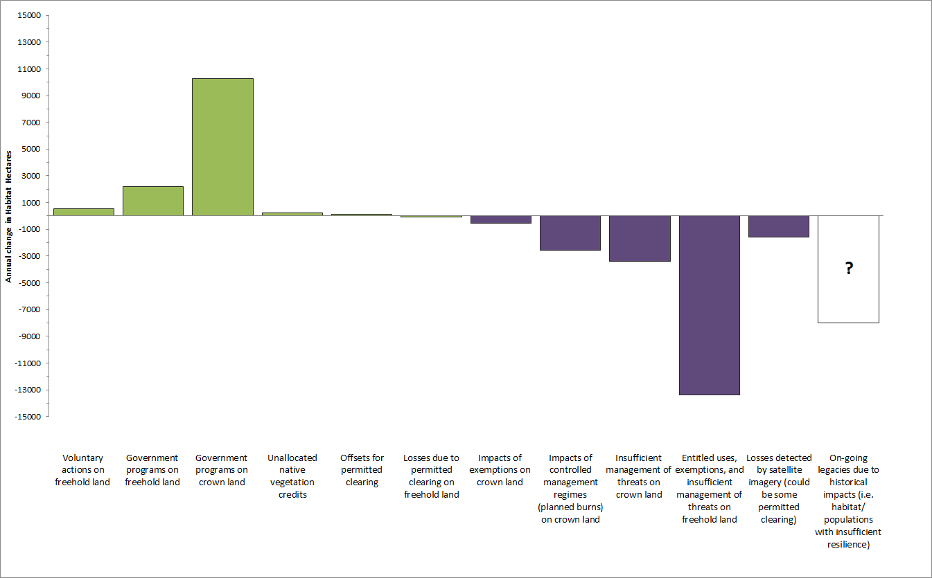

Progress with addressing information limitations (2020)
The First Approximation Report (2008) recommended a range of new information requirements to address limitations with that report. While some progress in improving the information has been made, these limitations remain valid:
- Better operational information on specific transactions – investment, permitted clearing and exemptions.
- New imagery and training data acquired at regular intervals to allow comparison across time of broad changes in extent and condition.
- Further research or activities to test the assumptions used to determine impact of management actions on change in vegetation.

Specific transactions – need for improved data on impacts to condition and extent
Reporting on government investment activity has improved since 2008 but is still not comprehensive. Work is continuing to more thoroughly report on government ‘transactions’ such as those by DELWP, Parks Victoria, NGOs and CMAs. Additional and improved data must be acquired to report more comprehensively and accurately in the future. There remains limited availability of data on some native vegetation losses such as hazardous tree removal, permitted clearing through Local Government approvals, clearing under exemptions on freehold land and illegal clearing. The Native vegetation removal regulations - Crown land exemption reports released for 2018/19 and 2019/20 detail impacts under the exemptions on Crown Land. Future reporting will include actions to counterbalance exemptions on crown land once data quality is improved.

Broad Changes - extent
DELWP has developed new information on trends in native vegetation extent and land use from 1987-2019, broken into 7 epochs. The acquisition of landsat (satellite) imagery, together with existing and a small amount of new training data, has provided a basis for modelling the distribution of native vegetation from a range of variables derived from satellite data sets. Training data is used to predict the relationship between the satellite imagery and native vegetation extent. The 7 epochs of satellite imagery enables the quantification of how vegetation extent has changed across Victoria since 1987

Broad Changes - condition
Plot-based vegetation surveys continue to be conducted across Victoria, and new remote-sensed data are regularly captured, such that the raw data for updated condition mapping have accumulated since 2008. This data is however limited in the number and location of surveys, with increased targeted surveys needed to improve the condition layer and enable a time series analysis for future reporting.
A new spatially-explicit, state-wide representation of habitat condition for the current period (2019/20), has been developed. This new model provides a methodology and approaches that can be updated every few years to track condition change.

Test the assumptions
There have been some activities to test assumptions on the impact of management actions on native vegetation through various DELWP programs and initiatives. DELWP has developed a framework and standards for monitoring native vegetation to inform management effectiveness studies and to help test assumptions.

