## Introduction

Biodiversity Response Planning (BRP) is a long-term area-based planning approach to biodiversity conservation in Victoria. It is designed to strengthen alignment, engagement and participation between government, Traditional Owners, non-government agencies and the community.

DELWP Regional staff have been working with stakeholders on actions to conserve biodiversity in specific landscapes, informed by the best available science and local knowledge.

These Fact Sheets capture a point in time, reflecting data and knowledge available in 2020. They provide information for many (but not all) landscapes across Victoria, containing general information on the key values and threats in each area, as well as the priority cost-effective actions that provide the best protection of biodiversity. Fact Sheets are intended to provide useful biodiversity information for the community, non-government and government organisations during project planning and development.

Further information and the [full list of Fact Sheets](http://www.environment.vic.gov.au/biodiversity/working-together-for-biodiversity) is available on the Department’s Environment website.

## Landscape description

This 2,617ha narrow strip of land follows the Yarra River from just below Pound Bend to Port Phillip Bay. The landscape reaches about 180m from the riverbank, has 46% native vegetation and is 45% public land.

*Note: Yarra River South West bisects the Melbourne – Inner Urban, North and East landscape.*

## Cultural importance

We recognise that the entire landscape has high cultural value for Traditional Owners. Some landscapes have notable cultural importance based on knowledge shared by Traditional Owners. This landscape includes lands of the Wurundjeri people and the Bunurong people.

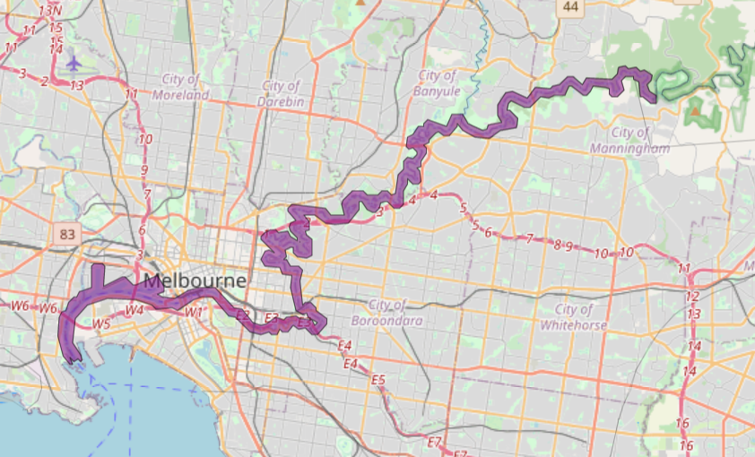Figure 1: Map showing location of Yarra River South West landscape (purple).

|  |
| --- |
| Habitat Distribution Models identify 0 species with more than 5% of their Victorian range in this landscape |
| * Plant0 Plant species with more than 5% of their Victorian range in this landscape * Notable species: Kilsyth South Spider-orchid (endangered, 2.2% statewide range in area), Slender Bitter-cress (poorly known, 2.0% statewide range in area), Silurian Striped Greenhood (endangered, 1.6% statewide range in area), Tall Club-sedge (poorly known, 1.1% statewide range in area), Clustered Lily (rare, 1.0% statewide range in area) |
| * Rat0 Mammal species with more than 5% of their Victorian range in this landscape * Notable species: Grey-headed Flying-fox (vulnerable, 0.33% statewide range in area) |
| * Snake0 Reptile species with more than 5% of their Victorian range in this landscape * Notable species: Eastern Snake-necked Turtle (data deficient, 0.35% statewide range in area), Grass skink FORM (P.pag/cry) (0.29% statewide range in area), Metallic Skink (0.17% statewide range in area), Glossy Grass Skink (vulnerable, 0.14% statewide range in area) |
| * Sparrow0 Bird species with more than 5% of their Victorian range in this landscape * Notable species: Eastern Koel (1.3% statewide range in area), Black-faced Cormorant (near threatened, 0.43% statewide range in area), Sooty Oystercatcher (near threatened, 0.39% statewide range in area), Red Knot (endangered, 0.38% statewide range in area), Pacific Gull (near threatened, 0.38% statewide range in area) |
| * Frog0 species of amphibians with more than 5% of their Victorian range in this landscape * Notable species: Pobblebonk Frog (*Limnodynastes dumerilii insularis*, 0.12% statewide range in area), Growling Grass Frog (endangered, 0.09% statewide range in area), Southern Toadlet (vulnerable, 0.07% statewide range in area) |

## Strategic Management Prospects

Strategic Management Prospects (SMP) models biodiversity values such as species habitat distribution, landscape-scale threats and highlights the most cost-effective actions for specific locations. More information about SMP is available in [NatureKit](https://www.environment.vic.gov.au/biodiversity/naturekit).

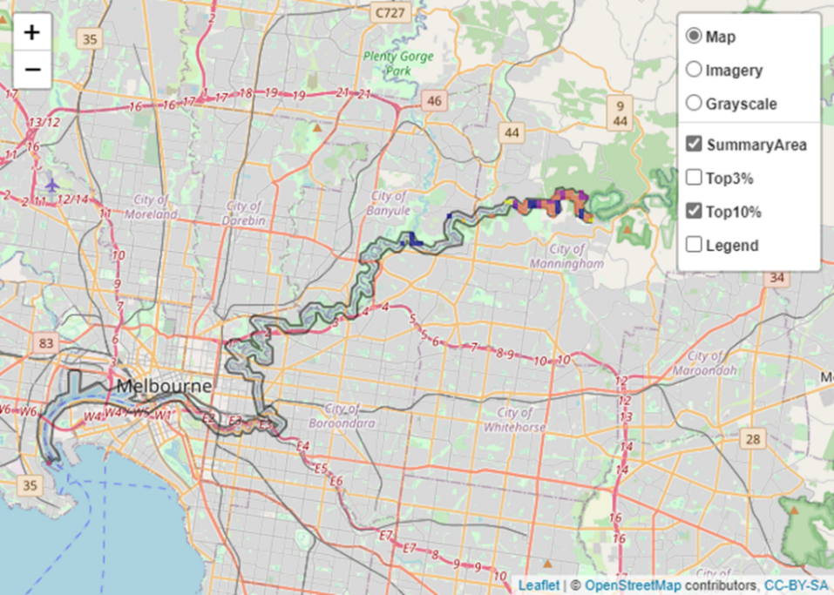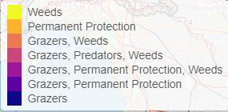Areas of Yarra River South West shown in Figure 2 have highly cost-effective actions (within the top 10% of cost-effectiveness for that action across the state) that provide significant benefit for biodiversity conservation.

Figure 2: The SMP priority actions which rank among the top 10% for cost-effectiveness of that action across the state. “Grazers” includes deer, domestic grazing, goats, horses, over-abundant kangaroos, pigs, rabbits and total grazing pressure

|  |  |  |
| --- | --- | --- |
| **Actions with area in the top 3% and top 10%** | | |
| Specific Action | Area in top 3% (ha) | Area in top 10% (ha) |
| Control Rabbits | 44 | 290 |
| Control Weeds | 0 | 216 |
| Domestic Grazing Control | 5 | 133 |
| Permanent Protection | 6 | 736 |
| Control Foxes | 0 | 12 |
| Control Cats | 0 | 12 |
| Revegetation | n/a | 6 |

|  |  |
| --- | --- |
| The most cost-effective actions for flora & fauna | |
| Plant | **Plants - Control weeds** |
| SparrowRatFrogSnake | **Birds, Mammals, Amphibians and Reptiles - Control domestic stock grazing** |

For a further in depth look into SMP for this landscape, please refer to [NatureKit](https://www.environment.vic.gov.au/biodiversity/naturekit).

## Current actions in Yarra River South West

|  |  |  |
| --- | --- | --- |
| Specific Actions | Current actions – top 10% (ha) | Current actions – outside top 10% (ha) |
| Rabbit Control | 112 | 228 |
| Weed Control | 20 | 9 |
| Fox Control | 5 |  |

Current actions – top 10% = The area (ha) of the specific action currently occurring in locations identified by SMP as being in the top 10% for cost-effectiveness for that action across the state

Current actions – outside top 10% = The area (ha) of the specific action currently occurring in locations within this landscape that are **not** identified by SMP as being in the top 10% for cost-effectiveness for that action across the state

## What you told us

SMP is just one tool to use in the process of understanding biodiversity values. Feedback from our stakeholders is also vitally important and forms the basis of our understanding of knowledge gaps.

### Stakeholder interest

##### Important landscapes

* Annulus Billabong Yarra Flats
* Banyule Flats Billabong
* Bolin Bolin Billabong
* Burke Road Billabong
* Hays Paddock Billabong
* Westgate Park Wetlands
* Yarra River Estuary
* Lenister Farm
* Yarra Bend Park

##### Current activities/programs/partnerships

* Port Phillip and Westernport CMA Regional Catchment Strategy – Naturelinks – Middle Yarra (concept phase)
* DELWP Shrine to Sea project
* Various Friends of groups, Landcare groups and other community groups focusing on biodiversity conservation
* Trust for Nature land covenanting program

### Additional threats

Threats identified through the consultation process (in addition to those modelled in SMP):

* High development pressures
* Invasive weeds
* Climate change
* Stormwater runoff
* Altered flow regimes
* Pollution