Introduction
Biodiversity Response Planning (BRP) is a long-term area-based planning approach to biodiversity conservation in Victoria. It is designed to strengthen alignment, engagement and participation between government, Traditional Owners, non-government agencies and the community.
DELWP Regional staff have been working with stakeholders on actions to conserve biodiversity in specific landscapes, informed by the best available science and local knowledge.
These Fact Sheets capture a point in time, reflecting data and knowledge available in 2020. They provide information for many (but not all) landscapes across Victoria, containing general information on the key values and threats in each area, as well as the priority cost-effective actions that provide the best protection of biodiversity. Fact Sheets are intended to provide useful biodiversity information for the community, non-government and government organisations during project planning and development.
Further information and the full list of Fact Sheets is available on the Department’s Environment website.

Landscape description
Wilkin Heathy Woodlands focus landscape is 58,754ha in size with 45% native vegetation cover remaining. Public land makes up 39% of the area.
Current ecological modelling shows Wilkin Heathy Woodlands focus landscape occurs largely in the Glenelg Plain Bioregion with a significant portion of the eastern extent occurring in the Dundas Tablelands Bioregion. The landscape has over 11,600ha of threatened Ecological Vegetation Classes (EVC) with Heathy Herb-rich Woodland, Damp Heathland/Damp Heathy Woodland Mosaics and Damp Sands Herb-rich Woodland EVCs dominating the remnant patches of native vegetation. The Victorian Biodiversity Atlas has records of 18 federally protected species, 33 state protected species and 83 rare or threatened species on the Victorian Advisory List occurring within the landscape.
The Gunditj Mirring Traditional Owner Aboriginal Corporation are Traditional Custodians of this focus landscape with current stakeholders including Birdlife Australia, Glenelg Hopkins Catchment Management Authority, Glenelg Shire Council, Greening Australia, Nature Glenelg Trust, Parks Victoria, Regional Roads Victoria, South West Environmental Alliance, Trust for Nature and Wannon Water.

Cultural importance
The Wilkin Heathy Woodland Focus Landscape may have been recognised by its Traditional Owners as occurring on Bocara Woorowwarook Mirring (River Forest Country)¹. Central to this focus landscape is the Bocara (Glenelg River), its tributaries and several wetlands which are scattered throughout the Forest Country¹. This section of the Glenelg River is also listed and protected under the Heritage Rivers Act 1992².

Stakeholder interest
There are numerous valuable ecological assets present in this focus landscape, including those identified by Traditional Owners, partners and community.

0BEcological Values identified by Traditional Owners, partners and community within this focus landscape
Nationally Important Wetland including the Lindsay Werrikoo Wetlands, Mundi-Selkirk Wetlands, Barrys Swamp and Bushland Reserve, Pieracle Swamp Wildlife Reserve, Red Hill Swamp Wildlife Reserve, and Burgess Swamp Wildlife Reserve | Glenelg River and Glenelg River Streamside Reserves
Stokes River and Stokes River Streamside Reserves | Killara State Forest
Wilkin Flora and Fauna Reserve | Mocamboro Flora Reserve
Weecurra State Forest | Winnap State Forest
Wilkin Flora and Fauna Reserve

Habitat Distribution Models identify 34 species with more than 5% of their modelled Victorian range in this focus landscape | Threatened terrestrial species within this Focus Landscape requiring specific actions other than those identified in Strategic Management Prospects (SMP)
30 plants, notably:  - Mellblom's Spider-orchid (Endangered)  - Bearded Flat-sedge (Vulnerable)  - Clustered Daisy-bush (Vulnerable)  - Heathy Guinea-flower (Vulnerable) | Mellblom's Spider-orchid  Bearded Flat-sedge  Eichler's Raspwort  Hairy Boronia  Heath Mouse
1 mammal
- Heath Mouse (Near threatened)
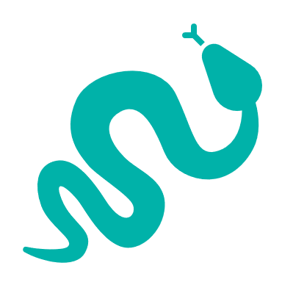
1 reptile
- Striped Worm-Lizard (Near threatened)
1 bird.
- South-eastern Red-tailed Black-Cockatoo (Endangered)
1 amphibian
- Southern Smooth Froglet

Strategic Management Prospects
Strategic Management Prospects (SMP) models biodiversity values such as species habitat distribution, landscape-scale threats and highlights the most cost-effectiveness action for specific locations. For a further in depth look into SMP for this landscape please refer to NatureKit.

Which landscape-scale actions are most cost-effective in this landscape?
The coloured areas in the map below indicate where the identified landscape-scale actions are most cost-effective and will maximise biodiversity benefit across Victoria for multiple species.
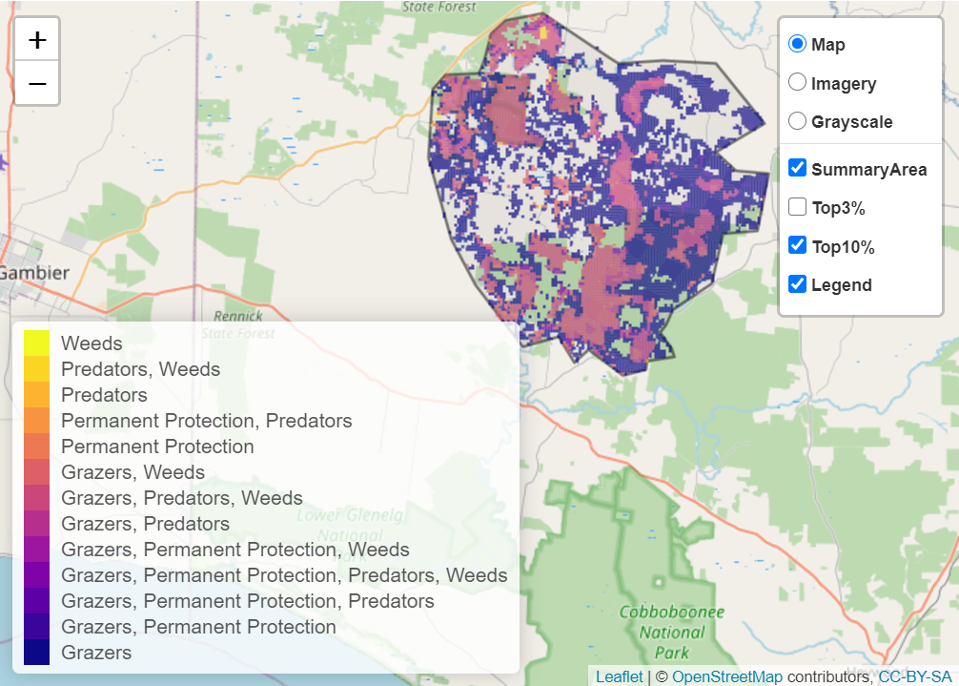

The main SMP priority actions within this focus landscape which rank among the top 10% for cost-effectiveness are listed on the right:
Control Pigs 37,842ha
Control Overabundant Kangaroos 16,713ha
Control Rabbits 15,174ha
Control Deer 14,385ha
Control Cats 11,905ha
Control Foxes 11,880ha
Control Weeds 10,533ha

Within this landscape, pig control, permanent protection (562ha), overabundant kangaroo control, deer control, weed control and rabbit control were also identified among the top 3% for cost-effectiveness.

Additional threats and considerations
Threats and considerations (in addition to those modelled in SMP) identified by Traditional Owners, partners and community groups during the BRP process for this focus landscape were:
Threats | Ecological processes and values requiring further considerations
Climate change | Appropriate burning regimes
Stock access to riparian and wetland areas | Wetland hydrology
Altered hydrology | Groundwater-dependent ecosystems
 | Aquatic/riparian species and catchment influences
 | Indicator species and ecosystem engineers
 | Mass defoliation events by invertebrates

References
- Parks Victoria, 2015. Ngootyoong Gunditj Ngootyoong Mara-South West Management Plan.
- Glenelg Hopkins Catchment Management Authority, 2013. Glenelg Hopkins Regional Catchment Strategy: https://info.ghcma.vic.gov.au/wp-content/uploads/2017/04/11259_GHCMA_RSC_WEB.pdf

