Introduction
Biodiversity Response Planning (BRP) is a long-term area-based planning approach to biodiversity conservation in Victoria. It is designed to strengthen alignment, engagement and participation between government, Traditional Owners, non-government agencies and the community.
DELWP Regional staff have been working with stakeholders on actions to conserve biodiversity in specific landscapes, informed by the best available science and local knowledge.
These Fact Sheets capture a point in time, reflecting data and knowledge available in 2020. They provide information for many (but not all) landscapes across Victoria, containing general information on the key values and threats in each area, as well as the priority cost-effective actions that provide the best protection of biodiversity. Fact Sheets are intended to provide useful biodiversity information for the community, non-government and government organisations during project planning and development.
Further information and the full list of Fact Sheets is available on the Department’s Environment website.

Landscape description
Budj Bim Volcanics focus landscape is 15,512ha in size with 73% native vegetation cover remaining. Public land makes up 46% of the area.
Current ecological modelling shows the Budj Bim Volcanics focus landscape occurring within the Victorian Volcanic Plain Bioregion and bounded along its southern and eastern extents by the Warrnambool Plain. The landscape has over 13,000ha of threatened Ecological Vegetation Classes (EVC) and is largely dominated by Stony Rises Woodland with scattered Deep and Shallow Freshwater Marsh EVCs found throughout. The Victorian Biodiversity Atlas has records of 9 federally protected species, 26 state protected species and 60 rare or threatened species on the Victorian Advisory List occurring within the landscape.
The Gunditj Mirring Traditional Owner Aboriginal Corporation are Traditional Custodians of this focus landscape, with current stakeholders including Basalt to Bay Landcare Network, Birdlife Australia, Glenelg Hopkins Catchment Management Authority, Glenelg Shire Council, Greening Australia, Moyne Shire Council, Nature Glenelg Trust, Parks Victoria, Regional Roads Victoria, Trust for Nature and Wannon Water.

Cultural importance
Budj Bim is recognised by the Gunditjmara as occurring on Tungatt Mirring (Stone Country) ¹ and is the source of the Tyrendarra lava flow. The wetlands, lakes and stony rises that occur throughout the Budj Bim Volcanics focus landscape are a result of past volcanic eruptions². Budj Bim and the Tungatt Mirring are an integral part to the story of the Gunditjmara people and their way of life for thousands of years², which is recognised internationally through UNESCO World Heritage listing of the Budj Bim Cultural Landscape as a place of unique cultural significance, being home to one of the world’s largest and oldest aquaculture systems³.

Stakeholder interest
There are numerous valuable ecological assets present in this focus landscape, including those identified by Traditional Owners, partners and community.

0BEcological Values identified by Traditional Owners, partners and community within this focus landscape
World Heritage Budj Bim Cultural Landscape – Tungatt Mirring (Stone Country) | Woodlands, wetlands and lakes
Nationally Important Wetland: Lake Condah | Condah Mission
Budj Bim National Park | Homerton Swamp
Tyrendarra Flora Reserve | Darlots Creek
Fitzroy River | Eumeralla River
Dunmore Bushland Reserve | Lake Gorrie and other wetlands

Habitat Distribution Models identify 1 species with more than 5% of its modelled Victorian range in this focus landscape | Threatened terrestrial species within this focus landscape requiring specific actions other than those identified in Strategic Management Prospects (SMP)
1 plant  - Annual Bitter-cress (Vulnerable) | Annual Bitter-cress

Strategic Management Prospects
Strategic Management Prospects (SMP) models biodiversity values such as species habitat distribution, landscape-scale threats and highlights the most cost-effectiveness action for specific locations. For a further in depth look into SMP for this landscape please refer to NatureKit.

Which landscape-scale actions are most cost-effective in this landscape?
The coloured areas in the map below indicate where the identified landscape-scale actions are most cost-effective and will maximise biodiversity benefit across Victoria for multiple species.
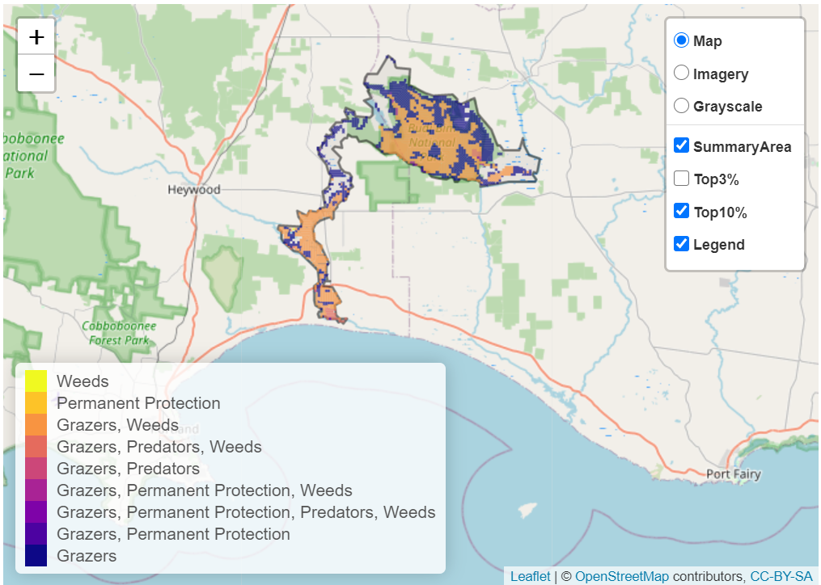

The main SMP priority actions within this focus landscape which rank among the top 10% for cost-effectiveness are listed on the right:
Control Rabbits 8,465ha
Control Pigs 7,641ha
Control Goats 5,914ha
Control Weeds 4,903ha
Control Deer 4,357ha

Within this landscape, rabbit control, pig control, goat control and permanent protection (52ha) were also identified among the top 3% for cost-effectiveness.

Additional threats and considerations
Threats and considerations (in addition to those modelled in SMP) identified by Traditional Owners, partners and community groups during the BRP process for this focus landscape were:
Threats | Ecological processes and values requiring further considerations
Climate change | Wetland hydrology
Habitat clearing | Groundwater-dependent ecosystems
Altered hydrology | Aquatic/riparian species and catchment influences
Koala over-browsing | Cultural heritage site
 | Indicator species and ecosystem engineers
 | Appropriate burning regimes

References
- Parks Victoria, 2015. Ngootyoong Gunditj Ngootyoong Mara-South West Management Plan.
- Gunditj Mirring Traditional Owners Aboriginal Corporation, 2014. Budj Bim Master Plan, 2014, report prepared by Tract Consultants Pty Ltd
- UNESCO, 2019. Budj Bim Cultural Landscape - World Heritage Centre: https://whc.unesco.org/en/list/1577/

