delwp.vic.gov.au

|  |
| --- |
| Biodiversity Response Planning  Co-design Overview Report |
|  |
| February 2018 |

|  |  |
| --- | --- |
|  |  |

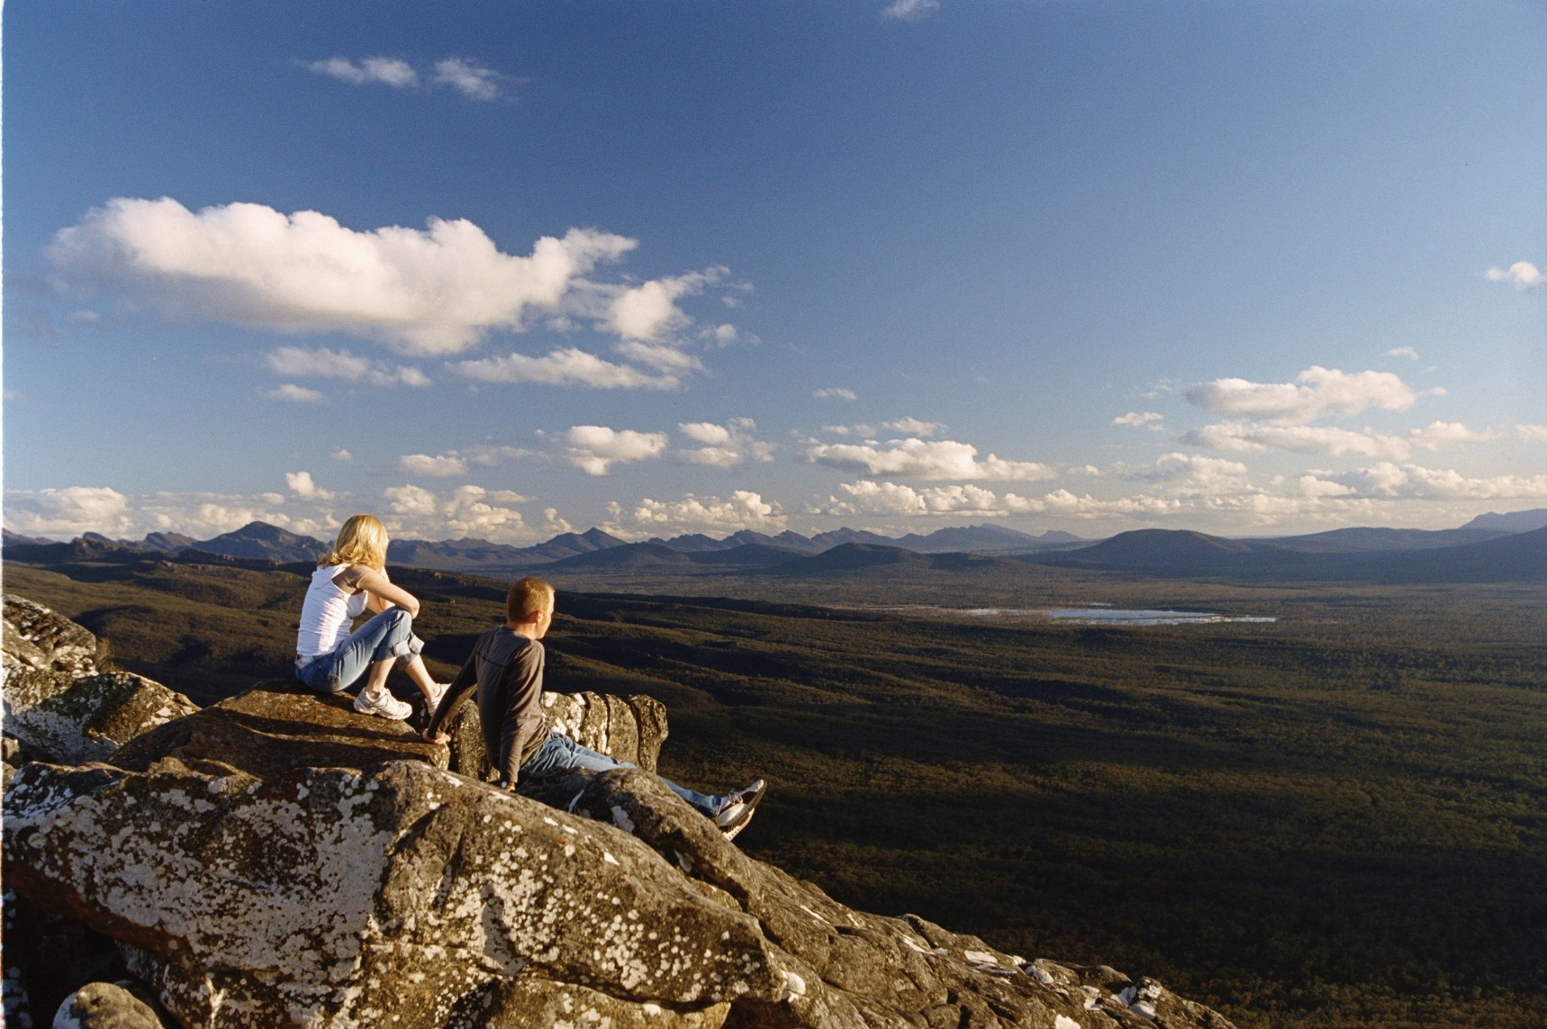

|  |  |  |  |
| --- | --- | --- | --- |
|  |  |  |  |
|  |  |  |  |

Photo credit

Cover image sourced from Parks Victoria

|  |
| --- |
| © The State of Victoria Department of Environment, Land, Water and Planning 2017  LogoThis work is licensed under a Creative Commons Attribution 4.0 International licence. You are free to re-use the work under that licence, on the condition that you credit the State of Victoria as author. The licence does not apply to any images, photographs or branding, including the Victorian Coat of Arms, the Victorian Government logo and the Department of Environment, Land, Water and Planning (DELWP) logo. To view a copy of this licence, visit <http://creativecommons.org/licenses/by/4.0/>  ISBN 978-1-76077-004-4 (pdf/online/MS word)  Disclaimer  This publication may be of assistance to you but the State of Victoria and its employees do not guarantee that the publication is without flaw of any kind or is wholly appropriate for your particular purposes and therefore disclaims all liability for any error, loss or other consequence which may arise from you relying on any information in this publication.  Accessibility  If you would like to receive this publication in an alternative format, please telephone the DELWP Customer Service Centre on 136186, email [customer.service@delwp.vic.gov.au](mailto:customer.service@delwp.vic.gov.au), or via the National Relay Service on 133 677 [www.relayservice.com.au](http://www.relayservice.com.au). This document is also available on the internet at [www.delwp.vic.gov.au](http://www.delwp.vic.gov.au). |

|  |
| --- |
| Biodiversity Response Planning  Co-design Overview Report |

Acknowledgements

|  |  |  |  |
| --- | --- | --- | --- |
|  |  |  |  |

The Department of Environment, Land, Water and Planning (DELWP) would like to acknowledge the significant contributions of Traditional Owners and Aboriginal Victorians, volunteers and community groups, non-government organisations, government and environment portfolio agencies who generously contributed their knowledge and perspectives to co-design Biodiversity Response Planning for Victoria.

|  |
| --- |
|  |

Contents

1. Introduction 1

1.1 Background 1

PART A: The Co-design 2

2. Co-design Process 2

2.1 Objectives 2

2.2 Participants 3

2.3 Methods 4

2.4 Workshop Management Challenges 6

2.5 Online tools 7

2.6 Evaluation 8

PART B: Biodiversity Response Planning foundations 9

3. Biodiversity Response Planning introduction 9

3.1 Why a new approach is needed 9

3.2 BRP Vision of Success 10

3.3 BRP definition 10

3.4 BRP phases 11

4. BRP Areas 12

5. Strategic Decision Making 15

5.1 An area based response to targets 15

5.2 Project Criteria for Phase 1 investment process (2017-18) 16

6. Governance, collaboration and partnerships 19

6.1 Objectives for collaboration and partnerships 19

6.2 Governance 20

6.3 BRP Roles and responsibilities 20

7. Stakeholders 23

8. Evaluation of Biodiversity Response Planning 27

9. Workplan 31

10. Resources 32

Appendix A. Organisations that participated in BRP co-design workshops 33

Appendix B. Negotiables and non-negotiables 35

Appendix C. BRP Steering Committee Terms of Reference 37

# Introduction

## Background

The Victorian Government released a 20-year biodiversity plan for Victoria titled *Protecting Victoria’s Environment – Biodiversity 2037* (Biodiversity 2037) on 4 April 2017.

Biodiversity 2037 states that “Victoria’s approach to biodiversity conservation needs to be modernised, with more inclusive collaboration between stakeholders to drive alignment, accountability and measurable improvement”. It proposes a new approach – called Biodiversity Response Planning (BRP).

The relevant priorities from Biodiversity 2037 that relate to BRP are:

* Priority 12. Adopt a collaborative biodiversity response planning approach to drive accountability and measurable improvement.
* Priority 13. Support and enable community groups, Traditional Owners, non-government organisations and sections of government to participate in biodiversity response planning.

The aims of Biodiversity Response Planning are to:

* strengthen participation, collaboration and alignment between government agencies, Traditional Owners, non-government agencies (NGOs) and the community, at a range of levels and scales to drive alignment, accountability and measurable improvement in biodiversity conservation; and
* deliver a statewide investment prospectus, organised by area, which will help guide investment decisions for institutions, organisations and funding streams over the long term, based on collective identification of priority on ground actions that contribute to the targets of Biodiversity 2037.

To determine how BRP should work in practice, the Department of Environment, Land, Water and Planning (DELWP) invited stakeholders and partners with an interest in biodiversity planning and management to come together and co-design the BRP process.

A series of workshops were held over October and November 2017, facilitated by Capire Consulting, appointed by DELWP to design and run the co-design process. Part A of this report describes the co-design process. Part B describes the outputs of the co-design process that set the foundations and direction for BRP. Documents to guide BRP implementation are being developed based on these outputs.

# PART A: The Co-design

# Co-design Process

This summary provides an outline of the Biodiversity Response Planning (BRP) co-design workshops. It covers the objectives of the workshops, the programming and some of the key challenges faced through the process and the solutions used to overcome them.

## Objectives

The BRP co-design workshops were underpinned by a set of objectives that were developed in the initial project planning phase, prior to the workshops. These objectives required the co-design process to be:

* Inclusive: the process includes experience, expertise and insights from all key stakeholder groups.
* Iterative: ideas and solutions are continually tested and evaluated with participants.
* Transparent: the co-design process, including rationale, progress and outcomes are shared and owned by participants.
* Enabling: there will be support in various forms available to all participants to address any barriers to participation.
* Respectful: all participants are considered experts and their input is valued.
* Innovative: participants can be creative and identify new ideas and approaches.
* Non-threatening: the process creates a safe space for participants to test their own assumptions.
* Outcomes focused: the process is designed to achieve a defined outcome/s.
* Accountable and measurable: participants are accountable for achieving the defined outcomes.

To test whether the workshops met these objectives, participants completed an evaluation at the end of each workshop. Participants rated the following questions on a scale of 1 – 5, with one being poor and five excellent. Below is a summary of participant responses, with an average of twenty responses across four workshops.

|  |  |
| --- | --- |
| **Evaluation Measure** | **Result** |
| How well did we ensure different experiences, insights and expertise were captured during the workshops? | 3.9 |
| How well did we share the rationale, progress and outcomes of the workshop with participants? | 4.0 |
| How well did we deliver the outcomes of the workshop? | 4.0 |
| How well did we create a space that all participants could feel safe, comfortable and able to participate in? | 4.3 |
| How well did we manage the workshop including RSVP process, registration and organisation on the day? | 4.3 |
| Did you feel your input was valued throughout the workshop activities? | 4.1 |

## Participants

The co-design of BRP generated a significant amount of interest and not everyone that wanted to attend could be included. Participants were selected from across the biodiversity sector based on the following criteria:

* currently involved in on-ground biodiversity planning and activity
* represent a cross section of biodiversity interests: Terrestrial, Marine/Coastal and Waterways
* represent a geographical spread of Victorian locations
* include at least 50% from community and non-government organisations
* can share a range of experiences, expertise and interests in biodiversity in Victoria

DELWP provided targeted support to help stakeholders participate in the co-design process.

Over 100 people participated in the workshops overall. This included a workshop with Traditional Owners, attended by representatives from five Traditional Owner groups and the Federation of Victorian Traditional Owner Corporations. The remainder of the workshops included a broad suite of biodiversity related organisations including state and local government, non-government organisations, community groups/networks and some Traditional Owner organisations. In total, 55 different organisations were represented, including:

* eight Traditional Owner corporations and representative groups (either attended in person or through consultation)
* twenty-nine non-government and community organisations
* one university
* six local government authorities and
* eleven state government agencies.

A full list of organisations that participated in the co-design process is provided in Appendix A.

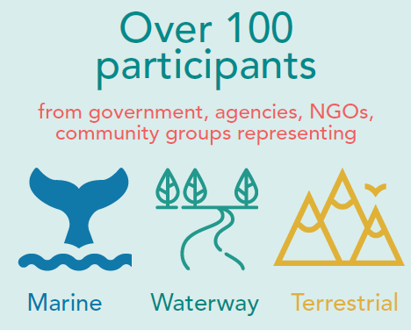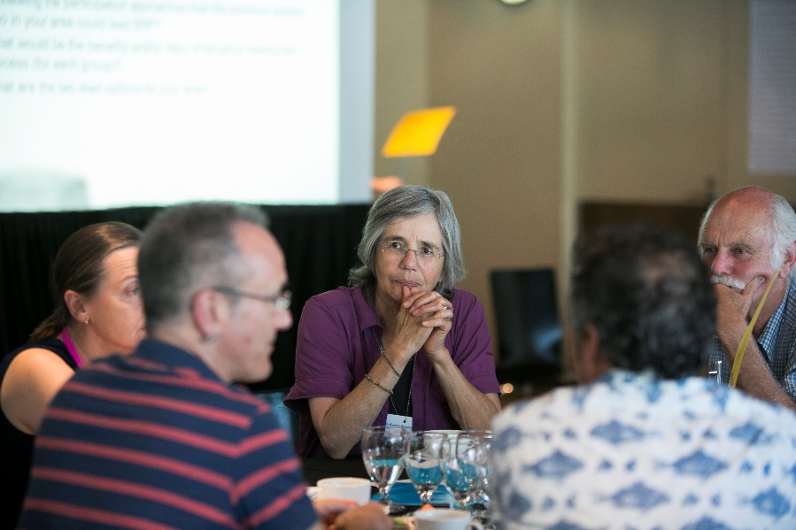

## Methods

The co-design process was run over six days in October and November of 2017. This structure allowed the sessions to build upon one another, and were also directly informed by the objectives. The first day was a workshop for Traditional Owners to provide their perspectives and identify key issues to be carried through the remainder of the co-design workshops. A summary of these key issues is provided below:

**Key messages from Traditional Owner workshop 26 October 2017.**

Key messages to take into the co-design workshops:

* Partnership means equal involvement and decision-making rights, 50/50 not 30/70.
* Traditional Owner groups must be able to participate in the level they want to participate in, for example leading a project not always subcontracted for works.
* Traditional Owner groups have limited capacity, they should be supported by DELWP and other to increase their capacity, this includes funding, staff and training. Capacity building should be approached long term, not just short-term funding cycles or staff secondments.
* Some Traditional Owner groups are interested in leading BRP processes.
* All areas, landscapes and animals are culturally significant, not just one’s country.
* Self-determination means empowering Traditional Owner groups to deliver processes and meet Biodiversity goals and targets, rather than just allowing them to apply for project specific funding. Invest and trust in the Mob to delivery biodiversity outcomes.

The remainder of the workshops included a broader suite of organisations as outlined in Section 2.2 above.

The approach started from a broad foundation, by introducing the project objectives and the project negotiables and non-negotiables – a list of things participants could and could not influence. The negotiables and non-negotiables are provided in Appendix B. As the program progressed, the workshops narrowed their focus to explore the specifics of BRP. The workshops concluded by finalising the approach and agreeing on next steps. The co-design workshop program is provided in Figure 1.

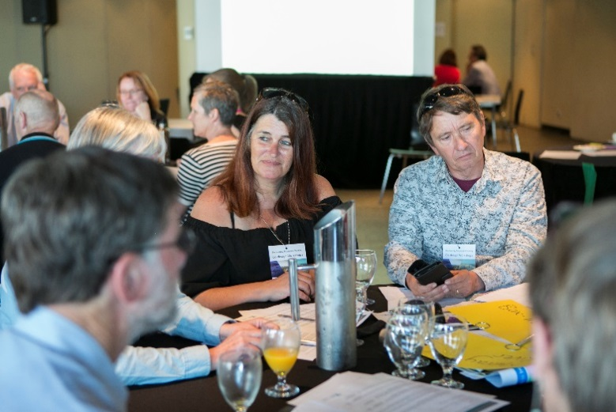

*‘It was good to have 50:50 government and community representation. Congratulations to DELWP for taking the risky & bold step putting it out there to co-design.’ (Participant)*

*‘Really well done. Great management of the mood and level of engagement in the room and well delivered.’ (Participant)*

|  |  |  |  |  |  |  |
| --- | --- | --- | --- | --- | --- | --- |
| Day | Day 1: Thursday  26 October | Day 2: Monday  30 October | Day 3: Tuesday  31 October | Day 4: Tuesday  14 November | Day 5: Wednesday  15 November | Day 6: Tuesday  21 November |
| Workshop details | Traditional Owners and Aboriginal Victorians Workshop  Objectives:   * To introduce the BRP rationale and background * To obtain feedback on current planning and collaboration practice * To provide input into the principles of BRP * To provide input into criteria for geographic regions and projects * To discuss obligations of successful projects and partners | Workshop 1A:  Topic: *Introduction and Principles*  Objectives:   * To introduce the BRP rationale and background * To present the principles of BRP * To present the role of Traditional Owners in BRP * To present the non-negotiable elements of BRP * To obtain feedback on current practice * To explore monitoring and evaluation criteria and approach | Workshop 2A:  Topic: *BRP Process*  Objectives:   * To explore broad collaboration and partnership opportunities * To discuss opportunities for strengthening partnerships (including with Traditional Owners) * To map existing BRP processes and resources * To explore opportunities for BRP processes including approach, timing, membership and key performance indicators | Workshop 3A:  Topic: *Engagement and Participation*  Objectives:   * To present a map of the BRP areas (based on criteria agreed in workshop session 2) * To explore opportunities for the engagement and active participation of stakeholders * To design a broader community engagement approach for BRP | Workshop 4A:  Topic: *Champions, Advocates and Capacity*  Objectives:   * To identify opportunities to establish a network of BRP champions and advocates * To identify gaps in capacity to successfully deliver BRP | Workshop 5A:  Topic: *Monitoring, Evaluation and ‘Pledging’*  Objectives:   * To agree on monitoring and evaluation criteria for the BRP process * To explore and agree on the ‘pledging’ process for partners and stakeholders |
| Workshop 1B:  Topic: *Establishing Geographic Areas*  Objectives:   * To agree on the criteria to establish the BRP areas | Workshop 2B:  Topic: *Participation and Decision Making*  Objectives:   * To explore the participatory intent of the BRP process including roles, responsibilities and terms of reference * To identify the mechanisms for strategic decision-making | Workshop 3B:  Topic: *Project Criteria*  Objectives:   * To explore criteria for prioritising BRP projects * To discuss the obligations of successful projects and partners | Workshop 4B:  Topic: *Testing the Approach*  Objectives:   * To test and futureproof the BRP process * To agree on key delivery and reporting requirements for BRP | Workshop 5B:  Topic: *Finalising the Co-design Process*  Objectives:   * To present and confirm the outcomes of the co-design process * To agree on next steps and timelines in the Biodiversity Response Planning process |

**Figure 1. BRP Co-design Workshop Program**

## Workshop Management Challenges

**High time commitment**

The co-design process was run over six days in October and November of 2017, including an initial workshop for Traditional Owners. This required participants to make a significant commitment to participate in the process.

To ensure the process was accessible, the project team agreed on a number of key strategies. First, the last five days of the program were divided into ten iterative workshops. This enabled, participants to make contributions to an aspect of the BRP, which would then influence other elements of the process, without having to be at all the workshops. Second, the process allowed for job-sharing so an organisation could be represented at all workshops even if representation was shared by multiple people. Finally, all the workshop presentations were live-streamed and key documents were uploaded onto an online portal allowing participants to follow the progress even if they could not attend in person.

**Supporting widespread regional participation**

The workshops sought input from a wide variety of stakeholders from government, agencies, NGOs and community groups working in biodiversity conservation across Victoria. As such, many of participants had to travel significant distances to attend the workshops.

To ensure participation from across Victoria, the middle four days of workshops were run as two, two-day back-to-back sessions. This allowed the first day to have a late start so regional participants could travel to the workshops that morning, while the second day had an early start and finish so they could return home that night. In addition, support was made available to cover the cost of participant transport and accommodation.

**Personal bias**

During the workshops participants were asked to provide feedback and input from a neutral position considering the needs of all stakeholders.

To remove personal bias from participant input, the workshops used activities which built empathy between stakeholders. This included mixing participants across groups in all activities which required them to come up with ideas together. In other activities, participants had to ‘think’ like the decision-makers. Similarly, all participants had access to the DELWP decision-makers who informed the participants of the decision-making process and all its considerations.

**Participant fatigue**

One workshop challenge was participant fatigue, particularly late afternoons.

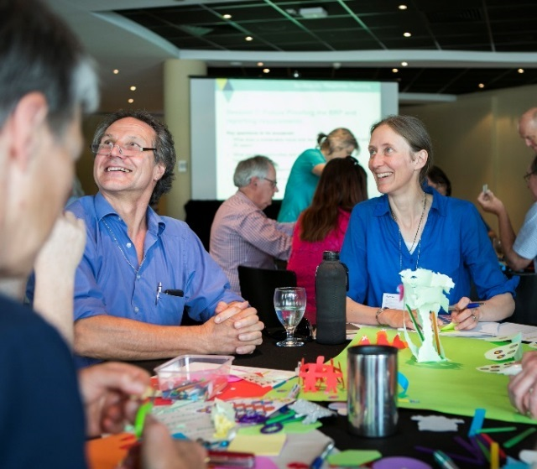This became evident on Day three when a creative session was run during the morning session using Lego to design the ‘building blocks of BRP’. This session generated a significant amount of activity and energy, however, the subsequent session was difficult for participants to engage with due to low energy; an observation that was also reflected in the workshop evaluation. This learning was incorporated into the programming of Day five, where a craft session was run in the afternoon rather than the morning, resulting in greater levels of engagement across both workshops.

*‘I loved the Lego building. I normally dislike creative endeavours however this was good and thought provoking.’ (Participant)*

**Creating a culturally appropriate environment**

A key objective of the co-design was to provide a safe space for participants to test their own assumptions.

Before the co-design workshops, DELWP asked Traditional Owner groups how they would like to contribute to the development of BRP. They informed DELWP the best way to do this would be through a separate forum that was run before the co-design process. This process allowed Traditional Owners to take part in the BRP co-design in a culturally safe space and ensure that their input was shared and carried through the subsequent ten co-design workshop sessions.

**Complex project**

The co-design workshops asked a lot of participants. They were required to understand the complex BRP process, the rationale behind it and what could and could not be influenced.

With this in mind, multiple Q&A sessions were built into the workshops. The responses to questions were presented at the start of sessions, published online or answered live in a forum style setting. The project negotiables and non-negotiables were printed out and placed on tables and as posters around the room. In addition, the project negotiables and non-negotiables that related to a workshop session were included in each presentation.

## Online tools

A key element of the co-design process was ensuring individuals and organisations from across Victoria could participate in all workshops without having to attend in person. To do this, the project used a variety of online tools which allowed remote participation.

Using the State Government engagement website ‘Engage Vic’, the project team set up a secure portal dedicated the BRP co-design. The portal allowed participants to access information, watch presentations and post questions or discussions. The portal was used to host all the documentation, workshop discussion summary reports and links to the live-stream.

A YouTube channel was set up to live-stream key presentations and discussions from the co-design, allowing participants to follow the workshops live from across Victoria. The channel was accessed by following a link posted on the Engage Vic portal. The YouTube live-stream has a chat section, which some viewers used to ask questions and provide responses to workshop activities. Streaming through YouTube also allowed participants to catch-up on a session they could not watch or attend as each streamed video was stored on the channel.

Over the course of the co-design workshops the live-streamed videos were viewed over 300 times, with an average view time of four and half minutes and, so far, have been streamed for 1,277 minutes, or 21 hours and 17 minutes.



streaming

*‘The portal was actually the most beneficial tool. Timely uploads allowed me to attend sessions with context.’ (Participant)*

## Evaluation

At the conclusion of the co-design process we asked the participants what they thought of the workshops and the workshop outcomes. Described below is a summary of responses.

|  |  |  |  |
| --- | --- | --- | --- |
| I understand the rationale behind employing a co-design process | The co-design process developed a collaborative approach to BRP | The co-designed BRP will ensure better biodiversity outcomes | I would attend another DEWLP co-design workshop |
| 100% strongly agree or agree | 83%  strongly agree or agree | 61%  strongly agree or agree | 85%  strongly agree or agree |

*'My favourite session was the crafternoon. It made us think differently and deliver collaboratively.’*

*‘The co-design has built a common understanding of the purpose and method of BRP process.’*

*‘Excellent facilitators and good process. Great to meet new people and to be part of the journey. Well done.’*

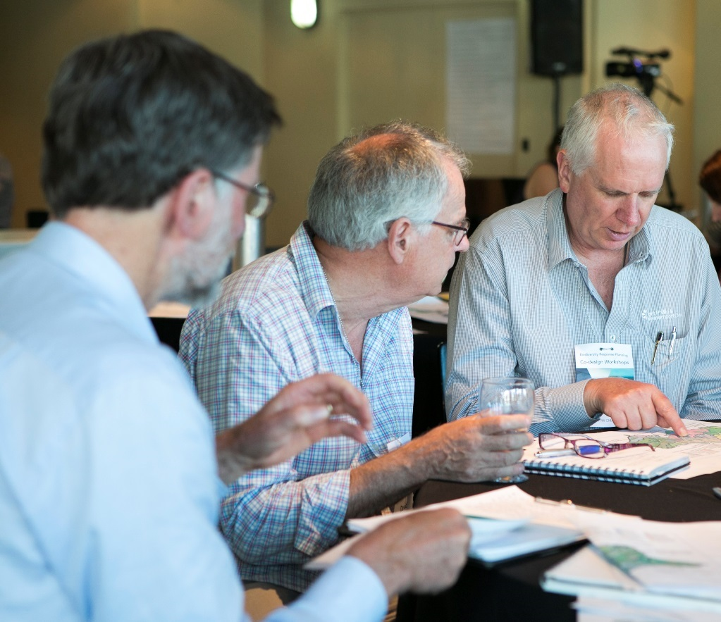

# PART B: Biodiversity Response Planning foundations

This section of the report represents the results of the co-design work described in Part A. These outputs set the foundations and direction for BRP into the future. DELWP will use the BRP foundations described in this section of the report to guide implementation of BRP in conjunction with partners and stakeholders. The first step will be an instructions and operations manual to guide BRP over the first 6 months that responds to the co-design foundations.

The content of Part B is largely the work of the participants in the co-design process. Where necessary DELWP has provided additional information beyond the scope of the co-design process itself, where this was requested by participants.

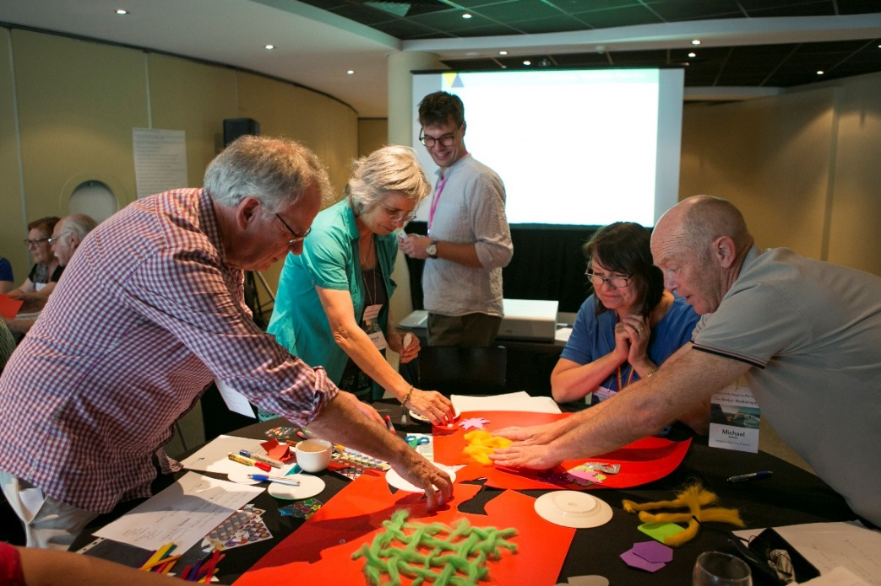

# Biodiversity Response Planning introduction

## Why a new approach is needed

Biodiversity 2037 highlighted that Victoria’s approach to biodiversity conservation needs to be modernised, with more structured collaboration between stakeholders to drive alignment, accountability and measurable improvement.

While the work of thousands of people and groups contributes to biodiversity conservation, more and better collaborative arrangements are needed, to promote:

* shared identification of objectives and priority actions
* increased complementarity of work through improved communication
* Traditional Owners and Aboriginal Victorians in practising their culture through Caring for Country
* improved targeting of effort
* efficiencies by reducing competition for resources
* an increased ability to report on, and communicate what has been achieved, including reporting on progress towards the Biodiversity 2037 targets.

To ensure everyone can participate in this collaborative process, the capacity of all interested parties and stakeholders needs to be supported and enabled.

Participants in the co-design process recognised that there is a lot of good work to build on, including existing collaborations, partnerships and networks that are working well. Workshop participants also identified areas for improvement, in addition to those outlined above, including:

* long term, strategic planning and priority setting
* strategic projects that can be delivered across land tenures and administrative boundaries at a landscape scale to align with ecological needs
* better integration of regional partnership processes and encouragement of participation
* greater stakeholder involvement in decision making
* greater consistency in governance arrangements across the sector.

## BRP Vision of Success

BRP is a long-term commitment to collaboratively addressing biodiversity needs in Victoria. Participants developed their visions for what BRP will achieve over the next five, ten and twenty years, which have been consolidated below:

***In 2023*** *there is agreement and acceptance of the biodiversity needs and priority projects within each area from a wide range of stakeholders with strong partnerships.*

***In 2027*** *Victoria’s biodiversity is improved through more collaborative planning and biodiversity response is normalised in everyday media, politics and land use planning.*

***In 2037*** *Victoria’s biodiversity is healthy, with strong resilient ecosystems consistently protected by a government that values biodiversity as a core obligation.*

These should be considered together with the vision of Biodiversity 2037: “*Victoria’s biodiversity is healthy, valued and actively cared for”.*

Participants were also asked to consider what successful BRP will look like. These success factor have been summarised below under five common themes:

* A shared vision
* Healthy natural environments throughout Victoria
* Collaboration across planning, management and monitoring and reporting
* Effective and consistent data collection, and
* An agreed governance framework.

## BRP definition

As stated in the introduction (section 1), BRP is a key component of the Victoria Governments Biodiversity 2037 strategy and seeks to modernise biodiversity conservation, with more inclusive collaboration between stakeholders to drive alignment, accountability and measurable improvement.

BRP will be a collaborative process to determine biodiversity projects and strengthen alignment between government agencies, Traditional Owners, NGOs, and the community. It aims to be a more integrated and inclusive approach to biodiversity management in Victoria that considers all environments, land tenures, has biodiversity as its core focus and uses the best available science. BRP will directly contribute to the Biodiversity 2037 goal ‘Victoria’s natural environment is healthy’ and as the BRP process matures will contribute to the goal that ‘Victorians value nature’.

The BRP process developed will be implemented through the first half of 2018, including the establishment of area-based biodiversity forums which will begin the process of identifying on-ground projects.

In each geographic area (see Section 4, BRP Areas), there will be collaborative and participatory process (outlined in section 6 Governance, Collaboration and Partnerships) to share information and perspectives. Through this process stakeholders will develop a collective response to the statewide targets for that area (i.e. what should and could be done to contribute to the statewide contributing targets) and develop a prioritised list of on-ground projects for each area and consider ‘multi area’ projects.

There is committed budget available from DELWP that will fund some of the recommended projects as well as the opportunity to create a prospectus of projects for other potential investors. DELWP will undertake assessment processes to determine how it will allocate its funding.

## BRP phases

The BRP process outlined in this document is not fixed for the next 20 years. DELWP and partners are committed to iteratively designing and refining the process to ensure collaboration is achieved and biodiversity outcomes are improved. The roll out of the BRP process can be considered as a phased approach, as detailed below.

The first phase of BRP in Jan-May 2018 is a trial phase involving identifying organisations to take on some key roles within each geographic area to initiate and coordinate the BRP work (as set out in Implementation roles and responsibilities in section 6.3). In Phase 1 this work will include a working group in each geographic area to collaboratively identify priority biodiversity themes and or landscapes and then to assist community development of collaborative, landscape scale projects, and consider and rank project proposals suitable for biodiversity investment by May 2018:

**Phase 1: January – May 2018**

* Initiate the BRP process (detailed in this document) in each area.
* Initial strategic planning: Focus on determining biodiversity priority themes and/or landscapes aligned to Strategic Management Prospects and current capacities and/or interests in each area
* Develop projects for the first cycle of new investment for Biodiversity 2037 to respond to these priorities.
* DELWP will lead the roll-out in most areas to get the process established.

There will be opportunities to review and update the process in 2019 and future years. As well as reviewing the process, there is strong interest in supporting other partners and organisations to progressively take up leadership roles in BRP for their areas, as BRP becomes more established and understood by the broader sector.

The BRP co-design process identified key actions under Phases 2 and 3 of BRP. These include:

**Phase 2: July – December 2018**

* Strategic planning: Develop a five-year collective response to the broader conservation needs for each area, including consideration of voluntary organisational ‘pledges’, and prepare contributions to an investment prospectus
* Commence implementation of the selected (multi-year) projects
* Encourage and support other organisations to take the lead in the on-going BRP process for their areas
* Undertake an initial evaluation of the BRP process.

**Phase 3: 2019 – 2020 and beyond**

* Implement improvements to BRP process identified through initial evaluation
* Formally incorporate ‘pledging’ process
* Review priorities, the investment prospectus and ‘pledging’
* Review roles and participation in the process
* Prepare for the second cycle of BRP investment.

# BRP Areas

Geographic Areas are required to focus discussions on coherent biodiversity conservation themes, and draw together participants with knowledge and interest in those themes.

Geographic Areas need to reflect and combine two ideas:

1. the ways in which biodiversity is organised – this enables strategic and inclusive thinking about all the species, ecosystems and issues relevant to the biodiversity of an area
2. the ways in which biodiversity-related partners are organised – this takes advantage of a variety of relationships from existing processes and networks.

It is recognised that biodiversity does not neatly fit into lines on maps, and that organisations have different roles and responsibilities (often without a primary focus on biodiversity) and their boundaries often are not aligned.

The following criteria for delineating Geographic Areas were developed by participants in co-design workshop discussions:

* consider cultural footprints (e.g. areas where similar cultural practice would occur such as burning, song lines, meeting places etc.) and create opportunities for healing the landscape
* based on existing biophysical boundaries, and ecological and biological processes
* build on existing social and collaborative networks
* build on existing connections to place and identity.

Boundaries must also be “porous” to ensure collaboration on issues significantly shared by neighbouring areas. This could extend to statewide collaborations on widespread issues. An approach to support development of ‘multi area’ projects is currently being developed.

Applying the criteria in practice involved combination of:

* biophysical drivers represented by landforms, catchments, climate zones, coastal processes and related land use/tenure patterns, with the emphasis for each Area depending on the most relevant ecological processes and linking to management or cultural practices
* broad collaborations represented by NRM agencies and landscape-scale thematic networks
* connections to place and identity represented by local-scale groups such as Local Government Areas, smaller Conservation Management Networks and Landcare Groups where feasible.

It is recognised that some people prefer the convenience of using existing organisational boundaries, whereas others have a preference for moving beyond existing boundaries to enable new views and leadership opportunities to be formed. The proposed areas (Figure 2) strike a balance between these preferences and provide the opportunity to focus on the development of coherent projects for addressing key threats to biodiversity. This will enable communities and networks to collectively take action to best improve the function and resilience of natural systems.

It is intended that the Marine & Coastal Habitats Area Working Group is convened as early as possible to enable it to provide advice to neighbouring terrestrially-based Areas on issues of particular concern to the marine and coastal environment.

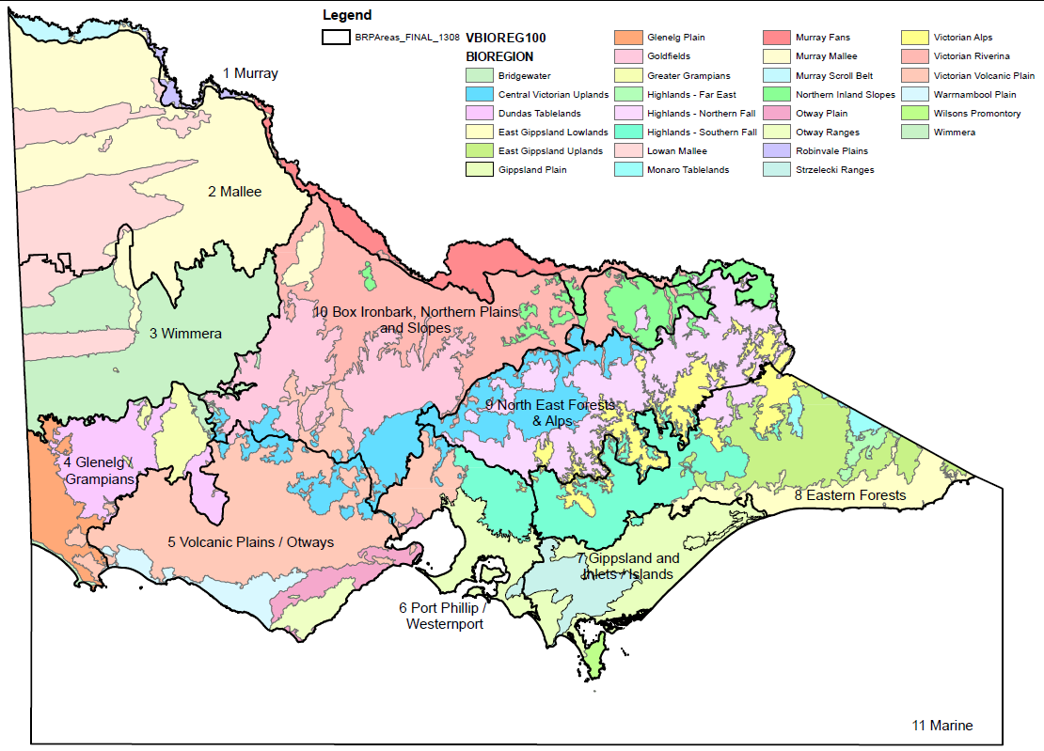

Figure 2: BRP Geographic Areas

The Geographic Areas are quite large. This is good for thinking in a strategic context, and reduces the number of Working Groups and Area Partnership Facilitators (see section 6); however, they are too large for local engagement. A nested approach is therefore intended. Where needed, within each Geographic Area distinctive landscapes and/or land management areas can be delineated as Sub-areas (see Figure 3) for example, Grampians NP, Otway’s Ranges & Plains, Wilsons Prom NP, Alps). Sub-areas could be supported by a more focused group and assist proponents to build strong projects.

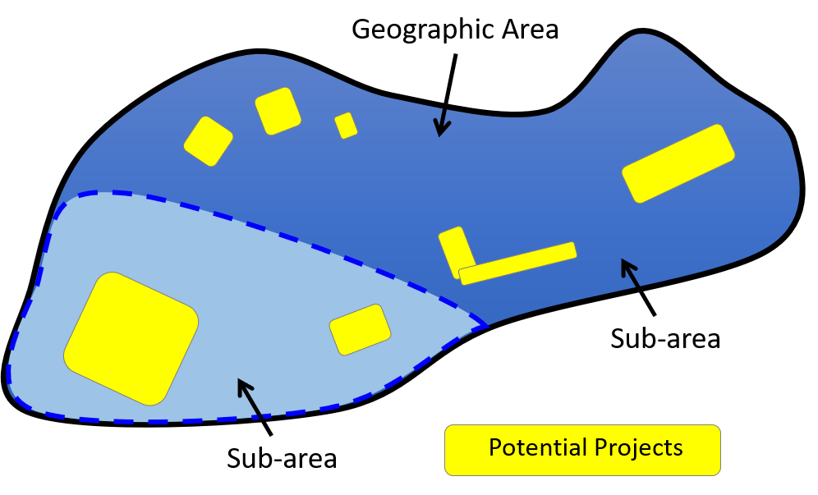

Figure 3: Nested approach to create sub-areas within BRP Geographic Areas, where needed

On the other hand, the number of Geographic Areas may also mean that participation by statewide organisations with limited regional presence is a challenge. Suitable arrangements to ensure that organisations with a statewide presence are supported and have the capacity to participate in BRP across are currently being developed. Area Leads will have the role of ensuring that these organisations are aware of and enabled to readily contribute to the relevant opportunities.

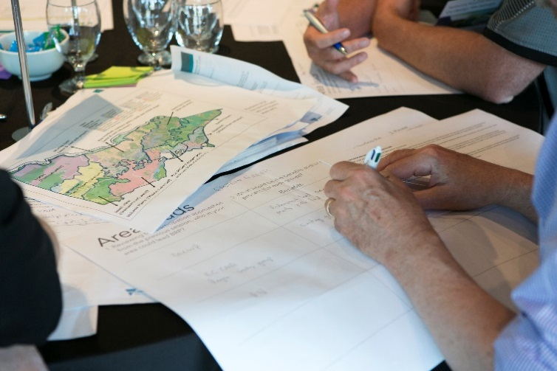

# Strategic Decision Making

## An area based response to targets

Each geographic area should develop a five-year response to the statewide targets, as envisaged in Biodiversity 2037.

This will be drawn from funded projects (these could be funded by state government or by other investors) and organisations’ voluntary pledges towards the statewide targets (described below). This should be used to build a shared narrative for that area that covers the key threats and issues, the collective biodiversity vision and overall response to the statewide targets. It is intended that area-based response to the statewide targets will be made publicly available, for example on a web page dedicated for this purpose (options for this are currently being scoped in conjunction with options for reporting through the Biodiversity 2037 implementation framework). Although this narrative and response to the statewide targets could be refreshed on a rolling basis, it would need to be reviewed at least every 5 years.

Given the timelines for investment (by mid-2018) the emphasis in early 2018 (Phase 1) will be on developing projects. Therefore, the development of a more considered five yearly area based response to the statewide targets is expected to be undertaken during Phase 2 in 2018-19.

**Pledging**

The idea of a ‘pledge’ as set out in Biodiversity 2037 is that organisations interested in contributing to biodiversity outcomes, including organisations participating in BRP, will be asked to ‘pledge’ their contribution to the statewide biodiversity targets. This statement of intent will be voluntary and non-binding.

It is intended that ‘pledges’ for organisations in each geographic area will be gathered together, and the sum of these pledges will form the basis of a collective area-based response to the statewide targets. Statewide organisations will be encouraged to make a single pledge, but consider how it relates to the relevant geographic areas.

Essentially, ‘pledging’ provides an opportunity for organisations to be recognised as partners in Biodiversity 2037, with every contribution helping to achieve the statewide targets and the goal that ‘Victoria’s natural environment is healthy’. This may also be broadened to include contributions towards the goal that ‘Victorians value nature’ as the BRP process matures.

Co-design participants identified what they would like to see the ‘pledging’ process achieve. This included:

* Shared impacts: pledging process should generate shared or communal impacts, providing an opportunity to encourage all organisations to work towards a common vision or goal, develop shared language and report against common measures.
* Visibility: pledging is an opportunity to increase the visibility and public profile of biodiversity and the work that is being undertaken by a broad range of organisations (government, agencies, NGOs, Traditional Owners, community). Promoting these contributions to protecting Victoria’s biodiversity will help to recognise achievements and increase awareness of the sector more generally.
* Realistic pledges: pledges should be realistic, based on an organisation’s level of commitment and anticipated capacity, but provide for flexibility to enable organisations to ‘stretch’ beyond business as usual activities. This will enable pledges to deliver achievable and realistic outcomes.
* Community involvement: pledging could contribute to community involvement in biodiversity responses and this should be encouraged and supported.

There were a number of questions and matters regarding how ‘pledging’ is described and what it encompasses which require consideration. Further work is needed, in consultation with key partners and stakeholders, to ensure that ‘pledging’ is well described, understood and accepted. .

Co-design participants recommended that ‘pledging’ be integrated into the BRP process by developing them as part of strategic decision making in Phase 2 of BRP in 2018-19 once targets, priorities and gaps have been identified for each geographic area.

To enable further development of the ‘pledging’ concept, and ensure acceptance and integration, a staged approach is proposed, commencing with a pilot in BRP Phase 2.

## Project Criteria for Phase 1 investment process (2017-18)

The following criteria will be applied for the BRP round of new DELWP biodiversity investment commencing in mid-2018.

**Eligible activities**

The focus for BRP Phase 1 will be **on-ground management actions**. There will be other processes for actions under the Victorians Valuing Nature goal, and for improving effectiveness through new knowledge and monitoring emerging trends (Biodiversity 2037 MER Framework – draft to be released soon).

The focus will be **the terrestrial environment**. There are currently other processes for the marine environment (i.e. an existing round of investment) and for the aquatic environment (current funding under Healthy Waterways Strategy). [NB. DELWP will continue to work on integrating biodiversity investment across marine, aquatic and terrestrial environments as indicated in Biodiversity 2037, with the aim of being better able to consider all three environments during the next cycle of BRP in 2021.]

**Biodiversity Assets**

The Strategic Management Prospects analysis considers many species and takes account of the degree of rarity, depletion and threat of each species. The analysis is designed to maximise the outcomes across species by identifying cost-effective options, and balancing consideration of actions at locations that benefit many species with actions that are particularly beneficial for species with limited options. This supports the Biodiversity 2037 intention of shifting towards earlier and more effective intervention in extinction processes.

**Biodiversity Outcomes**

The key driver of this investment is maximising net outcomes for biodiversity. Outcomes will be progressively assessed by the Change in Suitable Habitat measure of the Biodiversity 2037, and maximising biodiversity outcomes will be achieved through progressive alignment to the Strategic Management Prospects (SMP) decision-support tool, which will be used to report delivery against Biodiversity 2037 targets.

SMP:

* is informed by science and best practice methodologies
* endeavours to take account of climate change (further work to be done)
* identifies value for money, including consideration of future funding required to sustain outcomes
* identifies the most cost-effective landscape-scale actions at places
* is incorporating additional Specific Needs actions into the assessment process
* incorporates long-term survey and monitoring.

SMP will also be used to assess potential new actions that would be beneficial if effective mechanisms (policies, delivery methods, participation) can be demonstrated.

SMP provides valuable information and context to support decision-making, but is not intended to make decisions. There are a range of other practicalities that influence decision-making including the capability and capacity of managers to undertake an action and the feasibility of the action in the specific terrain or for that particular situation.

Over the next four years, DELWP will develop BRP targets and strategies for freshwater and marine environments and include relevant information into updated versions of SMP.

**Participant Outcomes**

It is highly desirable that processes and projects are effective for the participants. In addition to the biodiversity outcomes sought above, successful projects will:

* deliver good biodiversity outcomes
* recognise and respond to cultural heritage
* strengthen partnerships and collaboration between stakeholders and the community
* build capacity and address the aspirations of stakeholders and the community
* provide evidence of community engagement and support from the relevant group of stakeholders
* build on existing successful biodiversity management projects
* show long-term biodiversity outcomes and threat mitigation.

It is recognised that the importance of these features may vary depending on the nature of each project.

**Additional Considerations**

There are also some essential considerations:

* the process to develop a project must provide evidence of Traditional Owner engagement and participation at the level they want to, given the available resources
* the proponent must have the capacity to manage and deliver the project.

and some considerations that will only be relevant in some situations:

* leveraging of additional funds can strengthen the scale of a project, and innovation can make current and future projects more effective. In both cases, the core criteria of the relevant investors still need to be met.

**Funding allocation approach and governance**

Of the funds available for the Phase 1 on-ground investment across Victoria, DELWP will identify an initial allocation for each BRP Area based on the relative proportion of strong benefit/cost identified by SMP.

Seventy percent of these funds will be available for appropriate projects submitted by the Area, as agreed through the co-design process. The preference will be for a mix of sizes and lengths (1-3 years) focused on some of the priority themes and/or landscapes within the BRP Area (identified by the Working Group). Proposed projects should be ranked against each other.

Thirty percent of the funds will be reserved for competitive assessment across all geographic areas, as agreed through the co-design process. DELWP will use an Independent Panel to assist with this process.

Working Groups will also be encouraged to identify further projects (using broader criteria and scope) for inclusion in the Investment Prospectus.

Project criteria, approval of projects to be funded and determination of initial allocations to areas will be the decision of the Executive Director Biodiversity Division, DELWP. Working groups will determine which projects are put forward for funding decision by the Biodiversity Executive Director. The Independent Panel, which will make recommendations on projects to be funded from the statewide competitive pool, may also have a role in confirming recommended projects from the Working Groups prior to them going forward to the Biodiversity Executive Director. This could assist with probity and also confirm project criteria and other basic requirements are met.

Further guidance, details of other criteria (e.g. demonstrated capability to manage project finances, and deliver within specified timelines) and application templates will be provided by DELWP.

A schematic representation of this process is set out in Figure 4.

Suitable arrangements to ensure that organisations with a statewide presence are supported and have the capacity to participate in BRP without needing to be involved in 11 BRP area processes are currently being developed. An approach to support development of ‘multi area’ projects is also being developed.

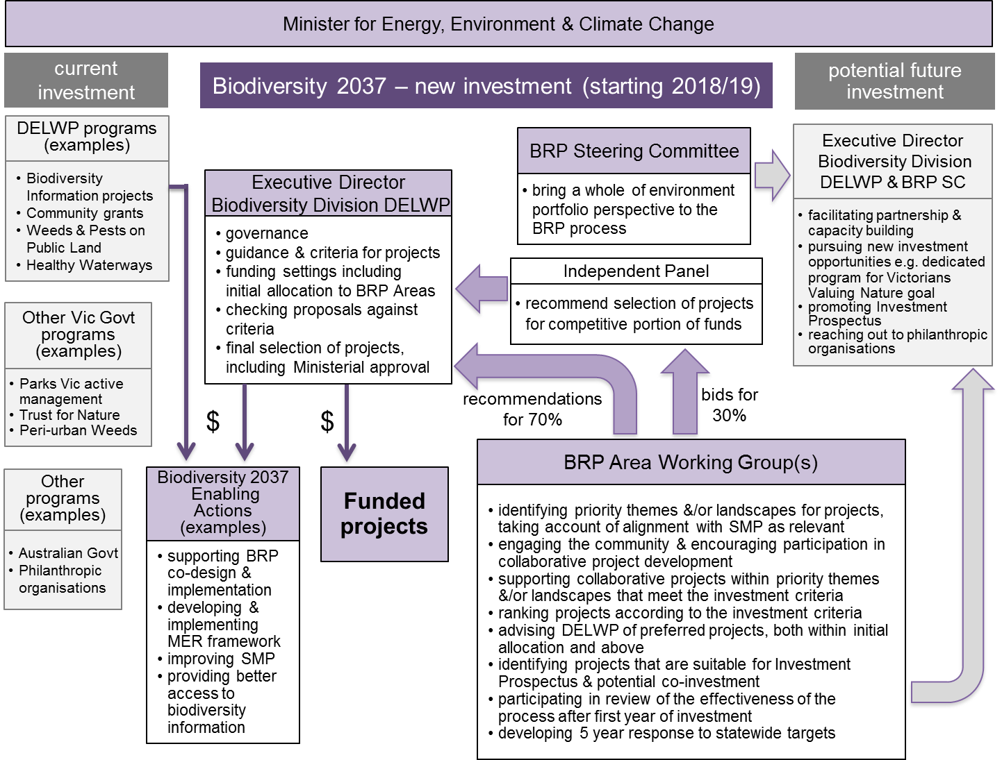

**Figure 4**. Funding and governance arrangements for biodiversity investment, including relevant Biodiversity Response Planning processes

# Governance, collaboration and partnerships

The following was discussed and agreed through the co-design process and will inform the preparation of guidance material to support BRP implementation (Phase 1).

## Objectives for collaboration and partnerships

Outlined below is a series of objectives to underpin collaboration and partnership throughout BRP. These objectives were co-designed with participants through the six days of workshops. There is no hierarchy or weighting within these objectives as they are strategic directions that outline what the BRP process aims to achieve.

1. *Empower Traditional Owners as equal partners in Biodiversity Response Planning*

Partnership means equal involvement and decision-making rights, and the ability to choose the level of involvement in a partnership or project. Traditional Owners need resourcing to enable ongoing participation and to exercise their cultural rights and obligations in relation to natural resource management, and meet aspirations of Country Plans.

1. *Support strong, long-term, flexible partnerships that operate beyond project or funding lifecycles*

Partnerships have sometimes been reactive and short-term, and oriented to funding applications and project-based goals. A long-term and consistent approach to partnerships provides a strong foundation for BRP and delivery. Appropriate incentives, resources and support to be provided to ensure levels of participation are sustained.

1. *Develop a shared response to Biodiversity 2037*

A collaboratively developed response to Biodiversity 2037 targets supports shared understanding and clear accountability for activities. The Biodiversity 2037 Monitoring Evaluation and Reporting Framework should support measuring against indicators to determine progress towards the targets and stakeholders will have the ability to celebrate success and apply leanings to improve future outcomes.

1. *Share information to empower stakeholders with the necessary knowledge.*

Partners share their information with each other, to support evidence-based decisions and improve outcomes, to enable and empower partners. The strengths and limitations of both scientific and practitioner knowledge need to be recognised and combined to improve outcomes and two-way knowledge sharing. Information needs to be practical and readily accessible. Partners also respect cultural knowledge, the role of Traditional Owners intellectual property rights and the appropriate ways that traditional ecological knowledge can be shared.

1. *Support and champion community and volunteer knowledge and contributions*

Grass-roots efforts and community-driven groups make huge contributions to biodiversity outcomes. Therefore, volunteers need to be recognised, and supported to participate and lead activities. This should include the full cycle of activities, from planning to on the ground delivery and ongoing monitoring. Collaboration of these efforts with Traditional Owner values and increased capacity will help to ensure that cultural rights and obligations are met by BRP.

1. *Encourage and embrace the diversity of views and knowledge held by participants at all levels from state-wide to local, from government, non-government and community*

With many experienced and diverse people, groups and organisations in Victoria, it is important that BRP utilises this knowledge to plan and deliver projects, and contribute to existing evidence base. It is important that BRP recognises and respects cultural rights and obligations that relate to NRM, i.e. cultural fire, forest gardening, caring for Country and healing Country.

Balancing and reconciling these objectives will be a significant task. It will require patience, time and lots of learning as well as reflection and changes to approaches within the partner organisations. Achieving this alignment and reconciliation will be a major and worthwhile accomplishment in itself.

## Governance

The BRP process and its establishment is overseen by a steering committee chaired by the Executive Director Biodiversity (DELWP) and comprising DELWP (2 x Regional Directors); Catchment Management Authorities (CMAs) (2 x CEOs and 1 x Board member), Parks Victoria (Chief Conservation Scientist), Trust for Nature (CEO) and Dja Dja Wurrung Clans Aboriginal Corporation (CEO). The purpose of the Steering Committee is to bring a whole of environment portfolio perspective to the Biodiversity Response Planning project. The BRP Steering Committee terms of reference are included in Appendix C of this report.

Biodiversity investment decisions including approval to fund projects are the responsibility of the Executive Director Biodiversity Division, DELWP. The Executive Director will be informed by recommendations from the Working Groups and by an Independent Panel. This is set out in Figure 4 (Section 3.2 above).

## BRP Roles and responsibilities

Outlined below are the key partnership and collaboration elements of the BRP. They include a statewide Steering Committee, and within each geographic area an Area Lead, BRP Partnership Facilitator and Working Group. Sub-groups may also be desirable in some cases.

**Statewide Steering Committee**

* group of senior executives from key organisations in the biodiversity sector including DELWP, CMAs, Parks Victoria, Trust for Nature, and Traditional Owners
* their role is to:
  + oversee the initial steps of establishing the BRP process, including co-design, communications and engagement
  + assist the establishment of BRP by supporting the outcomes and recommendations of the stakeholder co-design process
  + oversee the design and establishment of BRP across Victoria
  + identify strategic opportunities to connect BRP to other relevant processes at local, regional, state or national level.
* The draft BRP Steering Committee terms of reference are included in Appendix C of this report.

Each geographic area should have the following elements:

**Area Lead**

* an organisation that provides initial coordination prior to the appointment of the Working Group and BRP Partnership Facilitator
* establishes the Working Group and appoints a BRP Partnership Facilitator (considering skills, organisational interest and resource availability)
* Traditional Owners to be Area Lead where desired and where resources available
* considers and facilitates participation by statewide organisations with limited regional presence
* provide ongoing support as required.

**BRP Partnership Facilitator** (person(s) from the Area Lead organisation or another organisation within the geographic area)

* key point of contact and liaison providing overarching coordination of BRP within each geographic area
* encourages accountability and action
* ensures the Collaboration and Partnership Objectives are being met
* assists with skill development, information flow and information exchange (in collaboration with the Area Lead)
* ensures cultural rights and obligations relating to NRM are respected, i.e. cultural fire, forest gardening, caring for Country and healing Country
* strengthens partnerships with critical stakeholders, including Traditional Owners
* coordinates Working Group meetings and undertakes tasks for the Working Group including:
  + assisting with broader communications and engagement
  + documenting ‘pledges’
  + assisting with project documentation
* ensures a diverse range of views are represented throughout the BRP process
* facilitates cross area discussions
* develop and deliver a Stakeholder and Community Engagement Plan
* respects Intellectual Property Rights, including those of Traditional Owners.

**Working Groups**

* a panel of stakeholder representatives from diverse organisations and groups who are involved in on ground biodiversity response
* membership numbers are flexible, no more than 15 is recommended
* opportunity for all Traditional Owner groups in a geographic area to be members
* Traditional Owners are resourced to participate in Working Group
* Traditional Owners rights are respected relating to NRM, i.e. cultural fire, forest gardening, caring for Country and healing Country.
* core role is to:
  + identify priority themes and/or landscapes for projects, taking account of alignment with SMP as relevant
  + decide on priority projects
  + oversee the BRP Partnership Facilitator tasks and priorities
  + develop a 5-year response to the state-wide targets for that area (5 yearly ‘pledges’ and funded projects)
  + lead evaluation of the BRP process at the end of each ‘cycle’
* Working groups will also:
  + determine the depth and breadth of stakeholder and community engagement process (see below), and the role of any sub-groups
  + design and deliver the process to confirm priority BRP projects by May 2018
  + role in the evaluation of the BRP process (see section 6), and sharing lessons learnt
  + lead role in supporting cultural rights and obligations in relation to BRP
  + determine the long-term participation model of the Working Group
  + determine the ongoing Area Lead beyond 2018.

**Sub-groups (optional)**

* where appropriate sub groups to be formed to identify local priorities
* focus is on specific geographic sub-areas
* outcomes to be reported to Working Group
* same principles of participation as for Working Group

Note: **Stakeholder and Community Engagement** is a key responsibility of the Working Group, with support from the Partnership Facilitator and Area Lead. The following guidance is provided:

* opportunity for diverse voices to be heard through the BRP process
* engagement to include volunteers, interested community members and representatives of groups with an interest in biodiversity response
* engagement to include broader Aboriginal community engagement
* where possible the engagement should build on existing established networks and projects
* engage to focus on ideas for priority projects, and build on past experience and projects
* engagement activities to be flexible and could include community forums, surveys, meetings with existing groups and activities on Country with Traditional Owners.

Due to the constrained timelines for the implementation of Phase 1 of BRP by End-May 2017, it is *critical* that the Area Leads and likely arrangements for Partnership Facilitators are agreed and confirmed by the end of 2017. As was explained at the co-design workshops there are no additional resources available to implement these roles.

In this context, the co-design participants considered which organisations would be appropriate as Area Leads and DELWP was put forward as the most appropriate. Therefore, DELWP will be the Area Lead for all 11 geographic areas in Phase 1 of BRP and will help fulfil the Partnership Facilitator role. As set out above, the Partnership Facilitator tasks are quite varied, reflect different capabilities and therefore lend themselves to being shared by multiple individuals or organisations. It is anticipated that that DELWP and CMAs will jointly undertake these roles for Phase 1 of BRP.

There is strong interest in supporting other partners and organisations to progressively take up leadership roles in BRP for their areas as BRP becomes more established and understood by the broader sector. Area Leads will be reviewed following the implementation of Phase 1, with the intent that Traditional Owners and other organisations be encouraged and resourced to take up this role.

# Stakeholders

Outlined below (Figure 5 and Table 1) are the key stakeholders of BRP (Phase 1). The stakeholders are divided into three groups depending on their role in the BRP process These groups are **BRP delivery**, **primary stakeholders** and **secondary stakeholders**.

* Comprised of primary stakeholders, **BRP delivery** describes the roles involved in governance and managing the BRP process during Phase 1.
* The **primary stakeholder** group is constituted by groups and organisations that will be involved in BRP Working Groups or other processes, delivering projects and making ‘pledges’ or as major landholders in an area. Traditional Owners, equal partners in BRP, can choose the level of involvement in a partnership or project.
* The **secondary stakeholder** group consists of groups, organisations and individuals with an interest in biodiversity and may contribute to the on-ground delivery or projects, voluntarily ‘pledge’ a commitment towards the statewide targets or have an interest in biodiversity.

Below, Figure 5 provides examples of the three stakeholder groups, while Table 1 provides details of individual stakeholders and a brief description of their interest and role in BRP. Please note, these lists are not exhaustive.

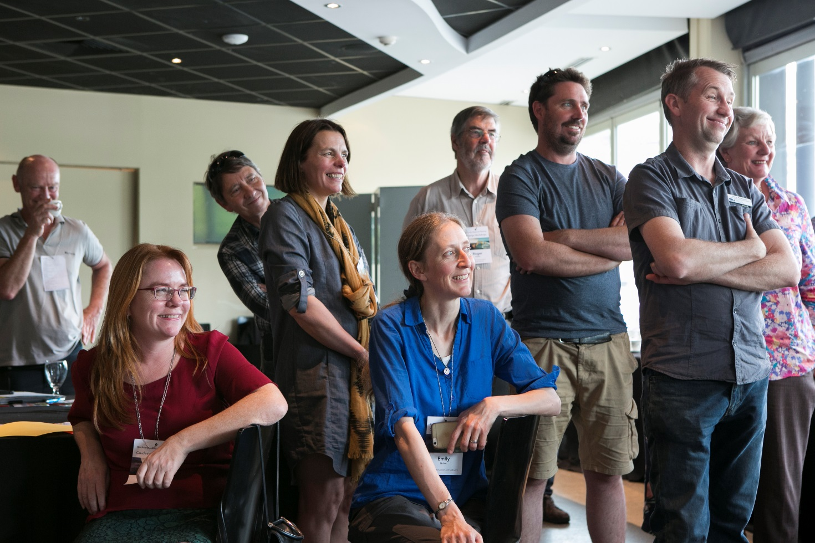

* BRP Steering Committee
* Area lead
* BRP Partnerships facilitator
* Working Group

**BRP Delivery**

**Primary Stakeholders**

**Secondary Stakeholders**

Community members

Special interest groups

Schools

Nature users

Residents

Universities

Researchers

Private business

NGOs

DEDJTR

Royal Botanic Gardens

Zoos Vic

Victorian Coastal Council

Landcare Victoria Inc.

Melbourne Water

Water Authorities

Local Government

Conservation Management Networks

Landcare Networks

Friends Groups

**Trust for Nature**

Major landowners (public & private)

**DELWP**

**Parks Vic**

**CMAs**

**Traditional Owners**

Figure 5: BRP Stakeholder map for Phase 1

Table 1: BRP stakeholders

| **Group** | **Stakeholder** | **Description** |
| --- | --- | --- |
| BRP delivery and governance | Area lead | See roles and responsibilities |
| BRP partnerships facilitator | See roles and responsibilities |
| Working group | See roles and responsibilities |
| BRP steering committee | See roles and responsibilities |
| Primary Stakeholders (Phase 1 deliverers) | DELWP | Has overall responsibility for delivering BRP and Biodiversity 2037. Will lead Phase 1 of BRP in most areas (Jan-May 2018) in collaboration with partners. DELWP is also a key land manager for public land. |
| CMAs | Lead NRM planning and coordinating agency, based on regional (catchment) boundaries; also manage waterways. May assist DELWP in leading Phase 1 of BRP in some areas. |
| Traditional Owners | Recognised as the Traditional Owners of the land (may or may not have native title or Registered Aboriginal Party status). Speak about issues relating to country, heal country and hold traditional ecological knowledge. Partners in decision making. Will be encouraged/assisted to take up BRP roles including leadership roles. |
| Parks Victoria | One of the key planning and delivery agencies on public land (manage parks and reserves). May assist DELWP in leading Phase 1 of BRP in some areas. |
| Trust for Nature | Key government delivery agency for private land conservation with statewide and regional presence. |
| Primary stakeholders | Other Government   * Other State government departments/agencies * Federal government departments/agencies | Government agencies and departments are involved in BRP as statutory authorities, delivery of projects and as large public land owners and managers. They will be encouraged to consider ‘pledging’ towards the statewide biodiversity targets. |
| Local Government | LGAs are involved in planning, coordinating and delivering land management and NRM programs at local level to varying degrees, and with high degree of community interface. |
| Water Authorities | Water Authorities can be involved in the management of waterways and land and some plan and manage biodiversity. |
| NGOs and peak bodies, e.g.:   * Landcare Victoria Inc. * Greening Australia * Bush Heritage Australia * Victorian National Parks Association * Nature Glenelg Trust * The Nature Conservancy | NGOs are involved variably at all levels in project planning and resourcing, on-ground project delivery, land management, coordination of volunteers and connecting people with nature among others. Opportunities for ‘pledging’. |
| Community groups e.g.:   * Conservation Management Networks * Friends groups * Landcare networks * Special interest groups | On-ground project delivery and coordination cross tenure. involved in delivering on-ground projects as volunteers. Opportunities for ‘pledging’. |
| Landowners such as farmers | Owners of large tracts of land on which projects take place |
| Secondary stakeholders | Community   * Nature users * Residents | Are involved in community engagement, and citizen science among other activities. |
| Education and research   * Schools * Universities   Researchers | Conduct research and educate future generations on biodiversity. |
| Private business   * Banks * Local business * Large Corporates | Potential funding and volunteering opportunities for biodiversity projects. Opportunities for ‘pledging’. |

# Evaluation of Biodiversity Response Planning

Participants highlighted the need to evaluate the success of Biodiversity 2037 over the next twenty years to ensure that the processes such as BRP and biodiversity outcomes are continuously improved and that implementation of Biodiversity 2037 is designed and delivered efficiently and effectively. A Monitoring Evaluation and Reporting (MER) Framework will be released shortly that describes key questions for the 5-yearly evaluation of Biodiversity 2037. The evaluation will look at:

* organisational arrangements accountable for ensuring that a program of activities is undertaken effectively and successfully
* strategic planning and processes that set direction, assign priorities and provide leadership for Biodiversity 2037
* mechanisms for coordinating the efforts of different agencies (and divisions within agencies), organisations and groups to work together in an effective and complementary manner.

The effectiveness of BRP process in achieving the vision of strengthening participation, collaboration and alignment between government agencies, Traditional Owners, non-government agencies (NGOs) and the community is also critical.

Co-design participants developed key evaluation questions to assess the BRP process, in the tables below. At the end of each BRP process, each area based Working Group and stakeholders will evaluate their collaborative process in accordance with these questions.

There will also be a process for reporting on on-ground actions consistently to contribute to reporting on progress towards the Biodiversity 2037 targets and the MER framework may consider the results of projects.

|  |  |
| --- | --- |
| **Key Evaluation Question: To what extent did participants in the Biodiversity Response Planning process collaborate?**   * What was the quality of collaboration? * Is there shared ownership of the process and identified biodiversity response? | |
| Excellent | * There is an appreciation for each other’s opinion and values * Potential issues and possible solutions identified * Traditional Owners had an equal say and collaborated as partners * Participants see how their views are shared and represented * Groups understand their role and support priorities even if their proposals are not adopted * Objectives and priority actions are built from the different perspectives * Cultural rights and values are included in the outcomes of the process |
| Good | * Shared values and targets between partners clearly articulated * Build capacity in partners so others can be represented in BRP forums * Potential issues and some solutions identified * Groups generally understand their role * Common goals are identified * Understanding and acknowledgement of cultural rights and values * Most Traditional Owners had an equal say and collaborated as partners |
| Just good enough | * Attempted BRP with new regional partners * Groups may disagree with priority list, but understand the logic behind prioritisation. * Groups attempt to develop shared goals * Some understanding and consideration of cultural rights * Traditional Owners involved in the process but not as partners |
| Less than good | * Not open to new partnerships and collaboration - status quo is maintained * Cannot agree on shared targets, do not meet partnership timelines and other requirements * Some cultural rights and values are partially understood but not considered * Consideration of the same topics and approaches as pre-BRP * Dominating groups have major influence on decisions * Traditional Owners treated as stakeholders rather than partners |
| Detrimental | * Poor relationships undermine the process * Inability for agreement on targets to be achieved, participants refuse to consider other perspectives * Exclusion of some partners * Participants feel pushed aside and side-lined * Decisions are not transparent and no clarity on decision-making process * Abandonment of process * Lacks opportunities for Traditional Owners to collaborate * Cultural rights are not understood and their value is disregarded |

|  |  |
| --- | --- |
| **Key evaluation question: To what extent were participants engaged in the BRP process?**   * How inclusive was the BRP process, was there sufficient representation? * Was the process cultural appropriate? * To what extent were participants heard? | |
| Excellent | * Large diversity of perspectives and stakeholders participate at all levels * All Traditional Owner groups are engaged throughout BRP and choose how they want to participate and utilise best approaches that work * All participants felt able to speak up, listened to, and had an opportunity to participate and design approaches * Manage the conversation and ensure all actively contribute * Participants are transparent in participation and engagement with each other * Cultural differences are respected and managed by all |
| Good | * Diversity of perspectives and stakeholders participate at most levels * Most Traditional Owners are engaged throughout BRP and have opportunity to voice interest and identify best approaches that will work for them * Most Cultural differences are respected by all participants * Most participants felt able to speak up, listened to, and had an opportunity to participate * Participants are transparent in their participation and engagement with each other most of the time * Conversation is managed and all participants contribute in some way |
| Just good enough | * Diversity of perspectives and stakeholders participate at some levels * Some Traditional Owners participate throughout BRP * Most participants felt able to speak up and had an opportunity to participate * Conversation managed in part so majority of group contributes * Acknowledged the need to understand and mostly respects cultural differences |
| Less than good | * Limited diversity of perspectives and stakeholders participate at some levels * Some Traditional Owners participate in parts of BRP process * Didn’t manage conversation so only some people in group contribute * Attendance without true participation * Limited understanding of cultural differences |
| Detrimental | * Lacks Traditional Owner participation throughout process * Limited diversity at all levels * Conversations dominated by several groups, leading to lack of diversity of perspectives and stakeholders participate at some levels * Ignored cultural differences * Participants and organisations cease participation and do not wish to be involved in the future |

|  |  |
| --- | --- |
| **Key evaluation question: To what extent was knowledge and information used to inform BRP?**   * What types of knowledge was shared and used? * How did SMP contribute to identifying priority projects, and how aligned are they? | |
| Excellent | * Priority projects strongly align to priority locations in SMP * Project methodology reflects current knowledge * Best practice knowledge applied to creative approaches to achieve outcomes * All participants have understanding of SMP * Wide dissemination of current science and learnings * Fully utilising participants’ skills and expertise * Cultural values and knowledge are respected and reflected |
| Good | * Some priority projects strongly align to priority locations in SMP * Many participants bring understanding of current knowledge incl. SMP and share * Utilising knowledge from a variety of sources * Current context and issues are researched prior to the visit * Have access to best available knowledge to make well informed decisions. * Cultural values and knowledge are respected and partially reflected |
| Just good enough | * Knowledge is drawn from the usual sources * Some projects show some alignment to SMP * Some information and knowledge is shared in the process * Cultural values and knowledge are acknowledged and considered |
| Less than good | * Disagreement amongst groups on information used * SMP and other tools not used due to questions of validity of data * Out of date information used to make decisions * Cultural values and knowledge are not acknowledged * No feedback to the community and a lack of transparency * Individual knowledge, opinion and emotion drives process * No sharing of learnings * Confidentiality of knowledge is breached |
| Detrimental | * Knowledge applied that has detrimental impact on biodiversity * Decisions based on the loudest voice rather than the best available knowledge * Knowledge ignored * Self-interest and lack of transparency in decision-making * Knowledge not applied * Low level of confidence in NRM process in community |

# Workplan

The next two years will play a critical role in successfully establishing and implementing BRP across all geographical areas. A strategic workplan will be developed to confirm key actions and milestone dates required to leverage BRP funding opportunities for each area. Table 2 below outlines an initial workplan, which will be amended over time as required, and can be used for each geographical area to develop a bespoke plan if required.

**Table 2: BRP workplan for the next 4 years**

|  |  |  |  |  |  |  |  |  |  |  |  |  |
| --- | --- | --- | --- | --- | --- | --- | --- | --- | --- | --- | --- | --- |
|  |  | 2017 | 2018 | | | | | | | 2019 | 2020 | 2021 |
| Action | **Responsibility** | Dec | Jan | Feb | Mar | Apr | May | Jun | Jul-Dec'18 | Jan-Dec | Jan-Dec | Jan-Dec |
| NEXT FIVE WEEKS | | | | | | | | | | | | |
| BRP Foundation Document finalised and endorsed | **DELWP** |  |  |  |  |  |  |  |  |  |  |  |
| State level Steering Committee finalised | **DELWP** |  |  |  |  |  |  |  |  |  |  |  |
| Area Leads appointed | **Steering Committee / DELWP** |  |  |  |  |  |  |  |  |  |  |  |
| DELWP regional resources identified | **DELWP** |  |  |  |  |  |  |  |  |  |  |  |
| Initial stakeholder and community engagement commenced within geographic areas | **Steering Committee / DELWP** |  |  |  |  |  |  |  |  |  |  |  |
| Engagement with Traditional Owners, CMAs and Parks Victoria to confirm initial roles in BRP | **Steering Committee / DELWP / Area Leads** |  |  |  |  |  |  |  |  |  |  |  |
| NEXT SIX MONTHS | | | | | | | | | | | | |
| Area based Working Groups established | **Area Lead** |  |  |  |  |  |  |  |  |  |  |  |
| Area Partnership Facilitators appointed | **Working Groups / Area Leads** |  |  |  |  |  |  |  |  |  |  |  |
| State level engagement strategy and tools developed | **DELWP** |  |  |  |  |  |  |  |  |  |  |  |
| Area based engagement plan | **Partnership Facilitator** |  |  |  |  |  |  |  |  |  |  |  |
| Area based strategic planning (priority themes or landscapes identified) | **Working Groups** |  |  |  |  |  |  |  |  |  |  |  |
| Working Groups to identify and prioritise projects for investment | **Partnership Facilitator & Working Groups** |  |  |  |  |  |  |  |  |  |  |  |
| NEXT TWELVE MONTHS | | | | | | | | | | | | |
| Project funding announced | **DELWP** |  |  |  |  |  |  |  |  |  |  |  |
| Projects implemented | **Working Groups** |  |  |  |  |  |  |  |  |  |  |  |
| Area based strategic planning | **Working Groups** |  |  |  |  |  |  |  |  |  |  |  |
| State level strategic planning and review | **DELWP / Steering Committee** |  |  |  |  |  |  |  |  |  |  |  |
| NEXT FOUR YEARS | | | | | | | | | | | | |
| 20-year BRP vision | **Working Groups** |  |  |  |  |  |  |  |  |  |  |  |
| BRP targets developed for freshwater and marine | **DELWP** |  |  |  |  |  |  |  |  |  |  |  |
| Funding secured for ‘Victorians Value Nature’ BRP goal | **DELWP** |  |  |  |  |  |  |  |  |  |  |  |
| BRP linked to statutory processes | **DELWP** |  |  |  |  |  |  |  |  |  |  |  |
| Strategic processes and approaches developed | **DELWP** |  |  |  |  |  |  |  |  |  |  |  |
| Ongoing monitoring and evaluation | **DELWP / All** |  |  |  |  |  |  |  |  |  |  |  |

Please note, arrows denote linked activities that have an interdependent relationship.

# Resources

Described below in table 4 are the series of resources to support the implementation of the BRP.

**Table 4: resources to support BRP implementation**

|  |  |  |
| --- | --- | --- |
| **No.** | **Resource** | **Description** |
| 1 | Working Group – Terms of Reference | Generic Terms of Reference template that can be used for the area specific Working Group. To be completed where necessary by Area Lead. |
| 2 | BRP Project Proposal Form | Template proposal for BRP projects. To be completed by groups and organisations with a potential BRP project. |
| 3 | Stakeholder and Community Engagement Plan | Template plan to describe key engagement activities in the area. To be completed by BRP Partnership Facilitator. |
| 4 | BRP Partnership Facilitator Role Description | Template role description for area BRP Partnership Facilitators. To be completed by Area Lead. |
| 5 | Key Messages and FAQs | Key communication resources to be used when disseminating information about BRP. To be used by the Area Lead, BRP Partnership Facilitator and Working Group. |
| 7 | Ongoing Cross-Cultural Awareness and Competency Training | TBC |
| 8 | Project Criteria | Criteria for developing project proposals. |
| 9 | Memorandum of Understanding (MOU templates) (if required) | MOU templates for partnerships that arise through the BRP process, for example for delivering projects. Alternatively, some of these partnership arrangements may be included within the relevant schedule of Catchment Partnership Agreements (refer Our Catchments Our Communities). |
| 10 | Training and data protocols for Strategic Management Prospects (SMP) | TBC |
| 11 | BRP Evaluation matrix | A matrix designed to guide the assessment of how well the BRP process has achieved its vision. |
| 12 | ‘Pledging’ template | A simple template to assist organisations to start considering what a ‘pledge’ could be for them |

# Appendix A. Organisations that participated in BRP co-design workshops

**A list of organisations represented by one or more participants in the BRP process. Please note that not all participants and organisation were present in all workshops.**

* Australian Government Department of Environment and Energy
* Ballarat Environment Network
* Barapa Barapa Water for Country Steering Committee
* Barengi Gadjin Land Council Aboriginal Corporation
* Barwon Coast Committee of Management Inc.
* Bass Coast Landcare Network
* Bass Coast Shire Council
* Bunurong Land Council Aboriginal Corporation
* Bush Heritage Australia
* Central Victorian Biolinks Alliance
* City of Melbourne
* Connecting Country
* Conservation Volunteers Australia
* Deakin University
* Department of Economic Development, Jobs, Transport and Resources
* Department of Environment, Land, Water and Planning
* Dja Dja Wurrung Clans Aboriginal Corporation
* East Gippsland Landcare Network Inc.
* East Gippsland Rainforest Conservation Management Network
* Environmental Farmers Network
* Eastern Maar Aboriginal Corporation
* Field Naturalist Club of Ballarat
* Friends of Harmers Haven
* Gippsland Plains Conservation Management Network
* Glenelg Hopkins Catchment Management Authority
* Greening Australia
* Gunaikurnai Land and Waters Aboriginal Corporation
* Hobsons Bay City Council
* Hume City Council
* Kara Kara Conservation Management Network
* Landcare Victoria Inc.
* Loddon Plains Conservation Management Network
* Loddon Plains Landcare Network
* Mid Loddon Conservation Management Network
* Moorabool Landcare Network
* Moorabool Shire Council
* Mornington Peninsula Shire Council
* Nature Glenelg Trust
* North Central Catchment Management Authority
* North East Catchment Management Authority
* Parks Victoria
* Phillip Island Nature Parks
* Port Phillip and Westernport Catchment Management Authority
* Red Hill South Landcare Group
* South Gippsland Conservation Society
* Strathbogie Ranges Conservation Management Network
* Taungurung Clans Aboriginal Corporation
* The Federation of Victorian Traditional Owner Corporations
* Trust for Nature
* Victorian Coastal Council
* Victorian Environmental Friends Network
* Victorian National Parks Association
* Wedderburn Conservation Management Network
* Wurundjeri Tribe Land and Compensation Cultural Heritage Council
* Zoos Victoria.

# Appendix B. Negotiables and non-negotiables

|  | **Non-negotiables** | **Negotiables** |
| --- | --- | --- |
| **Directions** | * The Biodiversity Plan, *Protecting Victoria’s Environment – Biodiversity 2037* (including the principles, vision, goals, statewide measures & targets) * The goal that ‘Victoria’s natural environment is healthy’ will be the primary focus for the first round of Biodiversity Response Planning (i.e. 2017-18) | * Projects and processes to implement *Biodiversity 2037,* including Biodiversity Response Planning |
| **Geographic areas** | * Defined geographic areas will be needed for Biodiversity Response Planning * Geographic areas will collectively cover the whole state (to avoid anyone who wants to participate feeling excluded) * Criteria will be used to define geographic areas | * The criteria to establish the Biodiversity Response Planning areas, including the number and location of geographic areas * How to efficiently and effectively connect organisations that have a statewide focus to biodiversity planning, including within the geographic areas * How to manage and address cross boundary issues * Criteria for when the geographic areas should be reviewed or be changed |
| **Partnership processes** | * Biodiversity Response Planning will include five-yearly responses to the statewide targets based on organisational ‘pledges’ and an annual action schedule (actual projects) for each geographic area * There will be a participatory process to develop collaborative projects in the first half of 2018 to be completed by May * Biodiversity Response Planning will be guided by the Biodiversity Plan’s principles * Traditional Owners are equal partners in Biodiversity Response Planning * Partners and interested stakeholders’ ability and capacity will be enhanced to support participation in Biodiversity Response Planning * Organisations that want to contribute to improved management of biodiversity can participate | * The Biodiversity Response Planning approach, scheduling, membership and key performance indicators * Opportunities for strengthening partnerships (including with Traditional Owners) * The participatory intent of the Biodiversity Response Planning process including roles, responsibilities and terms of reference * How to identify stakeholders who need the most support, and what is required to enable their participation * The broader community engagement approach for Biodiversity Response Planning * The opportunities to establish a network of Biodiversity Response Planning champions and advocates |
| **Project prioritisation and decision making** | * Projects need to be consistent with state government policy, particularly the Biodiversity Plan * Decision support tools (including Strategic Management Prospects) will be used to help identify areas and management actions that provide strong return on investment and contribution to statewide targets * State government on-ground biodiversity investment will go to projects identified through Biodiversity Response Planning processes in accordance with defined criteria, and will be progressively aligned to Strategic Management Prospects * Projects not funded by state government will be included in a statewide biodiversity investment prospectus (by geographical area) for use by other investors [This will be co-designed with potential investors and philanthropists through a separate process] | * The criteria for prioritising projects in the statewide biodiversity investment prospectus * How decision support tools, including Strategic Management Prospects (SMP), are used in practice * How projects not currently covered in SMP are considered in an equivalent manner * The mechanisms that can be used to deliver projects * How to futureproof the Biodiversity Response Planning process * Advice on opportunities for future improvements to SMP (there is a program of work planned for version 2 by mid-2019) |
| **Pledging** | * Participating organisations will be asked to voluntarily ‘pledge’ their contribution to the statewide biodiversity targets (a five-year statement of intent) | * The ‘pledging’ process for partners and stakeholders, including how this is brought into the collaborative Biodiversity Response Planning process |
| **Reporting** | * The Biodiversity Plan’s Monitoring, Evaluation and Reporting (MER) framework will be applied to projects funded by the state government, including the need for standard spatial reporting of actions * For each geographic area, there will be a stated contribution to the statewide targets (will eventually cover both goals of the Biodiversity Plan) * For each geographic area, there will be a report on annual progress with actions using standard output data | * Any additional obligations of successful projects and partners * The key delivery and reporting requirements for Biodiversity Response Planning |
| **Monitoring and Evaluation** | * The Biodiversity Response Planning process will be evaluated | * Monitoring and evaluation criteria for the Biodiversity Response Planning process |

# Appendix C. BRP Steering Committee Terms of Reference

**Purpose**

The purpose of the Steering Committee is to bring a whole of environment portfolio perspective to the Biodiversity Response Planning (BRP) project.

Specifically, the BRP Steering Committee will:

* Oversee the initial steps of establishing the BRP process, including co-design, communications and engagement;
* Assist the establishment of Biodiversity Response Planning by supporting the outcomes and recommendations of the stakeholder co-design process;
* Oversee the design and establishment of Biodiversity Response Planning across Victoria; and
* Identify strategic opportunities to connect Biodiversity Response Planning to other relevant processes at local, regional, state or national level.

**Biodiversity Response Planning objectives**

Biodiversity Response Planning is a new, modernised approach to biodiversity management described in Chapter 7 of *Protecting Victoria’s Environment - Biodiversity 2037* (Biodiversity 2037). It aims to:

* strengthen participation, collaboration and alignment between government agencies, Traditional Owners, NGO’s and the community, at a range of levels and scales to drive alignment, accountability and measurable improvement in biodiversity conservation; and
* deliver a statewide investment prospectus, organised by area, which guides investment decisions for all institutions, organisations and funding streams over the long term, based on the collective identification of the best actions in the right areas that contribute to the targets of Biodiversity 2037.

If successful, Biodiversity Response Planning will:

* Enhance the capacity of all interested organisations to participate;
* Promote efficiencies by reducing competition for resources;
* Promote improved targeting of effort;
* Promote shared identification of objectives and priority actions, informed by the best available science;
* Increase complementarity of work through improved communication; and
* Increase our ability to report on, and communicate, what has been achieved including our progress towards the targets in Biodiversity 2037.

**Responsibilities of Steering Committee members**

The Steering Committee provides an opportunity to demonstrate leadership, collaboration and learning between government agencies and to drive adaptive management and the creation of new knowledge through the process of Biodiversity Response Planning.

Steering Committee members are responsible for:

* Promoting the BRP objectives;
* Encouraging active participation in the BRP process, including working groups, co-design and implementation processes (e.g. biodiversity forums);
* Respecting the co-design process and promoting and/or supporting the results of this process as appropriate;
* Providing advice and expertise to assist the design and establishment of BRP;
* Actively promoting the principles and positive behaviours relevant to successful implementation of BRP such as collaboration, mutual respect, shared decision making, community focus and where practicable putting biodiversity outcomes ahead of organisational interests; and
* Identifying strategic communication opportunities.

**Meetings**

**Length and frequency**

The BRP Steering Committee will meet approximately bi-monthly for at least one hour from November 2017 to June 2018. The Steering Committee will then review progress and provide advice on future governance arrangements, including the need for and role of a Steering Committee beyond June 2018.

**Membership**

|  |  |  |  |
| --- | --- | --- | --- |
| **Role** | **Name** | **Title** | **Organisation** |
| Chair | Nina Cullen | Executive Director, Biodiversity Division | DELWP, Energy, Environment and Climate Change Group |
| General members | David Brennan | Chief Executive Officer | Wimmera Catchment Management Authority |
| Kevin Wood | Chief Executive Officer | Glenelg Hopkins Catchment Management Authority |
| Moragh Mackay | Board Member | Port Phillip and Westernport Catchment Management Authority |
| Rodney Carter | Chief Executive Officer | Dja Dja Wurrung Clans Aboriginal Corporation |
| Mark Norman | Chief Conservation Scientist | Parks Victoria |
| Kelly Crosthwaite | Regional Director, Port Phillip | DELWP, Forest Fire and Regions Group |
| Marg Allan | Regional Director, Loddon Mallee | DELWP, Forest Fire and Regions Group |
| Victoria Marles | Chief Executive Officer | Trust for Nature |