|  |
| --- |
| VBA – Editing your Species Records |
| How to edit, delete or add species and add further information to existing surveys in the Victorian Biodiversity Atlas |

## This is a basic step by step guidance document to help you edit existing information relating to the species records you submitted to the VBA

## *Tips*

*Throughout the VBA each window has a* ***?*** *in the top right hand corner – this is window-specific help that will provide further details about how to complete the fields.*

*Make sure that you have allowed pop-ups from your browser (you will need to allow these from the VBA site)*

*Also, throughout the VBA fields marked with a red dot (●) are mandatory fields and must be completed. The fields marked with a yellow dot (●) are conditional - if you complete one you must complete the others.*

With the VBA you are able to see and edit all the data you have contributed, even if it has not yet been published (i.e. it is still in draft form or was not confirmed by an Expert Reviewer).

If you notice an error in the site details or taxa recorded, or you have received a Further Information Request Letter from the VBA there will be a comment from the relevant Expert Reviewer about any additional information required.

The Letter will highlight the Survey ID (or General Observation ID), Site Name and the species record that has been reviewed.

1. Visit VBA (https://vba.dse.vic.gov.au/vba/) and Login using your Login Name & Password.
2. Navigate to the Contributor section in the top left of the Welcome page and then select My Projects (or My General Observations). From here you have access to all the projects you are associated with and can search for specific surveys (or general observations) using the Survey ID field: enter the relevant Survey ID then click on Search My Projects.
3. To view the survey sheets of the relevant project use the notepad symbol (highlighted above). Then select the relevant survey in the project (or general observation) by double-clicking on the survey (or clicking on the magnifying glass symbol) with the matching Survey ID number. This will open the survey screen.

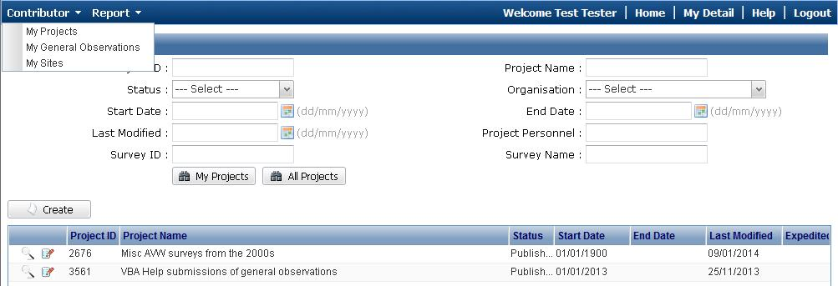

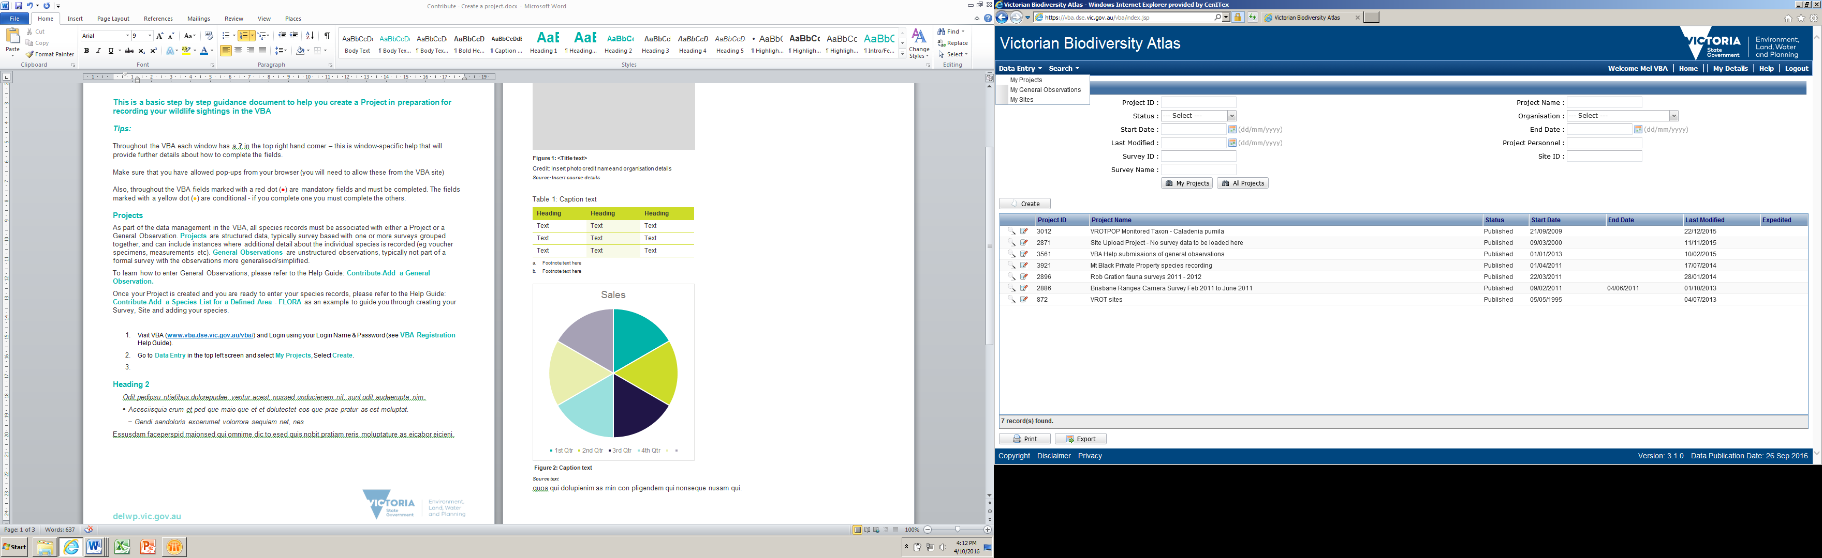

The steps described below relate to data entered in Projects (not General Observations).

1. To make a change to the species recorded in this survey, navigate to the species records screen:
   1. Select the Survey Method and Results tab
   2. Open the relevant Survey Method by clicking on the magnifying glass symbol
   3. Select the Species Records tab and click Edit. You can now change, delete or add species records, or add further information to existing species records.

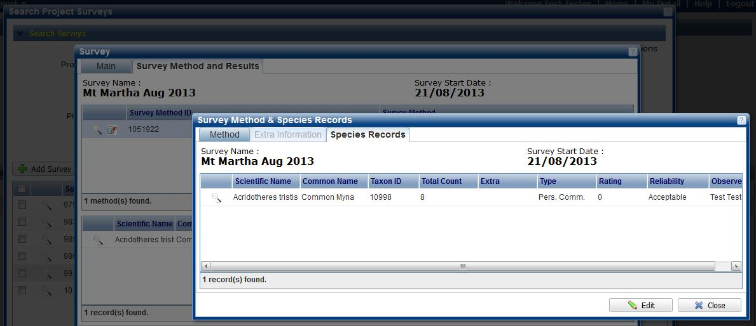

Add Comments or Attachments:

1. To add comments (eg to clarify how you determined the species identification) or a photograph, follow step 4, then type the text into the Comments field and/or click Attachments. If you add a photo, it is helpful for the Expert Reviewer and other users if you type “photo attached” into the Comments field of the species record. Finally, click Save & Resubmit. If your species record previously had a Reliability (eg Unconfirmed) it will now be cleared and the records will go back into the next Expert Review cycle.

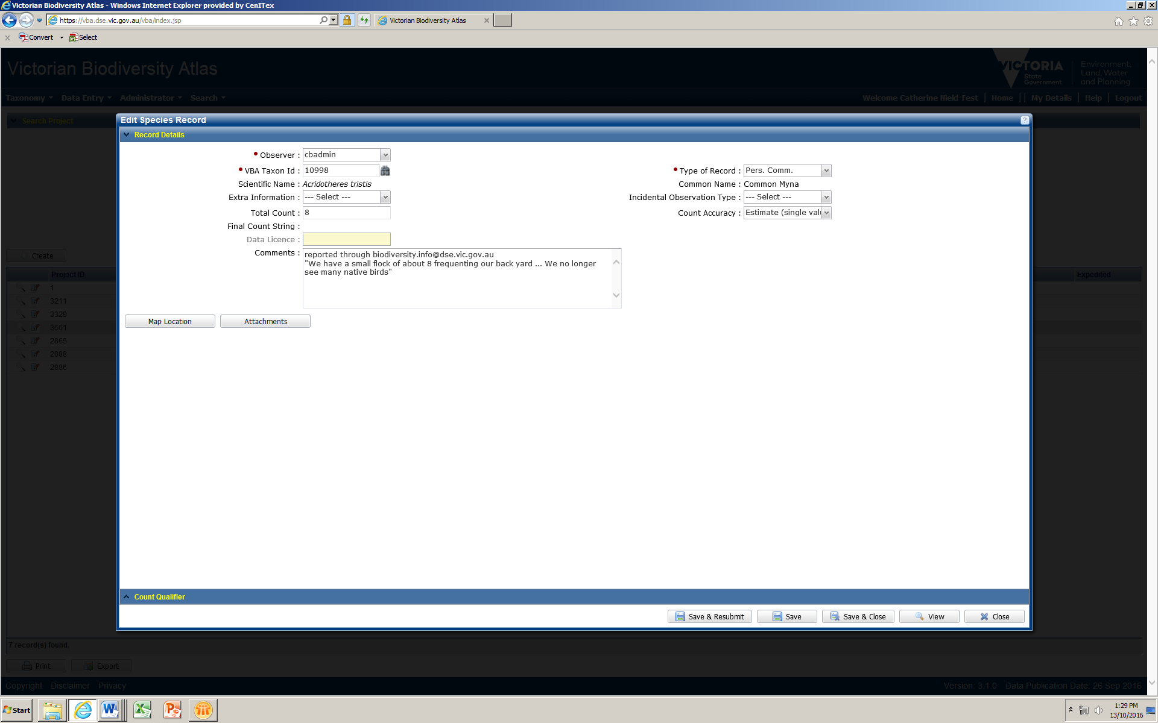

Change a Species:

1. To change the identification of one of your species records (eg from Common Myna to Noisy Miner), click the magnifying glass next to the species you want to change. If you know the VBA Taxon ID for the species you can enter it directly in the field and press Enter, otherwise, click on the binoculars and search for the correct species. Select the species you want to use, click Use Selected and Close.
2. If you have no further information to add, you can Save & Close. If your species record previously had a Reliability (eg Unconfirmed) it will now be cleared and the records will go back into the next Expert Review cycle.

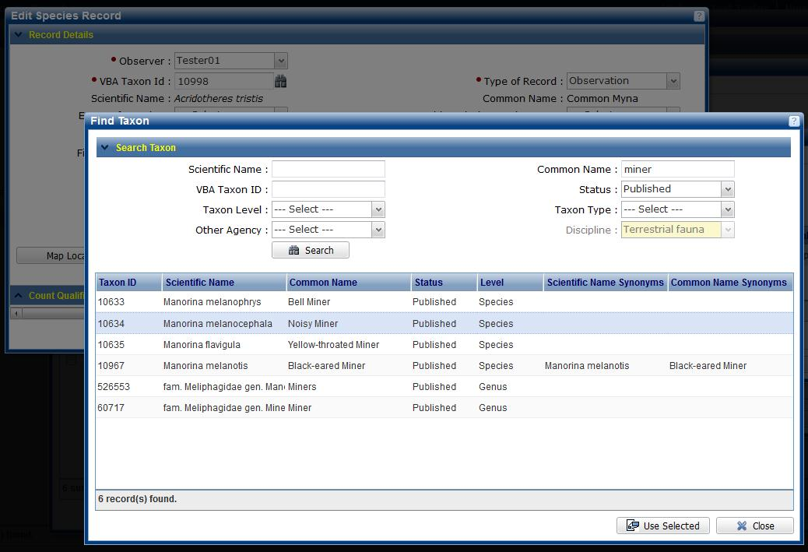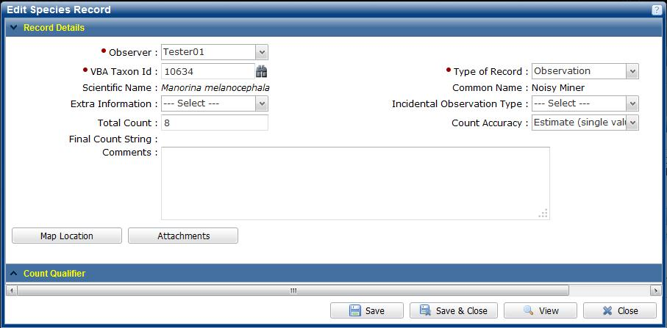

Add a new species:

1. If you want to add a species record, first make sure you are in the Survey Method & Species Records screen with the Species Records tab displayed and in Edit mode (refer to step 4 above):
   1. Click Add Taxon to open a new species record screen
   2. Enter the VBA Taxon Id and press Enter, or search for the taxon by clicking on the binoculars
   3. Select the species you wish to use, click Use Selected (this will return you to the Add Species Record screen)
   4. Enter the remaining mandatory fields, any other information you wish to add, then Save & Close

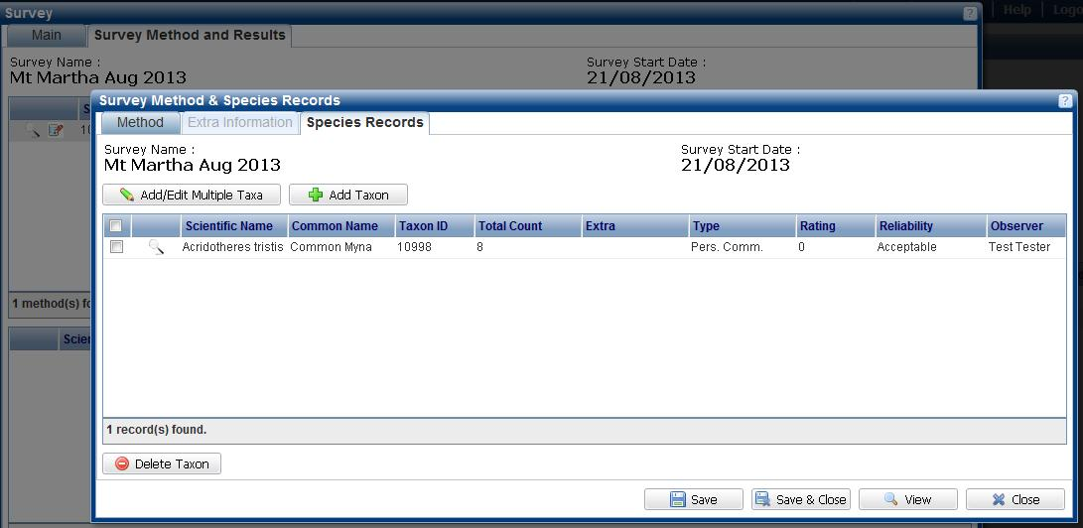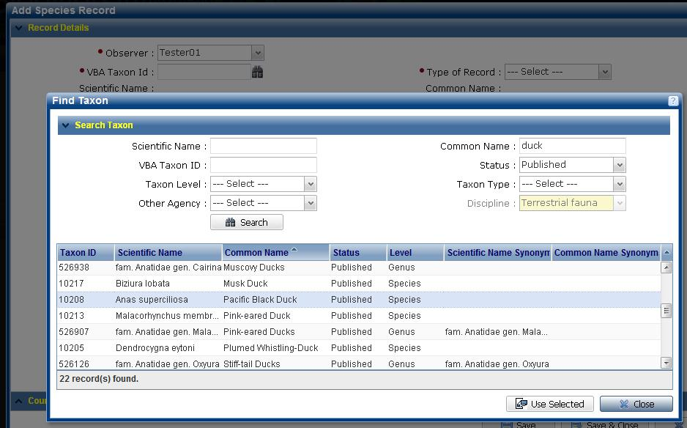

Delete a species:

1. If you want to delete a species record, first make sure you are in the Survey Method & Species Records screen with the Species Records tab displayed and in Edit mode (refer to step 4 above). Tick the box next to the species you want to delete and click Delete Taxon.

NOTE: If this is a record that has already been published (ie the Reliability is Acceptable or Confirmed), you will be asked for a reason which will be forwarded to the VBA Administrator for assessment and approval.

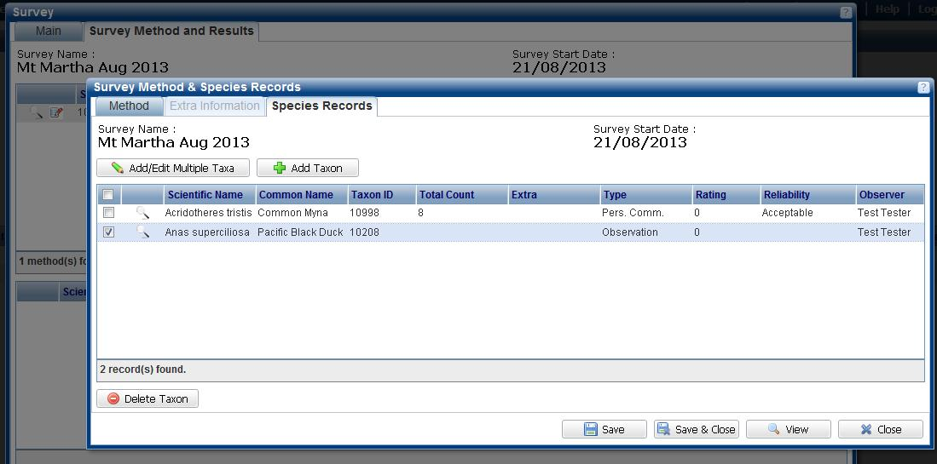

|  |  |
| --- | --- |
| © The State of Victoria Department of Environment, Land, Water and Planning 2017  LogoThis work is licensed under a Creative Commons Attribution 4.0 International licence. You are free to re-use the work under that licence, on the condition that you credit the State of Victoria as author. The licence does not apply to any images, photographs or branding, including the Victorian Coat of Arms, the Victorian Government logo and the Department of Environment, Land, Water and Planning (DELWP) logo. To view a copy of this licence, visit http://creativecommons.org/licenses/by/4.0/  Disclaimer  This publication may be of assistance to you but the State of Victoria and its employees do not guarantee that the publication is without flaw of any kind or is wholly appropriate for your particular purposes and therefore disclaims all liability for any error, loss or other consequence which may arise from you relying on any information in this publication. | Accessibility  If you would like to receive this publication in an alternative format, please telephone the DELWP Customer Service Centre on 136186, email [customer.service@delwp.vic.gov.au](mailto:customer.service@delwp.vic.gov.au) or via the National Relay Service on 133 677 [www.relayservice.com.au](http://www.relayservice.com.au). This document is also available on the internet at [www.delwp.vic.gov.au](http://www.delwp.vic.gov.au). |