Introduction
Biodiversity Response Planning (BRP) is a long-term area-based planning approach to biodiversity conservation in Victoria. It is designed to strengthen alignment, engagement and participation between government, Traditional Owners, non-government agencies and the community.
DELWP Regional staff have been working with stakeholders on actions to conserve biodiversity in specific landscapes, informed by the best available science and local knowledge.
These Fact Sheets capture a point in time, reflecting data and knowledge available in 2020. They provide information for many (but not all) landscapes across Victoria, containing general information on the key values and threats in each area, as well as the priority cost-effective actions that provide the best protection of biodiversity. Fact Sheets are intended to provide useful biodiversity information for the community, non-government and government organisations during project planning and development.
Further information and the full list of Fact Sheets is available on the Department’s Environment website.

Landscape description

The Bunguluke landscape covers 55,872ha with 16% of the area covered in native vegetation. The vast majority of the landscape is private land with only 2% designated public land. Refer to the map at the end of this Fact Sheet.

Cultural importance
We recognise that the entire landscape has high cultural value for Traditional Owners. Landscapes identified as having “notable” cultural importance is based on the density of recorded cultural heritage sites and knowledge shared by Traditional Owners. We also recognise that there are locations important to Traditional Owners not within these landscapes.

Stakeholder interest
As part of the BRP process held in October 2020, stakeholders were asked to nominate landscapes of interests. Dja Dja Wurrung and Barapa Country Aboriginal Corporation nominated Bunguluke.
Possible future investment/project development in this landscape will be available to any interested stakeholders in addition to those who nominated this landscape.

Ecological values identified by Traditional Owners, partners and community within this landscape
Remnant grasslands occur in this landscape; there are few remnant grasslands remaining, particularly on private land
Significant grassy woodlands
Significant grasslands
Threatened flora and fauna

 | Habitat Distribution Models identify 6 species with more than 5% of their Victorian range in this landscape | Traditional Owners, stakeholders and community groups identified the following species of interest within this landscape
 | 5 Plants; notably:  - Grassland Bindweed (Convolvulus graminetinus), endangered with 15% of its Victorian range in area  - Woolly Minuria (Minuria denticulata), rare with 9% of its Victorian range in area  - Oat Kangaroo-grass (Themeda avenacea), poorly known with 7% of its Victorian range in area | - Scaly Mantle  - Umbrella Wattle  - Hairy Tails  - Buloke  - Swamp Buttercup
 | Reptiles | - Carpet Python
 | 1 Bird:  - Plains-wanderer, endangered with 11% of its Victorian range in area | - Bush Stone-Curlew  - Brown Treecreeper (south-eastern spp.)  - Grey-crowned Babbler  - Plains-wanderer
Other | Sun Moths

Traditional Owners, stakeholders and community groups identified the following threats within this landscape
Cultivation of remnant grasslands
Lack of biomass management – undergrazing
Weed control
Lack of compliance of non-permitted clearing of grasslands
Overgrazing (lack of biomass present)
Pest animals

Strategic Management Prospects
Strategic Management Prospects (SMP) models biodiversity values such as species habitat distribution, landscape-scale threats and highlights the most cost-effective actions for specific locations. More information about SMP is available in NatureKit.

Additional threats
Threats identified (in addition to those modelled in SMP) through the consultation process were:
- alterations to hydrology
- land salinisation
- soil erosion
- habitat degradation due to extremes of climate and weather and lack of regeneration in some vegetation communities
- recreational activities causing fragmentation
- loss of vegetation and erosion
- legacy use of public land
- private land use impacting biodiversity
- inappropriate land use planning
- inappropriate fire regimes (planned burning and bushfires)
Some individual threatened species may also require targeted intervention, beyond actions to manage landscape-scale threats, to improve their future prospects.

Which landscape-scale actions are most cost-effective in this landscape?
The coloured areas indicate where the identified landscape-scale actions and locations are most cost-effective and will maximise biodiversity benefit across Victoria for multiple species.
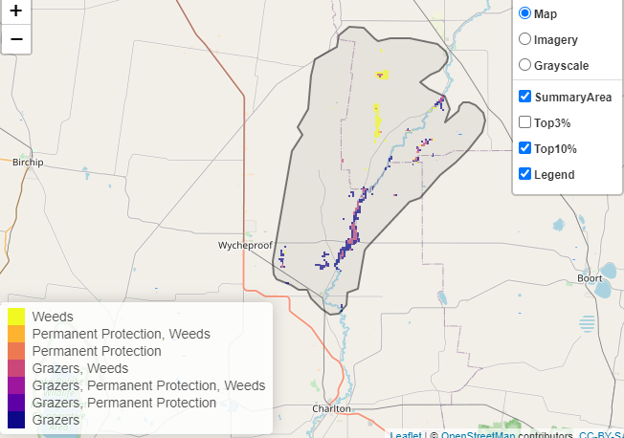
The SMP priority actions which rank among the top 10% for cost-effectiveness of that action across Victoria for much of the landscape are in order of the top 3 actions, see map and list below:
Control rabbits 1,352ha
Control weeds 952ha
Control domestic stock grazing 35ha

Of the top 10% of cost-effective actions, controlling rabbits provides the most cost-effective biodiversity benefits when considering all flora and fauna.

The most cost-effective action for flora and fauna
Plants, mammals, birds, reptiles, amphibians - Control rabbits

For a further in depth look into SMP for this landscape please refer to NatureKit.

