Introduction
Biodiversity Response Planning (BRP) is a long-term area-based planning approach to biodiversity conservation in Victoria. It is designed to strengthen alignment, engagement and participation between government, Traditional Owners, non-government agencies and the community.
DELWP Regional staff have been working with stakeholders on actions to conserve biodiversity in specific landscapes, informed by the best available science and local knowledge.
These Fact Sheets capture a point in time, reflecting data and knowledge available in 2020. They provide information for many (but not all) landscapes across Victoria, containing general information on the key values and threats in each area, as well as the priority cost-effective actions that provide the best protection of biodiversity. Fact Sheets are intended to provide useful biodiversity information for the community, non-government and government organisations during project planning and development.
Further information and the full list of Fact Sheets is available on the Department’s Environment website.

Landscape description
Drajurk - Nangeela Heathy Woodland focus landscape is 57,879ha in size with 63% covered of native vegetation remaining. Public land makes up 63% of the area.
Current ecological modelling shows the Drajurk - Nangeela Heathy Woodland focus landscape occurs largely within the Glenelg Plain Bioregion, bordering the Dundas Tablelands on its eastern flank with small areas occurring in the latter Bioregion. The landscape has approximately 15,000ha of threatened Ecological Vegetation Classes (EVC) and is largely dominated by Heathy Woodland EVC with dispersed areas of Damp Heathland/Damp Heathy Woodland Mosaics, Aquatic Herbland, Damp Sands Herb-rich Woodland, Sedge Wetland and Shallow Sands Woodland/Plains Sedgy Woodland/Seasonally Inundated Shrubby Woodland/Damp Sands Herb-rich Woodland Mosaic EVC throughout. The Victorian Biodiversity Atlas has records of 16 federally protected species, 28 state protected species and 80 rare or threatened species on the Victorian Advisory List occurring within the landscape.
The Gunditj Mirring Traditional Owner Aboriginal Corporation are Traditional Custodians of this focus landscape, with current stakeholders including Birdlife Australia, Glenelg Hopkins Catchment Management Authority, Glenelg Shire Council, Greening Australia, Nature Glenelg Trust, Parks Victoria, Regional Roads Victoria, Trust for Nature, Wannon Water and the West Wimmera Shire Council.

Cultural importance
The Drajurk - Nangeela Heathy Woodland focus landscape may have been recognised by its Traditional Owners as occurring on Woorrowarook Mirring (Forest Country)¹. Woorrowarook Mirring is noted as covering the forested plateaus in the north of the planning area of the Ngootyoong Gunditj Ngootyoong Mara South West Management Plan. The wetlands and forests of this landscape would have been rich in resources for the Traditional Owners. However, displacement from colonisation has left a significant gap in Aboriginal heritage knowledge in this area¹.

Stakeholder interest
There are numerous valuable ecological assets present in this focus landscape, including those identified by Traditional Owners, partners and community.

0BEcological Values identified by Traditional Owners, partners and community within this focus landscape
Nationally Important Wetland-Boiler Swamp System and Mundi-Selkirk Wetlands | Roseneath State Forest
Tooloy-Lake Mundi Wildlife Reserve | Tooloy Flora Reserve
Nangeela State Forest | Argyle State Forest
Drajurk State Forest | Numerous other wetlands
South-eastern Red-tailed Black Cockatoo habitat

Habitat Distribution Models identify 41 species with more than 5% of their modelled Victorian range in this focus landscape | Threatened terrestrial species within this focus landscape requiring specific actions other than those identified in Strategic Management Prospects (SMP)
35 plants, notably:  - Metallic Sun-orchid (Endangered)  - Small Bog-sedge (Vulnerable)  - Heathy Guinea-flower (Vulnerable) | Heathy Guinea-flower  Eichler's Raspwort
2 mammals
- Silky Mouse (Near threatened)
- Heath Mouse (Near threatened)
1 reptile
- Striped Worm Lizard (Near threatened)
1 bird
- South-eastern Red-tailed Black Cockatoo (Endangered)
2 amphibians
- Pobblebonk Frog
- Southern Smooth Froglet

Strategic Management Prospects
Strategic Management Prospects (SMP) models biodiversity values such as species habitat distribution, landscape-scale threats and highlights the most cost-effectiveness action for specific locations. For a further in depth look into SMP for this landscape please refer to NatureKit.

Which landscape-scale actions are most cost-effective in this landscape?
The coloured areas in the map below indicate where the identified landscape-scale actions are most cost-effective and will maximise biodiversity benefit across Victoria for multiple species.

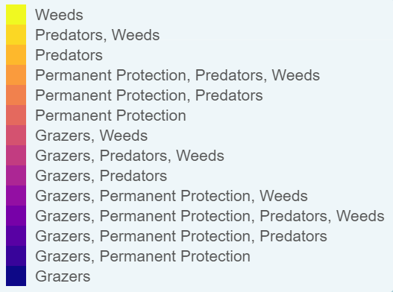
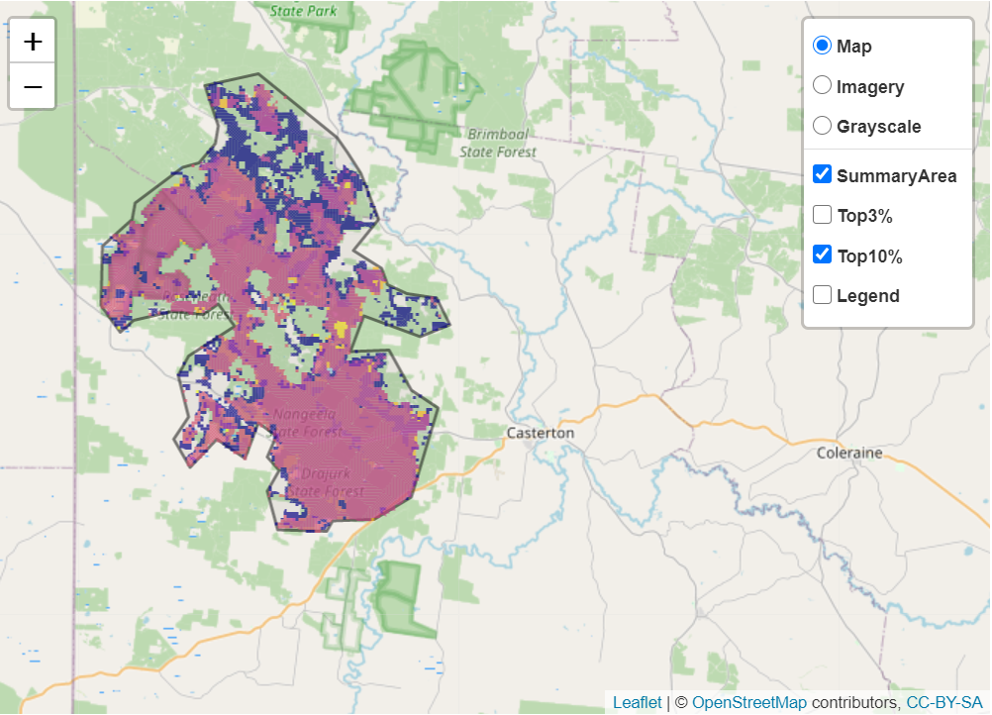

Control Deer 33,092ha
Control Cats 28,684ha
Control Foxes 28,458ha
Control Rabbits 27,020ha
Control Weeds 26,442ha
Control Overabundant Kangaroos 13,129ha
The main SMP priority actions within this focus landscape which rank among the top 10% for cost-effectiveness are listed on the right:

Within this landscape, overabundant kangaroo control, permanent protection, deer control, rabbit control, weed control, domestic grazing control and controlling total grazing pressure were also identified among the top 3% for cost-effectiveness.

Additional threats and considerations
Threats and considerations (in addition to those modelled in SMP) identified by Traditional Owners, partners and community groups during the BRP process for this focus landscape were:
Threats | Ecological processes and values requiring further considerations
Climate change | Appropriate burning regimes
Stock access to riparian and wetland areas | Wetland hydrology
Altered hydrology | Groundwater-dependent ecosystems
 | Aquatic/riparian species and catchment influences
 | Indicator species and ecosystem engineers
 | Mass defoliation events by invertebrates

References
- Parks Victoria, 2015. Ngootyoong Gunditj Ngootyoong Mara-South West Management Plan.

