Biodiversity 2037 Monitoring, Evaluation, Reporting and Improvements Framework (MERIF) Version 2.1

Protecting Victoria's Environment

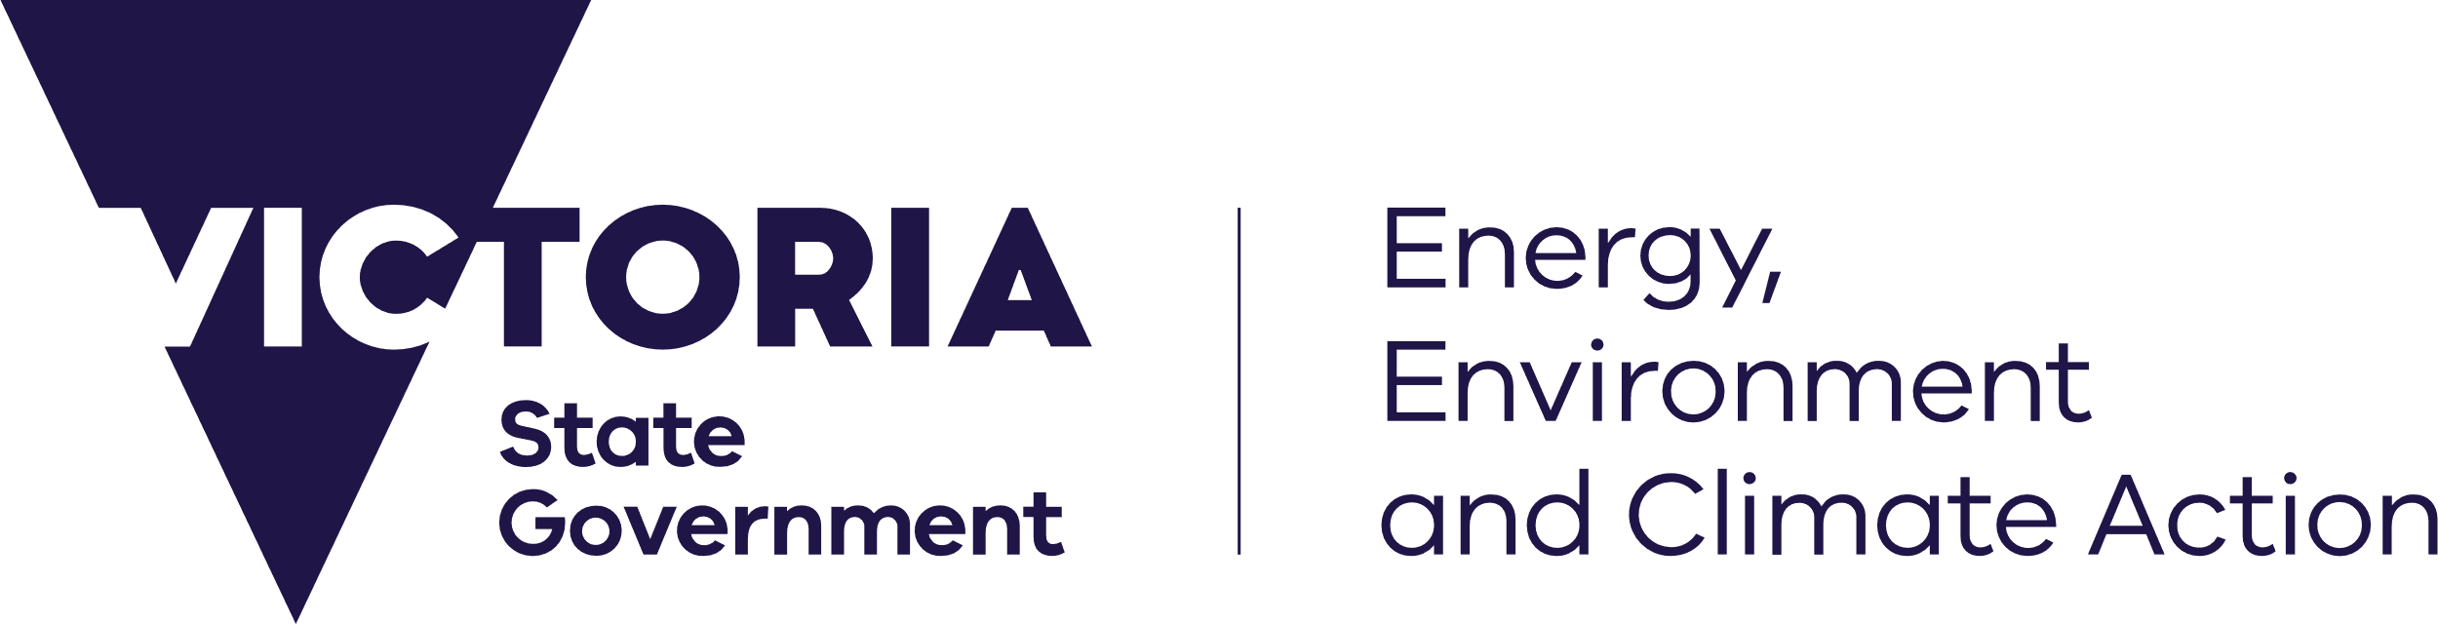



[deeca.vic.gov.au](https://delwpvicgovau-my.sharepoint.com/Users/fionadurante/Downloads/deeca.vic.gov.au)



We acknowledge and respect Victorian Traditional Owners as the original custodians of Victoria’s land and waters, their unique ability to care for Country and deep spiritual connection to it.

We honour Elders past and present whose knowledge and wisdom   
has ensured the continuation of culture and traditional practices.

DEECA is committed to genuinely partnering with Victorian Traditional Owners and Victoria’s Aboriginal community to progress their aspirations.

© The State of Victoria Department of Energy, Environment and Climate Action 2023.

Creative Commons

This work is licensed under a Creative Commons Attribution 4.0 International licence, visit the [Creative Commons website](http://creativecommons.org/licenses/by/4.0/) (<http://creativecommons.org/licenses/by/4.0/>).

You are free to re-use the work under that licence, on the condition that you credit the State of Victoria as author. The licence does not apply to any images, photographs or branding, including the Victorian Coat of Arms, and the Victorian Government and Department logos.

Disclaimer

This publication may be of assistance to you but the State of Victoria and its employees do not guarantee that the publication is without flaw of any kind or is wholly appropriate for your particular purposes and therefore disclaims all liability for any error, loss or other consequence which may arise from you relying on any information in this publication.

Accessibility

To receive this document in an alternative format, phone the Customer Service Centre on 136 186, email [customer.service@delwp.vic.gov.au](mailto:customer.service@delwp.vic.gov.au), or contact National Relay Service on 133 677. Available at [DEECA website](http://www.deeca.vic.gov.au/) (www.deeca.vic.gov.au).

Contents

1. Introduction 2

2. Logic framework 6

3. Monitoring progress 9

Biodiversity 2037 targets 9

4. Monitoring change in Biodiversity, management response and effectiveness 11

Biodiversity Indicator Framework 11

5. Evaluation of Biodiversity 2037 12

Approach 12

Key evaluation questions 13

Implementing the evaluation plan 14

Dissemination of results of the evaluation 14

6. Reporting 15

Indigenous Cultural Intellectual Property and Data Sovereignty 15

7. Biodiversity Knowledge Framework - Improving the rigour of decision-making and the effectiveness of actions 16

Overview 16

Biodiversity Knowledge Portal 17

Glossary 18

1. Introduction

Protecting Victoria’s Environment – Biodiversity 2037 ([Biodiversity 2037](https://www.environment.vic.gov.au/biodiversity/biodiversity-plan)) is Victoria’s twenty-year plan for the future of Victoria’s biodiversity. Biodiversity 2037 sets the ambitious yet achievable task of halting biodiversity decline, delivering a 100% net positive Change in Suitable Habitat in 50 years for threatened species (with associated co-benefits for non-threatened species), and sustaining the state’s strong economy.

While Biodiversity 2037 is a twenty-year plan, the Biodiversity 2037 Implementation Cycle provides for planning and continuous improvement in its delivery. The Four core components of the Biodiversity 2037 Implementation Cycle (Figure 1) are:

* + - The strategy itself (Biodiversity 2037) and its review after 20 years.
    - The enabling environment and planning process, including work that DEECA does to provide tools and systems, regulations and standards, access to land; collaborative planning, area-based identification of projects, locations and actions etc.
    - That everyone is undertaking actions that contribute to the targets of Biodiversity 2037 – this includes contributions from individuals, community groups, Traditional Owners, non-government organisations and government agencies.
    - **Monitoring, evaluating, reporting and improving how we do things. This will embed continuous improvement into planning and implementation of actions and support the potential refresh of Biodiversity 2037 every 5 years.**

Applying an adaptive management approach through this Implementation Cycle will ensure that delivery of the biodiversity outcomes is continuously improved, the implementation of Biodiversity 2037 is designed and delivered efficiently and effectively, and is responsive to emerging issues.

To support the Implementation Cycle, the Biodiversity 2037 Monitoring, Evaluation, Reporting and Improvement Framework (Biodiversity 2037 MERIF) has been developed to demonstrate that progress is being made in the collaborative efforts to deliver the outcomes and targets that will ensure that Victoria’s biodiversity is healthy, valued and actively cared for. Moreover, that these collaborative efforts are delivered in the most cost effective and efficient way. The Biodiversity 2037 MERIF supports whole-of-government transparency and accountability and is key input to updating the contributing targets and processes and the five-yearly refresh of Biodiversity 2037.

The Biodiversity 2037 MERIF provides an overarching framework that:

* + - gives guidance to the biodiversity sector on the desired outcomes of Biodiversity 2037 and the pathways to achieving them through our activities.
    - demonstrates accountability and transparency by outlining progress in achieving the targets and goals set out in Biodiversity 2037.
    - evaluates the implementation and effectiveness of Biodiversity 2037.
    - The Biodiversity 2037 MERIF is a living document and will be reviewed and updated regularly including as a result of evaluation and any refresh of Biodiversity 2037.

Figure 1: Biodiversity 2037 cycle. Light blue boxes indicate role of Biodiversity 2037 MERIF.

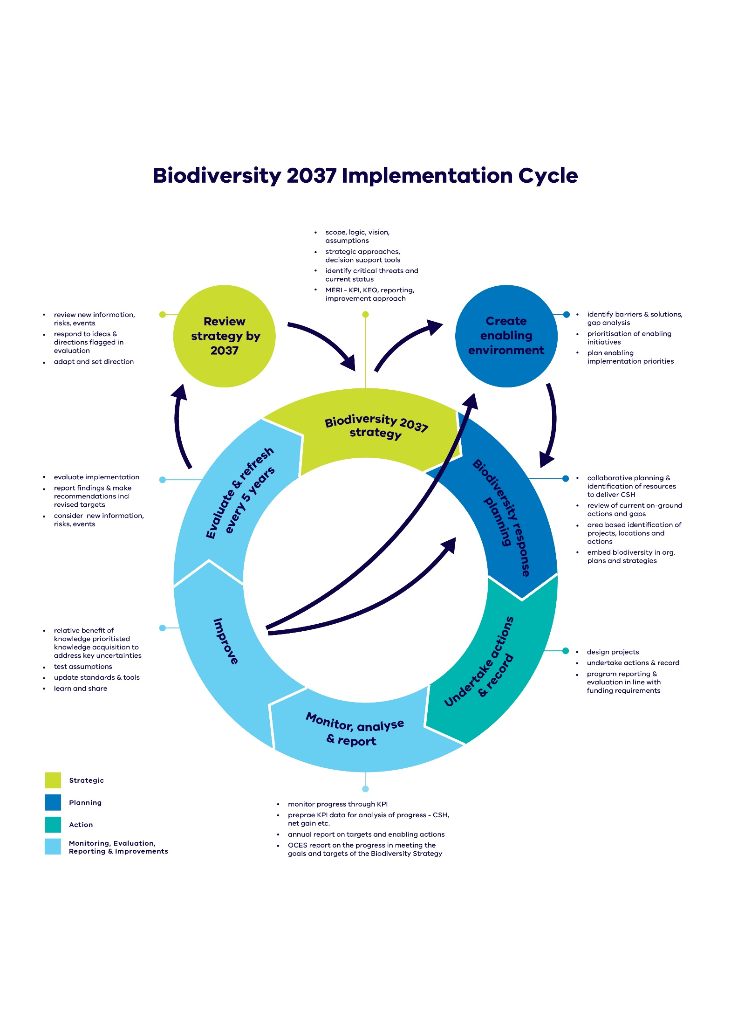

The Biodiversity 2037 MERIF provides the framework for evaluating the Biodiversity 2037 Plan and monitoring progress towards the state-wide and contributing targets, while the Biodiversity Indicator Framework (BIF) aims to monitor biodiversity change and action across the state (Figure 2). The Biodiversity Knowledge Framework provides a systematic approach to identifying and prioritising new knowledge (Figure 2).

Biodiversity Knowledge Framework

Biodiversity Indicator Framework

Biodiversity 2037 Monitoring, Evaluation, Reporting and Improvement framework

Biodiversity 2037 evaluation, progress towards state-wide and contributing targets

Change in biodiversity, management response and effectiveness indicators

Prioritisation of new knowledge

Priority for data collection and standards - inform how data should be provided (e.g. DEECA Output Data Standards) or inform different standards of delivery of an action (e.g. different standards of revegetation)

**Figure 2: Connection between documents describing Biodiversity 2037 targets, knowledge acquisition, and broader biodiversity reporting.**

The logic framework for Biodiversity 2037 is an important component of the Biodiversity 2037 MERIF. It describes the relationships between biodiversity activities and their outputs, and how these are expected to lead to outcomes. The purpose of the logic framework is to provide a basis for:

* + - informing the Implementation Cycle in order to support the expected outcomes.
    - determining the assumptions underpinning the logic.
    - identifying key evaluation questions.
    - undertaking evaluation of Biodiversity 2037 and informing adaptive improvements to the implementation of Biodiversity 2037.
    - communicating with key stakeholders about Biodiversity 2037.

A summary of the key elements of the logic framework are provided in Table 1.

**Table 1: Logic framework outline**

|  |  |
| --- | --- |
| **Logic framework** | **Definition** |
| Vision | A qualitative description of what is desired in the long term |
| Outcomes | Measurable collective contribution of delivering the outcomes to the vision |
| Intermediate outcomes | The impact of planned outputs measured at a midpoint between outputs and outcomes |
| Outputs | Direct result of the priorities, initiatives, programs and projects |
| Priorities, initiatives, programs and projects | Actions, on-ground activities, events, products of the program. |
| Inputs | Effort, materials, equipment and funds put into natural resource management to deliver outputs and, in the longer term, achieve outcomes and vision |

1. Logic framework

The Biodiversity 2037 Logic Framework describes the basis for how the implementation of Biodiversity 2037 will deliver the outcomes and vision of ensuing Victoria’s biodiversity is healthy, valued and actively cared for.

The logic and achievement of the vision and outcomes of Biodiversity 2037 are underpinned by intermediate outcomes, which are provided in Table 3 below. The logic framework may be updated in response to the evaluation or if there is a refresh of Biodiversity 2037, as new knowledge becomes available that verifies or refutes these assumptions.

The assumptions will be considered in the evaluations where monitoring of Biodiversity 2037 targets (Section 3) and reporting of indicators in the Biodiversity Indicator Framework report (Section 4) indicate that current activities are not achieving expected biodiversity outcomes. In some cases, research or data collection may be prioritised through the Biodiversity Knowledge Framework (Section 6) to test the assumptions.

Biodiversity 2037 is also subject to a range of external factors outside the scope and control of the strategy that may influence the ability to successfully deliver Biodiversity 2037 outputs and outcomes. Examples of external factors, which can be considered in the evaluations, are provided in Table 2.

**Table 2: External factors relevant to Biodiversity 2037.**

|  |
| --- |
| **External factors** |
| The global economy and its impact on Victoria may limit available funding for conservation activities from all possible funding avenues including voluntary works |
| Stochastic events such as fire, pest and disease outbreaks etc may impact on biodiversity values |
| The effects of climate change may:   * Change environment quicker than our management can respond * Lessen impact or over-ride the impact of management actions. |
| Levels of support and leadership across the sector and within Government may change |
| Pandemics (e.g. Covid 19) |
| Population growth |

| **Vision: Victoria’s biodiversity is healthy, valued and actively cared for.** This means that Victoria has functioning plant and animal populations, improved habitats and resilient ecosystems, even under climate change. This can only be supported through an understanding by Victorians that their personal wellbeing and the economic wellbeing of the State are dependent on the health of the natural environment. | | | | | |
| --- | --- | --- | --- | --- | --- |
|  | | | | | |
| **Problem statement** | **Inputs and enabling actions** | **Programs and projects** | **Outputs** | **Intermediate Outcomes** | **Outcomes** |
| Chapter 3: Victoria’s biodiversity continues to decline, and the current level of remedial effort is not sufficient or well enough targeted to make up for these losses in the face of climate change. | Funding  Authorising environment  Guidance, standards, processes, data systems  Decision support tool improvements  Policy, regulation and legislation (incl. updates)  Data collection and analysis  Governance  Relationships and co-operation with partners  Communications  Change management  Staff and staff time  Equipment and supplies  Access to land  Research and scientific base | Response planning  Actions to manage Broadscale threats  Actions to manage specific threats  Campaigns  Awareness raising  Education and training  Workshops and forums  Programs and projects  Business cases and opportunities  Cultural management practices | We:  enable everyone to provide the right data to measure their contributions  provide information on how to make better on-ground decisions to maximise biodiversity outcomes  integrate decision support tools into our processes  identify and fill priority knowledge gaps to continually improve our decision making | So:  decision support tools are improved, and more people are using them  people understand how to make better on-ground decisions including through the use of decision support tools | So that:  everyone has maximised their contribution to delivering the greatest overall benefit for biodiversity by undertaking the most beneficial actions in the relevant places |
| Chapter 4: Victorians are increasingly disconnected from nature and have limited awareness of the threats to, and benefits of biodiversity. This results in fewer Victorians acting to protect and enhance the natural environment. | We:  promote the importance of the State’s natural environment  provide more opportunities for Victorians to connect to and regularly spend time in nature  We sustain and increase opportunities to act for nature | So:  more Victorians are connected to nature  more Victorians protect or enhance the natural environment | So that:  Victorians are contributing to the health of Victoria’s biodiversity |
| Chapter 5: The environment is not equally considered in decision-making (when compared to economic and social outcomes). | We:  increase opportunities for more people to access or benefit from green areas to improve liveability, health and wellbeing  provide more opportunities through the nature-based tourism industry for Victorians to connect with nature | So:  Victorian communities benefit from improved liveability and nature-based tourism | So that:  Victoria has a healthy natural environment that underpins and sustains the prosperity of the Victorian economy and society |
| Chapter 6: There is inadequate investment to maintain and enhance biodiversity. This include persistent under investment to address legacy issues and to counter-balance ongoing losses. | We:  We implement a range of approaches to increase, sustain and maximise the potential of biodiversity funding  increase opportunities for private landholders to participate in biodiversity stewardship | So:  everyone invests in biodiversity  more private land is managed for biodiversity | So that:  investment is sufficient to stop biodiversity decline |
| Chapter 7: The sector is not operating efficiently or effectively. There is competition for funding, a lack of a shared vision for Victoria’s landscapes and barriers to stakeholder participation. | We:  enable more people and organisations to participate in collaborative planning for biodiversity  We facilitate a shared understanding of biodiversity needs and gaps | So:  delivery of biodiversity actions and resources is aligned and complementary to make the most of collective effort and skills of partners  So each organisations’ contribution to the outcomes is understood and valued | So that:  everyone is working cohesively to ensure biodiversity outcomes from their contribution are maximised |
| Chapter 8: The wellbeing of Traditional Owners has been compromised by a limited ability to connect to Country and execute their right to participate as equal partners in the management of Victoria’s natural resources. | We:  provide support for Traditional Owners and Aboriginal Victorians to actively participate in the collaborative biodiversity planning processes  support skills and capacity building activities for Traditional Owners and Aboriginal Victorians to manage Country  increase opportunities for Aboriginal environmental business and employment | So:  there is improved access to biodiversity and increased role of Aboriginal people in biodiversity management  there is increased practice of culture including acknowledging, recognising and respecting it in biodiversity planning and management  there is increased access to biodiversity for economic development | So that:  Traditional Owners and Aboriginal Victorians have improved wellbeing through connection to healthy Country |

**Table 3: Program logic to deliver the shared vision of Victoria’s biodiversity is healthy, valued and actively cared for**

1. Monitoring progress

To provide transparency and accountability to the community, there will be annual monitoring and reporting on progress towards achieving the goals and targets set out in Biodiversity 2037. Biodiversity 2037 presents a long-term vision for Victoria’s biodiversity, supported by the goal – Victoria’s natural environment is healthy. Underpinned by the Logic (Table 3), the Plan sets statewide and contributing targets for achieving the goals (Figure 3 & 4).

Achieving the statewide targets requires the establishment and maintenance of the actions identified by the contributing targets. The targets identify the area of management that needs to be reached, as soon as possible, and maintained over the 20-year life of the Plan. If effort slows or stops, in some cases even for a short time, the gains made over the preceding years may be lost. The sooner the actions to deliver the contributing targets are implemented, the more likely it is that the statewide targets will be achieved.

## Biodiversity 2037 targets

Protecting Victoria’s Environment - Biodiversity 2037 articulates a vision: **Victoria’s biodiversity is healthy, valued and actively cared for**. This vision can only be achieved through collective action. Together, we can ensure Victoria’s natural environment is healthy, has functioning plants and animal populations, improved habitats and resilient ecosystems, even under climate change. This will be achieved by stopping the overall decline of threatened species, securing the greatest possible number of species in the wild, and improving the overall extent and condition of habitat. The goals, state-wide, and contributing targets (Figure 3 and 4) are used to monitor and report annually on progress toward the vision of Biodiversity 2037 and to evaluate the implementation of Biodiversity 2037.

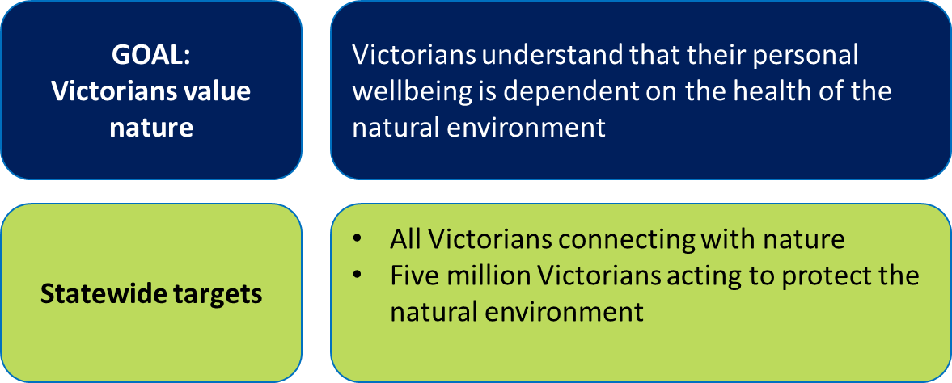

**Figure 3: Goal and state-wide target, to be reviewed every five years.**

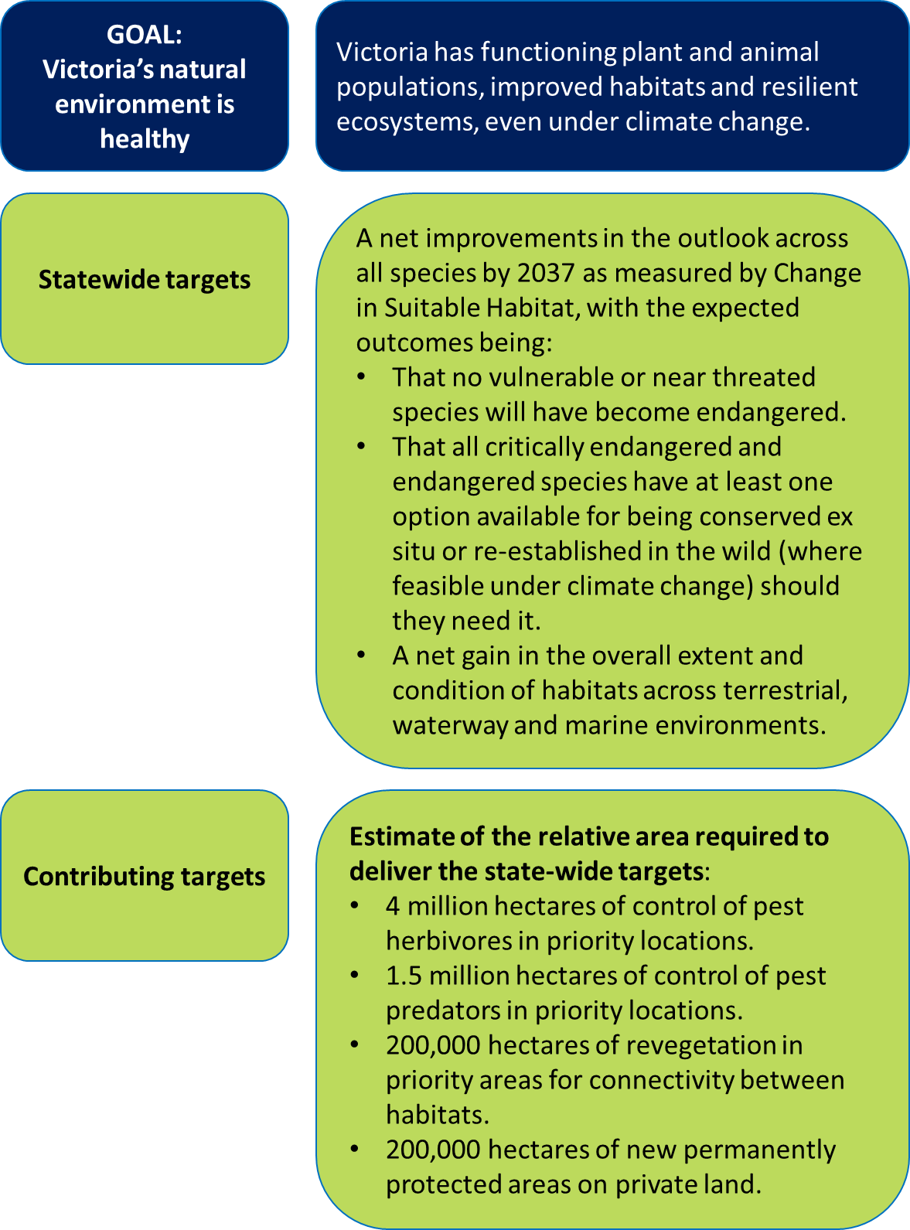

**Figure 4: Goal, state-wide target, and contributing targets, to be reviewed every five years.**

4. Monitoring change in Biodiversity, management response and effectiveness

## Biodiversity Indicator Framework

Biodiversity 2037 represents a contemporary approach to managing biodiversity. It brings together the latest conservation science and social science to help achieve the plan’s vision: that Victoria’s biodiversity is healthy, valued and actively cared for. To assess the state of Victoria’s biodiversity, a suite of biodiversity indicators has been developed to ensure comprehensive reporting on biodiversity.

The [Biodiversity Indicator Framework](https://www.environment.vic.gov.au/biodiversity/biodiversity-indicator-framework) (BIF) reports on biodiversity broadly, including assessing population trends and species status, forecasting the abundance and distribution of species under different management scenarios into the future, progress toward management outputs, the effectiveness of management actions, how Victorian’s are connecting with and valuing nature, and seeks alignment with Traditional Owner priorities for monitoring and reporting on the health of Country.

Under the BIF, biodiversity indicators are grouped into five key themes (Figure 5), where each theme allows for reporting on an important component of conserving and managing Victoria’s native flora and fauna. In combination, these themes provide the mechanism for monitoring and reporting on biodiversity more holistically and provide information that may identify potential trigger points for assessing when management responses may need to be reconsidered.

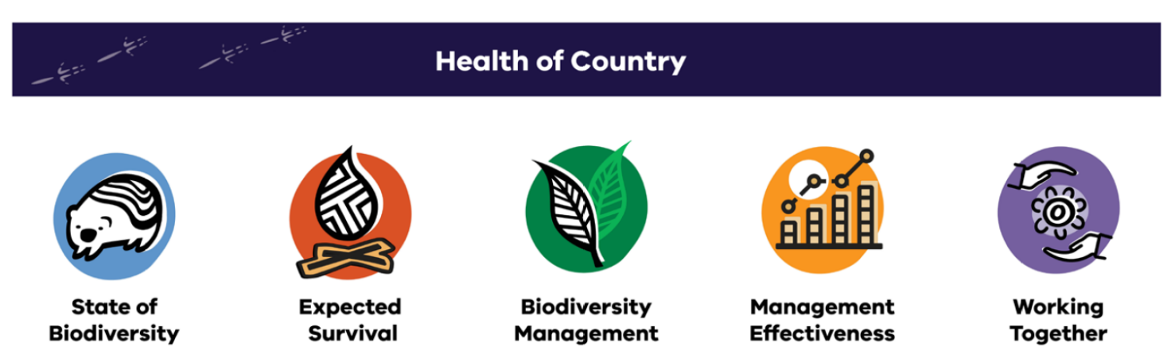

**Figure 5. Biodiversity Indicator Framework themes.**

5. Evaluation of Biodiversity 2037

The purpose of the evaluation is to assess the implementation of Biodiversity 2037 and provide recommendations on how it can be improved through time. Applying this adaptive management approach will ensure that delivery of biodiversity outcomes is continuously improved, and that implementation of Biodiversity 2037 is designed and delivered efficiently and effectively. The evaluation supports whole-of-government transparency and accountability.

There will be an evaluation of Biodiversity 2037 every five years looking across the whole of the biodiversity sector to assess how Biodiversity 2037 has been implemented and integrated into policies and programs. The results of the evaluation, together with State of the Environment report on progress towards Biodiversity 2037 outcomes, and other information will support a 5-yearly review of Biodiversity 2037.

These principles will underpin the design of this evaluation:

* + - it is collaborative and participatory, with all organisations contributing and telling their story in a way that makes sense to them.
    - there is a level of independence.
    - there is consistency in both the questions asked and the target data collection methods and there is baseline data where it makes sense to do so.
    - it is ongoing and proportionate with the effort in delivering Biodiversity 2037.

## Approach

The evaluation uses a participatory approach to assess the implementation of Biodiversity 2037, with a view to identifying recommendations for how implementation could be improved. The evaluation examines the collective effort in implementing Biodiversity 2037, the impact of this work, what is working well, what’s not, and the actions needed to improve implementation.

The evaluation uses a mix of internal and external evaluation techniques, interrogation of monitoring and reporting (under the Biodiversity 2037 MERIF and/or BIF), and dedicated data collection. It is designed to be user friendly and complement Biodiversity 2037’s commitment to a collaborative approach to biodiversity management in Victoria.

The evaluation approach is based on Collaborative Outcomes Reporting(adapted from Dart and Roberts (2014)[1]). This scale-able, participatory approach to impact evaluation draws on a range of evidence and expert and/or key stakeholder opinion to derive a “performance story” outlining the contribution of an intervention to outcomes.

Data collection and analysis is completed in two stages:

1. development of performance story reports for each outcome including synthesis of reporting against the targets
2. additional work at the whole of strategy level involving:
   1. synthesis across these performance story reports.
   2. collecting additional evidence to answer key evaluation questions.
   3. workshops to make sense of the evidence and identify opportunities to improve.

## Key evaluation questions

These four Key Evaluation Questions (KEQs; Table 4) guide the data collection for evaluation. The KEQs will be reviewed and revised as needed after each evaluation of Biodiversity 2037.

1. **Table 4: Key evaluation questions**

| **Key evaluation questions** | **Subsidiary questions** |
| --- | --- |
| To what extent has Biodiversity 2037 been **implemented** as described in the logic framework? If not, why not? | Is the Logic Framework still valid? Are the relationships and assumptions in the logic framework linking outputs to outcomes valid? |
| How **effective is the implementation** of Biodiversity 2037? | To what extent have the outcomes of Biodiversity 2037 been achieved? What else has emerged, positive and negative? |
| How effective were the different approaches adopted by Biodiversity 2037 to manage biodiversity and deliver on Biodiversity 2037’s vision and outcomes? |
| To what extent has Biodiversity 2037 influenced within DEECA, across government departments / authorities and amongst stakeholders? |
| What has helped and what has hindered effective implementation? |
| How strong is Biodiversity 2037’s **sustainability**? | How sustainable are established funding mechanisms? |
| To what extent has the conservation of biodiversity become part of society’s mainstream |
| How have landholders contributed to the sustainability? |
| To what extent has Biodiversity 2037 encouraged a paradigm shift away from traditional funding sources? |
| To what extent are extra resources required to maintain the outcomes already achieved? |
| What are the **lessons** for the future? | Has Biodiversity 2037 adopted the right mix of approaches to manage biodiversity and deliver on Biodiversity 2037’s vision and outcomes? |
| How appropriate were the tools and processes adopted in delivering Biodiversity 2037? |
| What are the lessons? For whom? |
| What needs to be done now? |

1. **Table 4: Outcome level key performance questions**

| **Key evaluation questions** | **Subsidiary questions** |
| --- | --- |
| To what extent have the Biodiversity 2037 outcome been achieved? If not, why not? | What were the accomplishments for each outcome against what was expected? (refer to the Logic Framework Biodiversity 2037 Implementation Framework and the Biodiversity 2037 priorities and initiatives) How were they delivered and by who? |
| How effective were the different approaches adopted for each outcome to bring about change? How have stakeholders and partners changed what they are doing? |
| How influential was Biodiversity 2037 in directing activity and policy within DEECA, across government departments and amongst stakeholders? |
| Is the Logic Framework still valid? Are the relationships and assumptions in the logic framework linking outputs to outcomes valid? |
| What was learned and what needs to be done next? |

## Implementing the evaluation plan

Some evidence collection and synthesis will be undertaken by internal DEECA staff. Most of the evaluation will be delivered by a contracted external evaluator, working closely with DEECA staff. Given the participatory nature of the evaluation approach, the consultant requires strong engagement and evaluation skills. There may be efficiencies in engaging the same contractor for both the outcome and whole of strategy level components of the evaluation.

## Dissemination of results of the evaluation

The evaluation will adopt a collaborative approach where key stakeholders are engaged with the evidence, make evaluative judgements and contribute to recommendations about how to improve. This approach encourages ownership and use of evaluation findings and embeds dissemination throughout.

This evaluation also has reporting requirements. Section 10.2 of Biodiversity 2037 commits DEECA to publicly report on the outcomes of the five-yearly evaluations. This evaluation will result in development of two reports: Performance Story reports for Biodiversity 2037 outcomes and an overarching report that synthesises information assessing implementation of Biodiversity 2037.

In addition to these reports, DEECA will consider disseminating findings using an interactive website. This innovative approach to reporting allows for including a variety of media (including videos) and can further promote uptake and use.

6. Reporting

Sharing progress against the targets of Biodiversity 2037 with the community provides the opportunity to further build awareness and connection with Victoria’s rich biodiversity, celebrate successes, and encourage further participation in acting to protect nature.

Reporting on Biodiversity 2037 implementation through the targets will be provided through the [DEECA website](https://www.environment.vic.gov.au/biodiversity/Implementing-Biodiversity-2037) and within the BIF. This will enable users to view progress against targets as new data is available for release. Data for most targets will be available and reported on an annual basis, others may be monitored over longer periods of time.

A core element required to measure the progress of Biodiversity 2037 is the contribution by partners of their output (activity) data – where the activity occurred, what was undertaken and to what standard. This data is an increasingly common standard utilised across a range of natural resource management programs in Victoria. Consistent collection and sharing of this data by each organisation will enable a range of reporting, including that required for Biodiversity 2037. For example, reporting on implementation of policies and regulations, reporting against catchment strategies or Country plans and the annual achievements of an organisation.

Data collected through the MERIF will generally be available through the DEECA data management systems where applicable (e.g. Victorian Biodiversity Atlas, NatureKit and the Victorian Government website: www.data.vic.gov.au). Consent or permission may be required for some data (e.g. species with sensitive requirements).

## Indigenous Cultural Intellectual Property and Data Sovereignty

Traditional Owners have asked DEECA to commit to Indigenous Data Sovereignty and put processes in place to recognise the right of Traditional Owners to govern the collection, ownership and use of data about their communities, people, land, and resources. In simple terms, Indigenous Data Sovereignty is the right of Indigenous peoples to own and control the data, knowledge or information that is about or relates to them.

Indigenous Data Sovereignty includes Indigenous people having governance of data that is generated by state infrastructure. It also requires access and control of data for governance: information that adequately reflects Indigenous cultural diversity, worldviews, and priorities. Indigenous Data includes information, interviews, surveys, statistics, reports, sound recordings, films, photographs, health records, mapping of Country, records and samples of plants and animals, languages, knowledge, art and stories. Indigenous data is often collective data and is important to Indigenous people to share and have access to, to pass down through the generations for nurturing and refining.

DEECA is implementing a pathway to an Indigenous Data Sovereignty Policy that includes collection and management of biodiversity data. While the Guiding Principles of Indigenous Data Sovereignty have been established, work is currently being undertaken to establish departmental systems, processes and tools that will support the delivery of a future Indigenous Data Sovereignty Policy.

# 

7. Biodiversity Knowledge Framework - Improving the rigour of decision-making and the effectiveness of actions

## Overview

Biodiversity 2037 – Protecting Victoria’s Environment emphasises that to deliver on the outcomes of the plan, there needs to be an increase in targeted data collection for evidence-based decision-making of both management actions and actions to increase Victorians connection to nature and encourage them to act for biodiversity. This includes progressively filling critical knowledge gaps, through targeted research and data gathering and ensuring that information is integrated across all environments (marine, waterway and terrestrial). Testing our assumptions, understanding the consequences of environmental change, management and human land use are essential components in protecting Victoria’s environment and ensuring continuous improvement. This is reinforced through the State of the Environment 2018 report which notes that Victoria’s science and data capability is diminished by a lack of coordination and a strategic approach to investing in the critical research that will enable better, and timelier, decision making and policy interventions.

Victoria’s biological heritage is diverse, as are those who research and manage it. Because of this, there are a broad range of views on Victoria’s research priorities, multiple approaches to addressing these research priorities and many important partners and stakeholders that can participate in addressing these knowledge gaps.

Both human behaviours and biodiversity conservation and management in Victoria is also complex, with many potential interacting components (e.g. food webs, unintended consequences of management), and so in identifying knowledge gaps it is important to take an integrated, whole-of-ecosystem approach. This means not just considering individual species or management actions, but also the relationship between them and other species, feedbacks and ecological processes that occur in Victoria’s ecosystems.

The changing nature and scale of both private and public investment in biodiversity conservation demands a systematic approach to improving our understanding the benefits of a management action, intervention or policy approach and risks that knowledge gaps and uncertainty associated with that intervention may have on Biodiversity 2037 in achieving its outcomes and vision.

A consistent, quantifiable and systematic approach is required to a) identify knowledge gaps and b) prioritise research investment to ensure that the research being invested in is strongly linked to policy and decision-making with a focus on strengthening Victoria’s ability to deliver on the vision of Biodiversity 2037.

The [Biodiversity Knowledge Framework](https://www.environment.vic.gov.au/biodiversity/knowledge-framework) provides the approach to identifying and prioritising knowledge gaps and uncertainties and has been developed to:

* Describe our shared understanding through causal models of a threat or disturbance process to a species or ecosystem, or barriers to human behavioural change; identify options for intervention, policy or management and predicted benefit or impact of those options. New models can be added as they are developed.
* Identify, compare and prioritise knowledge gaps across management actions/ interventions, environments (marine, freshwater and terrestrial) and systems (through an index describing the Relative Benefit of Knowledge). The prioritisation approach can also be used to assess proposals and project concepts for knowledge gaps that haven’t yet been identified.
* Provide a platform for partners and stakeholders to identify and include projects that are helping to address knowledge gaps and a process to update our understanding and causal models; and provide standards and tools as new knowledge is acquired that verifies or refutes assumptions and resolves uncertainty.

Although uncertainty is pervasive in biodiversity conservation, only a subset of knowledge gaps are likely to be critical to effective decision making. To meet the challenge of identifying knowledge gaps and prioritising research investment, the Biodiversity Knowledge Framework provides an approach for systematically describing uncertain elements in system understanding and those of higher priority. The broad approach of the Framework is outlined in Figure 5 with details provided in Appendix 2.

## Biodiversity Knowledge Portal

An online interactive portal has been developed to provide a platform for collating causal models and associated information. This enables partners and stakeholders to identify and include projects that are helping to address knowledge gaps and a process to update our understanding and causal models.

The online [Knowledge Portal](https://www.environment.vic.gov.au/biodiversity/knowledge-framework/knowledge-portal) enables the ability to:

* Select problem-response scenarios to view.
* View the benefit and uncertainty for the scenario.
* View the causal model for the scenario with clickable links.
* Add notes on research projects currently underway or completed that address a specific link.
* Comment or question a particular link or part of the causal model.
* Update and refine the causal model based on research results or other information.
* Progressively add new causal models for other problem-response scenarios.
* Identify knowledge gaps and research questions, ranked against Relative Biodiversity of Knowledge scores.

1. Glossary

|  |  |
| --- | --- |
| **Term** | **Definition** |
| Activity | The process of using labour and materials to produce outputs. |
| Adaptive management | A systematic approach for improving management by learning from management outcomes |
| Assumptions | Documented relationships between components of the logic framework |
| Delivery standard | A described standard to which works are delivered (e.g. revegetation standards) as agreed in the DEECA Delivery Standards |
| Effectiveness | Achievement of desired management outputs. Where efficiency refers to the value for the process, effectiveness refers to the quality of the result |
| Evaluation | Periodic assessment of policies, programs and projects against key evaluation questions |
| Key evaluation questions | Pre-determined questions which frame periodic evaluation of the performance of policies, programs and projects. The questions focus on impact, appropriateness, effectiveness, efficiency and legacy |
| Biodiversity indicator | A quantitative or qualitative factor or variable that provides a simple and reliable basis for assessing biodiversity trends or progress towards targets and outcomes. It is a unit of information measured over time that can help show change in a specific condition. |
| Logic framework | A conceptual model that shows the rationale behind a program or strategy. Outlines the anticipated cause-and-effect relationships between activities, outputs, outcomes and vision |
| Management | Activities conducted as part of a specific plan, strategy, program or project |
| Outcome | The impact of planned outputs measured during the timeframe specified |
| Output | The measurable result (goods or service) of activity over a fixed period of time delivered to a standard |
| Research | Targeted research, documented through robust experimental design, to improve our understanding of how outputs contribute to longer term management outcomes |
| Output data | An agreed output to the DEECA standard that is part of a list of outputs that forms the basis for investment and planning purposes. |
| Targets | Quantitative and qualitative, temporally and spatially bound, predicted outcomes or outputs. |

1. Dart, J., and Roberts, M. (2014) Collaborative Outcomes Reporting. BetterEvaluation.   
   Retrieved from <http://betterevaluation.org/plan/approach/cort>