delwp.vic.gov.au

|  |
| --- |
| Biodiversity 2037 Monitoring, Evaluation, Reporting and Improvements Framework (MERF) Version 2.0  Protecting Victoria's Environment |

|  |  |
| --- | --- |
|  |  |

|  |
| --- |
| Acknowledgment  We acknowledge and respect Victorian Traditional Owners as the original custodians of Victoria's land and waters, their unique ability to care for Country and deep spiritual connection to it. We honour Elders past and present whose knowledge and wisdom has ensured the continuation of culture and traditional practices.  We are committed to genuinely partner, and meaningfully engage, with Victoria's Traditional Owners and Aboriginal communities to support the protection of Country, the maintenance of spiritual and cultural practices and their broader aspirations in the 21st century and beyond. |
| © The State of Victoria Department of Environment, Land, Water and Planning 2019  LogoThis work is licensed under a Creative Commons Attribution 4.0 International licence. You are free to re-use the work under that licence, on the condition that you credit the State of Victoria as author. The licence does not apply to any images, photographs or branding, including the Victorian Coat of Arms, the Victorian Government logo and the Department of Environment, Land, Water and Planning (DELWP) logo. To view a copy of this licence, visit <http://creativecommons.org/licenses/by/4.0/>  ISBN 978-1-76105-116-6 (Print)  ISBN 978-1-76105-039-8 (pdf/online/MS word)  Disclaimer  This publication may be of assistance to you, but the State of Victoria and its employees do not guarantee that the publication is without flaw of any kind or is wholly appropriate for your particular purposes and therefore disclaims all liability for any error, loss or other consequence which may arise from you relying on any information in this publication.  Accessibility  If you would like to receive this publication in an alternative format, please telephone the DELWP Customer Service Centre on 136186, email [customer.service@delwp.vic.gov.au](mailto:customer.service@delwp.vic.gov.au), or via the National Relay Service on 133 677 [www.relayservice.com.au](http://www.relayservice.com.au). This document is also available on the internet at [www.delwp.vic.gov.au](http://www.delwp.vic.gov.au). |

Contents

1. Introduction 3

2. Logic framework 8

3. Monitoring progress 13

3.1 Vision: Victoria’s biodiversity is healthy, valued and actively cared for 14

3.2 Outcome: Delivering the greatest overall benefit for biodiversity 15

3.3 Outcome: Victorians are contributing to the health of Victoria’s biodiversity 16

3.4 Outcome: Victoria has a healthy natural environment that underpins and sustains the prosperity of the Victorian economy and society 17

3.5 Outcome: Everyone invests in a healthy environment 18

3.6 Outcome: Everyone is working cohesively 19

3.7 Outcome: Traditional Owners and Aboriginal Victorians have improved wellbeing through connection to healthy Country 20

3.8 Outcome: Victoria’s biodiversity is protected and managed 22

3.9 Outcome: The Victorian Government is driving the biodiversity agenda 24

4. Evaluation of Biodiversity 2037 25

4.1 Key evaluation questions 25

4.2 Approach 26

4.3 Implementing the evaluation plan 27

4.4 Dissemination of results of the evaluation 27

5. Reporting 28

5.1 Reporting on progress 28

5.2 State of the Environment Report 28

6. Biodiversity Knowledge Framework - Improving the rigour of decision-making and the effectiveness of actions 29

6.1 Overview 29

6.2 Online biodiversity knowledge framework 32

Glossary 33

Appendix 1 Change in Suitable Habitat 34

Appendix 2: A systematic approach to prioritisation 37

A2.1 Documenting our current understanding and uncertainty 37

A2.2 Causal models of scenario 40

A2.3 Translating knowledge gap to a research question 41

A2.4 Knowledge acquisition activities to address the research question 41

Appendix 3: Analysing and reporting against key performance indicators 43

Introduction

Protecting Victoria’s Environment – Biodiversity 2037 (Biodiversity 2037) is Victoria’s twenty-year plan for the future of Victoria’s biodiversity. It sets the ambitious and achievable task of stopping the decline of, and seeking a net improvement in the outlook across all species by 2037, while sustaining the state’s strong economy.

While Biodiversity 2037 is a twenty-year plan, the Implementation Cycle provides for planning and continuous improvement in its delivery. The Five core components of the Biodiversity 2037 Implementation Cycle (Figure 1) are:

* + - The strategy itself (Biodiversity 2037) and its review after 20 years
    - The enabling environment and planning process, including work that DELWP does to provide tools and systems, regulations and standards, access to land; collaborative planning, area-based identification of projects, locations and actions etc.
    - Everyone undertaking actions that contribute to the targets of Biodiversity 2037 – this includes all the contributions of individuals, community groups, Traditional Owners, non-government organisations and government agencies
    - **Monitoring, evaluating, reporting and improving how we do things. This will embed continuous improvement into planning and implementation of actions and support the refresh of Biodiversity 2037 every 5 years**
    - Five-yearly refresh of Biodiversity 2037.

Applying an adaptive management approach through this Implementation Cycle will ensure that delivery of the biodiversity outcomes is continuously improved and the implementation of Biodiversity 2037 is designed and delivered efficiently and effectively and is responsive to emerging issues.

Supporting this Implementation Cycle, the Biodiversity 2037 Monitoring, Evaluation, Reporting and Improvement Framework (Biodiversity 2037 MERF) has been developed to demonstrate the progress of the collaborative efforts to deliver the outcomes and targets and underpin adaptive management to ensure the vision that Victoria’s biodiversity is healthy, valued and actively cared for, is delivered in the most cost effective and efficient way. It will support whole-of-government transparency and accountability. It is a key input to updating the contributing targets and processes and the five-yearly refresh of Biodiversity 2037. The Biodiversity 2037 MERF provides an overarching framework that:

* + - gives guidance to the biodiversity sector on the desired outcomes of Biodiversity 2037 and the pathways to achieving them through our activities
    - demonstrates accountability by monitoring progress in achieving the targets set out in Biodiversity 2037
    - evaluates the implementation of Biodiversity 2037 to ensure that the management of Victoria’s environment is evidence-based, effective, efficient and has an on-going legacy
    - provides evidence in the short and long-term to demonstrate the level of investment needed to stop and reverse biodiversity decline
    - embeds continuous improvement in Biodiversity 2037, biodiversity conservation and management and the tools we use for modelling, mapping, making decisions and reporting
    - provides a timeline for the Biodiversity 2037 MERF components of the Implementation cycle (Figure 2)
    - supports the refresh of Biodiversity 2037

The Biodiversity 2037 MERF is a living document and will be reviewed and updated regularly including as a result of the evaluation and refresh of Biodiversity 2037.

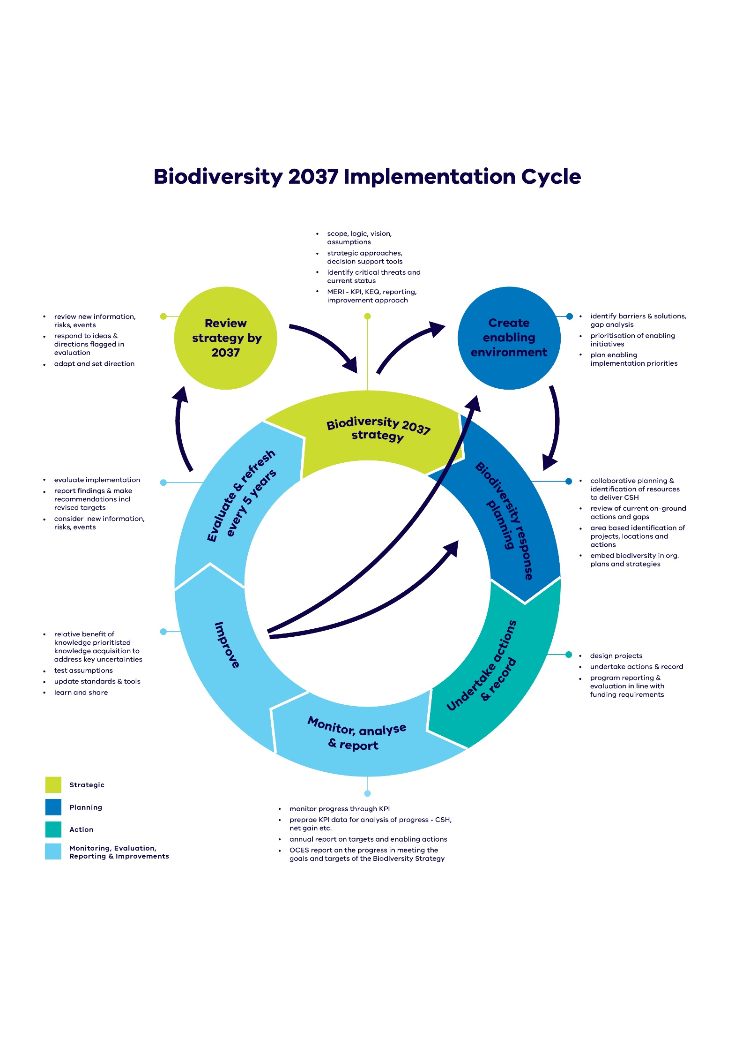

Figure 1: Biodiversity 2037 cycle. Light blue boxes indicate Biodiversity 2037-MERF

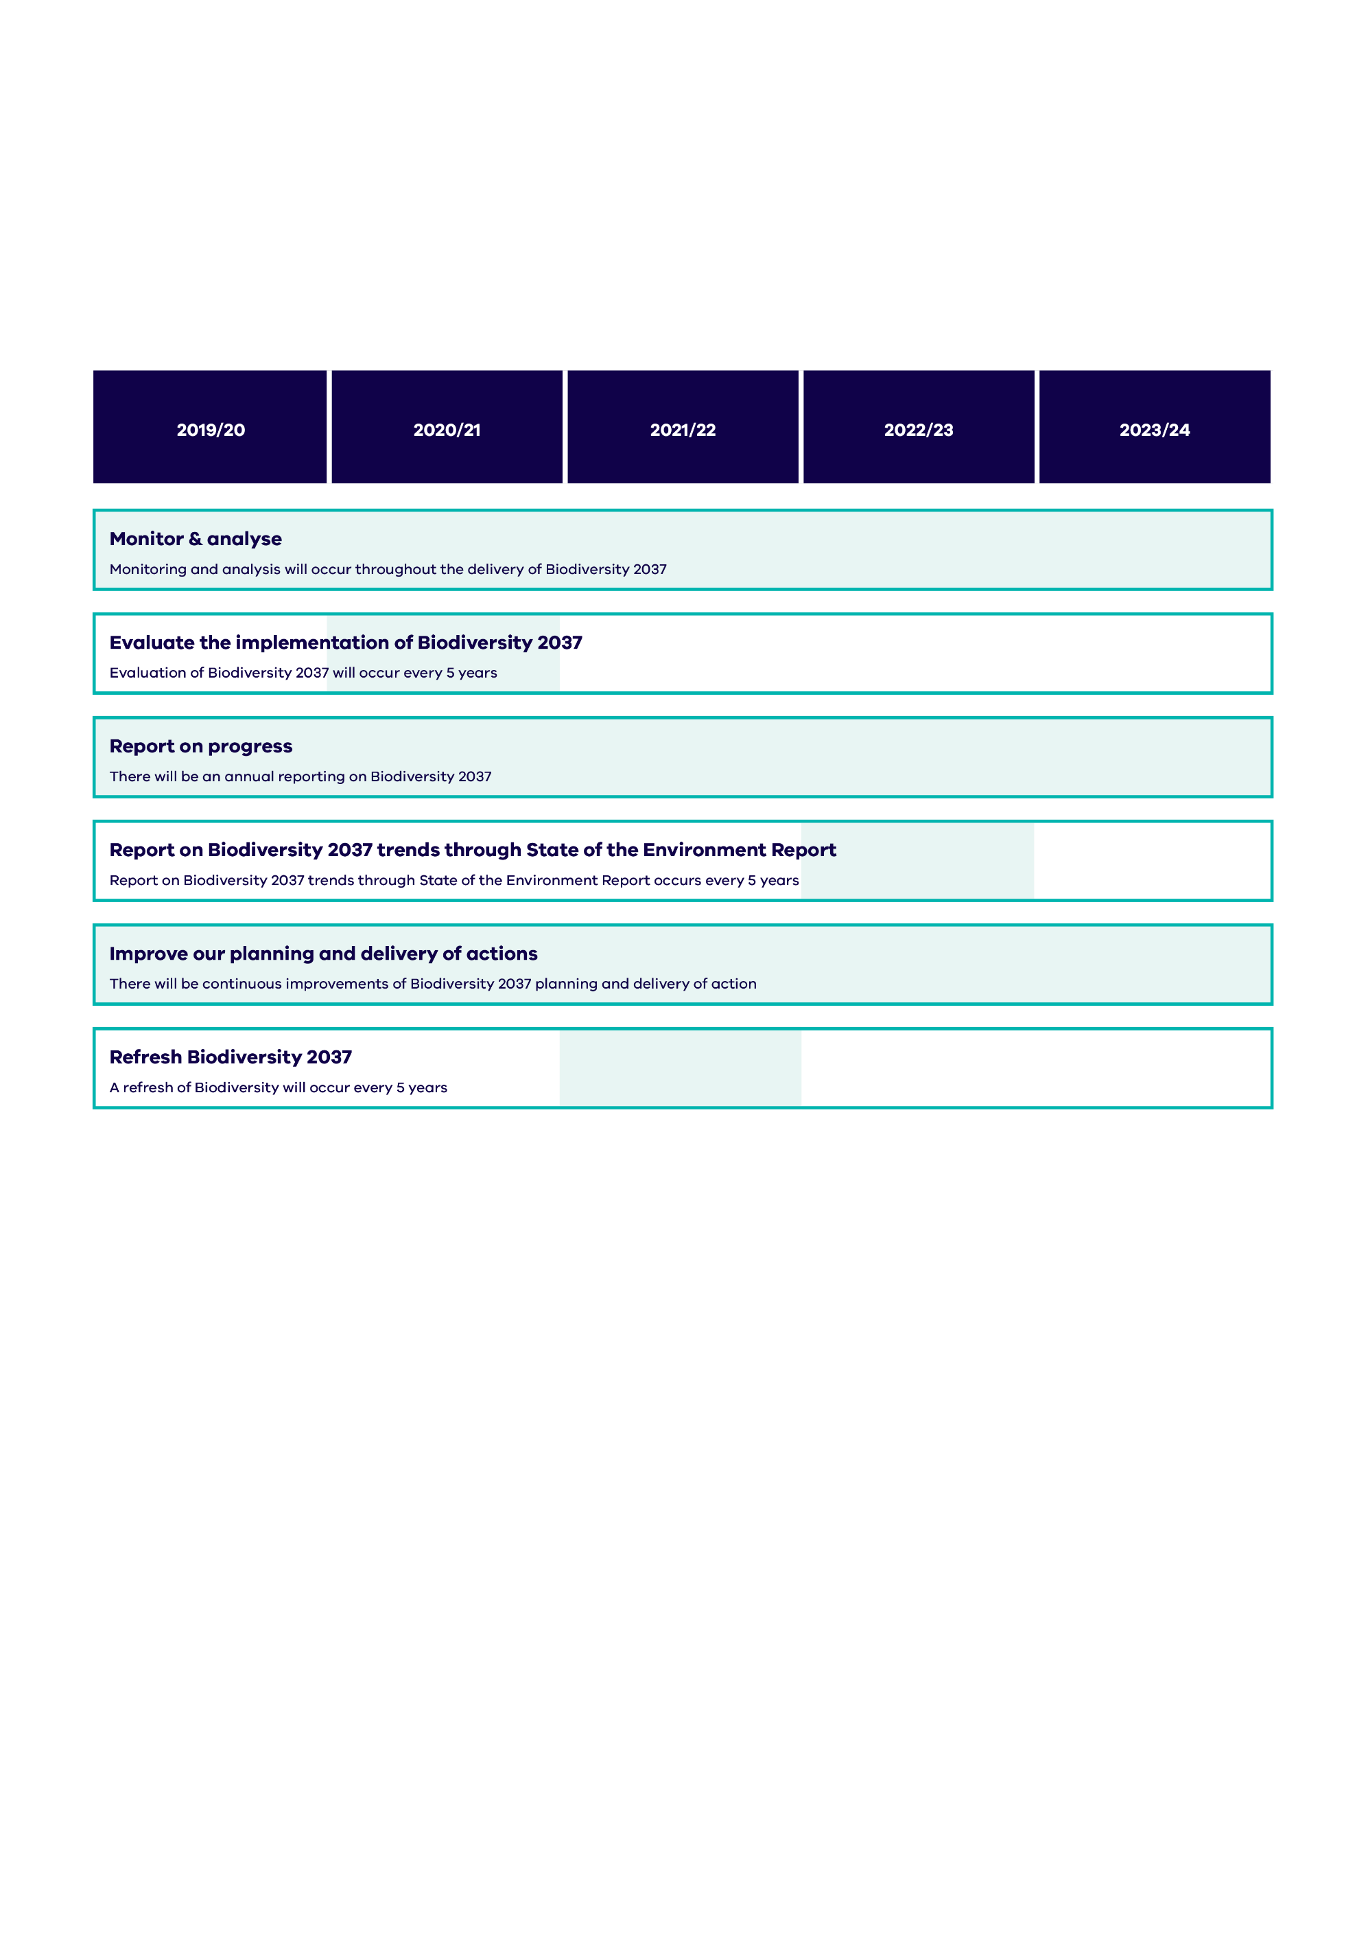**Figure 2: The pattern of activity for each area of the Biodiversity 2037 MERF. This pattern will be replicated every five years. Light blue shading indicates when each activity is expected to occur.**

The logic framework for Biodiversity 2037 is central to the design of the Biodiversity 2037 MERF. It describes the relationships between biodiversity activities and their outputs, and how these are expected to lead to outcomes. The purpose of the logic framework is to provide a basis for:

* + - informing the Implementation Cycle in order to support the expected outcomes
    - determining the assumptions underpinning the logic
    - identifying key evaluation questions and key performance indicators (see Section 3 – monitoring progress)
    - undertaking evaluation of Biodiversity 2037 and informing adaptive improvements to the implementation of Biodiversity 2037
    - communicating with key stakeholders about Biodiversity 2037.

A summary of the key elements of the logic framework, together with examples from Biodiversity 2037 are provided in Table 1.

**Table 1: Logic framework outline**

|  |  |  |
| --- | --- | --- |
| **Logic framework** | **Definition** | **Example from Biodiversity 2037** |
| Vision | A qualitative description of what is desired in the long term | Victoria’s biodiversity is healthy, valued and actively cared for. |
| Outcomes | Measurable collective contribution of delivering the outcomes to the vision | Everyone is working cohesively to ensure their contribution to biodiversity is maximised |
| Intermediate outcomes | The impact of planned outputs measured at a midpoint between outputs and outcomes | Biodiversity action is aligned and complementary to make the most of collective effort |
| Outputs | Direct result of the priorities, initiatives, programs and projects | More people and organisations participate in collaborative planning for biodiversity |
| Priorities, initiatives, programs and projects | Actions, on-ground activities, events, products of the program. | Area based forums to enable planning focus on biodiversity |
| Inputs | Effort, materials, equipment and funds put into natural resource management to deliver outputs and, in the longer term, achieve outcomes and vision | Funding, staff resources, legislation |

These key elements of the logic framework and how they are incorporated into components of the Biodiversity 2037 MERF are summarised in Figure 3 with more detail in the following sections of this document.

A screenshot of a cell phone

Description generated with very high confidence

**Figure 3: Summary and focus of each area of the Biodiversity 2037 MERF. Light blue shading indicates the relationship to the elements of the Biodiversity 2037 logic (inputs, outputs, outcomes, vision etc.).**

State of the Environment reporting on Biodiversity 2037

**Purpose**: Review and report on progress towards targets and goals using a rigorous, contemporary, scientific evidence base

**Approach**: 5-yearly reporting on Biodiversity 2037 key performance indicators including reporting on trends over time.

**Responsibility**: The Office of the Commissioner for Environmental Sustainability in conjunction with DELWP

Refresh Biodiversity 2037

**Purpose**: To enable Victoria to respond to ideas and directions flagged through the evaluation and review process, as well as to adapt its approach to account for new information, risks or significant events.

**Approach**: 5-yearly refresh based on evaluation of implementation, progress towards goals and targets of Biodiversity 2037 and emerging issues.

**Responsibility**: DELWP

Logic framework

A screenshot of a cell phone

Description generated with high confidence

The Biodiversity 2037 Logic Framework describes the basis for how the implementation of Biodiversity 2037 will deliver the outcomes and vision of ensuing Victoria’s biodiversity is healthy, valued and actively cared for. Each outcome provides the theory of change behind each of the chapters (chapters 3 to 10) in Biodiversity 2037. The Logic Framework included here is based on the current version of Biodiversity 2037 (2017) and will be reviewed and updated as part of the evaluation and refresh of Biodiversity 2037.

**Table 2: Program logic to deliver the shared vision of Victoria’s biodiversity is healthy, valued and actively cared for**

| **Vision: Victoria’s biodiversity is healthy, valued and actively cared for.** This means that Victoria has functioning plant and animal populations, improved habitats and resilient ecosystems, even under climate change. This can only be supported through an understanding by Victorians that their personal wellbeing and the economic wellbeing of the State are dependent on the health of the natural environment. | | | | | |
| --- | --- | --- | --- | --- | --- |
|  | | | | | |
| **Problem statement** | **Inputs and enabling actions** | **Programs and projects** | **Outputs** | **Intermediate Outcomes** | **Outcomes** |
| Chapter 3: Victoria’s biodiversity continues to decline, and the current level of remedial effort is not sufficient or well enough targeted to make up for these losses in the face of climate change. | Funding  Authorising environment  Guidance, standards, processes, data systems  Decision support tool improvements  Policy, regulation and legislation (incl. updates)  Data collection and analysis  Governance  Relationships and co-operation with partners  Communications  Change management  Staff and staff time  Equipment and supplies  Access to land  Research and scientific base | Response planning  Actions to manage broadscale threats  Actions to manage specific threats  Campaigns  Awareness raising  Education and training  Workshops and forums  Programs and projects  Business cases and opportunities  Cultural management practices | We:  enable everyone to provide the right data to measure their contributions  provide information on how to make better on-ground decisions to maximise biodiversity outcomes  integrate decision support tools into our processes  identify and fill priority knowledge gaps to continually improve our decision making | So:  decision support tools are improved, and more people are using them  people understand how to make better on-ground decisions including through the use of decision support tools | So that:  everyone has maximised their contribution to delivering the greatest overall benefit for biodiversity by undertaking the most beneficial actions in the relevant places |
| Chapter 4: Victorians are increasingly disconnected from nature and have limited awareness of the threats to, and benefits of biodiversity. This results in fewer Victorians acting to protect and enhance the natural environment. | We:  promote the importance of the State’s natural environment  provide more opportunities for Victorians to connect to and regularly spend time in nature  We sustain and increase opportunities to act for nature | So:  more Victorians are connected to nature  more Victorians protect or enhance the natural environment | So that:  Victorians are contributing to the health of Victoria’s biodiversity |
| Chapter 5: The environment is not equally considered in decision-making (when compared to economic and social outcomes). | We:  increase opportunities for more people to access or benefit from green areas to improve liveability, health and wellbeing  integrate the System of Environmental Economic Accounting principles into reporting across government, and into decision making and evaluation of social, economic and environmental outcomes and trade-offs  provide more opportunities through the nature-based tourism industry for Victorians to connect with nature | So:  So whole of government decision making considers Victoria’s valuable environmental assets (natural capital), and facilitates good decision making regarding the natural environment in the public and private sectors  Victorian communities benefit from improved liveability and nature-based tourism | So that:  Victoria has a healthy natural environment that underpins and sustains the prosperity of the Victorian economy and society |
| Chapter 6: There is inadequate investment to maintain and enhance biodiversity. This include persistent under investment to address legacy issues and to counter-balance ongoing losses. | We:  We implement a range of approaches to increase, sustain and maximise the potential of biodiversity funding  increase opportunities for private landholders to participate in biodiversity stewardship | So:  everyone invests in biodiversity  more private land is managed for biodiversity | So that:  investment is sufficient to stop biodiversity decline |
| Chapter 7: The sector is not operating efficiently or effectively. There is competition for funding, a lack of a shared vision for Victoria’s landscapes and barriers to stakeholder participation. | We:  enable more people and organisations to participate in collaborative planning for biodiversity  We facilitate a shared understanding of biodiversity needs and gaps | So:  delivery of biodiversity actions and resources is aligned and complementary to make the most of collective effort and skills of partners  So each organisations’ contribution to the outcomes is understood and valued | So that:  everyone is working cohesively to ensure biodiversity outcomes from their contribution are maximised |
| Chapter 8: The wellbeing of Traditional Owners has been compromised by a limited ability to connect to Country and execute their right to participate as equal partners in the management of Victoria’s natural resources. | We:  provide support for Traditional Owners and Aboriginal Victorians to actively participate in the collaborative biodiversity planning processes  support skills and capacity building activities for Traditional Owners and Aboriginal Victorians to manage Country  increase opportunities for Aboriginal environmental business and employment | So:  there is improved access to biodiversity and increased role of Aboriginal people in biodiversity management  there is increased practice of culture including acknowledging, recognising and respecting it in biodiversity planning and management  there is increased access to biodiversity for economic development | So that:  Traditional Owners and Aboriginal Victorians have improved wellbeing through connection to healthy Country |

| **Problem statement** | **Inputs** | **Priorities, initiatives, programs and projects** | **Outputs** | **Intermediate Outcomes** | **Outcomes** |
| --- | --- | --- | --- | --- | --- |
| Chapter 9: Threats to biodiversity are not considered across the landscape. The critical role of public lands and the reserve system for biodiversity conservation is unfulfilled due to inadequate resourcing. |  |  | We:  target key threats to biodiversity assets through cost-effective management actions  undertake specific threat management to meet the unique needs of individual species or situations  identify opportunities and complementary measures to ensure the reserve system is comprehensive, adequate and representative | So:  Threat management is strategic, consistent and sustained  Ecosystem functions are progressively restored across the landscape  Victoria’s protected areas have been maintained and enhanced on public and private land and adequately represented in a world class system of permanently protected areas | So that:  Victoria’s biodiversity is appropriately protected and managed across all landscapes (and seascapes) and the focus on broader scale threat management provides a preventative approach paired with specific threat management to meet the needs of individual species or situations |
| Chapter 10: There is inconsistent recognition across government of the importance of biodiversity to the broader economic, social and environmental agenda | We:  work together to adopt a whole of government approach to implementing Biodiversity 2037  increase transparency and accountability for biodiversity impacts across Government  improve Victoria’s legislative framework so that it is consistent with best practice principles and provides a modern and effective framework | So:  the whole of the Victorian Government and portfolio agencies contribute to Biodiversity 2037 and reflect this in strategies and annual business plans  Government and environmental portfolio agencies provide leadership in biodiversity management | So that:  the Victorian Government and environmental portfolio agencies are driving the agenda to improve biodiversity and making transparent decisions that impact on it. |

The logic and achievement of the vision and outcomes of Biodiversity 2037 are underpinned by a number of assumptions which are provided below. The logic framework may be updated through the evaluation and Biodiversity 2037 refresh process as new knowledge becomes available that verifies or refutes these assumptions.

The assumptions will be considered in the evaluations where monitoring of KPIs indicates that the current activities and their outputs are not achieving the expected outcomes. In some cases, research or data collection may be prioritised through the Biodiversity Knowledge Framework (Section 6) to test the assumptions.

**Table 3: Biodiversity 2037 assumptions**

|  |  |
| --- | --- |
| **Outcome** |  |
| Everyone has maximised their contribution to delivering the greatest overall benefit for biodiversity by undertaking the most beneficial action in the relevant place | The most beneficial actions are known and everyone can choose to undertake them in the relevant place  While there will continue to be fluctuations and trends, there will be no major step change in climate or a large-scale event over the implementation period |
| Victorians are connected to nature and contributing to the health of Victoria’s biodiversity | Increasing knowledge and awareness of the natural environment will lead to increases in Victorians valuing and acting to protect nature |
| Victorians with a greater sense of connection to nature will act to protect it more and support increased and sustained investment |
| Sustained economic output from Victoria’s economy is underpinned by a healthy natural environment | Nature-based tourism is sustainable and will have (at worst) a neutral impact on biodiversity |
| There will be no significant decisions to change land use over the implementation period, without consideration to the natural environment |
| Everyone invests in a healthy environment | When exposed to environmental concerns, the public will respond positively, and support increased and sustained investment |
| Organisations are working cohesively to ensure their contribution to biodiversity is maximised | A biodiversity focused planning process will provide more aligned outcomes (both to SMP and between projects) while decreasing competition between conservation organisations through identifying landscape scale outcomes than alternative approaches |
| Traditional Owners and Aboriginal Victorians have improved wellbeing through connection to healthy Country | Equal partnership with the State and increased empowerment to participate in biodiversity planning and management will support self-determination |
| Victoria’s biodiversity is protected and managed across all landscapes (and seascapes) and the focus on broader scale threat management provides a preventative approach paired with specific threat management to meet the needs of individual species or situations | Most endangered species will avoid complete extinction in some form, and the status of most vulnerable species will not worsen if sufficient threat management occurs |
| Mitigating threats to a species will, on balance lead to an increase in the persistence of the species |
| The Victorian Government and environmental portfolio agencies are working cohesively to improve biodiversity and making transparent decisions that impact on it | The biodiversity sector, and policy and management processes are agile enough to respond to emerging issues |

Biodiversity 2037 is also subject to a range of external factors outside the scope and control of the program that may influence the ability to successfully deliver Biodiversity 2037 outputs and outcomes.

Examples of external factors are provided in Table 4. External factors will be considered in the evaluations where monitoring of KPIs indicates that the current activities and their outputs are not achieving the Biodiversity 2037 outcomes. In some cases, research or data collection may be prioritised through the Biodiversity Knowledge Framework (Section 6) to test the assumptions.

**Table 4: External factors relevant to Biodiversity 2037.**

|  |
| --- |
| **External factors** |
| The global economy and its impact on Victoria may limit available funding for conservation activities from all possible funding avenues including voluntary works |
| Stochastic events such as fire, pest outbreak etc may impact on biodiversity values |
| The effects of climate change may:   * Change environment quicker than our management can respond * Lessen impact or over-ride the impact of management actions. |
| Levels of support and leadership across the sector and within Government |
| Population growth |

# 

Monitoring progress

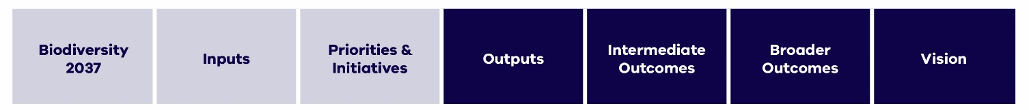

Based on the Logic Framework, key performance indicators (KPI) have been developed for each output, intermediate outcome and outcome, and the vision. The KPIs capture the intent and aspirations of the outcomes and provide transparency and accountability for reporting to the community, on achieving the targets set out in Biodiversity 2037. The KPI will contribute to the evaluation of Biodiversity 2037 and support the adaptive management of Biodiversity 2037.

The KPI are set out below. Monitoring of the KPIs will be undertaken in accordance with the specifications in the Biodiversity 2037 Data Dictionary (Figure 4). This sets out the types of monitoring activities that will occur, the type of data collected, the source of the data, the frequency, disaggregation, protocols and responsibilities. To ensure consistency, in some instances, a management or delivery standard, and data standard will be developed to describe the format and field requirements for data used in the KPI calculations for example DELWP output data standards.

**Figure 4: Connection between nested documents describing Biodiversity 2037 key performance indicators**

## Vision: Victoria’s biodiversity is healthy, valued and actively cared for

Acknowledging that the personal wellbeing of every Victorian and the economic wellbeing of the state are dependent on the health of the natural environment, Protecting Victoria’s Environment - Biodiversity 2037 articulates a new vision: Victoria’s biodiversity is healthy, valued and actively cared for. This vision can only be achieved through collective action. Together, we can ensure Victoria’s natural environment is healthy, has functioning plants and animal populations, improved habitats and resilient ecosystems, even under climate change. This will be achieved by stopping the overall decline of threatened species, securing the greatest possible number of species in the wild, and improving the overall extent and condition of habitat.

**Table 5: Key performance indicators for Biodiversity 2037**

|  |  |
| --- | --- |
|  | **Vision** |
| Victoria’s Biodiversity is healthy, valued and actively cared for  **(on average) Per Cent Change in Suitable Habitat expected over 50 years from sustained improved management for threatened species**  **(on average) Per Cent Change in Suitable Habitat expected over 50 years from sustained improved management for culturally significant species**  **% of all species with positive Per Cent Change in Suitable Habitat expected over 50 years from sustained improved management** | |
|

## Outcome: Delivering the greatest overall benefit for biodiversity

Despite on-going management and concentrated efforts to protect Victoria’s environment, our state’s biodiversity continues to decline. The current level of remedial effort is not sufficient and needs to be more targeted to ensure that everyone’s contribution is focused on delivering the most beneficial actions in the relevant places, particularly under the game changing influence of climate change. Decision-support tools will help to inform how and where to focus our collective efforts alongside a knowledge framework that establishes processes to identify, prioritise and fill knowledge gaps and address uncertainties. This ensures that our decision-support tools, data and data management systems are continually improved, so that people’s contributions to the targets can be measured and their data reflected through the tools. Key steps in achieving this outcome include ensuring the tools are user-friendly, raising awareness of the tools and the benefits they provide and ensuring people are trained to use the tools

**Table 6. Key performance indicators for outcome 1: Delivering the greatest overall benefit (KPI provided in bold)**

|  |  |  |
| --- | --- | --- |
| **Output** | **Intermediate outcome** | **Outcome** |
| We enable everyone to provide the right data to measure their contributions   * **% of NRM organisations contributing output data and species records** * **% of NRM organisations with Intellectual Property agreements with Traditional Owner groups** | So decision support tools are improved, and more people are using them   * **Total Relative Benefit of Knowledge delivered** | So that everyone has maximised their contribution to delivering the greatest overall benefit for biodiversity by undertaking the most beneficial action in the relevant place   * **% alignment of actions with the most beneficial action in relevant places** |
| We provide information on how to make better on-ground decisions to maximise biodiversity outcomes   * **Number of system hits on NatureKit** * **% of surveyed staff who report they have provided information on tools** |
| We integrate decision support tools into our processes   * **% of surveyed organisations using common decision support tools to drive actions** * **% of surveyed organisations that report they have integrated the tools in their processes** | So people understand how to make better on-ground decisions including through the use of decision support tools   * **Progress made against Tool response register to new knowledge and information** * **% of survey respondents who report a good understanding of how to make better decisions** |
| We identify and fill priority knowledge gaps to continually improve our decision making  **Number of causal models developed and parametrised to identify knowledge gaps**   * **Number of causal models integrating cultural values, uses and rights** |

## Outcome: Victorians are contributing to the health of Victoria’s biodiversity

1. Victorians that identify a connection to nature are more likely to act to protect and enhance our natural environment. To achieve this outcome, collectively we need to provide more opportunities for Victorians to connect with and value the natural environment and Aboriginal culture, recognise its diverse benefits and act to protect it.

**Table 7: Key performance indicators for outcome 2: Victorians place more importance on a healthy environment and contribute to its health (KPI provided in bold)**

|  |  |  |
| --- | --- | --- |
| **Output** | **Intermediate outcome** | **Outcome** |
| We promote the importance of the State’s natural environment   * **Number of engagement events incorporating nature and and/or Aboriginal cultural messaging** * **Number of publications** | * So more Victorians are connected to nature * **Mean level of connection to nature of program participants and surveyed Victorians**   **Number of program participants**   * So more Victorians protect or enhance the natural environment * **% of campaigns that meet their reach and impact targets** * **% alignment of actions with the most beneficial action in relevant places by community groups** * **Number of volunteer hours** * **Effectiveness of volunteer sector score** | * So that Victorians are contributing to the health of Victoria’s biodiversity * **Victorians contribute to health of biodiversity score** |
| We provide more opportunities for Victorians to connect to and regularly spend time in nature   * **Number of programs providing opportunities to connect with nature and/ or Aboriginal culture** |
| We sustain and increase opportunities to act for nature   * **Number of behaviour change campaigns** * **Number of opportunities listed on the “Victoria it’s in our Nature” website** |

## Outcome: Victoria has a healthy natural environment that underpins and sustains the prosperity of the Victorian economy and society

The services provided by a healthy environment and the benefits it provides underpins and sustains Victoria’s economy and way of life. In achieving this outcome, the environment is better integrated into decision making and equally considered alongside with social and economic benefits. The economic benefits of a healthy environment are preserved for the future and Victorians and others who visit our state’s natural attractions benefit from improved liveability and sustainable nature-based tourism.

**Table 8: Key performance indicators for outcome 3: So that Victoria has a healthy natural environment that underpins and sustains the prosperity of the Victorian economy and society (KPI provided in bold)**

|  |  |  |
| --- | --- | --- |
| **Output** | **Intermediate outcome** | **Outcome** |
| We increase opportunities for more people to access or benefit from green areas to improve liveability, health and wellbeing   * **Hectares of green roof area** * **Proportion of urban population within (400m) walkable distance of public open space** | So whole of government decision making considers Victoria’s valuable environmental assets (natural capital), and facilitates good decision making regarding the natural environment in the public and private sectors  **Number of instances which use biodiversity information within the SEEA framework as an input into policy/ program or industry development** | So that Victoria has a healthy natural environment that underpins and sustains the prosperity of the Victorian economy and society  **Value of ecosystem services provided by Victoria’s environmental and cultural assets** |
| We integrate the SEEA principles into reporting across government, and into decision making and evaluation of social, economic and environmental outcomes and trade-offs  **Number of reports developed that utilise the System of Environmental Economic Accounting (SEEA) principles** |
| We provide more opportunities through the nature-based tourism industry for Victorians to connect with nature  **Number and purpose (nature and/ or Aboriginal culture) of licenced tourism operators supported in parks by Parks Victoria** | So Victorian communities benefit from improved liveability and nature-based tourism  **$ contribution of nature-based activities in parks to the economy**  **Number of jobs generated through nature-based activities in parks**  **Increased proportion of green wedges and peri-urban areas with plans** |

## Outcome: Everyone invests in a healthy environment

1. To ensure that our natural environment is healthy everyone needs to invest to maintain and enhance biodiversity. Key to this is addressing that there is inadequate investment to maintain and enhance biodiversity. This include persistent under-investment to address legacy issues and to counter-balance ongoing losses. In achieving this outcome, investment for the protection and restoration of biodiversity will be increased and sustained by utilising a variety of funding sources and tools. It acknowledges both the monetary investment by different levels of government and non-government organisations and the investment from landholders via private land conversation efforts.
2. **Table 8: Key performance indicators for outcome 4: Everyone invests in a healthy environment (KPI provided in bold)**

|  |  |  |
| --- | --- | --- |
| **Outputs** | **Intermediate outcomes** | **Outcome** |
| We implement a range of approaches to increase, sustain and maximise the potential of biodiversity funding   * **Number of approaches used to increase, sustain or maximise funding** | So everyone invests in biodiversity  **Average amount invested per year**  **Number of different funding sources by organisation** | So that investment is sufficient to stop biodiversity decline  **5 yearly Biodiversity 2037 targets on track** |
| We increase opportunities for private landholders to participate in biodiversity stewardship   * **Number of programs for biodiversity stewardship (including through cultural practices) on private land** * **% of local governments with natural resource management rate relief/ incentive schemes** | So more private land is managed for biodiversity  **% of habitat on Victorian private land with actions for biodiversity** |

## Outcome: Everyone is working cohesively

To achieve our shared vision for Victoria’s biodiversity to be healthy, valued and actively cared for, we need to work more cohesively. Reducing competition for funding, ensuring a shared vision for Victoria’s landscape and barriers to stakeholder participation will increase efficiency and effectiveness across Victoria’s landscapes. A true collaborative approach will make the most of the time, resources and funding, and ensure investment and actions are aligned. In achieving this outcome, a collaborative approach to achieving the targets of Biodiversity 2037 is required. A key step in achieving this outcome is providing support for community groups, Traditional Owners, non-government organisations and sections of the government to participate in biodiversity planning and response processes.

1. **Table 9: Key performance indicators for outcome 5: Everyone is working cohesively (KPI provided in bold)**

|  |  |  |
| --- | --- | --- |
| **Output** | **Intermediate outcome** | **Outcome** |
| We enable more people and organisations to participate in collaborative planning for biodiversity   * **% of organisations participating in Biodiversity Response Planning** * **Number of organisations (including Traditional Owner groups) supported to participate** | So delivery of biodiversity actions and resources is aligned and complementary to make the most of the collective effort and skills of partners  **Collective effort and skills score** | * So that everyone is working cohesively to ensure biodiversity outcomes from their contribution are maximised * **Contribution is maximised score** |
| We facilitate a shared understanding of biodiversity needs and gaps  **% of Biodiversity Response Planning landscape areas with a situation and gap analysis** | So each organisations contribution to the outcomes is understood and valued  **% of organisations that contribute to the Change in Suitable Habitat target**  **% of organisations that identify their contribution the Biodiversity 2037 outcomes** |

## Outcome: Traditional Owners and Aboriginal Victorians have improved wellbeing through connection to healthy Country

1. To improve Traditional Owner and Aboriginal Victorians wellbeing they need to connect to Country and execute their right to participate in the management of Victoria’s natural resources. In achieving this outcome, Aboriginal Victorians and Traditional Owners will be equal partners in managing biodiversity thereby contributing to the health of Victoria’s environment, enabling a stronger connection to Country and providing the right to self-determination whereby all peoples can freely pursue their economic, social and cultural development.
2. The key performance indicators in Table 10 are consistent with the Victorian Aboriginal Affairs Framework. Table 10 will be updated in accordance with relevant indicators in DELWP’s Munganin Gadhaba and the Victorian Balit Murrup (Aboriginal social and emotional wellbeing framework 2017-2022) once that work is complete. This may result in changes or the inclusion of additional key performance indicators.
3. **Table 10: Key performance indicators for outcome 6: Aboriginal Victorians have opportunity, prosperity and are connected to Country (KPI provided in bold)**

|  |  |  |
| --- | --- | --- |
| **Outputs** | **Intermediate outcomes** | **Outcome** |
| We provide support for Traditional Owners and Aboriginal Victorians to actively participate in the collaborative biodiversity planning processes  **Number of formal partnership agreements for planning and management between Aboriginal communities and key NRM agencies**   * **% of Traditional Owner organisations participating in Biodiversity Response Planning** | So there is improved access to biodiversity and increased role of Aboriginal people in biodiversity management  **Number of Whole of Country Plans published**  **Number of Joint Management Plans and Co-management plans and area of land covered**  **Area of public land and arrangements for management with Traditional Owners** | So that Traditional Owners and Aboriginal Victorians have improved wellbeing through connection to healthy Country  **TBD** |
| We support skills and capacity building activities for Traditional Owners and Aboriginal Victorians to manage Country  **Number of cultural burns conducted**  **Average area of cultural burns conducted**  **Number of capacity building activities** | So there is increased practice of culture including acknowledging, recognising and respecting it in biodiversity planning and management  **Participation in community events which celebrate Aboriginal culture**  **Investment in Aboriginal culture revitalisation programs** |
| We increase opportunities for Aboriginal environmental business and employment  **Number of jobs through natural resource management funding**  **Number of seed funding or business cases supported**  **Distribution of employment of Aboriginal people across organisational levels in NRM organisations** | So there is increased access to biodiversity for economic development  **Number of Victorian natural resource management business-owner-managers who are Aboriginal**  **Number of Aboriginal owned natural resource management businesses that government enters into a purchase agreement with as a proportion of small to medium enterprises government enters into a purchase agreement with** |

## Outcome: Victoria’s biodiversity is protected and managed

Public land, the parks reserve system and private land plays a critical role for conservation across Victoria. To enhance protected areas and maximise the value of both public and private land contribute to biodiversity, restoration and strategic threat management needs to be consistent and sustained across the landscape and there needs to be adequate resourcing. In achieving this outcome, the number of species becoming threatened will decrease by focusing on prevention and early intervention rather than just crises response. The range of threats across the landscape will be considered and actions that provide the most cost-effective benefits to the most amount of species will be undertaken. Specific direct interventions for some endangered and critically endangered species will also be required and their relative benefit compared to landscape scale actions will be considered.

A key step in achieving this outcome is managing biodiversity across different landscapes and tenures including:

* managing and enhancing protected areas on public land to deliver improved biodiversity conservation and a comprehensive, adequate and representative reserve system
* increasing permanently protected habitats on private land by providing incentives and support to landholders

1. **Table 11: Key performance indicators for outcome 7: Victoria’s biodiversity is protected and managed (KPI provided in bold)**

| **Outputs** | **Intermediate outcomes** | **Outcome** |
| --- | --- | --- |
| We target key threats to biodiversity assets through cost-effective management actions  **Hectares of on-ground biodiversity actions**  **Hectares of cultural practice** | So threat management is strategic, consistent and sustained  **Hectares of herbivore control in priority locations**  **Hectares of pest predator control in priority locations**  **Hectares of weed control in priority locations**  **Hectares of habitat extent**  **Amount of habitat (Habitat Hectares)** | So that Victoria’s biodiversity is appropriately protected and managed across all landscapes (and seascapes) and the focus on broader scale threat management provides a preventative approach paired with specific threat management to meet the needs of individual species or situations  **Number of vulnerable or near-threatened species that become endangered**  **% of critically endangered and endangered species that have at least one option available for being conserved ex-situ or re-established in the wild (where feasible under climate change) should they need it**  **Threatened Species Index** |
| We undertake specific threat management to meet the unique needs of individual species or situations  **Number of specific threat actions**  **Number of threatened species programs overseen by Cultural governance frameworks** | So ecosystem functions are progressively restored across the landscape  **Hectares of revegetation in priority locations for habitat connectivity**  **Number of landscapes where ecosystems are being restored through enhancement or restoration of functional species niches or cultural practices** |
| We identify opportunities and complementary measures to ensure the reserve system is comprehensive, adequate and representative  **Opportunities and complementary measure identified** | So Victoria’s protected areas have been maintained and enhanced on public and private land and adequately represented in a world class system of permanently protected areas  **Number and area of parks managed for conservation purposes**  **Extent and representation of ecological vegetation classes in the CAR reserve system**  **Hectares of new permanently protected area on private land**  **Hectares of private and public land recognised as Indigenous Protected Areas** |

## Outcome: The Victorian Government is driving the biodiversity agenda

1. To achieve Biodiversity 2037 vision the Victorian Government needs to recognise the importance of biodiversity to the broader economic, social and environmental agenda. In achieving this outcome, the Victorian Government will develop the right settings and create the enabling environment so that everyone can effectively contribute to the vision that *Victoria’s biodiversity is healthy, valued and actively cared for*.
2. The Victorian Government will demonstrate leadership by adopting a whole-of-government approach to implementing *Biodiversity 2037* and transparently account for biodiversity impacts across government. It will regularly evaluate and report on the effectiveness of *Biodiversity 2037* to ensure that biodiversity outcomes are continuously improved.
3. **Table 12: Key performance indicators for outcome 8: The Victorian Government is driving the biodiversity agenda (KPI provided in bold)**

|  |  |  |
| --- | --- | --- |
| **Output** | **Intermediate outcome** | **Outcome** |
| We work together to adopt a whole of government approach to implementing Biodiversity 2037  **Number of cross-government activities on biodiversity or nature** | So the whole of the Victorian Government and portfolio agencies contribute to Biodiversity 2037 and reflect this in strategies and annual business plans  **% of Victorian Government and portfolio agencies who include the vision for Biodiversity in their strategies or business plans including confirming and enabling the role of Traditional Owners to plan, manage, inform and deliver biodiversity programs** | So that The Victorian Government and environmental portfolio agencies are driving the agenda to improve biodiversity and making transparent decisions that impact it  **Overall extent and condition of habitats (in habitat hectares) across terrestrial, waterway and marine habitats** |
| We increase the transparency and accountability for biodiversity impacts across Government  **% of Government and portfolio agencies that report on activities that impact the environment (output data)** | So Government and environmental portfolio agencies provide leadership in biodiversity management  **Leadership in biodiversity management score** |
| We improve Victoria’s legislative framework so that it is consistent with best practice principles and provides a modern and effective framework  **Key pieces of legislation or regulations have been amended to give effect to the vision of Biodiversity 2037** |

Evaluation of Biodiversity 2037

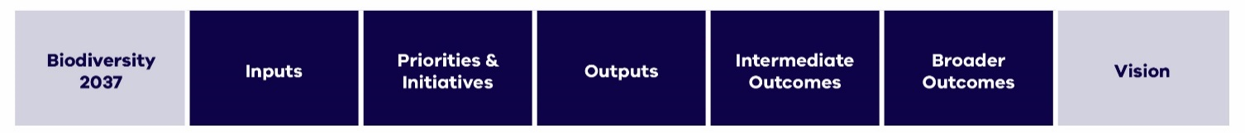

The purpose of the evaluation is to assess the success of Biodiversity 2037 over the next twenty years and provide recommendations on how it can be improved. Applying this adaptive management approach will ensure that delivery of biodiversity outcomes is continuously improved, and that implementation of Biodiversity 2037 is designed and delivered efficiently and effectively. The evaluation supports whole-of-government transparency and accountability.

There will be an evaluation of Biodiversity 2037 every five years looking across the whole of the biodiversity sector to assess how Biodiversity 2017 has been implemented and integrated into policies and programs. The results of the evaluation, together with State of the Environment report on progress towards Biodiversity 2037 outcomes, and other information will support a 5-yearly review of Biodiversity 2037.

These principles will underpin the design of this evaluation:

* + - it is collaborative and participatory, with all organisations contributing and telling their story in a way that makes sense to them
    - there is some independence
    - there is consistency in both the questions asked and the KPI data collection methods and there is baseline data where it makes sense to do so
    - it is ongoing and proportionate with the effort in delivering Biodiversity 2037.

## Key evaluation questions

These four Key Evaluation Questions (KEQs) (Table 13) guide the data collection for this evaluation.

1. **Table 13: Key evaluation questions**

| **Key evaluation questions** | **Subsidiary questions** |
| --- | --- |
| To what extent has Biodiversity 2037 been **implemented** as described in the logic framework? If not, why not? | Is the Logic Framework still valid? Are the relationships and assumptions in the logic framework linking outputs to outcomes valid? |
| How **effective is the implementation** of Biodiversity 2037? | To what extent have the outcomes of Biodiversity 2037 been achieved? What else has emerged, positive and negative? |
| How effective were the different approaches adopted by Biodiversity 2037 to manage biodiversity and deliver on Biodiversity 2037’s vision and outcomes? |
| To what extent has Biodiversity 2037 influenced within DELWP, across government departments / authorities and amongst stakeholders? |
| What has helped and what has hindered effective implementation? |
| How strong is Biodiversity 2037’s **sustainability**? | How sustainable are established funding mechanisms? |
| To what extent has the conservation of biodiversity become part of society’s mainstream |
| How have landholders contributed to the sustainability? |
| To what extent has Biodiversity 2037 encouraged a paradigm shift away from traditional funding sources? |
| To what extent are extra resources required to maintain the outcomes already achieved? |
| What are the **lessons** for the future? | Has Biodiversity 2037 adopted the right mix of approaches to manage biodiversity and deliver on Biodiversity 2037’s vision and outcomes? |
| How appropriate were the tools and processes adopted in delivering Biodiversity 2037? |
| What are the lessons? For whom? |
| What needs to be done now? |

## Approach

The evaluation will use a participatory approach to assess the implementation of Biodiversity 2037, with a view to identifying recommendations for how implementation could be improved. This evaluation examines the collective effort in implementing Biodiversity 2037, the impact of this work, what is working well, what’s not and the actions needed to improve implementation.

The evaluation will use a mix of internal and external evaluation, interrogation of monitoring and reporting (under the Biodiversity 2037 MERF) and dedicated data collection. It is designed to be user friendly and complement Biodiversity 2037’s commitment to a collaborative approach to biodiversity management in Victoria.

The evaluation approach is based on Collaborative Outcomes Reporting(adapted from Dart and Roberts (2014)[1]). This scale-able, participatory approach to impact evaluation draws on a range of evidence and expert and/or key stakeholder opinion to derive a “performance story” outlining the contribution of an intervention to outcomes.

Data collection and analysis will be completed in two stages:

1. development of performance story reports for each outcome including synthesis of reporting against the KPI
2. additional work at the whole of strategy level involving:
   1. synthesis across these performance story reports
   2. collecting additional evidence to answer key evaluation questions
   3. workshops to make sense of the evidence and identify opportunities to improve.

A Collaborative Outcomes Reporting approach will be used for each of the eight Biodiversity 2037 outcomes. This is a participatory approach that describes what was achieved and how the work (in this case implementation of Biodiversity 2037) contributed to the results. It uses the logic framework, KPIs, evidence collection and expert and/or stakeholder input to develop ‘performance stories’ outlining the contribution of activities to outcomes. This approach is also scalable and suited to emerging outcomes from complex interventions (such as implementation of Biodiversity 2037).

The Collaborative Outcomes Reporting approach includes a planning workshop to identify evaluation questions relevant to each outcome in the logic model. These are example questions that align with the overarching Key Evaluation Questions (Table 14).

The eight outcome performance story reports alone will be insufficient to answer the key evaluation questions and additional work at the whole of strategy level is required. This whole of strategy approach draws on these reports but also uses additional evidence collection and synthesis in a participatory, collaborative approach.

1. **Table 14: Outcome level key performance questions**

| **Key evaluation questions** | **Subsidiary questions** |
| --- | --- |
| To what extent have the Biodiversity 2037 outcome been achieved? If not, why not? | What were the accomplishments for each outcome against what was expected? (refer to the Logic Framework Biodiversity 2037 Implementation Framework and the Biodiversity 2037 priorities and initiatives) How were they delivered and by who? |
| How effective were the different approaches adopted for each outcome to bring about change? How have stakeholders and partners changed what they are doing? |
| How influential was Biodiversity 2037 in directing activity and policy within DELWP, across government departments and amongst stakeholders? |
| Is the Logic Framework still valid? Are the relationships and assumptions in the logic framework linking outputs to outcomes valid? |
| What was learned and what needs to be done next? |

## Implementing the evaluation plan

Some evidence collection and synthesis will be undertaken by internal DELWP staff. Most of the evaluation will be delivered by a contracted external evaluator, working closely with DELWP staff. Given the participatory nature of the evaluation approach, the consultant requires strong engagement and evaluation skills. There may be efficiencies in engaging the same contractor for both the outcome and whole of strategy level components of the evaluation.

## Dissemination of results of the evaluation

The evaluation will adopt a collaborative approach where key stakeholders are engaged with the evidence, make evaluative judgements and contribute to recommendations about how to improve. This approach encourages ownership and use of evaluation findings and embeds dissemination throughout.

This evaluation also has reporting requirements. Section 10.2 of Biodiversity 2037 commits DELWP to publicly report on the outcomes of the five-yearly evaluations. This evaluation will result in development of two reports: Performance Story reports for each Biodiversity 2037 outcome and an overarching report that synthesises information assessing implementation of Biodiversity 2037.

In addition to these reports, DELWP will consider disseminating findings using an interactive website. This innovative approach to reporting allows for including a variety of media (including videos) and can further promote uptake and use.

Reporting

Sharing outcomes and progress against the KPIs and targets of Biodiversity 2037 with the community provides the opportunity to further build awareness and connection with Victoria’s rich biodiversity, celebrate successes, and encourage further participation in acting to protect nature.

## Reporting on progress

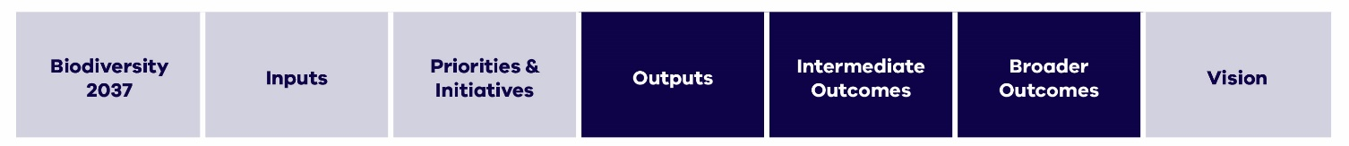

Reporting on Biodiversity 2037 implementation through the KPIs will be provided through the DELWP website. This will enable users to view progress against KPIs as new data is available for release. Data for many KPIs will be available on an annual basis, others may be monitored over longer periods of time to reflect the sensitivity to change for the KPI (Appendix 3).

A core element required to measure the progress of Biodiversity 2037 is the contribution by partners of their output (activity) data – where the activity occurred, what was undertaken and to what standard. This data is an increasingly common standard utilised across a range of natural resource management programs in Victoria. Consistent collection and sharing of this data by each organisation will enable a range of reporting, including that required for Biodiversity 2037. For example, reporting on implementation of policies and regulations, reporting against catchment strategies or Country plans and the annual achievements of an organisation.

Data collected through the MERF will generally be available through the DELWP data management systems (Victorian Biodiversity Atlas, NatureKit and the Victorian Government website: www.data.vic.gov.au). Consent or permission may be required for some data (e.g. species with sensitive requirements).

## State of the Environment Report

A screenshot of a cell phone

Description generated with high confidence

The Commissioner for Environmental Sustainability Victoria will report on progress against the KPIs and targets as part of the State of the Environment (SoE) reporting. The SoE 2018 report was the first time that the Biodiversity 2037 target reporting were included and although only a short time into the implementation of Biodiversity 2037 provided an opportunity to establish and align requirements as well as demonstrate initial progress. The State of the Environment reporting will transition to digital reporting in the longer term, which provides the ability for more regular updates on progress than the 5-yearly reporting cycle provides.

# 

Biodiversity Knowledge Framework - Improving the rigour of decision-making and the effectiveness of actions

A screenshot of a cell phone

Description generated with high confidence

## Overview

Biodiversity 2037 – Protecting Victoria’s Environment emphasises that to deliver on the outcomes of the plan, there needs in be an increase in targeted data collection for evidence-based decision-making of both management actions and actions to increase Victorians connection to nature and encourage them to act for biodiversity. This includes progressively filling critical knowledge gaps, through targeted research and data gathering and ensuring that information is integrated across all environments (marine, waterway and terrestrial). Testing our assumptions, understanding the consequences of environmental change, management and human land use are essential components in protecting Victoria’s environment and ensuring continuous improvement. This is reinforced through the State of the Environment 2018 report which notes that Victoria’s science and data capability is diminished by a lack of coordination and a strategic approach to investing in the critical research that will enable better, and timelier, decision making and policy interventions.

Victoria’s biological heritage is diverse, as are those who research and manage it. Because of this, there are a broad range of views on Victoria’s research priorities, multiple approaches to addressing these research priorities and many important partners and stakeholders that can participate in addressing these knowledge gaps.

Both human behaviours and biodiversity conservation and management in Victoria is also complex, with many potential interacting components (e.g. food webs, unintended consequences of management), and so in identifying knowledge gaps it is important to take an integrated, whole-of-ecosystem approach. This means not just considering individual species or management actions, but also the relationship between them and other species, feedbacks and ecological processes that occur in Victoria’s ecosystems.

The changing nature and scale of both private and public investment in biodiversity conservation demands a systematic approach to improving our understanding the benefits of a management action, intervention or policy approach and risks that knowledge gaps and uncertainty associated with that intervention may have on Biodiversity 2037 in achieving its outcomes and vision.

A consistent, quantifiable and systematic approach is required to a) identify knowledge gaps and b) prioritise research investment to ensure that the research being invested in is strongly linked to policy and decision-making with a focus on strengthening Victoria’s ability to deliver on the vision of Biodiversity 2037.

The Biodiversity Knowledge Framework provides the approach to identifying and prioritising knowledge gaps and uncertainties and has been developed to:

* Describe our shared understanding through causal models of a threat or disturbance process to a species or ecosystem, or barriers to human behavioural change; identify options for intervention, policy or management and predicted benefit or impact of those options. New models can be added as they are developed.
* Identify, compare and prioritise knowledge gaps across management actions/ interventions, environments (marine, freshwater and terrestrial) and systems (through an index describing the Relative Benefit of Knowledge). The prioritisation approach can also be used to assess proposals and project concepts for knowledge gaps that haven’t yet been identified.
* Provide a platform for partners and stakeholders to identify and include projects that are helping to address knowledge gaps and a process to update our understanding and causal models; and provide standards and tools as new knowledge is acquired that verifies or refutes assumptions and resolves uncertainty.
* Although uncertainty is pervasive in biodiversity conservation, only a subset of knowledge gaps are likely to be critical to effective management. To meet the challenge of identifying knowledge gaps and prioritising research investment, the Biodiversity Knowledge Framework provides an approach for systematically describing uncertain elements in system understanding and those of higher priority. The broad approach of the Framework is outlined in Figure 5 with details provided in Appendix 2.
* **Problem-response scenarios** describe particular biodiversity management scenarios that may benefit from knowledge acquisition. These scenarios inform the development of **causal models**. Causal models describe the relationship between the important biodiversity values and management or intervention (e.g. control method, effect of disturbance) components within the scenario. Developing causal models for each scenario ensures that in assessing **knowledge gaps**, a whole-of-ecosystem view of the management problem is used. By describing the relative uncertainty of links in each causal model via best case and worst-case models, and the potential gain in benefit (Change in Suitable Habitat) from resolving the uncertainty, a ranking of knowledge gaps can be obtained according to an index of **Relative Benefit of Knowledge.**

|  |
| --- |
| Relative Benefit of Knowledge  This index enables comparison of knowledge gaps both within a causal model and across problem-response scenarios. Candidate research projects will typically aim to resolve a small subset of contrasting links documented in best- and worst-case causal models. The value of resolving uncertainty in a subset of links can be estimated by multiplying the expected gain in benefit that would be achieved by resolving the uncertainty for a problem-response scenario (i.e. resolving *all* contrasting links) by the proportional reduction in distance between best and worst-case that could potentially be achieved by resolving the target link or subset of link(s) to be addressed by a candidate project.  Relative Benefit of Knowledge  **Expected gain** in Suitable Habitat from resolving all uncertain elements  **Proportional reduction** in uncertainty from resolving target elements.  =  x   1. **Figure 4: Calculation of the index of Relative Benefit of Knowledge for resolving a knowledge gap**   *Expected gain* provides an assessment to quantify how the additional information can improve the predicted biodiversity benefit. It is the expected difference in the benefit (in this case the weighted sum of Change in Suitable Habitat) as a result of the management action, with and without the knowledge acquisition to resolve any uncertainties.  *Proportional reduction* identifies the amount of uncertainty resolved by calculating the improvement in proportional distance between the best and worst-case causal models, assuming the knowledge acquisition succeeds in resolving the knowledge gap. |

* Highly ranked knowledge gaps are then expressed as priority research questions which could be stronger candidates for resolving uncertainty that is directly linked to better management outcomes. The most appropriate form of knowledge acquisition can then be identified and undertaken as a knowledge acquisition project with the results of the project directly feeding back to improve policies, standards and decision-support tools such as Change in Suitable Habitat and Strategic Management Prospects.

A screenshot of a cell phone

Description generated with very high confidence

1. **Figure 5: A systematic approach to improving the rigour of decision-making and the effectiveness of actions**

Knowledge is conceived to be broad and knowledge gaps may require different approaches to resolve them. The types of activity to resolve priority knowledge gaps may include inductive and deductive scientific research, taxonomy, evaluation and assessment, studies of a species ecology, Traditional Knowledge, data collection, social research, inventory, monitoring, surveys, investigating new technologies, citizen science and data synthesis and analysis. In some cases, a multi-disciplinary approach will be important.

## Online biodiversity knowledge framework

An online interactive portal will be developed to provide a platform for collating causal models and associated information. This will also enable partners and stakeholders to identify and include projects that are helping to address knowledge gaps and a process to update our understanding and causal models.

This will include several additions and refinements designed to make it more comprehensive, more user-friendly and have the ability to feed new knowledge into management decision systems (such as SMP).

Over time, the online portal will enable the ability to:

* select problem-response scenarios to view
* View the benefit and uncertainty for the scenario
* View the causal model for the scenario with clickable links
* Add notes on research projects currently underway or completed that address a specific link
* Comment or question a particular link or part of the causal model
* Update and refine the causal model based on research results or other information
* Progressively add new causal models for other problem-response scenarios
* Identify knowledge gaps and research questions, ranked against Relative Biodiversity of Knowledge scores

1. Glossary

|  |  |
| --- | --- |
| Term | Definition |
| Activity | The process of using labour and materials to produce outputs. |
| Adaptive management | A systematic approach for improving management by learning from management outcomes |
| Assumptions | Documented relationships between components of the logic framework |
| Delivery standard | A described standard to which works are delivered (e.g. revegetation standards) as agreed in the DELWP Delivery Standards |
| Effectiveness | Achievement of desired management outputs. Where efficiency refers to the value for the process, effectiveness refers to the quality of the result |
| Evaluation | Periodic assessment of policies, programs and projects against key evaluation questions |
| Key evaluation questions | Pre-determined questions which frame periodic evaluation of the performance of policies, programs and projects. The questions focus on impact, appropriateness, effectiveness, efficiency and legacy |
| Key performance indicator (KPI) | A quantitative or qualitative factor or variable that provides a simple and reliable basis for assessing progress towards outcomes. It is a unit of information measured over time that can help show change in a specific condition. A given output or outcomes can have multiple key performance indicators |
| Logic framework | A conceptual model that shows the rationale behind a program or strategy. Outlines the anticipated cause-and-effect relationships between activities, outputs, outcomes and vision |
| Management | Activities conducted as part of a specific plan, strategy, program or project |
| Outcome | The impact of planned outputs measured during the timeframe specified |
| Output | The measurable result (goods or service) of activity over a fixed period of time delivered to a standard |
| Research | Targeted research, documented through robust experimental design, to improve our understanding of how outputs contribute to longer term management outcomes |
| Output data | An agreed output to the DELWP standard that is part of a list of outputs that forms the basis for investment and planning purposes. |
| Targets | Quantitative and qualitative, temporally and spatially bound, predicted outcomes or outputs. |

Appendix 1 Change in Suitable Habitat

Change in Suitable Habitat is a purpose-built, scientific measure developed in 2016 by DELWP. It provides a practical KPI for estimating net improvement in the outlook for species from our management actions. Like persistence or viability, Change in Suitable Habitat is a current estimate of the likelihood of future outcomes rather than a snapshot of the current situation. Since the purpose here is to consider what could most effectively be done to make things better, the measure is designed to capture the expected difference between action and no action. Change is often slow, so the length of time used for estimating change (50 years) was chosen as a balance between the potential to observe an effect but not so long as to make predictions too uncertain. This period of time also requires consideration of the expected impacts of climate change.

To facilitate the use of this metric, DELWP has developed decision support models or processes for calculating the metric or making decisions including the Strategic Management Prospects tool and Specific Needs Assessments. The calculation of Change in Suitable Habitat relies on subject specific assumptions and knowledge (e.g. on species, threats, likelihood of success of delivering the predicted outcome, changes in human behaviour etc. Change in Suitable Habitat and underlying calculations and support models will be used for multiple objectives including to:

* Prioritise management actions to deliver against the Biodiversity 2037 outcomes
* Provide a means for collating and consolidating information relevant to the management of the species and communities or changes in behaviour
* Provide a transparent repository of information that can be updated over time and encourage contribution from the scientific community
* Provide a transparent exploration of the trade-offs between the outcomes of different actions
* Identify key uncertainties relating to the management of species and communities or behaviour change and thus assist in prioritising improvements to Biodiversity 2037 through knowledge acquisition
* Reporting on progress towards the targets

Persistence of native species is the fundamental idea of conservation biology. It depends on the characteristics of:

* + - individuals (e.g. finding and competing for habitat, food, mates)
    - populations (e.g. birth and death rates, mobility, genetic diversity)
    - ecosystems (e.g. disturbance regimes, interactions between species).

Although each of these characteristics can be described to some extent for some species, typically there are limited data, particularly for understanding the viability of populations. A practical measure of net improvement thus relies on habitat and threat information, often requiring extrapolation from available data. Like persistence or viability, improvement is a current estimate of the likelihood of future outcomes rather than a snapshot of the current situation. Since the purpose here is to consider what could most effectively be done to make things better, the measure is designed to capture the expected difference between action and no action.

Change in Suitable Habitat at the location level has initially been estimated by an expert elicitation approach. Experts were presented with threat and action scenarios for particular populations of species. The experts answered questions regarding the likelihood of that species still existing at the location if an action (or set of actions) was or wasn’t undertaken. Change is often slow, so the length of time used for estimating change (50 years) was chosen as a balance between the potential to observe an effect but not so long as to make predictions too uncertain. Experts were asked for their confidence level around each estimate. Different scenarios were presented for different species, but also for the same species in different locations.

The data collected can be calibrated between experts, and in time with known actual situations. Due to the large number of species, threats and varied habitat contexts, experts addressed scenarios for a representative subset of species and contexts. Estimates were based on continuous, sustained management being delivered, over the 50-year time period. As depicted in Figure 8, the probability that species will still be present if sustained investment and management is supplied is X. However, if threats are not managed, the probability that the species will be present in the long term is Y. The difference between X and Y indicates the likely level of improvement. In the best-case scenarios, there is a significant positive change that is sufficient to deliver a reversal of a downward trend. However, there are also several scenarios that achieve less than this.

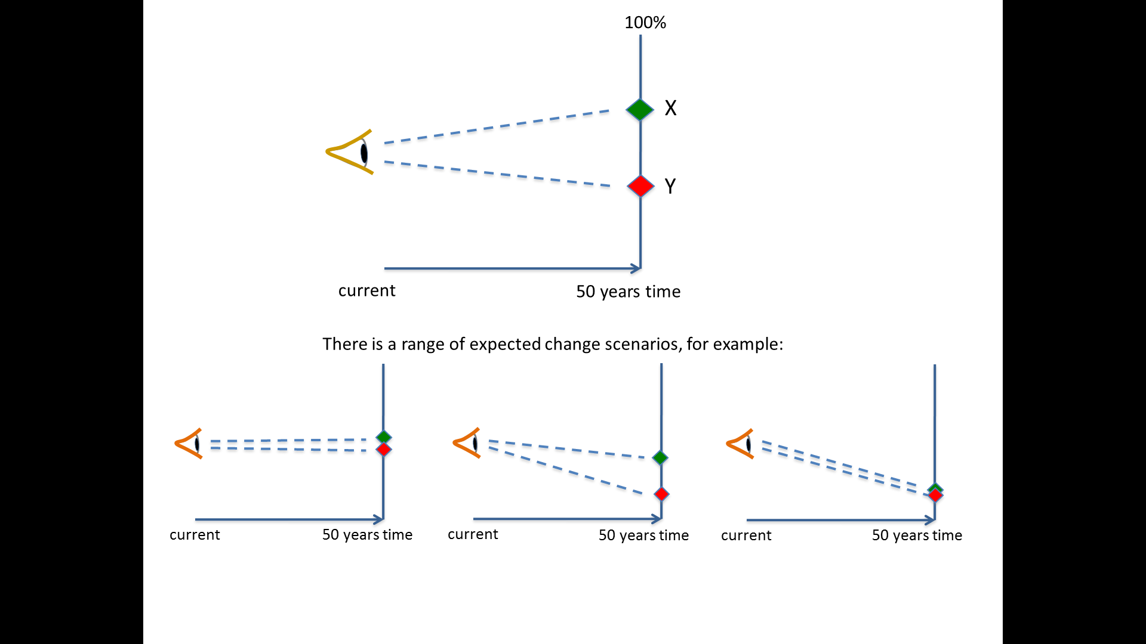

Given a scenario that a species is present at a location and specified threats are occurring…

What is the probability that the species is still present if threat(s) are managed over this time?

**(X – Y / Y) = % improvement**

What is the probability the species is still present if threat(s) are **not** managed over this time?

|  |  |  |
| --- | --- | --- |
| Small improvement – the species maintains its presence at a location. e.g. a common species that is resilient to predicted threats. | Significant improvement but the species is still declining. e.g. a small mammal responds well to predator control, but small population size is still a threat. | No improvement – no effective treatment of predicted threat. e.g. a rainforest fern that is sensitive to drying under climate change. |

**Figure 5: Estimates of the likelihood of species persistence**

Based on this elicited data, trait-based modelling was used to infer across all species, extrapolating information regarding the response of species to different scenarios to other species with similar traits (Figure 6).

Benefit data for a subset of species based on expert elicitation

Extrapolated to species with similar traits.

For example, birds with similar:

* Mass
* Brood size
* Egg mass
* Diet
* Feeding strategy
* Nesting habit
* Habitat preference

Benefit data for remaining species based on species with similar traits

Yellow faced Honeyeater

Fuscous Honeyeater

Purple Gaped Honeyeater

Grey-fronted Honeyeater

Brown-headed Honeyeater

**Figure 6: Example of extrapolating response information**

Current data on Change in Suitable Habitat focuses on treatment of common widespread threats or actions (e.g. invasive species, revegetation) with the expectation that further actions, particularly those requiring direct manipulations to improve adaptation to climate change (e.g. translocations, genetic strengthening) will be progressively assessed using this measure.

Since the KPI is applied in an equivalent manner to different species as well as scenarios, this provides an essential contribution to thinking about how to maximise benefits across all species.

The CSH is supported by contributing KPI and targets (indicated under the intermediate outcomes and outcomes in the following tables) that highlight the actions that need to be established and maintained in order for the CSH target to me achieved. The contributing targets identify the area of management in priority locations that needs to be achieved, as soon as possible, and maintained over the 20-year life of the plan. If effort slows or stops, in some cases even for a short time, the gains made over the preceding years of effort could be lost. The sooner the actions to deliver the contributing targets are implemented and sustained, the more likely it is that the state-wide targets will be achieved.

# 

Appendix 2: A systematic approach to prioritisation

## A2.1 Documenting our current understanding and uncertainty

**Describing the problem-response scenario**

**Problem-response scenarios** describe particular biodiversity management scenario that may benefit from knowledge acquisition. They are a structured description of a given scenario, considering the relevant biodiversity values (e.g. threatened species, species guild, ecological community), the problem (e.g. threatening processes, emerging issues, pest plants and animals, policy barriers, lack of awareness, low connection to nature etc.), the response (e.g. on-ground management actions, communications campaign, school education activity, policy interventions) and quantified estimates of the potential benefits of implementing the response for the biodiversity values, and the level of uncertainty associated with the response. These estimates are measured in terms of Change in Suitable Habitat and can be calculated from the library of species responses to management in Strategic Management Prospects or elicited separately using the Specific Needs framework.

The scale of the scenario is flexible. It may be broad, for example based on an ecosystem or threatening process where broadscale management actions may apply, or it may be targeted towards a threatened species requiring specific threat management to that situation.

**Measuring benefits and uncertainty of a management action, intervention or policy**

Interventions under Biodiversity 2037 seek to deliver a particular outcome, given the available budget. This may be to increase the ability of a species to persist in the wild or an increased connection to nature. To plan and prioritise which management actions, behaviour change activities or policy interventions we will do, and where, we want to know how a particular response activity could impact the desired outcome.

While a measure to quantify the benefits of activities to encourage people to connect and value nature is yet to be developed, a new measure – Change in Suitable Habitat - was developed under Biodiversity 2037 and is used for looking at biodiversity (species) benefits. In the case of biodiversity, we want to know how particular management actions benefit different species of plants and animals in different locations, and how that benefit may vary across species and locations.

Change in Suitable Habitat was developed to provide a consistent measure of the relative contribution of management actions to habitat quality and populations’ persistence across many different species. It provides a transparent, comparable and consistent measure of the benefit of different conservation actions for individual or groups of species. The anticipated Change in Suitable Habitat gained by a species from an action is calculated using elicited expert judgments of a species’ likelihood of persistence at a location under management and under no management, and then extrapolated spatially using a model of the species’ distribution. The magnitude of anticipated Change in Suitable habitat is sometimes known with precision, but it can be highly uncertain. Uncertainty implies the possibility of windfall outcomes for conservation alongside the possibility of abject failure. The Biodiversity Knowledge Framework seeks to identify key elements of uncertainty that improve prospects for success and limit exposure to failure.

By estimating anticipated Change in Suitable Habitat, uncertainty in expert judgements is also explicitly captured, where experts have provided plausible lower and upper bounds of changes in persistence probability for a species and action. Quantifying the benefits and uncertainty of each action allows us to identify which actions we can be relatively more certain about having a positive outcome for biodiversity and actions for which the consequences are uncertain.

To quantify this appropriately a standard set of information is required. Where do the biodiversity assets occur across the state? What are the threats or disturbance processes operating at those locations? Which of these threats can be addressed directly through management and what are the potential benefits of those management actions for the biodiversity assets?

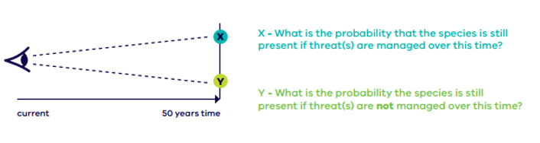

**Figure 7. Quantifying benefits through formal elicitation of expert judgment.**

Biodiversity 2037 provides two pathways for quantifying the benefits and uncertainties of an action. A number of broadscale terrestrial management actions have been included in the Strategic Management Prospects decision-support tool (SMP) where the benefits and uncertainty of actions have already been quantified. For actions not in SMP, a specific needs assessment (Figure 8) can be undertaken to quantify the benefits and uncertainties of the intervention. The specific needs process follows the same method used to collect expert judgements for the landscape-scale actions in SMP but focuses on bespoke actions and how they benefit a particular species in more specific locations. Because it uses the same method and quantifies benefit in the same manner as SMP, the results (and their uncertainty) can be directly compared.

**Gaps?**

**Gaps?**

1. What **biodiversity assets** occur

at **each place**?

4. Which actions at each place

could provide the

**greatest cost-effective benefits** for biodiversity **across Victoria**?

2. What are common **landscape-scale threats**?

How do they **interact**?

3. Which **actions** could provide the

**most benefits** to the species at **each place**?

What are their **indicative costs?**

Which **species** receive these **benefits**?

**Strategic Management Prospects**

**broad landscape-scale threats (terrestrial)**

A. Where do **species** occur?

Where are their **strongholds**?

B. What are other

**more-specific** **threats**?

C. Which **actions/locations** could provide **other benefits** to **particular species**?

What are their **indicative costs?**

How much **benefit** is received?

D. How does the **cost-effectiveness**

of these specific actions

**compare to the integrated analysis**?

**Specific Needs**

**actions for individual species &/or situations**

**Gaps?**

**Figure 8: Pathways to quantify benefits and uncertainties in actions**

Strategic Management Prospects

For management actions in SMP, benefit and uncertainty information can be identified from the expert elicited species responses to management actions. These data exist for fourteen landscape scale actions and their benefits for all Victorian terrestrial vertebrates and nearly all vascular plants ([see here](https://www.environment.vic.gov.au/__data/assets/pdf_file/0035/82997/5-NaturePrint-Strategic-Management-Prospects-inputs.pdf) for more information). These data are represented as the expected change in persistence probability for a species in a location as a result of a management action, as well as the plausible range (level of uncertainty) that change in persistence probability could fall within (Figure 9).

Actions that have high benefits (i.e. relatively large change in persistence probability scores) and high uncertainty (i.e. wide upper and lower plausible bounds) are likely to have a relatively high value of information. That is, resolving the uncertainty around these actions will have a significant positive influence on biodiversity decision making.

The library of spatially explicit benefit of action data for a range of species in SMP provides a strong basis for which to identify where research projects can help to resolve the uncertainty most influential in biodiversity decision making.

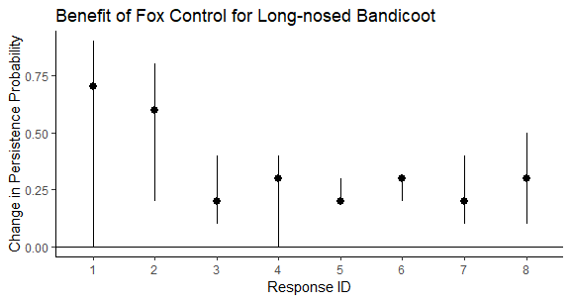

**Figure 9: Expert estimates for the benefit of fox control for the long-nosed bandicoot for different scenarios across Victoria. Dots represent the best guess, and the lines represent the plausible bounds that experts suggested that benefit values could fall between.**

Specific Needs

Management actions that are not currently considered in Strategic Management Prospects (e.g. genetic rescue, translocation, artificial habitat creation, regulatory actions, marine or freshwater management actions) will also need to be considered in the portfolio of possible research questions and knowledge gaps. These actions will require a ‘specific needs’ analysis. The specific needs process follows the same method used to collect expert judgements for the landscape-scale actions in SMP but focuses on bespoke actions and how they benefit a particular species in more specific locations. Because it uses the same method and quantifies benefit in the same manner as SMP (i.e. expected change in persistence probability for a species), the results (and their uncertainty) can be directly compared (Figure 10).

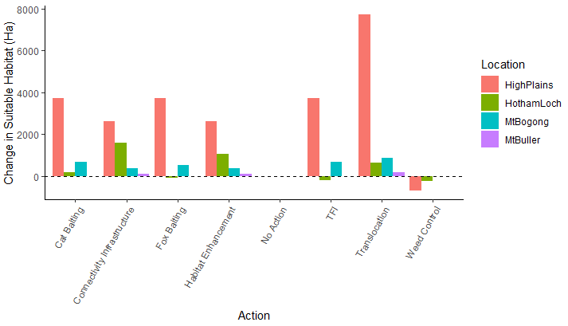

**Figure 10: Anticipated Change in Suitable Habitat for the Mountain Pygmy Possum in different locations across its range for a set of bespoke and landscape scale actions.**

## A2.2 Causal models of scenario

After identifying the broad actions and species for which we are most uncertain (e.g. the benefit of fox control on small and medium sized mammals), a deeper dive into the ecological and human mechanisms influencing this uncertainty is required to identify knowledge gaps and therefore research questions. This is achieved through the development of causal models that map the causal relationships between ecological and human components relevant to the benefit of an action being realised. This is done using a technique called fuzzy cognitive mapping.

Causal models (describing the difference between the best and worst-case causal models) (Figure 1) represent our shared understanding of the management action, and uncertainty in that understanding, and how drivers and threats, and other relevant processes interact to influence the availability of Suitable Habitat for the species.  Causal models are graphical representations in which key concepts are nodes and causal relationships are the links between them. The models reflect a narrative of cause and effect, summarising what experts believe to be the key elements of a system, their dependencies and interactions. Positive links indicate a direct relationship between parent and child notes (as the parent increases, so too does the child, or as the parent decreases so too does the child). Negative links indicate inverse relationships (as the parent increases the child decreases or as the parent decreases the child increases). The strength of the association between parent and child nodes is captured qualitatively (e.g. weak, moderate, strong) and assigned a corresponding numerical descriptor (1, 2, or 3).

The sign and strength of causal links between the nodes allow coarse inferences of the influence of actions throughout the system under best-case and worst-case understandings.

Contrasts between best-case and worst-case causal models can be characterised by a distance metric derived from graph theory. The proportional reduction in the distance metric between the best and worst-case causal models will be calculated for each contrasting link (i.e. knowledge gap) in the models. Contrasts in links between best case and worst-case models may be small (e.g. weakly negative versus moderately negative, -1 vs -2) or large (strongly negative versus strongly positive -3 vs +3). In general, larger contrasts represent higher priority knowledge gaps than lesser contrasts.

**A2.3 Comparing and prioritising knowledge gaps**

Consistent with the Biodiversity 2037 approach to comparing across actions to identify those that are most cost-effective, it is important to be able to compare across knowledge gaps in different systems to identify the best candidates for investment in knowledge acquisition. This will be done on the basis of the index of **relative benefit of knowledge** as a proxy for value of information (Figure 6). This is to ensure that the knowledge gain will translate into a practical outcome and improve current practice and policy.

This index enables comparison of knowledge gaps both within a causal model and across problem-response scenarios. Candidate research projects will typically aim to resolve a small subset of contrasting links documented in best- and worst-case conceptual models. The value of resolving uncertainty in a subset of links can be estimated by multiplying the expected gain in benefit that would be achieved by resolving the uncertainty for a problem-response scenario (i.e. resolving *all* contrasting links) by the proportional reduction in distance between best and worst-case that could potentially be achieved by resolving the target link or subset of link(s) to be addressed by a candidate project.

Relative Benefit of Knowledge

**Expected gain** from resolving all uncertain elements

**Proportional reduction** in uncertainty from resolving target elements.

=

x

Figure 6: Calculation of the index of Relative Benefit of Knowledge for resolving a knowledge gap.

*Expected gain* provides an assessment to quantify how the additional information can improve the predicted biodiversity benefit. It is the expected difference in the benefit (in this case the weighted sum of Change in Suitable Habitat) as a result of the management action, with and without the knowledge acquisition to resolve any uncertainties.

*Proportional reduction* identifies the amount of uncertainty resolved by calculating the improvement in proportional distance between the best and worst-case causal models, assuming the knowledge acquisition succeeds in resolving the knowledge gap.

## A2.3 Translating knowledge gap to a research question

Highly ranked knowledge gaps are then expressed as **priority research questions** which could be subject to funding. For instance, an uncertain relationship between fire and the effect of a weed control method on weed density could be expressed as the following research question: “What is the most effective, in terms of long-term reduction in weed density, fire-age to undertake weed control in location X.”

## A2.4 Knowledge acquisition activities to address the research question

Researchers seeking to address the knowledge gap can then identify the most **appropriate form of knowledge acquisition** and design a knowledge acquisition or research project, with the results of the project directly feeding back to improve policy, management standards, program design and decision-support tools such as Strategic Management Prospects. Knowledge activities may include:

* Manipulative ‘management experiments or trials’ or natural experiments
* Data synthesis and analysis, meta-analysis, systematic review
* Species surveys or monitoring (incl. long term monitoring)
* Ecological studies
* Collation of Traditional Knowledge
* Questionnaires, evaluation and experimental assessment
* Testing new innovations and technology
* Citizen science (which may use some of the approaches listed here)
* Pilot or proof of concept studies, scenario analyses, reviews, case studies etc.

Appendix 3: Analysing and reporting against key performance indicators

| **Key performance indicator** | **Method** | **Proposed timing for report** | |
| --- | --- | --- | --- |
| **Annually** | **Five- yearly** |
| **Vision: Victoria’s biodiversity is healthy, valued and actively cared for** | | | |
| (on average) % Change in Suitable Habitat expected over 50 years from sustained improved management for threatened species | Analysis based on output data | 🗸 |  |
| (on average) % Change in Suitable Habitat expected over 50 years from sustained improved management for culturally significant species | Analysis based on output data. Species identified by Traditional Owner groups | 🗸 |  |
| % of all species with positive % Change in Suitable Habitat expected over 50 years from sustained improved management | Analysis based on output data | 🗸 |  |
| **Outcome 1: Delivering the greatest overall benefit** | | | |
| % alignment of actions in priority locations | Analysis based on output data | 🗸 |  |
| Total Relative Benefit of Knowledge delivered | Analysis based on Relative Benefit of Knowledge metric |  | 🗸 |
| Progress made against Tool response register to new knowledge and information | Review Tool response register |  | 🗸 |
| % of survey respondents who report a good understanding of how to make better decisions | Survey - Decision support |  | 🗸 |
| % of NRM organisations contributing output data and species records | Analysis based on output data and VBA users | 🗸 |  |
| % of NRM organisations with Intellectual Property agreements with Traditional Owner groups | TBD |  | 🗸 |
| Number of system hits on NatureKit | Analysis of NatureKit web services statistics | 🗸 |  |
| % of surveyed staff who report they have provided information on tools | Survey - Decision support |  | 🗸 |
| % of surveyed organisations using common decision support tools to drive actions | Survey - Decision support |  | 🗸 |
| % of surveyed organisations that report they have integrated the tools in their processes | Survey - Decision support |  | 🗸 |
| Number of causal models developed and parametrised to identify knowledge gaps | Analysis of Biodiversity Knowledge Framework models | 🗸 |  |
| Number of causal models integrating cultural values, uses and rights | Analysis of Biodiversity Knowledge Framework models | 🗸 |  |
| **Outcome 2: Victorians place more importance on a healthy environment and contribute to its health** | | | |
| Victorians contribute to health of biodiversity score | Scorecard assessment - data requirements TBD |  | 🗸 |
| Mean level of connection to nature of program participants and surveyed Victorians | Collate data from organisations survey of program participants  Survey - Victorians |  | 🗸 |
| Number of program participants | Output data | 🗸 |  |
| % of campaigns that meet their reach and impact targets | Follow up from output data |  | 🗸 |
| % alignment of priority actions and locations by community groups | Analysis based on output data | 🗸 |  |
| Number of volunteer hours | Provided by Volunteering Naturally program | 🗸 |  |
| Effectiveness of volunteer sector score | Scorecard assessment - data requirements TBD |  | 🗸 |
| Number of engagement events incorporating nature and and/or Aboriginal cultural messaging | Output data | 🗸 |  |
| Number of publications | Output data | 🗸 |  |
| Number of programs providing opportunities to connect with nature and/ or Aboriginal culture | Output data | 🗸 |  |
| Number of behaviour change campaigns | Output data | 🗸 |  |
| Number of opportunities listed on the “Victoria it’s in our Nature” website | Provided by Volunteering Naturally program | 🗸 |  |
| **Outcome 3: So that Victoria has a healthy natural environment that underpins and sustains the prosperity of the Victorian economy and society** | | | |
| Value of ecosystem services provided by Victoria’s environmental and cultural assets | TBD |  | 🗸 |
| Number of instances which use biodiversity information within the SEEA framework as an input into policy/ program or industry development | TBD |  | 🗸 |
| $ contribution of nature-based activities in parks to the economy | Provided by Parks Victoria |  | 🗸 |
| Number of jobs generated through nature-based activities in parks | Provided by Parks Victoria |  | 🗸 |
| Increased proportion of green wedges and peri-urban areas with plans | Survey - through Municipal Association of Victoria (TBC) |  | 🗸 |
| Hectares of green roof area | Survey - through Municipal Association of Victoria (TBC) |  | 🗸 |
| Proportion of urban population within (400m) walkable distance of public open space | Survey - through Municipal Association of Victoria (TBC) |  | 🗸 |
| Number of reports developed that utilise the System of Environmental Economic Accounting (SEEA) principles | TBD |  | 🗸 |
| Number and purpose (nature and/ or Aborignal culture) of licenced tourism operators supported in parks by Parks Victoria | Provided by Parks Victoria |  | 🗸 |
| **Outcome 4: Everyone invests in a healthy environment** | | | |
| 5 yearly Biodiversity 2037 targets on track | Analysis based on KPIs/ targets |  | 🗸 |
| Average amount invested per year | Survey – NRM organisations | 🗸 |  |
| Number of different funding sources by organisation | Survey - NRM organisations | 🗸 |  |
| % of Victorian private land with actions for biodiversity | Analysis based on output data | 🗸 |  |
| Number of approaches used to increase, sustain or maximise funding | Survey - NRM organisations |  | 🗸 |
| Number of programs for biodiversity stewardship (including through cultural practices) on private land | Analysis based on output data |  | 🗸 |
| % of local governments with natural resource management rate relief/ incentive schemes | Survey - through Municipal Association of Victoria (TBC) |  | 🗸 |
| **Outcome 5: Everyone is working cohesively** | | | |
| Contribution is maximised score | Scorecard assessment - data requirements TBD |  | 🗸 |
| Collective effort and skills score | Scorecard assessment - data requirements TBD |  | 🗸 |
| % of organisations that contribute to the Change in Suitable Habitat target | Analysis based on output data | 🗸 |  |
| % of organisations that identify their contribution the Biodiversity 2037 outcomes | Desktop review of organisational strategies |  | 🗸 |
| % of organisations participating in Biodiversity Response Planning | Analysis of BRP documentation |  | 🗸 |
| Number of organisations (including Traditional Owner groups) supported to participate | Analysis of BRP documentation |  | 🗸 |
| % of Biodiversity Response Planning landscape areas with a situation analysis | Analysis of BRP documentation |  | 🗸 |
| **Outcome 6: Aboriginal Victorians have opportunity, prosperity and are connected to Country** | | | |
| TBD |  |  | 🗸 |
| Number of Whole of Country Plans published | Document review |  | 🗸 |
| Number of Joint Management Plans and Co-management plans and area of land covered | Analysis of Indigenous Land Use Agreement data |  | 🗸 |
| Area of public land and arrangements for management with Traditional Owners | Follow up with Parks Victoria and DELWP |  | 🗸 |
| Participation in community events which celebrate Aboriginal culture | TBD | 🗸 |  |
| Investment in Aboriginal culture revitalisation programs | Analysis of output data | 🗸 |  |
| Number of Victorian natural resource management business-owner-managers who are Aboriginal | Collated through VAAF reporting |  | 🗸 |
| Number of Aboriginal owned natural resource management businesses that government enters into a purchase agreement with as a proportion of small to medium enterprises government enters into a purchase agreement with | Collated through VAAF reporting |  | 🗸 |
| Number of formal partnership agreements for planning and management between Aboriginal communities and key NRM agencies | Analysis of output data | 🗸 |  |
| % of Traditional Owner organisations participating in Biodiversity Response Planning | Analysis of BRP documentation |  | 🗸 |
| Number of cultural burns conducted | Analysis of output data | 🗸 |  |
| Average area of cultural burns conducted | Analysis of output data | 🗸 |  |
| Number of capacity building activities | Analysis of output data | 🗸 |  |
| Number of jobs through natural resource management funding | Analysis of output data | 🗸 |  |
| Number of seed funding or business cases supported | Analysis of output data | 🗸 |  |
| Distribution of employment of Aboriginal people across organisational levels in NRM organisations | Collated through VAAF reporting |  | 🗸 |
|  |  |  |  |
| **Outcome 7: Victoria’s biodiversity is protected and managed** | | | |
| Number of vulnerable or near-threatened species that become endangered | Analysis of changes in Conservation status |  | 🗸 |
| % of critically endangered and endangered species that have at least one option available for being conserved ex-situ or re-established in the wild (where feasible under climate change) should they need it | Review of database recording options |  | 🗸 |
| Threatened Species Index | Provided through organisation responsible for Index |  | 🗸 |
| Hectares of herbivore control in priority locations | Analysis of output data | 🗸 |  |
| Hectares of pest predator control in priority locations | Analysis of output data | 🗸 |  |
| Hectares of weed control in priority locations | Analysis of output data | 🗸 |  |
| Hectares of native vegetation extent across the state |  |  |  |
| Amount of Habitat (Habitat Hectares) |  |  |  |
| Hectares of revegetation in priority locations for habitat connectivity | Analysis of output data | 🗸 |  |
| Number of landscapes where ecosystems are being restored through enhancement or restoration of functional species niches or cultural practices | Analysis of output data | 🗸 |  |
| Number and area of parks managed for conservation purposes | Analysis of reserve system |  | 🗸 |
| Extent and representation of ecological vegetation classes in the CAR reserve system | Analysis of reserve system and updated Ecological Vegetation Classes extent – relies on updated Native vegetation extent |  | 🗸 |
| Hectares of new permanently protected area on private land | Analysis of output data since 2017 | 🗸 |  |
| Hectares of private and public land recognised as Indigenous Protected Areas | Data provided by Commonwealth | 🗸 |  |
| Hectares of on-ground biodiversity actions | Output data | 🗸 |  |
| Hectares of cultural practice | Output data | 🗸 |  |
| Number of specific threat actions | Output data | 🗸 |  |
| Number of threatened species programs overseen by Cultural governance frameworks | Review of documentation | 🗸 |  |
| Opportunities and complementary measure identified | Review of documentation |  | 🗸 |
| **Outcome 8: The Victorian Government is driving the biodiversity agenda** | | | |
| A Net Gain in the overall extent and condition of habitats across terrestrial, waterway and marine habitats | Analysis of output data  Modelled extent and condition of habitats based on new on-ground data and expert elicitation (all available new data plus specific data collection at least every 5 years) |  | 🗸 |
| % of Victorian Government and portfolio agencies who include the vision for Biodiversity in their strategies or business plans including confirming and enabling the role of Traditional Owners to plan, manage, inform and deliver biodiversity programs | Review of documentation |  | 🗸 |
| Leadership in biodiversity management score | Scorecard assessment – data requirements TBD |  | 🗸 |
| Number of cross-government activities on biodiversity or nature | Review of VEF minutes | 🗸 |  |
| % of Government and portfolio agencies that report on activities that impact the environment (output data) | Analysis of output data | 🗸 |  |
| Key pieces of legislation or regulations have been amended to give effect to the vision of Biodiversity 2037 | TBD |  | 🗸 |

1. Dart, J., and Roberts, M. (2014) Collaborative Outcomes Reporting. BetterEvaluation.   
   Retrieved from <http://betterevaluation.org/plan/approach/cort>