
Merran's Sun-orchid
Thelymitra merraniae
Action Statement

Flora and Fauna Guarantee Act 1988 No. 155

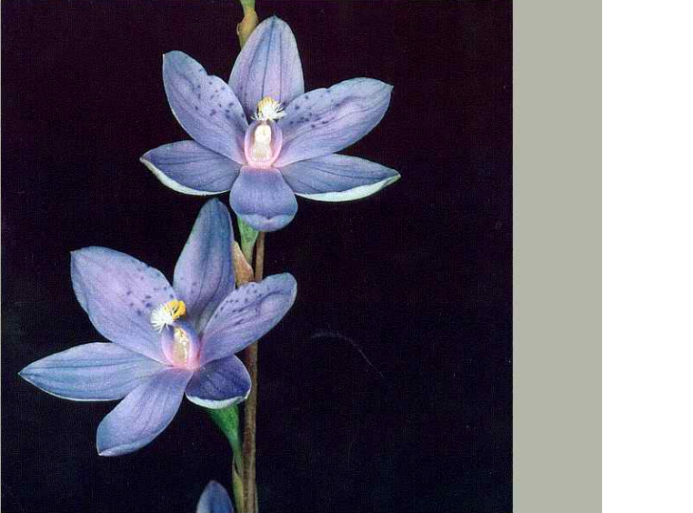

Description and distribution
Merran's Sun-orchid (Thelymitra merraniae) is a slender terrestrial orchid to 40 cm tall. It perennates via an underground ovoid tuber. It has several reddish sheathing bracts and has one to six flowers c. 25 mm in diameter, rich purple to bluish with the dorsal sepal and petals with a few scattered darker spots. The column is up to 4mm long, bluish in colour, yellow tipped with cream hairy tufts. Flowering is from October to November. Flowers require warm sunny conditions to open (Backhouse & Jeanes 1995). A full botanical description of the species is provided by Nicholls (1929) and a further description is given in Jones (1988) and Backhouse & Jeanes (1995).
Merran's Sun-orchid was first discovered at Moggs Creek near Aireys Inlet in south-western Victoria in November 1929. It was not recorded again until 1992. It has subsequently been found on the Mornington Peninsula at Crib Point. It is also known from South Australia and New South Wales (Backhouse & Jeans 1995).
No known populations occur within formal conservation reserves. Two populations occur at Moggs Creek, one on private land, the other within a small Shire reserve.
The small population of about 10 plants at Crib Point is located at the Lorna’s Triangle Bushland Reserve. This reserve is managed by the Mornington Peninsula Shire Council under a Committee of Management (Bittern Bushland Preservation Association Inc.). Another population may still occur near Governors Road.
Populations formerly occurred on the railway reserve at Crib Point but these populations are now extinct due to past management practices (G. Backhouse pers. comm.).

Merran's Sun-orchid (Thelymitra merraniae)
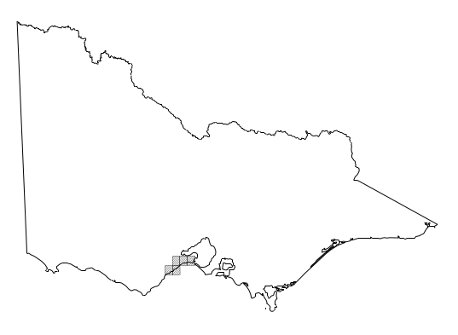

Distribution in Victoria
(from Flora Information System, NRE 2002)

Habitat
The species grows in heathlands, woodlands and open forests, often in low-lying areas around swamp margins or depressions. Soil types include well-drained sands and clay loams and heaver moist peaty soils (Backhouse & Jeanes 1995). It can grow as a single plant or in small, scattered groups.
Life history and ecology
Little is known regarding the ecology and biology of the species. It appears to have very narrow habitat requirements and may require some form of disturbance such as fire to assist with re-colonisation. Due to the limited number of populations and individual plants, genetic diversity may be of major importance to its potential for survival and re-colonisation. Research has been carried out on other species of Thelymitra with regards to propagation and seed germination. Species of Sun-orchids can be cultivated easily, as long as appropriate media and mycorrhizal fungi are used (Leigh et al. 1984).
There is considerable speculation amongst orchid taxonomists and field naturalists that Merran’s Sun-orchid is a hybrid between two widespread sun-orchids. The taxonomy of this species, and Victorian Thelymitra species generally, is presently under review by the Royal Botanic Gardens.
Conservation status
National conservation status
Merran's Sun-orchid is not listed under the Environment Protection and Biodiversity Conservation Act 1999.
Victorian conservation status
Merran's Sun-orchid is currently classified as ‘Endangered’ in Victoria (DSE 2003).
Merran's Sun-orchid is listed as threatened under the Flora and Fauna Guarantee Act 1988 (SAC 1994).
Decline and threats
Threatening processes to the known populations are from human disturbance such as: uncontrolled slashing and clearing of vegetation for fire prevention works, public utilities and housing development. Trampling occurs from foot traffic and vehicles due to uncontrolled access. Illegal picking or digging up of plants for decoration or specimen collections could occur.
The orchids at Moggs Creek sites are subject to impacts from residential subdivision and associated developments.
Merran’s Sun-orchid is at serious risk of extinction in the wild because the limited number of small populations are threatened. The continuation of present land use and residential development may cause loss of its preferred habitat of coastal heathlands, woodlands and open forests.
Destruction of habitat is threatening known populations at Moggs Creek near Anglesea and Crib Point on the Mornington Peninsula. The site at Forest Drive Moggs Creek, has a population of approximately 80-90 plants. This area is currently under threat from a high density residential subdivision. The other site on Timbara Estate is a small population of approximately 10-20 plants. This population could also be threatened by human disturbance.
The population at Lorna’s Triangle is under threat from weed invasion and the loss of suitable habitat due to the thickening of vegetation along the fire breaks (R. Adair pers. comm.). Other sites around Governors Road, are under threat from human disturbance, such as residential development and loss of habitat (G. Backhouse & R. Myers pers. comm.).
In its final recommendation the Scientific Advisory Committee (SAC 1994) determined that the Merran’s Sun-orchid was:
- in a demonstrable state of decline which is likely to result in extinction; and
- significantly prone to future threats which are likely to result in extinction; and
- very rare in terms of abundance or distribution.
Previous management action
There has been little active management for Merran’s Sun-orchid populations.
The National Herbarium of Victoria has undertaken propagation trials with seed collected from Moggs Creek. Seedlings were raised, however, leaves were deformed. This may have been caused by techniques used (J. Jeanes pers. comm.). Further propagation of the orchid has been successfully undertaken and a number of plants in cultivation are currently being studied (A. Paget pers. comm.).
Moggs Creek
Members of ANGAIR have been monitoring the two sites and have assisted with the orchid’s conservation by keeping the sites free of invasive weeds.
There has been ongoing discussion for the protection of the orchid, with the Surf Coast Shire and the proponent of the subdivision at Forest Drive.
Fencing of the Forest Drive population and the establishment of a shire reserve managed by the Surf Coast Shire was in 2000.
Crib Point
The populations of orchids at the Governors Road location have had very little protection and these populations have been almost eliminated due to residential development. The Lorna’s Triangle Natural Bushland Reserve, is controlled by the Mornington Peninsula Shire Council via a works agreement with the Bittern Bushland Preservation Association. The Association manages this reserve for the maintenance and enhancement of indigenous biodiversity.
Major conservation objective
Long-term objective
To ensure that the Merran’s Sun-orchid can survive, flourish and retain its potential for evolutionary development in the wild.
Objectives of this Action Statement
- Protect existing populations of Merran’s Sun-orchid and encourage natural regeneration.
- Determine taxonomic status of Merran’s Sun-orchid, including evaluation of its possible hybrid status.
Intended management action
The intended management actions listed below are further elaborated in DSE’s Actions for Biodiversity Conservation database. Detailed information about the actions and locations, including priorities, is held in this system and will be provided annually to land managers and other authorities.
Monitoring
- Monitor populations annually during the flowering period. Adopt standardised methods for monitoring and assessment. Register all data on relevant Departmental data bases (eg. VRoTPop). Assess validity and scope of past monitoring surveys. Assess success of any past management actions. Assess existing sites to determine if the orchid population will survive under proposed management actions. (Management actions should be under point 7)
Responsibility: DSE SW Region, DSE Port Phillip Region
Survey
- Undertake searches of similar habitats near known locations and previous sites or where orchid populations are likely to occur but are not yet recorded. Ensure all sites are recorded in appropriate databases.
Responsibility: DSE SW Region, DSE Port Phillip Region
Liaison and planning
- Provide information to, and liaise with, relevant management authorities and private property owners, to ensure the long-term protection of populations, possibly via conservation covenants or other agreements.
Responsibility: DSE SW Region, DSE Port Phillip Region
- Liaise with adjoining landowners to prevent the spread of garden escapes and the dumping of garden refuse into the orchid’s habitat.
Responsibility: DSE SW Region, DSE Port Phillip Region, local government
- Incorporate information on the locations and management requirements of Merran’s Sun-orchid into local planning schemes and overlays. Ensure that sites are protected in planning decisions and in the course of other Council activities.
Responsibility: Mornington Peninsula and Surf Coast Shires
- Incorporate actions to protect, enhance and restore Merran’s Sun-orchid habitat into relevant Regional Catchment Strategies or their subordinate strategies via Biodiversity Action Plans. Implement these actions, according to priority, as resources become available, in conjunction with other agencies, community groups and landholders.
Responsibility: Corangamite and Port Phillip Catchment Management Authorities
- Assist and coordinate activities of local conservation groups, field naturalists and committees of management to enhance the conservation of Merran’s Sun-orchid through grant funding.
Responsibility: DSE SW Region, DSE Port Phillip Region
- Develop management prescriptions for each of the existing sites and incorporate into a broader management plan for the reserves.
Responsibility: DSE SW Region, DSE Port Phillip Region, land owners/managers
Site management
- Erect fences/barriers to control access and minimise inadvertent damage or disturbance where necessary.
Responsibility: DSE SW Region, DSE Port Phillip Region, land owners/managers
Compiled by Steven McDougall, Flora and Fauna Management Officer, DSE South-west Region, Colac.
Further information can be obtained from Department of Sustainability and Environment Customer Service Centre on 136 186.
Flora and Fauna Guarantee Action Statements are available from the Department of Sustainability and Environment website: http://www.dse.vic.gov.au
This Action Statement has been prepared under section 19 of the Flora and Fauna Guarantee Act 1988 under delegation from Chloe Munro, Secretary, Department of Natural Resources and Environment, October 2002.
© The State of Victoria, Department of Sustainability and Environment, 2003
Published by the Department of Sustainability and Environment, Victoria. 8 Nicholson Street, East Melbourne, Victoria 3002 Australia
This publication may be of assistance to you but the State of Victoria and its employees do not guarantee that the publication is without flaw of any kind or is wholly appropriate for your particular purposes and therefore disclaims all liability for any error, loss or other consequence which may arise from you relying on any information in this publication.
ISSN 1448-9902

- Assess weed problems annually and determine management actions in line with current practices for sensitive areas.
Responsibility: DSE SW Region, DSE Port Phillip Region, land owners/managers
- Carry out environmental burns as considered appropriate to optimise the orchid’s habitat.
Responsibility: DSE SW Region, DSE Port Phillip Region, land owners/managers
Taxonomic research
- Undertake taxonomic investigation of populations of Merran’s Sun-orchid and related sun-orchids, to clarify status in regard to morphological stability and fertility.
Responsibility: Royal Botanic Gardens
References
Backhouse, G. & Jeanes, J. (1995) The Orchids of Victoria. Miegunyah Press Melbourne.
DSE (2003) Advisory List of Rare or Threatened Plants in Victoria – 2003. Department of Sustainability and Environment: East Melbourne. (available on the DSE web site)
DSE (2004) Flora Information System (electronic flora database). Department of Sustainability and Environment: Melbourne.
Ewart, A. J. (1930) Flora of Victoria. MacMillan Melbourne University
Jones, D. L. (1988) Native Orchids of Australia. Reed Sydney.
Leigh, J., Boden, R. & Briggs, J. (1984) Extinct and Endangered Plants of Australia. MacMillan.
Morgan, K., & MacDonald, M. (1994) The Moggs Creek Orchid Journal of the Orchid Species Society of Victoria Vol 13 No1.
Nicholls, W. H. (1929) A new species of Thelymitra. Victorian Naturalist. 46: ??
Nicholls, W. H. (1951) Orchids of Australia - Plate 7. Georgian House: Melbourne.
SAC (1994) Final recommendation on nomination for listing: Thelymitra merraniae Merran’s Sun-orchid (Nomination No: 293). Scientific Advisory Committee, Flora and Fauna Guarantee. Department of Conservation and Natural Resources: Melbourne.

