|  |
| --- |
| VBA – Editing Site Details |
| How to edit existing sites in the Victorian Biodiversity Atlas |

## This is a basic step by step guidance document to help you edit existing information relating to the species records you submitted to the VBA.

## *Tips*

*Throughout the VBA each window has a* ***?*** *in the top right hand corner – this is window-specific help that will provide further details about how to complete the fields.*

*Make sure that you have allowed pop-ups from your browser (you will need to allow these from the VBA site)*

*Also, throughout the VBA fields marked with a red dot (●) are mandatory fields and must be completed. The fields marked with a yellow dot (●) are conditional - if you complete one you must complete the others.*

With the VBA you are able to see and edit all the data you have contributed, even if it has not yet been published (i.e. it is still in draft form or was not confirmed by an Expert Reviewer).

If you notice an error in the site details or taxa recorded, or you have received a Further Information Request Letter from the VBA there will be a comment from the relevant Expert Reviewer about any additional information required.

The Letter will highlight the Survey ID (or General Observation ID), Site Name and the species record that has been reviewed.

1. Visit VBA (https://vba.dse.vic.gov.au/vba/) and Login using your Login Name & Password.
2. Navigate to the Data Entry section in the top left of the Welcome page and then select My Projects (or My General Observations). From here you have access to all the projects you are associated with and can search for specific surveys (or general observations) using the Survey ID field: enter the relevant Survey ID then click on Search My Projects (see below).

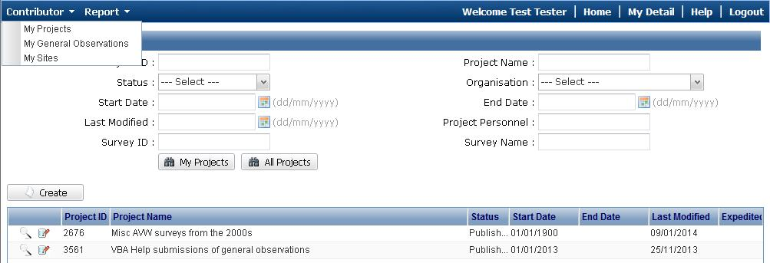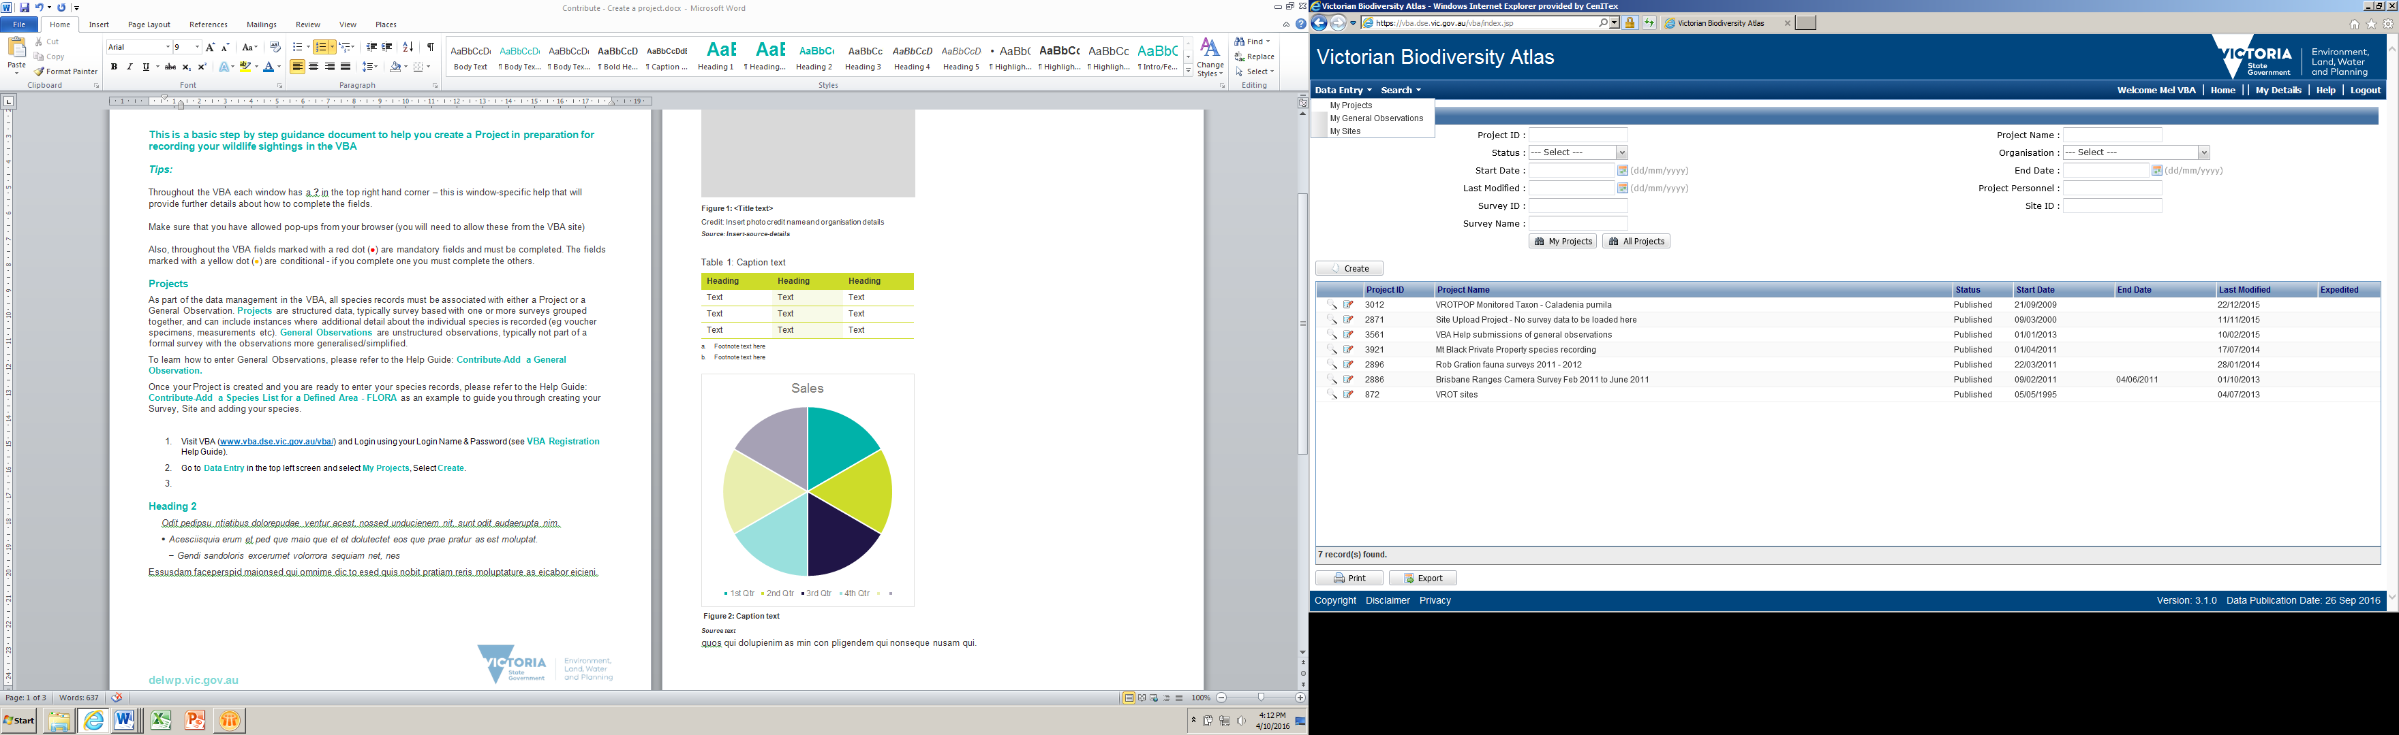



1. To view the survey sheets of the relevant project use the notepad symbol (highlighted above). Then select the relevant survey in the project (or general observation) by double-clicking on the survey (or clicking on the magnifying glass symbol) with the matching Survey ID number. This will open the survey screen.
2. To edit site details click the Site Detail and Map button. From the Site detail and map screen you can edit any of the site details.
3. If you need to move the site to its correct position you can either plot the position directly on the map or type in the coordinates:
4. navigate to the correct position on the map, click Plot and click on the map OR
5. type the coordinates into the Point Information section of the screen, click Validate Location (this will reposition the map and zoom in to the new point location so you can double-check that it is plotting where you expect).
6. When the point is displayed in the correct position and you are happy with the Site Name, Locality Description, Accuracy etc, click Save.

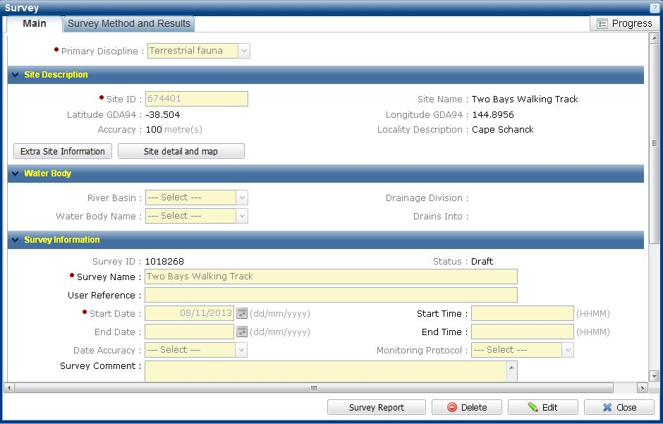

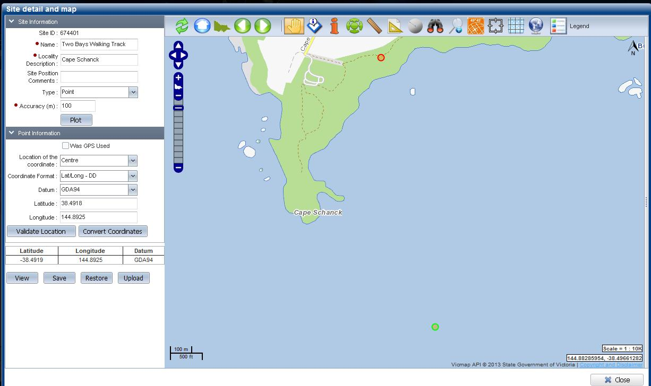

NOTES:

Unless the survey has a Status of Draft, you will need to enter a reason for why the site is being edited which will be forwarded to the VBA Administrator for assessment and approval prior to the system accepting the change(s).

If there is more than one survey associated with the site you want to move the VBA will prevent you from saving any edits and will tell you to contact the VBA Administrator. In this instance, please email [vba.help@delwp.vic.gov.au](mailto:vba.help@delwp.vic.gov.au) with the Survey ID(s), required change(s) and a reason for the requested edit. In cases where it is not appropriate to edit an existing site, a new site can be created and linked to the existing survey by clicking Edit on the Survey screen and clicking Create New Site from the Site Description section (see below). Complete the required fields, click Save, and Close.

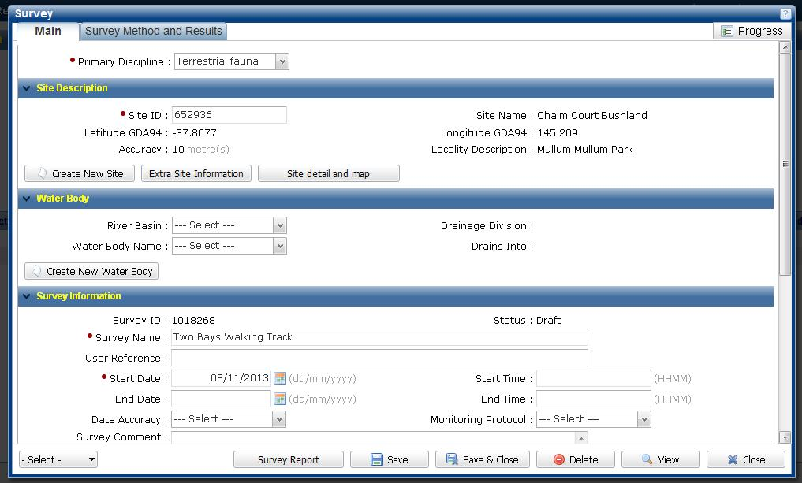

|  |  |
| --- | --- |
| © The State of Victoria Department of Environment, Land, Water and Planning 2017  LogoThis work is licensed under a Creative Commons Attribution 4.0 International licence. You are free to re-use the work under that licence, on the condition that you credit the State of Victoria as author. The licence does not apply to any images, photographs or branding, including the Victorian Coat of Arms, the Victorian Government logo and the Department of Environment, Land, Water and Planning (DELWP) logo. To view a copy of this licence, visit http://creativecommons.org/licenses/by/4.0/  Disclaimer  This publication may be of assistance to you but the State of Victoria and its employees do not guarantee that the publication is without flaw of any kind or is wholly appropriate for your particular purposes and therefore disclaims all liability for any error, loss or other consequence which may arise from you relying on any information in this publication. | Accessibility  If you would like to receive this publication in an alternative format, please telephone the DELWP Customer Service Centre on 136186, email [customer.service@delwp.vic.gov.au](mailto:customer.service@delwp.vic.gov.au) or via the National Relay Service on 133 677 [www.relayservice.com.au](http://www.relayservice.com.au). This document is also available on the internet at [www.delwp.vic.gov.au](http://www.delwp.vic.gov.au). |