Introduction
Biodiversity Response Planning (BRP) is a long-term area-based planning approach to biodiversity conservation in Victoria. It is designed to strengthen alignment, engagement and participation between government, Traditional Owners, non-government agencies and the community.
DELWP Regional staff have been working with stakeholders on actions to conserve biodiversity in specific landscapes, informed by the best available science and local knowledge.
These Fact Sheets capture a point in time, reflecting data and knowledge available in 2020. They provide information for many (but not all) landscapes across Victoria, containing general information on the key values and threats in each area, as well as the priority cost-effective actions that provide the best protection of biodiversity. Fact Sheets are intended to provide useful biodiversity information for the community, non-government and government organisations during project planning and development.
Further information and the full list of Fact Sheets is available on the Department’s Environment website.

Landscape description
Dundonnell focus landscape is 97,826ha in size with 19% native vegetation cover remaining. Public land makes up 1% of the area.
Current ecological modelling shows the Dundonnell focus landscape occurs within the Victorian Volcanic Plain Bioregion and is bounded by the Dundas Tablelands Bioregion along its north-eastern extent. The landscape has around 6,600ha of threatened Ecological Vegetation Classes (EVC) with only small fragmented patches of endangered Plains Grassland, Plains Grassy Woodland, Plains Grassy Wetland, and Creekline Grassy Woodland EVCs remaining. The Victorian Biodiversity Atlas has records of 20 federally protected species, 45 state protected species and 78 rare or threatened species on the Victorian Advisory List occurring within the landscape.
The Eastern Maar Aboriginal Corporation are Traditional Custodians of this focus landscape, with current stakeholders including Birdlife Australia, Glenelg Hopkins Catchment Management Authority, Grampians Wimmera Mallee Water, Greening Australia, Moyne Shire Council, Nature Glenelg Trust, Parks Victoria, Regional Roads Victoria, Trust for Nature, and Wannon Water.

Cultural importance
In Meerreengeeye Ngakeepoorryeeyt¹, the Dundonnell focus landscape largely occurs in Hill Country which acknowledges its historic importance for trade routes and seasonal food for the Eastern Maar people. To the south, Dundonnell is bounded by dry hinterland forest which would have supported the the Eastern Maar with abundant resources, and the Lava Flow Country, known for its abundant resources and important meeting places for First Nations people¹.

Stakeholder interest
There are numerous valuable ecological assets present in this focus landscape, including those identified by Traditional Owners, partners and community.

0BEcological Values identified by Traditional Owners, partners and community within this focus landscape
Mount Fyans Wildlife Reserve | Darlington Common Flora Reserve
Lake Terrinallum Wildlife Reserve | Lake Barnie Bolac Wildlife Reserve
Lake Eyang Wildlife Reserve | Salt Creek
Mount Emu Creek | Pink Lake Wildlife Reserve
Salt Lake Streatham Wildlife Reserve | Natural Temperate Grasslands including on high conservation roadsides
Woorndoo Grasslands Reserve | Nerrin Nerrin area
Tiverton Sanctuary | Brolga flocking sites
Notable populations of rare orchids including Basalt Rustyhood, Leprechaun Greenhood Orchid and Dense Greenhood Orchid

Habitat Distribution Models identify 35 species with more than 5% of their modelled Victorian range in this focus landscape | Threatened terrestrial species within this focus landscape requiring specific actions other than those identified in Strategic Management Prospects (SMP)
34 plants, notably:  - Basalt Rustyhood (Endangered)  - Leprechaun Greenhood (Endangered)  - Dense Greenhood (Endangered) | Corangamite Water Skink
1 reptile
- Corangamite Water Skink (Critically endangered)

Strategic Management Prospects
Strategic Management Prospects (SMP) models biodiversity values such as species habitat distribution, landscape-scale threats and highlights the most cost-effectiveness action for specific locations. For a further in depth look into SMP for this landscape please refer to NatureKit.

Which landscape-scale actions are most cost-effective in this landscape?
The coloured areas in the map below indicate where the identified landscape-scale actions are most cost-effective and will maximise biodiversity benefit across Victoria for multiple species.

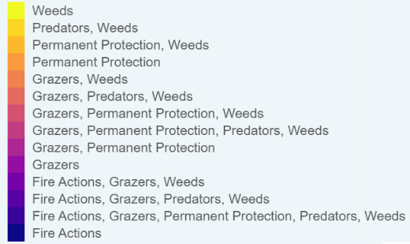
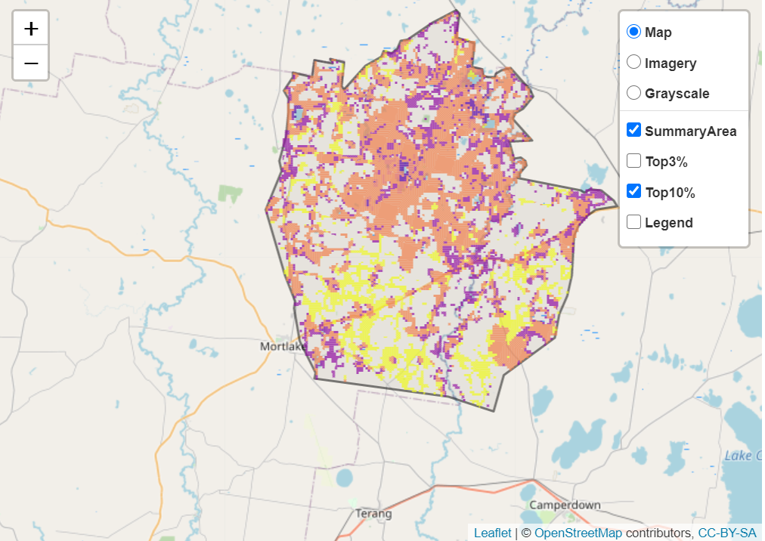
The main SMP priority actions within this focus landscape which rank among the top 10% for cost-effectiveness are listed on the right:
Control Rabbits 48,708ha
Control Weeds 39,576ha
Control Foxes 1,850ha
Ecological Burning 567ha
Revegetation 283ha

Within this landscape, rabbit control, weed control and permanent protection (10ha) were also identified among the top 3% for cost-effectiveness.

Additional threats and considerations
Threats and considerations (in addition to those modelled in SMP) identified by Traditional Owners, partners and community groups during the BRP process for this focus landscape were:
Threats | Ecological processes and values requiring further considerations
Climate change | Wetland hydrology
Habitat clearing | Groundwater-dependent ecosystems
Altered hydrology | Aquatic/riparian species and catchment influences
Stock access to riparian and wetland areas | Indicator species and ecosystem engineers

References
1. Eastern Maar Aboriginal Corporation, 2015. Meerreengeeye Ngakeepoorryeeyt, Eastern Maar Country Plan.

