What is NVIM?
NVIM Quick Reference Guide
Native vegetation permitted clearing regulations
– mapped and modelled information

NVIM stands for Native Vegetation Information Management and is a system to access Victoria’s native vegetation information.

Accessing NVIM
NVIM is a web-based system available to the public –http://nvim.depi.vic.gov.au. The home page provides information about the system and tools available.

About mapped and modelled template
Under Victoria’s native vegetation permitted clearing regulations, native vegetation condition scores and strategic biodiversity scores are required for a proposed clearing or offset sites. The mapped and modelled template has been developed to assist users to determine these scores.
- Select the map template
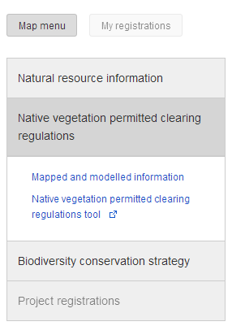
- From the home page, under NVIM map select Proceed to map.
- On information panel, select Native vegetation permitted clearing regulations.
- Select the Mapped and modelled information template.
- Search for property
- Enter a full property address or a Standard Parcel Identifier (SPI) in the Search bar (note: SPI is separated using “\”).
- Address will be displayed in information panel on the left and marked on map (Note: several options may appear – choose one and the map zooms to display the parcel).
- For more advanced searching please see the Quick reference guide – General.
- Mark out area of interest
- Select a drawing tool from the Select draw tool drop list a the top of the map. Note only the polygon and circle will provide a calculable result.
- Drawing tools available in NVIM include:
  - Draw a polygon to mark up an area
  - Draw a line to indicate a fence line
  - Place a point to mark out a feature
  - Mark a circle to outline a 15m radius circle around a point or a scattered tree.
- All areas marked up will be numbered and should be clearly identified.
- For more information on drawing tools please see the Quick reference guide – General.
- Calculating scores
- The information panel contains the calculable scores:
  - Scores can be calculated for native vegetation condition and strategic biodiversity score.
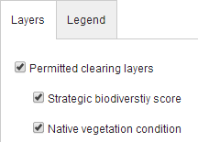
  - To calculate the scores select one or both layers from the Layers menu.
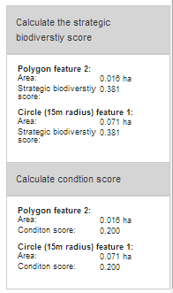
- Viewing the scores
- When layer is selected and native vegetation has been marked select to Calculate strategic biodiversity score or to Calculate condition score in the information panel.
- Scores are returned for each polygon or circle marked on the map.
- Scores are recalculated when drawings are edited or moved.
For more information on editing and moving your drawings please see the Quick reference guide – General.

Common errors
- Errors have been built into NVIM to return common error messages if:
  - the area drawn is too large
  - drawing is outside Victoria or over a water body the calculations will return an exception value (-99)
- A result cannot be calculated for a point or a line.

Points to Note
- No information can be saved. To save your work we suggest doing a screen print or printing the page to a PDF.
- NVIM is not supported by Internet Explorer 8 or below. Please use Internet Explorer 9 or later, Chrome or Firefox.

Other reference guides for NVIM
Other reference guides to use in conjunction with this one include for specific templates include:
- General - provides more information on searching, selecting templates and layers, using the drawing, editing and deleting tools.
- Native vegetation for permitted clearing regulations tool.
- Estimate your obligations under the Biodiversity Conservation Strategy
- Biodiversity in the Victorian planning provisions

More Information
Further information regarding the NVIM system is available on the DEPI website www.depi.vic.gov.au/nvim

