|  |
| --- |
| Information for applicants |
| Yellingbo Conservation Area Community Reference Group |

|  |  |
| --- | --- |
| Roles: | Group member, Chairperson |
| Organisation: | Yellingbo Conservation Area Community Reference Group |
| Reports to: | Regional Director, Port Phillip Region Department of Environment, Land, Water and Planning |
| Area of Interest: | Yarra Valley and southern Dandenong Ranges (as per attached map) |

# Information and forms to be provided by applicants

## Curriculum Vitae

Applicants must provide a full and detailed CV, which should be current, typed and dated. Your CV must include the following information:

* A brief statement of your current employment and any previous roles that you think will benefit the community reference group;
* Any relevant qualifications;
* your current memberships of any other Commonwealth and Victorian government bodies and non-government bodies (i.e. board memberships, committees, council memberships, community groups).

## Expression of Interest

As well as providing your CV, applicants are required to complete the Application form on [www.delwp.vic.gov.au/YCACRG](http://www.delwp.vic.gov.au/YCACRG) The Application form allows you to outline your skills relating to the Key Selection Criteria described in the Position Description.

## Declaration of Private Interests, Australian Securities and Investments Commission (ASIC) & Australian Financial Security Authority (AFSA) checks

Information for declaration of private interests, ASIC & AFSA checks is completed as part of the application.

A declaration of private interests ensures that prior to appointing an applicant to the Community Reference Group, the Regional Director is aware if the candidate has any pecuniary or other interest that could conflict with the proper performance of their duties as a Community Reference Group member or could reasonably give rise to an expectation of a conflict of interest. Declaring a conflict of interest may not necessarily make you ineligible for appointment.

If you are appointed to the Community Reference Group, you will be required to submit your declaration of private interests to the chairperson of the Community Reference Group to manage potential conflicts of interest. You will be required to update this form annually or if your circumstances change.

## Probity Checks

Department of Premier and Cabinet’s *[Appointment and Remuneration Guidelines for Victorian Government Boards Statutory Bodies and Advisory Committees](http://www.dpc.vic.gov.au/index.php/policies/governance/appointment-and-remuneration-guidelines)* require that all applicants undergo the following probity checks to the satisfaction of the Regional Director, prior to their appointment to the Community Reference Group:

* a National Criminal Record Check; and
* Australian Securities & Investment Commission (ASIC) & Australian Financial Security Authority (AFSA) checks.

DELWP utilises the services of Mercury Search and Selection Pty Ltd (trading as fit2work) for these probity checks.

## National Criminal Record Check/Consent Form

All board appointees are required to undertake a national police check. DELWP will contact you at the appropriate time to undertake the police check.

## ASIC and AFSA checks

DELWP uses the personal information you provide to undertake ASIC and AFSA checks. This involves comparing your name, current address and date of birth against the names of people listed in AFSA’s ‘National Personal Insolvency Index’ and ASIC’s registers (e.g. ASIC’s ‘Banned & disqualified persons’ register). Due to the limitations of the information contained in these databases, your check may produce a potential match with someone listed in those databases. If this is the case, you will be contacted for clarification. DELWP may request that you complete a statutory declaration confirming that you are not the person listed in those databases.

## Number of vacancies

The Regional Director will appoint 12 members. The 12 members will include the chairperson and deputy Chairperson and an elected representative from both the Yarra Ranges Council and Cardinia Shire Council.

# Anticipated appointment process time

|  |  |
| --- | --- |
| Expression of Interest open on DELWP website | 14/5/2019 |
| Expression of Interest close | 11/06/2019 |
| Applications reviewed, and short list approved | 12/06/2019 |
| Candidates interviewed | Week commencing 24/06/2019 |
| Successful candidates notified | Week commencing 22/07/2019 |
| Letter of appointment sent to successful candidates | Week commencing 22/07/2019 |
| Anticipated first meeting of the CRG | Early August 2019 |

## Relevant policy and approvals

Government expectations regarding recruitment to statutory positions are set out in the [*Appointment and Remuneration Guidelines 2018*](http://www.dpc.vic.gov.au/index.php/policies/governance/appointment-and-remuneration-guidelines)  Under the criteria established in these guidelines the Community Reference Group is a Group C Band 3 organisation. The Community Reference Group can be formed as a “Departmental Advisory Committee” (departmental advisory committee means a non-statutory advisory committee established by the Secretary by terms of reference).

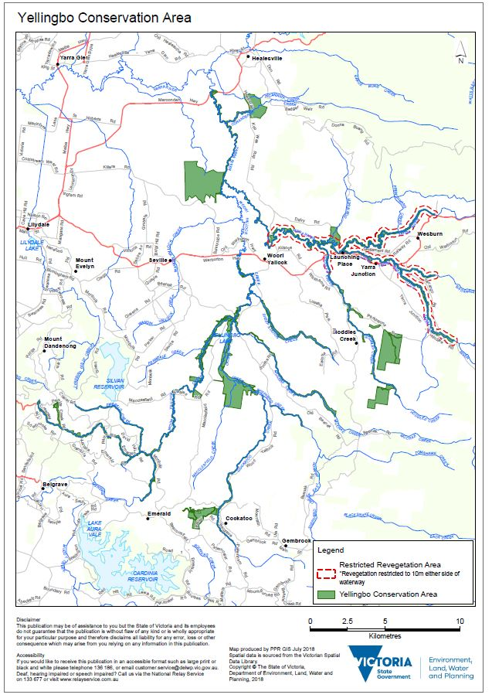

|  |  |
| --- | --- |
| © The State of Victoria Department of Environment, Land, Water and Planning 2019  LogoThis work is licensed under a Creative Commons Attribution 4.0 International licence. You are free to re-use the work under that licence, on the condition that you credit the State of Victoria as author. The licence does not apply to any images, photographs or branding, including the Victorian Coat of Arms, the Victorian Government logo and the Department of Environment, Land, Water and Planning (DELWP) logo. To view a copy of this licence, visit http://creativecommons.org/licenses/by/4.0/  Disclaimer  This publication may be of assistance to you but the State of Victoria and its employees do not guarantee that the publication is without flaw of any kind or is wholly appropriate for your particular purposes and therefore disclaims all liability for any error, loss or other consequence which may arise from you relying on any information in this publication. | Accessibility  If you would like to receive this publication in an alternative format, please telephone the DELWP Customer Service Centre on 136186, email [customer.service@delwp.vic.gov.au](mailto:customer.service@delwp.vic.gov.au), or via the National Relay Service on 133 677 [www.relayservice.com.au](http://www.relayservice.com.au). This document is also available on the internet at [www.delwp.vic.gov.au](http://www.delwp.vic.gov.au). |