Biodiversity 2037
Implementation Framework
  - February 2018

Acknowledgements
The Victorian Government proudly acknowledges Victoria’s Aboriginal community and their rich culture and pays respect to their Elders past and present.

We acknowledge Aboriginal people as Australia’s first people’s and communities to Victorian life and how this enriches us. We embrace the spirit of reconciliation, working towards the equality of outcomes and ensuring an equal voice.
Author
Department of Environment, Land, Water and Planning
Photo credit
Broderick Street
© The State of Victoria Department of Environment, Land, Water and Planning 2018
This work is licensed under a Creative Commons Attribution 4.0 International licence. You are free to re-use the work under that licence, on the condition that you credit the State of Victoria as author. The licence does not apply to any images, photographs or branding, including the Victorian Coat of Arms, the Victorian Government logo and the Department of Environment, Land, Water and Planning (DELWP) logo. To view a copy of this licence, visit http://creativecommons.org/licenses/by/4.0/
ISBN 978-1-76047-881-0 (pdf/online)
Disclaimer
This publication may be of assistance to you but the State of Victoria and its employees do not guarantee that the publication is without flaw of any kind or is wholly appropriate for your particular purposes and therefore disclaims all liability for any error, loss or other consequence which may arise from you relying on any information in this publication.
Accessibility
If you would like to receive this publication in an alternative format, please telephone the DELWP Customer Service Centre on 136186, email customer.service@delwp.vic.gov.au, or via the National Relay Service on 133 677 www.relayservice.com.au. This document is also available on the internet at www.delwp.vic.gov.au.

Biodiversity 2037 Implementation Framework

Biodiversity 2037
Protecting Victoria’s Environment – Biodiversity 2037 (Biodiversity 2037) is the Victorian Government’s ambitious plan to stop the decline of our biodiversity and achieve overall biodiversity improvement over the next 20 years.
It makes the case for increase effort and defines a modern approach to managing our biodiversity.
It is underpinned by ground-breaking science that for the first time allows us to get upstream of the problem of Victoria’s biodiversity decline.

Turning the plan into action
This Implementation Framework is a comprehensive action plan that will deliver on the Victorian Government’s ambitious environmental agenda to prioritise the care and protection of our natural environment.
The framework highlights key Victorian Government actions that will help implement the priorities of the Biodiversity 2037 over the next four years.
The Framework is arranged by 20 priorities of Biodiversity 2037 and contains 89 enabling actions that will make biodiversity protection in Victoria more efficient and effective. For each action there is a timeframe, status, related Biodiversity 2037 goal, lead delivery organisation and partner organisations.

Reporting on progress
The Victorian Government is committed to keeping the community informed about work to implement the Biodiversity Plan.
The Department of Environment, Land, Water and Planning will undertake annual monitoring and reporting in consultation with other relevant departments and agencies.
Annual reporting will include updates to the status of actions and their implementation arrangements. New actions that deliver on Biodiversity 2037 priorities may be added as part of the annual update, as approved by the Minister for Energy, Environment and Climate Change or other relevant ministers.
The Biodiversity 2037 Monitoring, Evaluation and Reporting Framework will track progress against the goals and targets of Biodiversity 2037.

Stay up to date
Check www.environment.vic.gov.au to stay up to date with news about Biodiversity 2037 and progress on the Implementation Framework.

Navigating this Framework
This Implementation Framework identifies the key implementation actions for each of the 20 priorities of Biodiversity 2037.

Example layout:
Priority 4 – Increase opportunities for all Victorians to have daily connections with nature
The implementation action description and reference number
The goal(s) of Biodiversity 2037 relevant to the implementation action supports
The implementation theme that the action supports
The lead agencies responsible for delivering the implementation action
The partner agencies or groups that will support the implementation action
The timeframe for the delivery of the action.
- Short (1-2 years),
- Medium (2-4 years), or
- Long (4+ years).
The indication of implementation progress.
- Planned,
- Commenced, or
- Completed,
4.4 – Implement the Victorian Memorandum for Health and Nature through projects that enable more Victorians to connect with and be active in the natural environment
Goal | Victorians value nature
Theme | Nature is Good Medicine
Lead | Parks Victoria, Department of Health and Human Services, Department of Environment, Land Water and Planning
Partners | Royal Botanic Gardens Victoria, Local Government
Timeframe | Medium (2-4 years)
Status | Commenced

The relevant Protecting Victoria’s Environment – Biodiversity 2037 priority.
Table of Contents
Biodiversity 2037 Implementation Framework 1
Biodiversity 2037 1
Turning the plan into action 1
Reporting on progress 1
Stay up to date 1
Navigating this Framework 2
Example layout: 2
Implementation Actions 4
Priority 1 – Deliver cost-effective results utilising decision-support tools in biodiversity planning processes to help achieve and measure against the targets 4
Priority 2 – Increase the collection of targeted data for evidence-based decision making and make all data more accessible. 7
Priority 3 – Raise the awareness of all Victorians about the importance of the state’s natural environment 10
Priority 4 – Increase opportunities for all Victorians to have daily connections with nature 12
Priority 5 – Increase opportunities for all Victorians to act to protect biodiversity 16
Priority 6 – Embed consideration of natural capital into decision making across the whole of government, and support industries to do the same 19
Priority 7 – Help to create more liveable and climate-adapted communities 21
Priority 8 – Better care for and showcase Victoria’s environmental assets as world class natural and cultural tourism attractions 24
Priority 9 – Establish sustained funding for biodiversity 28
Priority 10 – Publish an Investment Prospectus to communicate to prospective investment partners the funded, unfunded and partially-funded projects that are needed to meet the targets 29
Priority 11 – Increase incentives and explore market opportunities for private landholders to conserve biodiversity 30
Priority 12 – Adopt a collaborative biodiversity response planning approach to drive accountability and measurable improvement 32
Priority 13 – Support and enable community groups, Traditional Owners, non-government organisations and sections of government to participate in biodiversity response planning 34
Priority 14 – Engage with Traditional Owners to include Aboriginal values and traditional ecological knowledge in biodiversity planning and management 35
Priority 15 – Support Aboriginal access to biodiversity for economic development 37
Priority 16 – Build capacity to increase Aboriginal participation in biodiversity management 38
Priority 17 – Deliver excellence in management of all public land and waters 39
Priority 18 – Maintain and enhance a world-class system of protected areas 43
Priority 19 – Adopt a whole-of-government approach to implementing this Plan 44
Priority 20 – Establish a transparent evaluation process to report on progress towards delivering the Plan 47

Implementation Actions

Priority 1 – Deliver cost-effective results utilising decision-support tools in biodiversity planning processes to help achieve and measure against the targets

1.1 – Launch Strategic Management Prospects to guide biodiversity decision-making. The tool will be supported by training materials and continuously improved with the incorporation of new data and user feedback
Goal | Victoria’s natural environment is healthy
Theme | Nature-tech
Lead | Department of Environment, Land, Water and Planning
Partners | Parks Victoria, Museums Victoria, Royal Botanic Gardens Victoria, Phillip Island Nature Parks, Zoos Victoria, Trust for Nature, Catchment Management Authorities, Local Government, Interested Victorian Traditional Owner Groups, NGO Sector
Timeframe | Short (1-2 years)
Status | Commenced

1.2 – Assist community groups to upload historic biodiversity survey data into the Victorian databases such as the Victorian Biodiversity Atlas, to help improve decision-making tools such as Strategic Management Prospects.
Goal | Victoria's natural environment is healthy
Theme | Nature-tech
Lead | Department of Environment, Land, Water and Planning
Partners | All interested natural resource management partners including Interested Victorian Traditional Owner Groups
Timeframe | Medium (2-4 years)
Status | Planned

1.3 – Develop a cost-benefit framework to identify the most realistic conservation options for our most endangered species, in the context of threats such as climate change
Goal | Victoria's natural environment is healthy
Theme | Mobilising our Ecosystem Engineers
Lead | Department of Environment, Land, Water and Planning
Partners | Zoos Victoria, Trust for Nature, Royal Botanic Gardens Victoria, Museums Victoria and Parks Victoria
Timeframe | Long (4+ years)
Status | Planned

1.4 – Review the availability of existing digital engagement tools that help Victorians connect with or act to protect nature and identify opportunities to enhance or integrate these systems
Goal | Victorians value nature
Theme | Nature-tech
Lead | Department of Environment, Land, Water and Planning
Partners | Victorian Government Departments and agencies, Department of Education and Training, Interested Victorian Traditional Owner Groups and the NGO Sector
Timeframe | Short (1-2 years)
Status | Planned

1.5 – Establish a multi-agency natural resource management climate adaptation network that links research, planning and action across partner organisations
Goal | Victoria's natural environment is healthy
Theme | Climate-ready Ecosystems
Lead | Catchment Management Authorities
Partners | Victorian Government Departments and agencies, Academic Research Sector, Victorian Traditional Owners and the NGO Sector
Timeframe | Medium (2-4 years)
Status | Commenced

1.6 – Use the best available climate science to better understand the likely impacts of climate change on key species and ecosystems, and trial management actions that will maximise their adaptive capacity
Goal | Victoria's natural environment is healthy
Theme | Climate-ready Ecosystems
Lead | Department of Environment, Land, Water and Planning
Partners | Zoos Victoria, Parks Victoria, Royal Botanic Gardens Victoria, Catchment Management Authorities, Phillip Island Nature Parks, Museums Victoria, Academic Research Sector, Interested Victorian Traditional Owners
Timeframe | Long (4+ years)
Status | Commenced

1.7 – Implement adaptive management and planning for key Victorian environmental assets through:
The final Port Phillip Bay Environmental Management Plan
Conservation Action Plans for the Parks Victoria estate
Conservation Planning for Trust for Nature priority areas
Goal | Victoria's natural environment is healthy
Theme | Protecting Biodiversity Together
Lead | Parks Victoria, Trust for Nature, Catchment Management Authorities, Department of Environment, Land, Water and Planning
Partners | Department of Economic Development, Jobs, Transport and Resources and other interested natural resource management partners including Victorian Traditional Owners
Timeframe | Long (4+ years)
Status | Commenced

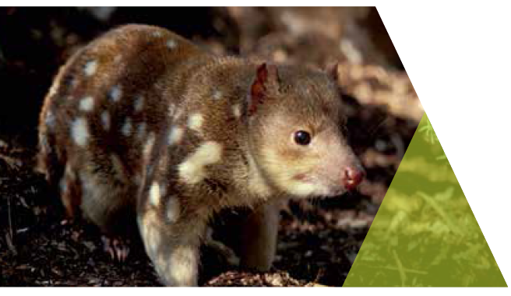

Priority 2 – Increase the collection of targeted data for evidence-based decision making and make all data more accessible.

2.1 – Fill critical biodiversity knowledge gaps by funding and coordinating research and long-term monitoring programs
Goal | Victoria's natural environment is healthy
Theme | Nature-tech
Lead | Department of Environment, Land, Water and Planning, Parks Victoria, Zoos Victoria, Royal Botanic Gardens Victoria, Museums Victoria
Partners | Zoos Victoria, Office of the Commissioner for Environmental Sustainability, Academic Research Sector, Department of Economic Development, Jobs, Transport and Resources
Timeframe | Long (4+ years)
Status | Commenced

2.2 – Conduct targeted data collection and monitoring of threatened species interventions

Goal | Victoria's natural environment is healthy
Theme | Nature-tech
Lead | Zoos, Victoria, Department of Environment, Land, Water and Planning, Parks Victoria, Royal Botanic Gardens Victoria, Museum Victoria
Partners | Department of Environment, Land, Water and Planning, Parks Victoria, Zoos Victoria, Royal Botanic Gardens Victoria. Academic Research Sector, Interested Victorian Traditional Owner Groups
Timeframe | Long (4+ years)
Status | Commenced

2.3 – Develop VBA GO, a mobile-enabled Victorian Biodiversity Atlas to allow rapid, real-time entry of species records on a mobile device and provide for more engaged citizen science
Goal | Victoria's natural environment is healthy, and  Victorians value nature
Theme | Nature-tech
Lead | Department of Environment, Land, Water and Planning
Partners | All interested natural resource management partners
Timeframe | Short (1 year with continuous improvement)
Status | Commenced

2.4 – Develop a new Marine Biodiversity Policy and establish a Marine and Coastal Knowledge Framework to guide the collection, management and use of marine biodiversity data to maximise the effectiveness of targeted actions to manage marine biodiversity
Goal | Victoria's natural environment is healthy
Theme | Protecting Biodiversity Together
Lead | Department of Environment, Land, Water and Planning, Department of Economic Development, Jobs, Transport and Resources
Partners | Parks Victoria, Zoos Victoria, Office of the Commissioner for Environmental Sustainability, Museums Victoria
Timeframe | Short (1-2 years)
Status | Planned

2.5 – Launch a new NatureKit web mapping and reporting tool to make Victorian biodiversity data and information products more accessible to all Victorians
Goal | Victoria's natural environment is healthy, and  Victorians value nature
Theme | Nature-tech
Lead | Department of Environment, Land, Water and Planning
Partners | NA
Timeframe | Short (1 year with continuous improvement)
Status | Completed
Update | NatureKit was launched on 30 June 2017 as a new platform for supporting  biodiversity decisions.  This map-based website provides access to species records, vegetation  mapping, strategic biodiversity values, strategic management prospects, and  marine bathymetry and habitat. NatureKit has been accessed by over 7,000  users since its release.  Find out more about NatureKit here: http://naturekit.biodiversity.vic.gov.au

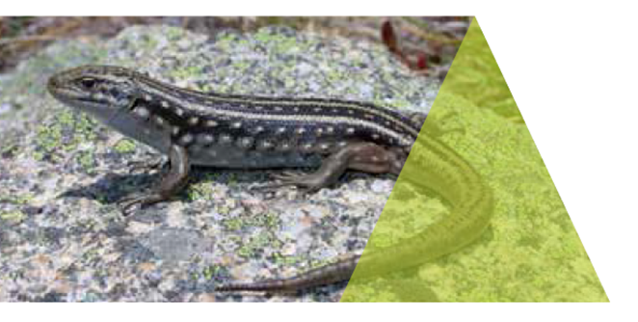

Priority 3 – Raise the awareness of all Victorians about the importance of the state’s natural environment

3.1 – Develop and publish a theoretical model that describes the pathway to action, from Victorians connecting with nature, to valuing it and acting to improve biodiversity
Goal | Victoria's natural environment is healthy
Theme | VicEnvironments
Lead | Department of Environment, Land, Water and Planning
Partners | Royal Botanic Gardens Victoria, Zoos Victoria, Parks Victoria, Museums Victoria, Interested Victorian Traditional Owner Groups
Timeframe | Short (1 year with continuous improvement)
Status | Commenced

3.2 – Establish a brand that identifies current and future projects that contribute to Biodiversity 2037 to help promote biodiversity objectives
Goal | Victoria's natural environment is healthy
Theme | VicEnvironments
Lead | Department of Environment, Land, Water and Planning
Partners | All interested natural resource management partners including Victorian Traditional Owners
Timeframe | Short (1 year with continuous improvement)
Status | Planned

3.3 – Engage Victorians with key biodiversity objectives and actions, by showcasing Victoria’s rich biodiversity through ongoing public, science and education programs
Goal | Victoria's natural environment is healthy
Theme | VicEnvironments
Lead | Parks Victoria, Museums Victoria, Royal Botanic Gardens Victoria, Phillip Island Nature Parks, Zoos Victoria, Trust for Nature, Catchment Management Authorities, Department of Environment, Land, Water and Planning
Partners | NGO Sector, Interested Victorian Traditional Owner Groups, Local Government
Timeframe | Long (4+ years)
Status | Planned

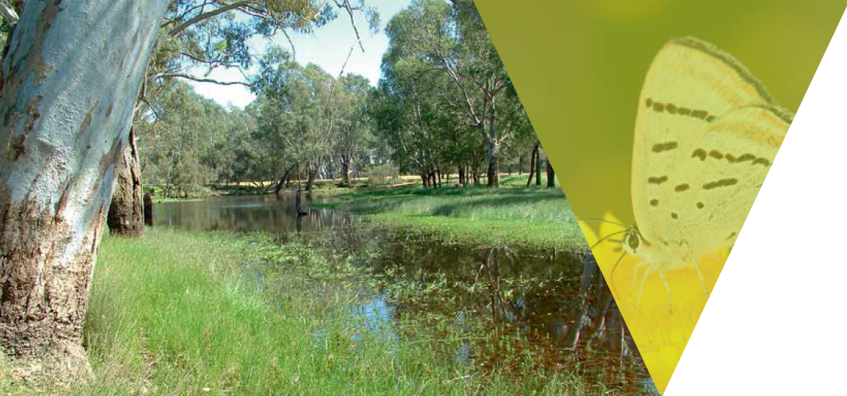

Priority 4 – Increase opportunities for all Victorians to have daily connections with nature

4.1 – Establish a framework for researching how Victorians value nature. A first step will be working with peak bodies and community groups to establish this baseline information about how Victorians connect to nature and act to protect it
Goal | Victoria's natural environment is healthy
Theme | VicEnvironments
Lead | Department of Environment, Land, Water and Planning
Partners | Parks Victoria, Museums Victoria, Royal Botanic Gardens Victoria, Phillip Island Nature Parks, Zoos Victoria, Trust for Nature, Catchment Management Authorities, Local Government, NGO Sector, Academic Sector, Interested Victorian Traditional Owner Groups
Timeframe | Medium (2-4 years)
Status | Planned

4.2 – Support Victorians who experience barriers to connecting with nature to take their first steps into nature through skills-based events in parks such as learn to camp programs
Goal | Victorians value nature
Theme | Steps into nature
Lead | Parks Victoria, Department of Health and Human Services, Department of Environment, Land Water and Planning
Partners | Interested Victorian Traditional Owner Groups
Timeframe | Medium (2-4 years)
Status | Planned

4.3 – Support the Nature Play, Bush Kinders and Outdoor Learning to enable kids to connect with nature
Goal | Victorians value nature
Theme | Steps into nature
Lead | Department of Health and Human Services
Partners | Department of Education and Training, NGO Sector, Parks Victoria, Royal Botanic Gardens Victoria, Museums Victoria, Zoos Victoria, Department of Environment, Land, Water and Planning
Timeframe | Short (1-2 years)
Status | Commenced

4.4 – Implement the Victorian Memorandum for Health and Nature through projects that enable more Victorians to connect with and be active in the natural environment
Goal | Victorians value nature
Theme | Nature is Good Medicine
Lead | Parks Victoria, Department of Health and Human Services, Department of Environment, Land Water and Planning
Partners | Royal Botanic Gardens Victoria, Local Government
Timeframe | Medium (2-4 years)
Status | Commenced

4.5 – Activate community health in nature programs, such as Park Prescriptions, Forest Bathing, Bush Therapy and Therapeutic Horticulture
Goal | Victorians value nature
Theme | Nature is Good Medicine
Lead | Parks Victoria, Department of Health and Human Services, Department of Environment, Land Water and Planning
Partners | Local Government
Timeframe | Medium (2-4 years)
Status | Planned

4.6 – Grow the range of YouthNatureConnect programs that help teens develop outdoor skills, get fit, connect with their peers, build emotional resilience and enjoy nature
Goal | Victorians value nature
Theme | Nature is Good Medicine
Lead | Parks Victoria
Partners | Department of Education and Training, NGO Sector, Interested Victorian Traditional Owner Groups
Timeframe | Medium (2-4 years)
Status | Planned

4.7 – Develop Spring into Nature events to promote the benefits of getting into nature and protecting it for the health and wellbeing of current and future generations
Goal | Victorians value nature
Theme | Nature is Good Medicine
Lead | Trust for Nature
Partners | Department of Environment, Land, Water and Planning, Parks Victoria
Timeframe | Medium (2-4 years)
Status | Planned

4.8 – Improve monitoring and reporting of Victoria’s environment, health and liveability outcomes to ensure Victorians are well informed about the state of their environment
Goal | Victorians value nature
Theme | Nature is Good Medicine
Lead | Department of Environment, Land, Water and Planning
Partners | Environment Protection Authority Victoria, Victorian Government Departments and agencies, Office of the Commissioner for Environmental Sustainability
Timeframe | Medium (2-4 years)
Status | Commenced

4.9 – Through the Recreational Values Program, provide better information to the community about the opportunities to enjoy and limitations on recreational use of waterways
Goal | Victorians value nature
Theme | Steps into nature
Lead | Department of Environment, Land, Water and Planning
Partners | Rural Water Corporations, Catchment Management Authorities and the Victorian Environmental Water Holder
Timeframe | Medium (2-4 years)
Status | Commenced

4.10 – Develop programs, in partnership with Traditional Owner and Aboriginal Groups, to enable children, youth and elders to reconnect to Country for cultural, spiritual, and health and wellbeing benefits
Goal | Victorians value nature
Theme | Caring for Biodiversity on Country
Lead | Parks Victoria
Partners | Interested Victorian Traditional Owner Groups
Timeframe | Medium (2-4 years)
Status | Planned

Priority 5 – Increase opportunities for all Victorians to act to protect biodiversity

5.1 – Develop new community conservation campaigns at Phillip Island Nature Parks that encourage Victorians to protect wildlife and their habitat in both marine and terrestrial environments
Goal | Victoria's natural environment is healthy
Theme | Protecting Biodiversity Together
Lead | Phillip Island Nature Parks, Local Government
Partners | NA
Timeframe | Short (1-2 years)
Status | Commenced

5.2 – Raise awareness across the Victorian community about protecting wildlife, by continuing to involve Victorians in successful community conservation campaigns
Goal | Victoria's natural environment is healthy
Theme | Protecting Biodiversity Together
Lead | Zoos Victoria
Partners | Phillip Island Nature Parks, Local Government, Museums Victoria
Timeframe | Long (ongoing)
Status | Commenced

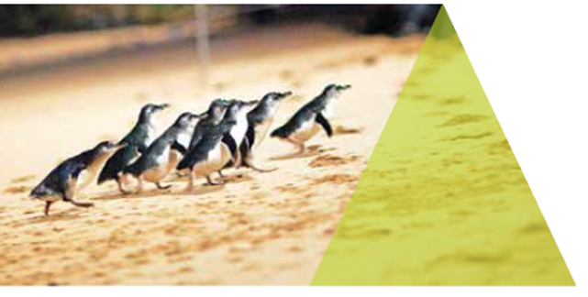

5.3 – Support more Victorians to be citizen scientists through programs that engage the community on environmental issues
Goal | Victoria's natural environment is healthy, and Victorians value nature
Theme | VicEnvironments
Lead | Department of Environment, Land, Water and Planning
Partners | Phillip Island Nature Parks, Local Government, Royal Botanic Gardens Victoria, Museums Victoria, Parks Victoria, NGO Sector
Timeframe | Short (1-2 years)
Status | Commenced

5.4 – Work with Victorian education providers to strengthen existing programs within the curriculum to increase the availability of nature-based learning and outdoor learning opportunities. This will be supported by initiatives such as Resource Smart Schools
Goal | Victorians value nature
Theme | Steps into nature
Lead | Sustainability Victoria, Department of Education and Training
Partners | Department of Environment, Land, Water and Planning, Trust for Nature
Timeframe | Medium (2-4 years)
Status | Planned

5.5 – Support Victoria's conservation volunteer groups such as Landcare, Coastcare and Friends Groups to continue building environmental and community resilience
Goal | Victoria's natural environment is healthy, and Victorians value nature
Theme | Protecting Biodiversity Together
Lead | Department of Environment, Land, Water and Planning
Partners | NGO Sector, Parks Victoria, Catchment Management Authorities, Trust for Nature
Timeframe | Short (1 year)
Status | Commenced

5.6 – Significantly grow and diversify volunteering opportunities in parks through programs such as Friends Groups, Campground Host and Volunteer Track Rangers both in and around Melbourne as well as Regional Victoria
Goal | Victoria's natural environment is healthy, and Victorians value nature
Theme | Steps into Nature
Lead | Parks Victoria
Partners | Department of Environment, Land, Water and Planning, NGO Sector
Timeframe | Long (Ongoing)
Status | Commenced

Priority 6 – Embed consideration of natural capital into decision making across the whole of government, and support industries to do the same

6.1 – Utilise the UN System of Environmental Economic Accounting (UN SEEA) to support statutory reporting in the environment portfolio and develop capabilities to inform policy
Goal | Victoria's natural environment is healthy, and Victorians value nature
Theme | VicEnvironments
Lead | Department of Environment, Land, Water and Planning
Partners | Parks Victoria, Office of the Commissioner for Environmental Sustainability, Environment Protection Authority Victoria, Department of Economic Development, Jobs, Transport and Resources, VicForests
Timeframe | Long (4+ years)
Status | Commenced

6.2 – Work across Australian government, science and business sectors to develop a strategy for a common approach and practical uses for the implementation of the United Nations System for Environmental-Economic Accounting (UN SEEA)
Goal | Victorians value nature
Theme | VicEnvironments
Lead | Commonwealth Government and Department of Environment, Land, Water and Planning
Partners | Australian Bureau of Statistics, and other Australian jurisdictions, Business Sector, Interested Victorian Traditional Owner Groups
Timeframe | Short (1 year)
Status | Commenced

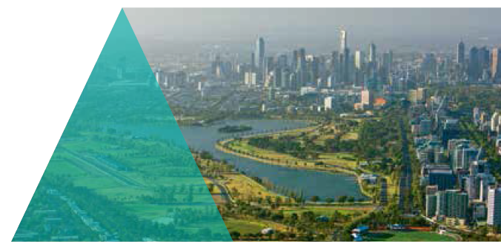

6.3 – Establish a whole-of-Victorian Government working group to prioritise and coordinate state level efforts for the Victorian implementation of United Nations System for Environmental-Economic Accounting (UN SEEA)
Goal | Victoria's natural environment is healthy, and  Victorians value nature
Theme | VicEnvironments
Lead | Department of Environment, Land, Water and Planning
Partners | Whole-of-Victorian Government and Interested Victorian Traditional Owner Groups
Timeframe | Medium (2-4 years)
Status | Commenced

Priority 7 – Help to create more liveable and climate-adapted communities

7.1 – Support the establishment of new green infrastructure to maximise the co-benefits to communities and test new approaches for connecting Victorians to nature in an urban context
Goal | Victorians value nature
Theme | Steps into nature
Lead | Department of Environment, Land, Water and Planning
Partners | University of Melbourne, Department of Health and Human Services, Water Corporations, Local Government, Port Phillip and Westernport Catchment Management Authority, Victorian Planning Authority
Timeframe | Long (4+ years)
Status | Commenced

7.2 – As part of the Climate Change Adaptation Plan 2017-2020, undertake a state-wide sectoral and regional economic vulnerability assessment that will include an overview of the vulnerability of biodiversity to climate change impacts, including riverine flood and fire
Goal | Victoria's natural environment is healthy, and  Victorians value nature
Theme | Climate-ready ecosystems
Lead | Department of Environment, Land, Water and Planning
Partners | Academic Sector
Timeframe | Short (1-2 years)
Status | Commenced

7.3 – As part of the Climate Change Adaptation Plan 2017-2020, commission new climate projections for Victoria that will provide downscaled information about the impacts of climate change on Victoria. Guidance products will be produced to make this localised climate change data accessible to the community
Goal | Victoria's natural environment is healthy, and  Victorians value nature
Theme | Climate-ready ecosystems
Lead | Department of Environment, Land, Water and Planning
Partners | The Commonwealth Scientific and Industrial Research Organisation
Timeframe | Short (1-2 years)
Status | Commenced

7.4 – Through the implementation of Plan Melbourne 2017-2050 support local government to complete and implement green wedge management plans to protect and enhance the agricultural, biodiversity, environmental, natural resource, tourism, landscape and other values of each of Melbourne’s green wedges
Goal | Victoria's natural environment is healthy, and  Victorians value nature
Theme | VicEnvironments
Lead | Department of Environment, Land, Water and Planning
Partners | Local Government, Department of Economic Development, Jobs, Transport and Resources, Parks Victoria
Timeframe | Medium (2-4 years)
Status | Commenced

7.5 – Through the implementation of Plan Melbourne 2017-2050, establish the Great Yarra Parklands from the crown land reserves along the metropolitan Yarra River (from Warrandyte to Port Phillip, excluding reserves for the port) as a state urban parkland
Goal | Victoria's natural environment is healthy, and  Victorians value nature
Theme | VicEnvironments
Lead | Department of Environment, Land, Water and Planning
Partners | Local Government, Department of Economic Development, Jobs, Transport and Resources, Parks Victoria, Melbourne Water and the Wurunjeri Council
Timeframe | Short (1-2 years)
Status | Commenced

7.6 – Prepare a metropolitan open space strategy that enhances recreation, amenity, health and wellbeing, species diversity, sustainable water management and urban cooling across Melbourne
Goal | Victoria's natural environment is healthy, and  Victorians value nature
Theme | VicEnvironments
Lead | Department of Environment, Land, Water and Planning
Partners | Victorian Planning Authority, Local Government, Port Phillip and Westernport Catchment Management Authority, Department of Health and Human Services, Parks Victoria, Trust for Nature, Royal Botanic Gardens Victoria
Timeframe | Medium (2-4 years)
Status | Planned

Priority 8 – Better care for and showcase Victoria’s environmental assets as world class natural and cultural tourism attractions

8.1 – Fund on-ground actions that help achieve the Biodiversity 2037 targets in partnership with communities, land managers, Traditional Owners and natural resource management agencies
Goal | Victoria's natural environment is healthy, and  Victorians value nature
Theme | Protecting Biodiversity Together
Lead | Department of Environment, Land, Water and Planning
Partners | All interested natural resource management partners including Victorian Traditional Owners
Timeframe | Long (4+ years)
Status | Planned

8.2 – Protect the environmental values of Melbourne’s coasts, waterways and bays (including the Yarra River, Western Port’s sensitive RAMSAR wetlands)
Goal | Victoria's natural environment is healthy, and  Victorians value nature
Theme | Protecting Biodiversity Together
Lead | Department of Environment, Land, Water and Planning
Partners | Parks Victoria, Catchment Management Authorities, Department of Economic Development, Jobs, Transport and Resources, Trust for Nature, Phillip Island Nature Parks, NGO Sector
Timeframe | Medium (2-4 years)
Status | Planned

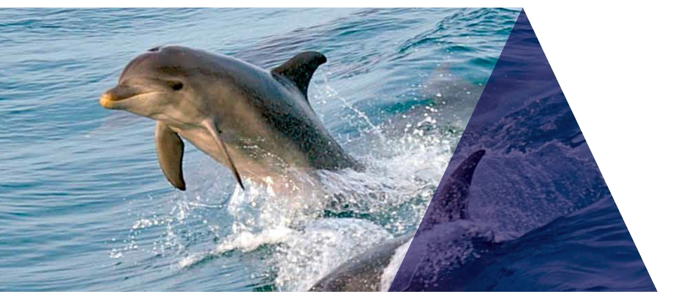

8.3 – Investigate the feasibility of establishing feral predator-free sanctuaries through projects at Wilsons Promontory National Park that have the potential to enable the restoration of vegetation communities and faunal assemblages
Goal | Victoria's natural environment is healthy, and  Victorians value nature
Theme | Mobilising our Ecosystem Engineers
Lead | Parks Victoria
Partners | Zoos Victoria, Department of Environment, Land, Water and Planning, Victorian Traditional Owner Groups, NGO Sector
Timeframe | Short (1-2 years)
Status | Commenced

8.4 – Maintain a fox-free environment on Phillip Island into the future and investigate the potential for Phillip Island to introduce appropriate threatened species of wildlife
Goal | Victoria's natural environment is healthy, and  Victorians value nature
Theme | Mobilising our Ecosystem Engineers
Lead | Phillip Island Nature Parks
Partners | Department of Environment, Land, Water and Planning, Interested Victorian Traditional Owner Groups, NGO Sector
Timeframe | Medium (2-4 years)
Status | Commenced

8.5 – Identify natural assets that could be enhanced to provide major tourism, cultural and economic benefits for Victoria in the future, and document these in relevant regional strategies
Goal | Victoria's natural environment is healthy, and  Victorians value nature
Theme | VicEnvironments
Lead | Department of Environment, Land, Water and Planning, Catchment Management Authorities
Partners | Parks Victoria, Parks Victoria, Catchment Management Authorities, Trust for Nature, NGO Sector, Interested Victorian Traditional Owner Groups, Local Government, Water Corporations, Regional Development Victoria
Timeframe | Medium (2-4 years)
Status | Planned

8.6 – Develop a Parks Victoria Visitor Engagement Framework to improve visitor experiences
Goal | Victorians value nature
Theme | Steps into nature
Lead | Parks Victoria
Partners | NA
Timeframe | Medium (2-4 years)
Status | Planned

8.7 – Develop new programs and site interpretation at Royal Botanic Gardens of Victoria, to help Victorians value and understand biodiversity, and support conservation initiatives
Goal | Victorians value nature
Theme | Steps into nature
Lead | Royal Botanic Gardens Victoria
Partners | Business and Philanthropic Sector
Timeframe | Medium (2-4 years)
Status | Planned

8.8 – Implement initiatives that increase awareness and activate values and care for priority local species
Goal | Victoria's natural environment is healthy, and  Victorians value nature
Theme | Steps into nature
Lead | Zoos Victoria
Partners | Department of Environment, Land, Water and Planning, Parks Victoria, Royal Botanic Gardens of Victoria
Timeframe | Medium (2-4 years)
Status | Planned

Priority 9 – Establish sustained funding for biodiversity

9.1 – Examine, and where appropriate adopt, a variety of approaches to secure sustained funding for biodiversity using established and emerging mechanisms such as matched crowd funding and revolving funds
Goal | Victoria's natural environment is healthy, and  Victorians value nature
Theme | Protecting Biodiversity Together
Lead | Trust for Nature, Department of Environment, Land, Water and Planning
Partners | Department of Environment, Land, Water and Planning, Catchment Management Authorities, NGO Sector
Timeframe | Medium (2-4 years)
Status | Planned

Priority 10 – Publish an Investment Prospectus to communicate to prospective investment partners the funded, unfunded and partially-funded projects that are needed to meet the targets

10.1 – Publish a web-based Biodiversity Investment Prospectus that allows investors to browse prospective projects and partnership opportunities that will further support on-ground investment towards the Plan’s targets. The prospectus will offer a variety of innovative funding mechanisms that link investors to community and Traditional Owner actions for biodiversity
Goal | Victoria's natural environment is healthy, and  Victorians value nature
Theme | Protecting Biodiversity Together
Lead | Department of Environment, Land, Water and Planning
Partners | Business and Philanthropic Sector, Zoos Victoria, Museums Victoria, Trust for Nature, Office of the Commissioner for Environmental Sustainability, Royal Botanic Gardens Victoria, and NGO Sector
Timeframe | Short (1-2 years)
Status | Planned

10.2 – Launch an inaugural biodiversity investment roundtable with key stakeholders including government, business, philanthropy and volunteer representatives to discuss principles and opportunities for good-practice private environmental investment
Goal | Victoria's natural environment is healthy, and  Victorians value nature
Theme | Protecting Biodiversity Together
Lead | Department of Environment, Land, Water and Planning
Partners | Business and Philanthropic Sector, Catchment Management Authorities, Parks Victoria, Zoos Victoria, Museums Victoria, Trust for Nature, Office of the Commissioner for Environmental Sustainability and Royal Botanic Gardens Victoria
Timeframe | Short (1-2 years)
Status | Commenced

Priority 11 – Increase incentives and explore market opportunities for private landholders to conserve biodiversity

11.1 – Examine the suite of Victorian private land conservation mechanisms and programs to assess their complementarity and investigate the pathways with the highest potential to increase landholder participation in biodiversity protection
Goal | Victoria's natural environment is healthy, and  Victorians value nature
Theme | Protecting Biodiversity Together
Lead | Trust for Nature, Department of Environment, Land, Water and Planning, Catchment Management Authorities
Partners | Private landholders, Victorian Traditional Owner Groups
Timeframe | Short (1-2 years)
Status | Commenced

11.2 – Undertake a co-design process with key stakeholders to review and update voluntary biodiversity management standards
Goal | Victoria's natural environment is healthy, and  Victorians value nature
Theme | Protecting Biodiversity Together
Lead | Department of Environment, Land, Water and Planning
Partners | Private landholders, Trust for Nature, Department of Economic Development, Jobs, Transport and Resources, Catchment Management Authorities and other partners
Timeframe | Medium (2-4 years)
Status | Planned

11.3 – Initiate new biodiversity conservation auctions as a mechanism to protect biodiversity, particularly native vegetation on private land
Goal | Victoria's natural environment is healthy
Theme | Protecting Biodiversity Together
Lead | Department of Environment, Land, Water and Planning
Partners | Trust for Nature
Timeframe | Short (1-2 years)
Status | Planned

Priority 12 – Adopt a collaborative biodiversity response planning approach to drive accountability and measurable improvement

12.1 – Co-design and implement the Biodiversity Response Planning process with stakeholders and partners across Victoria
Goal | Victoria's natural environment is healthy, and  Victorians value nature
Theme | Protecting Biodiversity Together
Lead | Department of Environment, Land, Water and Planning
Partners | Victorian Government Environment Portfolio Agencies, Local Councils, Traditional Owners, NGO Sector
Timeframe | Short (1-2 years)
Status | Planned

12.2 – Launch ActivityKit - a new user-friendly tool for stakeholders and partners to input standard output data for reporting of progress towards state-wide biodiversity targets
Goal | Victoria's natural environment is healthy, and  Victorians value nature
Theme | Nature-tech
Lead | Department of Environment, Land, Water and Planning
Partners | Landcare Groups, Local Government, Traditional Owners, NGO Sector
Timeframe | Short (1 year with continuous improvement)
Status | Commenced

12.3 – Support partners and stakeholders to report on-ground actions to measure the collective impact towards the Biodiversity 2037 targets
Goal | Victoria's natural environment is healthy
Theme | Protecting Biodiversity Together
Lead | Department of Environment, Land, Water and Planning
Partners | All interested natural resource management partners including Victorian Traditional Owners
Timeframe | Long (4+ years)
Status | Commenced

12.4 – Update the conservation status of Victorian species using the IUCN Red List criteria as proposed under the Common Assessment Method (CAM)
Goal | Victoria's natural environment is healthy
Theme | Nature-tech
Lead | Department of Environment, Land, Water and Planning
Partners | All interested natural resource management partners including Victorian Traditional Owners
Timeframe | Short (1-2 years)
Status | Commenced

Priority 13 – Support and enable community groups, Traditional Owners, non-government organisations and sections of government to participate in biodiversity response planning

13.1 – Work with community groups and other organisations needing training, information or other assistance to engage in the biodiversity response planning process
Goal | Victoria's natural environment is healthy, and  Victorians value nature
Theme | Protecting Biodiversity Together
Lead | Department of Environment, Land, Water and Planning
Partners | Interested Victorian Traditional Owner Groups, Victorian Government Environment Portfolio Agencies
Timeframe | Short (1-2 years)
Status | Commenced

13.2 – When invited, partner with Traditional Owners to undertake Healthy Country Planning and assist with and acquisition & protection of freehold land
Goal | Victoria's natural environment is healthy, and  Victorians value nature
Theme | Caring for Biodiversity on Country
Lead | Trust for Nature
Partners | Department of Environment, Land, Water and Planning, Catchment Management Authorities, Interested Victorian Traditional Owner Groups
Timeframe | Medium (2-4 years)
Status | Commenced

Priority 14 – Engage with Traditional Owners to include Aboriginal values and traditional ecological knowledge in biodiversity planning and management

14.1 – Empower and Enable Interested Victorian Traditional Owners to deliver Biodiversity 2037 in equal partnership across all levels of natural resource management delivery
Goal | Victoria's natural environment is healthy, and  Victorians value nature
Theme | Caring for Biodiversity on Country
Lead | Department of Environment, Land, Water and Planning, Dja Dja Wurrung Clans Aboriginal Corporation, the Federation of Victorian Traditional Owners and other interested Victorian Traditional Owner Groups
Partners | Sustainability Victoria, Parks Victoria, Environment Protection Authority, Royal Botanic Gardens Victoria, Trust for Nature, Catchment Management Authorities, Zoos Victoria, Office of the Commissioner for Environmental Sustainability
Timeframe | Long (Ongoing)
Status | Commenced

14.2 – Through the implementation of Plan Melbourne 2017-2050 create opportunities for Aboriginal people to be actively involved in the identification, protection, rehabilitation and ongoing management of cultural heritage places across Melbourne, working with Traditional Owners, Aboriginal community organisations, Governments and others
Goal | Victoria's natural environment is healthy, and  Victorians value nature
Theme | Caring for Biodiversity on Country
Lead | Department of Premier and Cabinet
Partners | Traditional Owners, Parks Victoria, Local Government, Victorian Planning Authority, Victorian Aboriginal Heritage Government, Department of Environment, Land, Water and Planning, Royal Botanic Gardens Victoria
Timeframe | Long (Ongoing)
Status | Commenced

14.3 – Through the implementation of Plan Melbourne 2017-2050 prepare waterway corridor master plans for priority waterways to ensure that Traditional Owner and community values of waterways, such as access, amenity and connection to nature, are protected and improved
Goal | Victoria's natural environment is healthy, and  Victorians value nature
Theme | VicEnvironments
Lead | Department of Environment, Land, Water and Planning
Partners | Melbourne Water, Parks Victoria, Local Government, Victorian Planning Authority
Timeframe | Medium (2-4 years)
Status | Commenced

14.4 – In partnership with Victoria's Traditional Owners, understand how Traditional Owner ecological knowledge and contemporary biodiversity management can be integrated into joint management planning
Goal | Victorians value nature
Theme | Caring for Biodiversity on Country
Lead | Department of Environment, Land, Water and Planning
Partners | Interested Victorian Traditional Owner Groups, Department of Environment, Land, Water and Planning, Parks Victoria, Royal Botanic Gardens Victoria
Timeframe | Long (4+ years)
Status | Commenced

Priority 15 – Support Aboriginal access to biodiversity for economic development

15.1 – Prioritise opportunities for Traditional Owners and Aboriginal Victorian employment and capability building as part of biodiversity investment processes and other operational natural resource management activities
Goal | Victoria's natural environment is healthy
Theme | Caring for Biodiversity on Country
Lead | Department of Environment, Land, Water and Planning
Partners | Interested Victorian Traditional Owner Groups and other interested natural resource management partners
Timeframe | Long (4+ years)
Status | Planned

15.2 – Work with Aboriginal natural resource management crews and cultural heritage officers to manage or assess privately protected areas, including Trust for Nature reserves and covenants
Goal | Vic  toria's natural environment is healthy
Theme | Caring for Biodiversity on Country
Lead | Trust for Nature
Partners | Interested Victorian Traditional Owner Groups, Department of Environment, Land, Water and Planning, Catchment Management Authorities
Timeframe | Long (4+ years)
Status | Commenced

Priority 16 – Build capacity to increase Aboriginal participation in biodiversity management

16.1 – Provide training and resources for Victorian Traditional Owner Groups to contribute to data collection, extract and use data and utilise biodiversity management decision-support tools
Goal | Victoria's natural environment is healthy, and  Victorians value nature
Theme | Caring for Biodiversity on Country
Lead | Department of Environment, Land, Water and Planning
Partners | Interested Victorian Traditional Owner Groups
Timeframe | Long (4+ years)
Status | Planned

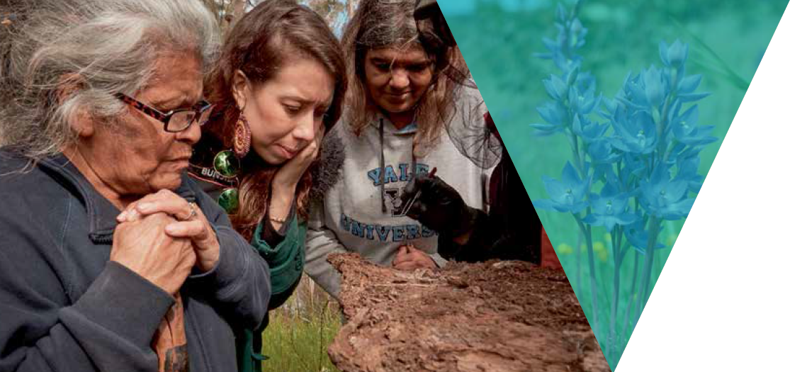

Priority 17 – Deliver excellence in management of all public land and waters

17.1 – Reduce the impact of key invasive species such as feral cats, deer, and wild dogs and new or emerging environmental weeds according to the principles set out in the Invasive Plants and Animals Policy Framework using Strategic Management Prospects as guidance. A first step will be the develop a deer management strategy that sets a strategic plan to maintain sustainable hunting opportunities while reducing the impact of deer on biodiversity on all land tenures of the state
Goal | Victoria’s natural environment is healthy
Theme | Mobilising our Ecosystem Engineers
Lead | Department of Environment, Land, Water and Planning and Department of Economic Development, Jobs, Transport and Resources
Partners | Parks Victoria, Game Management Authority, Trust for Nature, Interested Victorian Traditional Owner Groups
Timeframe | Medium (2-4 years)
Status | Planned

17.2 – Develop a weed knowledge centre and work with partners to identify and progressively fill key knowledge gaps about new and emerging weed threats to Victoria's biodiversity
Goal | Victoria’s natural environment is healthy
Theme | Nature-tech
Lead | Department of Environment, Land, Water and Planning, Department of Economic Development, Jobs, Transport and Resources
Partners | Royal Botanic Gardens Victoria. All interested natural resource management partners including Victorian Traditional Owners
Timeframe | Short (1-2 years)
Status | Planned

17.3 – Protect biodiversity with enhanced environmental compliance in relation to the Flora and Fauna Guarantee Act, and wildlife, native vegetation, non-indigenous heritage, public land, timber harvesting, tour operators and bushfire prevention
Goal | Victoria's natural environment is healthy
Theme | Protecting Biodiversity Together
Lead | Department of Environment, Land, Water and Planning
Partners | NA
Timeframe | Medium (2-4 years)
Status | Planned

17.4 – Maintain existing native apex predators in natural ecosystems and, investigate the potential functional role of reintroduced native apex predators in north-west Victoria
Goal | Victoria’s natural environment is healthy
Theme | Mobilising our Ecosystem Engineers
Lead | Department of Environment, Land, Water and Planning
Partners | Zoos Victoria, Parks Victoria, Trust for Nature, Department of Economic Development, Jobs, Transport and Resources, Interested Victorian Traditional Owner Groups
Timeframe | Medium (2-4 years)
Status | Planned

17.5 – Work with partners including Victorian Traditional Owner Groups and other stakeholders to review management standards (including for revegetation), to increase incorporation of traditional ecological knowledge and ensure effectiveness under future climate scenarios
Goal | Victoria's natural environment is healthy
Theme | Protecting Biodiversity Together
Lead | Department of Environment, Land, Water and Planning
Partners | Trust for Nature, Park Victoria, Aboriginal Victorians, Department of Economic Development, Jobs, Transport and Resources and other interested natural resource management partners including Victorian Traditional Owners
Timeframe | Medium (2-4 years)
Status | Planned

17.6 – Implement relevant actions from Regional Waterway Strategies and protect the drought refugia areas, identified in the Regional NRM Climate Change Adaptation Plans
Goal | Victoria's natural environment is healthy
Theme | Climate-ready Ecosystems
Lead | Catchment Management Authorities
Partners | Department of Economic Development, Jobs, Transport and Resources and other interested natural resource management partners including Victorian Traditional Owners
Timeframe | Long (4+ years)
Status | Planned

17.7 – Provide access to Decision Support Tools to inform better fertiliser and nitrogen application to reduce nutrient losses to waterways
Goal | Victoria's natural environment is healthy, and  Victorians value nature
Theme | Nature-tech
Lead | Department of Economic Development, Jobs, Transport and Resources
Partners | Private sector
Timeframe | Short (1-2 years)
Status | Commenced

17.8 – Develop a Biodiversity Emergency Response Framework that enables rapid decision making for biodiversity after major events such as bushfires or floods
Goal | Victoria's natural environment is healthy
Theme | Protecting Biodiversity Together
Lead | Department of Environment, Land, Water and Planning
Partners | Zoos Victoria, Parks Victoria, Department of Economic Development, Jobs, Transport and Resources, Emergency Management Victoria, Phillip Island Nature Parks
Timeframe | Medium (2-4 years)
Status | Commenced

17.9 – Implement the Living with Wildlife Action Plan which sets out four key action areas which will deliver improvements in policy, regulation and management of wildlife for the future
Goal | Victoria’s natural environment is healthy
Theme | Mobilising our Ecosystem Engineers
Lead | Victoria’s natural environment is healthy and Victorians value nature
Partners | Department of Economic Development, Jobs, Transport and Resources and NGO Sector
Timeframe | Medium (2-4 years)
Status | Planned

17.10 – Design a net gain approximation approach which includes terrestrial, marine and freshwater environments and commence work on a new Net Gain Approximation Report
Goal | Victoria's natural environment is healthy
Theme | Protecting Biodiversity Together
Lead | Department of Environment, Land, Water and Planning
Partners | NA
Timeframe | Medium (2-4 years)
Status | Planned

Priority 18 – Maintain and enhance a world-class system of protected areas

18.1 – Investigate opportunities to secure more permanently protected areas on private land
Goal | Victoria's natural environment is healthy, and  Victorians value nature
Theme | Protecting Biodiversity Together
Lead | Trust for Nature
Partners | Private Landholders, Department of Economic Development, Jobs, Transport and Resources and the Philanthropic sector
Timeframe | Medium (2-4 years)
Status | Planned

18.2 – Establish land management agreements with private landholders as part of integrated land, water and biodiversity management programs identified as priorities in Regional Catchment Strategies across Victoria to complement the reserve and private land covenanting systems
Goal | Victoria's natural environment is healthy
Theme | Protecting Biodiversity Together
Lead | Catchment Management Authorities
Partners | Private Landholders, Trust for Nature
Timeframe | Medium (2-4 years)
Status | Planned

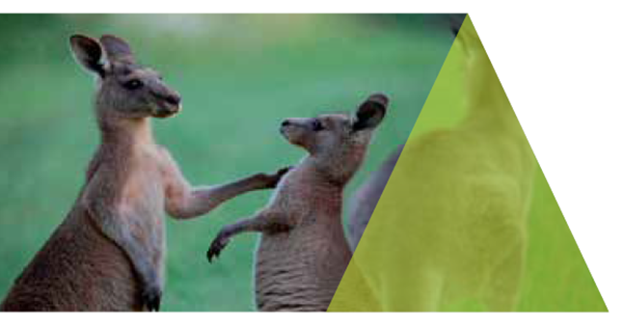

Priority 19 – Adopt a whole-of-government approach to implementing this Plan

19.1 – Establish the VicEnvironments leadership forum for Victorian Government environment portfolio agencies to coordinate actions that achieve the goals and targets of Biodiversity 2037
Goal | Victoria's natural environment is healthy
Theme | VicEnvironments
Lead | Department of Environment, Land, Water and Planning, Sustainability Victoria, Parks Victoria, Environment Protection Authority, Royal Botanic Gardens Victoria, Phillip Island Nature Parks, Trust for Nature, Catchment Management Authorities, Zoos Victoria, Office of the Commissioner for Environmental Sustainability and Dja Dja Wurrung Aboriginal Corporation
Partners | NA
Timeframe | Short (1 year)
Status | Commenced

19.2 – Develop policy and accounting mechanisms to ensure that biodiversity losses that occur outside the regulatory system are appropriately counter-balanced at a whole of state level. A first step will be establishing a counterbalance statement for public land
Goal | Victoria's natural environment is healthy
Theme | VicEnvironments
Lead | Department of Environment, Land, Water and Planning
Partners | NA
Timeframe | Short (1-2 years)
Status | Commenced

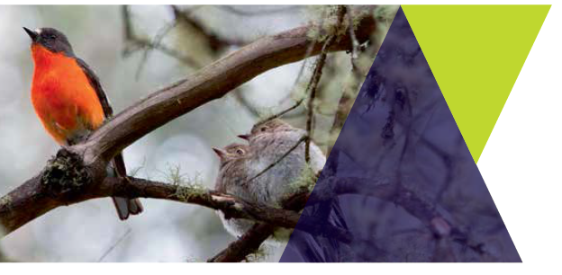
19.3 – Complete the Review the Flora and Fauna Guarantee Act 1988 and identify reforms for consideration by government
Goal | Victoria's natural environment is healthy
Theme | Protecting Biodiversity Together
Lead | Department of Environment, Land, Water and Planning
Partners | NA
Timeframe | Short (1-2 years)
Status | Commenced

19.4 – Ensure delivery of actions to implement the Government response to the Independent Inquiry into the EPA that promote biodiversity outcomes, specifically:
introducing a statutory objective for EPA to protect human health and environment from pollution and waste
create a consolidated and enhanced environmental health capability for Victoria
review Victoria's air and water monitoring networks
examine how to best address complex environment protection and public health issues
establish processes for better coordination of environmental management, monitoring and reporting in Victoria
Goal | Victoria's natural environment is healthy
Theme | VicEnvironments
Lead | Environment Protection Authority Victoria, Department of Environment, Land, Water and Planning
Partners | NA
Timeframe | Medium (2-4 years)
Status | Commenced

19.5 – Develop a Feral Cat Action Plan and review the legislative framework to enable the control of feral cats for the protection of Victoria's biodiversity and threatened wildlife
Goal | Victoria’s natural environment is healthy
Theme | Mobilising our Ecosystem Engineers
Lead | Department of Environment, Land, Water and Planning
Partners | Department of Economic Development, Jobs, Transport and Resources, Zoos Victoria, Parks Victoria, Phillip Island Nature Parks
Timeframe | Short (1-2 years)
Status | Planned

19.6 – Develop the next Zoos Victoria Wildlife Conservation Master Plan for 2019-2024
Goal | Victoria's natural environment is healthy
Theme | Protecting Biodiversity Together
Lead | Zoos Victoria
Partners | All interested natural resource management partners including Victorian Traditional Owners, Federal Government, NGO Sector, Academic Research Sector, Private Sector
Timeframe | Short (1-2 years)
Status | Commenced

Priority 20 – Establish a transparent evaluation process to report on progress towards delivering the Plan

20.1 – Release and implement the first iteration of the Biodiversity 2037 Monitoring, Evaluation and Reporting Framework (MERF)
Goal | Victoria's natural environment is healthy, and  Victorians value nature
Theme | Protecting Biodiversity Together
Lead | Department of Environment, Land, Water and Planning
Partners | Victorian Government environment agencies, NGO Sector, Interested Victorian Traditional Owner Groups, Office of the Commissioner for Environmental Sustainability, Academic Research Sector
Timeframe | Short (1 year)
Status | Completed
Update | The first iteration of the Biodiversity 2037 Monitoring, Evaluation and Reporting Framework (MERF) is available for download here: https://www.environment.vic.gov.au/biodiversity/biodiversity-plan

20.2 – Co-design a biodiversity conservation forum for Biodiversity 2037
Goal | Victoria's natural environment is healthy
Theme | Protecting Biodiversity Together
Lead | Department of Environment, Land, Water and Planning
Partners | NGO Sector, Interested Victorian Traditional Owner Groups, Academic Research Sector
Timeframe | Short (1-2 years)
Status | Planned

20.3 – Host the 7th Global Botanic Gardens Congress International in Melbourne to demonstrate the vital role of botanic gardens in connecting people with nature
Goal | Victorians value nature
Theme | Steps into nature
Lead | Royal Botanic Gardens Victoria
Partners | Local Government, Melbourne Convention Centre
Timeframe | Long (4+ years)
Status | Planned

20.4 – Establish a baseline for reporting on Victoria's biodiversity to inform the Victorian State of the Environment Report 2018
Goal | Victoria's natural environment is healthy, and  Victorians value nature
Theme | VicEnvironments
Lead | Office of the Commissioner for Environmental Sustainability
Partners | All data custodians
Timeframe | Medium (2-4 years)
Status | Planned

