|  |
| --- |
| Icon Species 2023-25  Guidelines |

Authors

Kellie Doering, Team Lead - Environment Programs, Regions, Environment, Climate Action and First Peoples, DEECA

Nick McCristal, Senior Policy Officer, Threatened Species, Regions, Environment, Climate Action and First Peoples

Reviewer/s

Michelle Ballentine, Manager - Environment Programs, Biodiversity Programs and Partnerships Branch, DEECA

**Approver**

Steven Lynch, Director, Biodiversity Programs and Partnerships Branch, DEECA

Photo credit

Southern Purple Spotted Gudgeon. Photo credit - Doug Gimesy

|  |
| --- |
| Acknowledgment  We acknowledge and respect Victorian Traditional Owners as the original custodians of Victoria's land and waters, their unique ability to care for Country and deep spiritual connection to it. We honour Elders past and present whose knowledge and wisdom has ensured the continuation of culture and traditional practices.  We are committed to genuinely partner, and meaningfully engage, with Victoria's Traditional Owners and Aboriginal communities to support the protection of Country, the maintenance of spiritual and cultural practices and their broader aspirations in the 21st century and beyond. |
| © The State of Victoria Department of Energy, Environment and Climate Action 2023  LogoThis work is licensed under a Creative Commons Attribution 4.0 International licence. You are free to re-use the work under that licence, on the condition that you credit the State of Victoria as author. The licence does not apply to any images, photographs or branding, including the Victorian Coat of Arms, the Victorian Government logo and the Department of Energy, Environment and Climate Change (DEECA) logo. To view a copy of this licence, visit <http://creativecommons.org/licenses/by/4.0/>  Disclaimer  This publication may be of assistance to you but the State of Victoria and its employees do not guarantee that the publication is without flaw of any kind or is wholly appropriate for your particular purposes and therefore disclaims all liability for any error, loss or other consequence which may arise from you relying on any information in this publication.  Accessibility  If you would like to receive this publication in an alternative format, please telephone the DEECA Customer Service Centre on 136186, email [customer.service@deeca.vic.gov.au](mailto:customer.service@deeca.vic.gov.au) or via the National Relay Service on 133 677 [www.relayservice.com.au](http://www.relayservice.com.au). This document is also available on the internet at [www.deeca.vic.gov.au](http://www.deeca.vic.gov.au). |

Contents

1. What is the Icon Species program? 4

2. Traditional Owner self-determination and engagement 4

3. Icon Species 2023-25 program overview 5

4. Who can apply? 5

5. Who cannot apply? 6

6. Activities eligible for funding 6

7. Activities ineligible for funding 6

8. How do I apply? 7

9. Eligibility of applications 7

10. Assessment criteria 7

11. Supporting documents required 9

12. Notification process 9

13. Further information 9

Appendix 1 – Funding Conditions 10

Appendix 2 – DEECA Participant Release Form 13

## What is the Icon Species program?

The Icon Species program was established in 2016 and targets actions to support the recovery of threatened species that have a high community profile and are at an immediate risk of rapid decline or extinction (including localised extinction).

The Icon Species program funds eligible organisations to undertake projects that support outcomes for threatened species aligned with Victoria’s strategy for biodiversity *Protecting Victoria’s Environment – Biodiversity 2037* (Biodiversity 2037)and in doing so will contribute to the following state-wide target of the strategy that all critically endangered and endangered species will have at least one option available for being conserved ex situ or re-established in the wild (where feasible under climate change) should they need it.

The Victorian Government funds landscape-scale activities and broad scale threat management actions through programs such as Protecting Biodiversity, Weeds and Pests on Public Land, and the Victorian Deer Control Program. These programs provide cost-effective benefits for the maximum number of species and provide a preventative approach, reducing the risk of species becoming more threatened. Further information regarding a range of these program is available [here](https://www.environment.vic.gov.au/invasive-plants-and-animals/invasive-species-on-public-land/weeds-and-pests-on-public-land-program).

The intent of the Icon Species Program is to fund actions that are specific and important for the persistence of a threatened species and are complementary to broadscale actions for biodiversity such as herbivore and predator control. This program targets specific opportunities to undertake works for the most threatened species which won't respond sufficiently to standard landscape-scale actions.

**Program objective**

To provide financial support, policy guidance, and decision support to deliver cost-effective conservation projects for threatened species which require ‘direct’ management interventions.

**Program outcomes**

1. Increased persistence of threatened species funded through the program in the short-term through to longer-term.
2. Increased capacity in the conservation sector through support for the delivery of actions and sharing knowledge, including through the delivery of novel and bespoke management actions.

## Traditional Owner self-determination and engagement

DEECA supports the self-determination of Traditional Owners. For projects on public land, appropriate partnership with Traditional Owners should be considered as early as possible in the project development, in line with Pupangarli Marnmarnepu ‘*Owning Our Future*’ Aboriginal Self-Determination Reform Strategy 2020-2025. For example, discussions at a relevant forum, a site visit on Country and/or demonstrated ‘in principle’ support from the Traditional Owner group specific to that area.

<https://www.deeca.vic.gov.au/aboriginalselfdetermination/self-determination-reform-strategy>

Applicants are strongly encouraged to read the relevant Country Plan prior to commencing any engagement and to understand the Traditional Owner group’s legal status and rights under the relevant legislation. Applicants who are not Traditional Owner Corporation registered under the Corporations (Aboriginal and Torres Strait Islander) Act 2006 (CATSI Act), will need to obtain a letter of support for the project and for the organisation from the Traditional Owner Corporation of the Country where the works are proposed prior to any works commencing.

If the proposed works are on Country where there is a formally recognised Traditional Owner Corporation (Registered Aboriginal Parties (RAP)), the letter should be from the RAP. Where the location has no RAP, letter/s of support should be from relevant Traditional Owner groups with interest in the area of the proposed works.

Accordingly, where appropriate, projects should factor in adequate budget for Traditional Owners to be adequately renumerated and resourced. Sufficient time should be allocated to allow for projects to be delivered in true partnership.

## Icon Species 2023-25 program overview

|  |  |
| --- | --- |
| **Icon Species 2023-25** | **Program details** |
| Applications open | Monday 8 April 2024 |
| Applications close | **5pm** Tuesday 30 April 2024 |
| Total Funding pool | $1,850,000 |
| Maximum funding amount | $100,000 (excluding GST) per project  No minimum funding limit |
| Project Duration | 12 months from contracting |
| Multiple applications | Multiple grant applications may be submitted from a single proponent, provided they are for different species |
| Co-investment | Applicants are encouraged to consider co-investment contribution opportunities which can include financial, in-kind or volunteer contributions |
| Selection process | Targeted application process with assessment criteria |
| Assessment and contracting | May – July 2024 |
| Project commencement date | Upon contracting |
| Project completion date | 12 months after contacting occurs |
| Final acquittal report submitted | One month after the project completion date |

## Who can apply?

The following organisations can apply for funding:

* Government environment portfolio partners with suitable capacity to deliver threatened species conservation projects, including, but not limited to; Zoos Victoria, Royal Botanic Gardens of Victoria, Parks Victoria, Trust for Nature and Phillip Island Nature Parks.
* DEECA Regions and the Arthur Rylah Institute
* Catchment Management Authorities (CMAs) and Melbourne Water
* Academic and scientific research institutions
* Local Government Agencies
* Non-Government Organisations (NGOs)
* Not-for-Profit or Philanthropic organisations
* Traditional Owner Organisations

All applicants must have;

* a demonstrated capacity and track record in the effective delivery of conservation programs to conserve threatened species;
* insurance coverage for its operational and business risks public liability insurance ($10 million minimum) and personal accident insurance cover to safeguard any volunteers and participants involved in the funded activities;
* systems, processes and procedures in place to identify and manage risk that complies with all relevant laws and regulations including the Occupational Health and Safety Act 2004 and Occupational Health and Safety Regulations 2017; and
* systems, processes and procedures to ensure good governance, and a high standard of quality assurance for project delivery.

In addition, to be eligible for funding, not for profit and Traditional Owner organisations applicants must:

* be an incorporated body, cooperative or association (including business associations), and
* be financially solvent.

## Who cannot apply?

The following organisations and individuals cannot apply for funding:

* individuals
* government agencies (excluding the ones listed in Section 4)
* primary and secondary education institutions
* private sector businesses
* community groups (e.g. Friends of groups or Landcare groups)

## Activities eligible for funding

The following types of activities (or projects) are eligible for funding through this round.

* Direct management interventions for threatened species that will not sufficiently benefit from broader landscape-scale activities, including, but not limited to:
  + captive breeding and release programs;
  + genetic management interventions, including translocations;
  + seed banking;
  + provision of artificial habitat such as appropriate nest boxes; and
  + a range of potentially novel and/or bespoke interventions with suitable evidence that they will achieve cost-effective conservation outcomes.
* Research to fill critical knowledge gaps including:
  + Research required to subsequently enable the types of management interventions detailed above. The link between research and associated management should be made very clear in associated proposals.

Other activities and expenditure items will be considered, providing that the need is justified in the application.

There are no caps or limits for eligible items. Value for money will be a key consideration as part of the assessment process.

## Activities ineligible for funding

The Icon Species program will not fund the following activities:

* activities associated with native vegetation offset sites to meet a condition of a permit, contract or investment program.
* purchase or use of barbed wire fencing.
* purchase of goods or services for competitions, prizes, giveaways, vouchers or alcohol
* ongoing maintenance activities.
* where existing funding is already allocated from another program for the activity.
* recurrent operating costs, for example rent and utility costs, and/or activities establishing expectations of ongoing funding.
* purchasing of computers, laptops or smartphones
* political campaigning or advocacy activities for political parties.
* activities for Helmeted Honeyeater and Leadbeater’s Possum (as funding is provided under the Faunal Emblems Program for these species).

## How do I apply?

Applications are to be submitted online using the Grants Online portal. To apply, go to the grant program web page accessed [here](https://deeca.my.site.com/publicform?id=a0hRF000000A0I5) and click on the ‘Start New Application’ button. To return to a saved draft application, click on the ‘Access Saved Application’ button.

**Attaching required documents:**

Supporting documents must be in an acceptable file type, such as Word, Excel, PDF, or JPEG. The maximum file size for each file is 5MB.

You will receive an application number when you submit an application online. Please quote this number in all communications with the department relating to your application.

If you have documents to submit that cannot be attached to your online application you can email them to [grantsinfo@deeca.vic.gov.au](mailto:grantsinfo@deeca.vic.gov.au) quoting your application number. Attach all documents to one email, zipping the files if required.

Make sure your application is submitted by **5pm on Tuesday 30 April 2024.**

**Note:** No hard copy applications will be accepted. Late applications will not be considered.

If you require assistance submitting your application online, email [grantsinfo@deeca.vic.gov.au](mailto:grantsinfo@deeca.vic.gov.au)

## Eligibility of applications

As part of the eligibility stage, applicant organisations and applications will be reviewed to ensure they meet all the following eligibility criteria before proceeding to the assessment stage.

* the funding amount requested is $100,000 or less (excluding GST).
* the applicant has attached the mandatory Budget and Activities spreadsheet and Spatial data requirements.
* applicant organisations will be assessed to determine the applicant’s capacity to deliver the project. Where proponents are determined to not adequately meet this parameter, they will be deemed ineligible for funding through this round of the program.
* applicants have no overdue reports from previous Icon Species funding rounds (2016-2021).
* applicants have a minimum of $10 million public liability insurance and personal accident insurance.

## Assessment criteria

Eligible project applications will be assessed by panel members with technical expertise in threatened species and grant administration.

In addition to the assessment criteria listed in the proceeding table, the assessment panel will also take into consideration the final mix of species and locations in their final recommendation for funding.

|  |  |  |
| --- | --- | --- |
| **Assessment Criteria** | **Weighting** | **Assessment Criteria Description** |
| **Threatened Species priority** | **60%** | **To what extent is the threatened species you are focusing on a priority?**  *Assessment will be in consideration of the following:*   * Conservation risk – critically endangered and endangered species that require specific interventions and have a very high, high or unknown genetic risk, will be scored higher. * Action statements - projects with actions listed in the Action statement for your species, will be scored higher. For further information on Action statements, visit   <https://www.environment.vic.gov.au/conserving-threatened-species/action-statements>   * If no action statement exists for your species, then inclusion in the Action Statement Priority Preparation List will be scored higher. For further information, visit [Action Statement Priority Preparation List](https://www.environment.vic.gov.au/__data/assets/pdf_file/0032/612986/Action-Statement-priority-100-preparation-list-2022-2023.pdf). * Urgent Actions - special consideration will be given for urgent actions around threatened species. |
| **Anticipated impact, project delivery and risk management** | **30%** | **What is the anticipated impact of the project on threatened species and to what extent can the applicant deliver the project and manage risks?**  *Assessment will be in consideration of the following:*   * Extent to which the proposal represents cost-effective investment, value for money including amount of in-kind contribution. * Evidence of Traditional Owner partnerships * Best practice methods and approaches and/or risk mitigation for innovative/untested methods. * Previous expertise and experience in delivering threatened species projects. * Applicant’s capability and capacity, technical feasibility and timing to deliver the project. * Likelihood of obtaining permits or approvals, if required. |
| **Additional biodiversity and community benefits** | **10%** | **To what extent does the project propose additional biodiversity and community benefits for the State of Victoria?**  *Assessment will be in consideration of the following:*   * Projects that build on previous Icon Species investment. * Demonstrated need for the project and community benefit. * Projects which are complemented by landscape scale biodiversity investment. For further information, visit <https://www.environment.vic.gov.au/> * Projects that can be sustained into the future (ie. legacy beyond the funding period). |

## Supporting documents required

The following documentation is required for application submissions:

* Budget and Activities spreadsheet*
* spatial data files of your project area**
* any supporting documents such as management plans, research that may assist justification of your project need/cost-effectiveness.

*\* mandatory documentation using the Icon Species* *Budget and Activities spreadsheet template to ensure your application is eligible for assessment. Other budget spreadsheets will not be accepted.*

*\*\* mandatory spatial data in the form of ESRI shapefiles. For further information on how to create a project area shapefile, click* [*here*](https://www.environment.vic.gov.au/biodiversity/investing-in-biodiversity/icon-species)*.*

## Notification process

Applicants will be notified of the outcomes of their submission in writing after the assessment process is completed. All decisions are final and are not subject to further review. Unsuccessful applicants are encouraged to seek feedback on their application.

Successful applicants will receive a Funding Agreement via email and the signed funding agreement and required documentation must be signed and submitted by the notified due date. Additional funding conditions can be found in **Appendix 1**.

## Further information

If you have questions about the Icon Species funding program, email [enviro.grants@deeca.vic.gov.au](mailto:enviro.grants@deeca.vic.gov.au).

For technical support with Grants Online, email [grantsinfo@deeca.vic.gov.au](mailto:grantsinfo@deeca.vic.gov.au) or call the DEECA Customer Contact Centre on 136 186 and quote your application number.

## Appendix 1 – Funding Conditions

**Traditional Owner partnership and engagement**

Successful applicants will be required to undertake the following as part of their funding conditions;

* engage with Traditional Owners and partner where possible.
  + If the proposed works are on Country where there is a formally recognised Traditional Owner Corporation (Recognised Aboriginal Parties (RAPs), then the RAP should be engaged and be supportive of the project.
  + Where the location has no RAP, support should be sought from the relevant Traditional Owner Group/s with interest in the area of the project.
* seek and obtain where necessary, advice and permissions from Traditional Owners and Aboriginal Victoria regarding cultural heritage where proposed activities may affect Indigenous sites or places of value.
* Intellectual Property - Indigenous Cultural Knowledge. The funding agreement does not extend to intellectual property, which is based on, or related to, Aboriginal cultural knowledge, except by prior agreement between the Department and the Organisation, acting in consultation with Aboriginal Victoria.

**Funding agreements**

Successful applicants must enter into a funding agreement with Department of Energy, Environment and Climate Action (DEECA). The Victorian Common Funding Agreement is used for funding agreements with not-for-profit organisations.

The DEECA Transfer Payment Funding Agreement is used for Victorian public entities, as defined under section 5 of the *Public Administration Act 2004.*

It is recommended that applicants review the terms and conditions before applying. Information about the Victorian Common Funding Agreement is available on <https://www.vic.gov.au/victorian-common-funding-agreement>

**Research permits**

Assessment and monitoring of Victoria’s flora and fauna may require a permit. See: https://www.vic.gov.au/research-permits

Permits to conduct these activities may be required under the following acts:

* *Wildlife Act 1975* (Vic)
* *Flora and Fauna Guarantee Act 1988* (Vic)
* *Reference Areas Act* *1978* (Vic)
* *Forests Act 1958* (Vic)

Assessment and monitoring in Parks Victoria managed land may require a Research Activity Access Agreement: see <https://www.parkconnect.vic.gov.au/scientific-research-permit/>.

**Other legislative and regulatory requirements**

Successful applicants must also ensure that the project complies with all requirements set out in any applicable State, Commonwealth, territory and local government laws, including those all necessary planning approvals and/or permits are or will be in place prior to the commencement of on ground activities for the project.

**Tax implications**

Applicants should consult the Australian Taxation Office or seek professional advice on any taxation implications that may arise from this grant funding.

**Acknowledging the Victorian Government’s support**

Successful applicants are expected to acknowledge the Victorian Government’s support and promotional guidelines (<https://www2.delwp.vic.gov.au/grants>) will form part of the funding agreement. Successful applicants must liaise with the departmental program area to coordinate any public events or announcements related to the project.

**Payments**

Payments will be made as long as:

* the funding agreement has been signed by both parties;
* grant recipients provide reports as required, or otherwise demonstrate that the activity is progressing as expected;
* other terms and conditions of funding continue to be met.

**Monitoring**

Grant recipients are required to comply with monitoring and reporting requirements as outlined in the funding agreement. This may include progress reports, photos, videos, case study, site inspection, completion reports and acquittal documentation, and will link to outcomes in *Protecting Victoria’s Environment – Biodiversity 2037* plan.

On completion of a project the group will need to submit a final report to acquit the funds and demonstrate the outcomes of the project. Recipients will have four weeks from their project end delivery date to submit their final report.

**Photos of Projects**

DEECA may use the photos and materials you provide as part of your reporting, to publicise funded projects, and may retain the photos for future possible use in other communications materials. Please refer to the standard terms and conditions of the Participant Release Form found in **Appendix 2**.

**Videos of Projects**

DEECA may use the videos you provide as part of your reporting, to publicise funded projects, and may retain the videos for future possible use in other communications materials. Please refer to the standard terms and conditions of the Participant Release Form found in **Appendix 2**.

**Acknowledging the Victorian Government for their support**

Successful applicants are expected to acknowledge the Victorian Government’s support and promotional guidelines will form part of the funding agreement. Please read the [Acknowledgment and Publicity Guidelines for Victorian Government Funding Support](https://www.deeca.vic.gov.au/__data/assets/word_doc/0022/392503/DEECA-Acknowledgement-and-Publicity-Guidelines.docx).

Successful applicants must liaise with the departmental program area to coordinate any public events or announcements related to the project.

**Privacy**

Any personal information about you or a third party in your application will be collected by the department for the purposes of administering your grant application and informing Members of Parliament of successful applications. Personal information may also be disclosed to external experts, such as members of assessment panels, or other Government Departments for assessment, reporting, advice, comment or for discussions regarding alternative or collaborative grant funding opportunities. If you intend to include personal information about third parties in your application, please ensure that they are aware of the contents of this privacy statement.

Any personal information about you or a third party in your correspondence will be collected, held, managed, used, disclosed or transferred in accordance with the provisions of the *Privacy and Data Protection Act 2014* and other applicable laws.

DEECA is committed to protecting the privacy of personal information. You can find the DEECA Privacy Policy online at www.deeca.vic.gov.au/privacy.

Requests for access to information about you held by DEECA should be sent to the Manager Privacy, P.O. Box 500 East Melbourne 8002 or contact by emailing [Foi.unit@deeca.vic.gov.au](mailto:Foi.unit@deeca.vic.gov.au).

## Appendix 2 – DEECA Participant Release Form

 

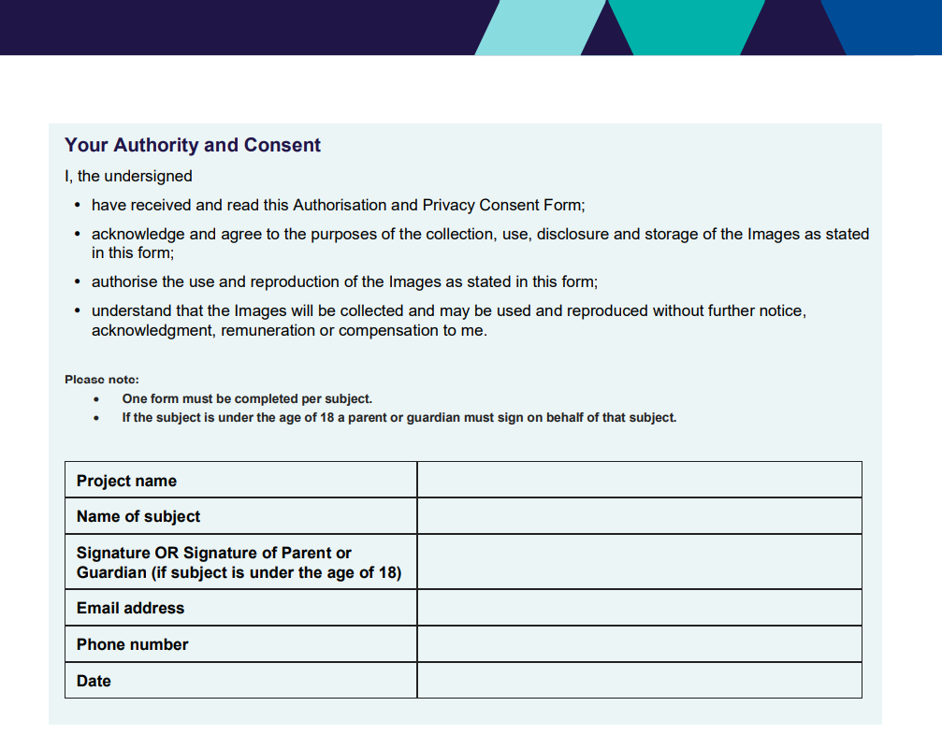 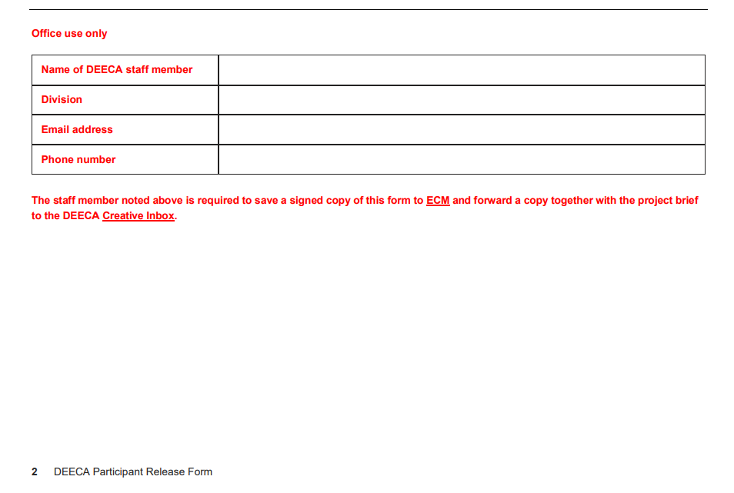

deeca.vic.gov.au