# 

|  |
| --- |
| Biodiversity Knowledge Framework |

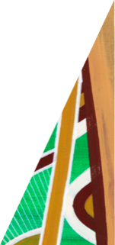

deeca.vic.gov.au

The **Biodiversity Knowledge Framework** is an exciting new method for identifying and prioritising important research questions and the effectiveness of management projects.

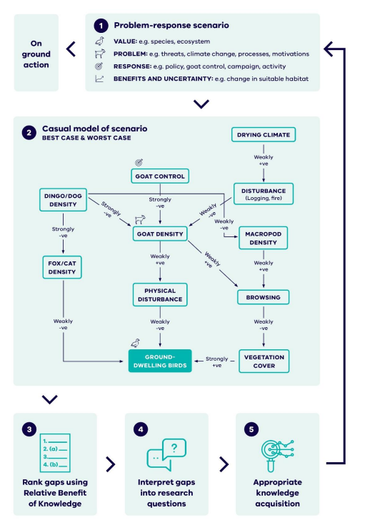

**The Biodiversity Knowledge Framework**

Targeted data collection is critical for effective evidence-based decision making. We know that knowledge gaps exist that are important to understand to undertake effective management; our challenge is to identify these knowledge gaps and prioritise them for research investment. New information is most valuable when it addresses uncertainty and knowledge gaps that, when resolved, informs highly beneficial management actions.

Resources for undertaking biodiversity conservation are always finite and limited. [**The Biodiversity Knowledge Framework**](https://www.environment.vic.gov.au/biodiversity/knowledge-framework) helps us to understand which knowledge gaps, when addressed, will have the greatest potential to inform the best management approaches for achieving positive biodiversity outcomes. It provides a consistent and transparent approach for prioritising and selecting research questions.

**How does the Biodiversity Knowledge Framework work?**

The **Biodiversity** **Knowledge Framework** uses modelling (see below) to describe the relationship between biodiversity values and management actions in different scenarios. Experts assess these models and identify uncertainty within these relationships. Given different levels of uncertainty, the Framework suggests what the best- and worst-case scenario might be for different actions.

**Figure 1**. Biodiversity Knowledge Framework Lifecycle

**Causal Models**

A systematic approach has been developed to work through the identification and prioritisation of knowledge gaps (Figure 3). Under this approach, problem-response scenarios describe particular biodiversity management situations that may benefit from knowledge acquisition. These scenarios inform the development of causal models. Causal models describe the relationship between important biodiversity values and management or intervention (e.g., control method, effect of disturbance) components within the scenario. Developing causal models for each scenario ensures that in assessing knowledge gaps, a whole-of-ecosystem view of the management problem is used.

**Relative Benefit of Knowledge**

Using a calculation called **Relative Benefit of Knowledge (RBK)** (how much benefit we may get from investing in one piece of research over another), we determine which knowledge gaps, when filled, have the greatest potential to guide biodiversity management and achieve the vision of Biodiversity 2037. This informs the sector in prioritising investment in research.

**Knowledge Portal**

The **Knowledge Portal** prioritises research by ranking the RBK. Highly ranked knowledge gaps can then be translated into priority research questions. Causal models will be progressively added to the Knowledge Framework over time and updated as new information becomes available. Experts are encouraged to develop causal models using this approach, seeking input from other relevant experts, and submit them for inclusion in the Knowledge Framework.

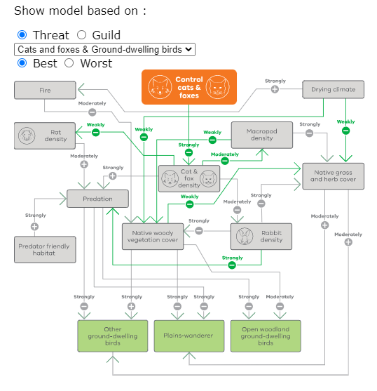

**Figure 2**. Best Case Scenario causal model - control of cats and foxes and ground dwelling birds

The **Knowledge Portal**is an interactive tool for viewing and interacting with current individual causal models created under the Biodiversity Knowledge Framework

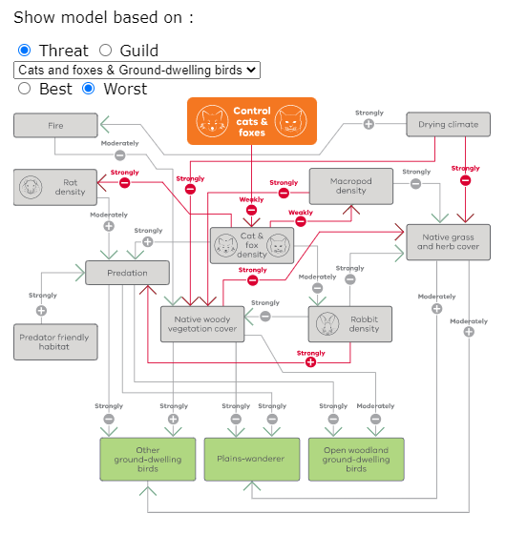

**Figure 3.** Worst Case Scenario causal model - control of cats and foxes and ground dwelling birds

The Knowledge Portal can be found at: <https://www.environment.vic.gov.au/biodiversity/knowledge-framework/knowledge-portal>

**Frequently Asked Questions**

**What is the Biodiversity Knowledge Portal used for?**

The Knowledge Portal provides access to the existing causal models that underpin the Biodiversity Knowledge Framework.

Through the Portal users can:

* Select problem-response scenarios to view. These scenarios often reflect an issue in the natural environment which may be resolved through management or research.
* View the relevant causal model for the scenario with clickable links that explore strengths of relationships.
  + Leave constructive feedback, comments or questions about specific links or other parts of a causal model by contacting us at: [biodiversity.knowledge@delwp.vic.gov.au](mailto:biodiversity.knowledge@delwp.vic.gov.au)
  + Identify knowledge gaps and prioritise research questions.

This ensures a consistent and transparent approach to prioritising and selecting research that aims to improve our understanding of the actions and outcomes needed to better protect biodiversity.

**How do I use the Knowledge Portal?**

Under ‘Show model based on’:

1. Click either the ‘Threat’ or ‘Guild’ (a group of species that use the same resources) button, this will generate the list of models available.
2. Choose the model you are interested in from the selectable list, the selection will be displayed in the orange box on the model.
3. Click either ‘Best’, for a best-case scenario or ‘Worst’ for the worst case-scenario. Selecting ‘Best’ will result in an optimistic view, that is the conservation outcomes may be better than expected; selecting ‘Worst’ will result in a negative view, that is conservation outcomes are unlikely to be effective.

**What is a Causal Model?**

Causal models are used to describe and visualise a system and the relationship between variables within that system.

Causal models represent a simplification of our understanding of the relationships between elements of a system, in this case, ecological interactions between threats, actions and species. It incorporates defined variables (represented as nodes) and the relationships between them (edges/arrows).

**How is a Causal Model built?**

The [**Biodiversity 2037: Manual for the identification and prioritisation of biodiversity actions and knowledge gaps provides**](https://www.environment.vic.gov.au/__data/assets/pdf_file/0040/497659/Manual-for-the-identification-and-prioritisation-of-biodiversity-actions-and-knowledge-gaps_final.pdf)[(accessible Word DOC version)](https://www.environment.vic.gov.au/__data/assets/word_doc/0032/497660/Manual-for-the-identification-and-prioritisation-of-biodiversity-actions-and-knowledge-gaps_final.docx)detailed steps for creating and analysing causal models.

|  |  |
| --- | --- |
| © The State of Victoria Department of Energy, Environment and Climate Action 2023  This work is licensed under a Creative Commons Attribution 4.0 International licence. You are free to re-use the work under that licence, on the condition that you credit the State of Victoria as author. The licence does not apply to any images, photographs or branding, including the Victorian Coat of Arms, the Victorian Government logo and the Department of Energy, Environment and Climate Change (DEECA) logo. To view a copy of this licence, visit http://creativecommons.org/licenses/by/4.0/  **Disclaimer**  This publication may be of assistance to you, but the State of Victoria and its employees do not guarantee that the publication is without flaw of any kind or is wholly appropriate for your particular purposes and therefore disclaims all liability for any error, loss or other consequence which may arise from you relying on any information in this publication. | **Accessibility**  If you would like to receive this publication in an alternative format, please telephone the DEECA Customer Service Centre on 136186, email [customer.service@delwp.vic.gov.au](mailto:customer.service@delwp.vic.gov.au) or via the National Relay Service on 133 677 [www.relayservice.com.au](http://www.relayservice.com.au). This document is also available on the internet at [www.deeca.vic.gov.au](http://www.deeca.vic.gov.au). |

**How has the Portal been used to date?**

Research on some highly ranked research questions has already begun. Current research questions informed and funded through the Knowledge Framework can be explored in [**this map**](https://delwp.maps.arcgis.com/apps/MapTour/index.html?appid=40575a7dd09a4dd58335afc11eedfcf2), and the following questions have work currently underway:

* Does fox control reduce fox densities to a point where there can be substantial benefit for small to medium sized ground dwelling mammals? What circumstances influence the success of fox control (e.g., disturbances, alternative prey ability)?
* To what extent to dogs/dingoes take fox bait? What are the broader ecosystem implications of reduced dog/dingo densities?
* Does deer control reduce deer densities to a point where native trees and shrubs substantially benefit?

In identifying these research questions, consideration was also given to whether equivalent research was already underway, for example through an [**Australian Research Council-linkage grant**](https://www.arc.gov.au/grants/linkage-program/linkage-projects)or [**Biodiversity Response Planning**](https://www.environment.vic.gov.au/biodiversity/working-together-for-biodiversity) capability projects (such as on deer and cat control methods).