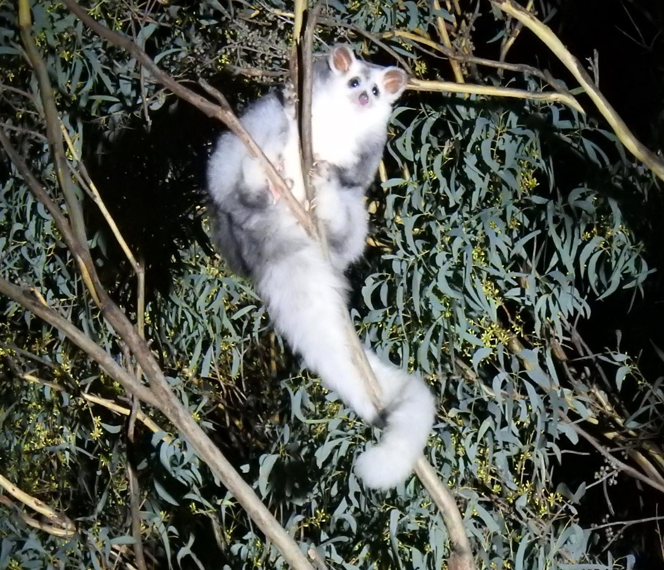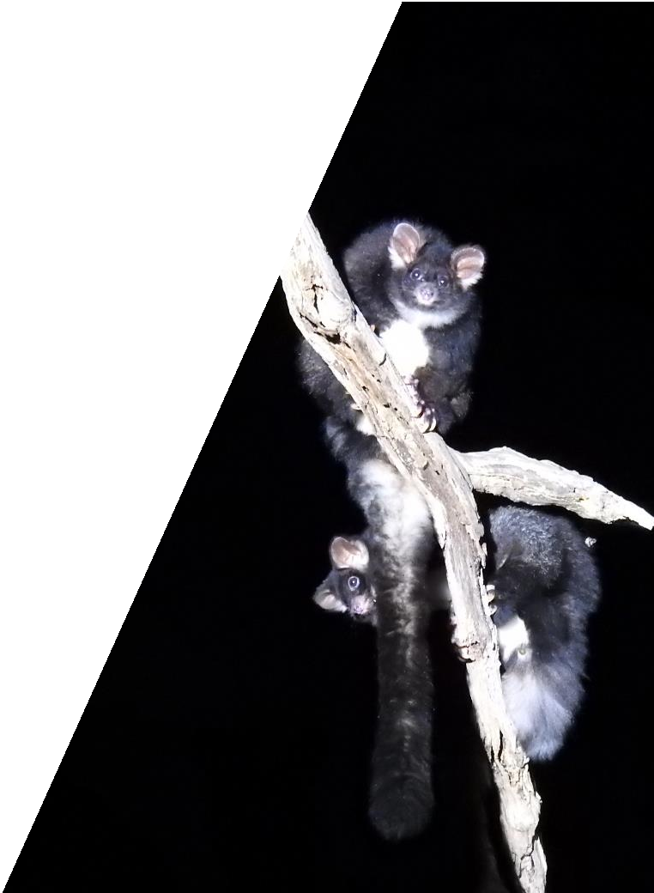Greater Glider
(Petauroides volans subsp. volans)

Action Statement No. 267
Flora and Fauna Guarantee Act 1988

Version 1.0

Photo credit
Cover photos: Stephen Smith - DELWP

© The State of Victoria Department of Environment, Land, Water and Planning 2019
This work is licensed under a Creative Commons Attribution 4.0 International licence. You are free to re-use the work under that licence, on the condition that you credit the State of Victoria as author. The licence does not apply to any images, photographs or branding, including the Victorian Coat of Arms, the Victorian Government logo and the
Department of Environment, Land, Water and Planning (DELWP) logo. To view a copy of this licence, visit http://creativecommons.org/licenses/by/4.0/

ISBN 978-1-76077-268-0 (pdf/online/MS word)

Disclaimer
This publication may be of assistance to you but the State of Victoria and its employees do not guarantee that the publication is without flaw of any kind or is wholly appropriate for your particular purposes and therefore disclaims all liability for any error, loss or other consequence which may arise from you relying on any information in this publication.

Accessibility

If you would like to receive this publication in an alternative format, please telephone the DELWP Customer Service Centre on 136186, email customer.service@delwp.vic.gov.au or via the National Relay Service on 133 677 www.relayservice.com.au. This document is also available on the internet at www.delwp.vic.gov.au.

Contents

Executive Summary 2
Conservation Measures 2
Previously Announced Actions 2
Other actions 2
Description 3
Distribution 3
Habitat 4
Life history and ecology 4
Conservation status 5
National conservation status 5
Victorian conservation status 5
Threats 5
Social and economic issues 6
Timber supply 6
Bushfire risk 6
Animal welfare 6
Existing conservation measures 6
Survey 6
Modelling 7
Timber harvesting 7
Fire management 7
Hazardous tree management 8
Research 8
Conservation objectives, measures and intended management actions 9
References 11

Executive Summary

This action statement is prepared under section 19 of the Flora and Fauna Guarantee Act 1988. It provides information about the Greater Glider – its distribution, habitat, life history and threats – and sets out a range of measures to ensure it can survive and flourish in Victoria’s native forests.
The Victorian Government has committed to the following measures to benefit the Greater Glider:

Conservation Measures
- Immediate protection of more than 96,000 hectares of State forest in the Strathbogie Ranges, in the Central Highlands, in East Gippsland and near Mirboo North. An indicative map of these areas is included at Attachment 1. When boundaries are finalised, an update to this action statement will be released that includes the final map.
- The end of timber harvesting in old-growth forest immediately.
- Phase-out of native forest timber harvesting by 2030.
- A state-wide prescription to provide additional protection in timber harvesting coupes where 5 or more Greater Gliders per spotlight kilometre are observed.

Previously Announced Actions
- Protection of all living large old trees of greater than 2.5 metres diameter.
- Reservation of the ~2,500 hectare “Kuark Forest” in East Gippsland.

Other actions
- Further research to improve our understanding of biology, habitat and threats.
- Enhanced protection from the impacts of bushfires and planned burning.

Greater Gliders – ten fast facts
- Greater Gliders occur in foothill and mountain forests from central Victoria to Queensland.
- They are mostly solitary.
- They need large tree hollows for shelter (each animal uses multiple hollows).
- They eat eucalypt leaves but prefer particular species.
- They can glide up to 100 metres between trees using a membrane between fore and hind legs.
- They begin breeding from two years old and can live to around eight years old.
- Females only have a single offspring per year but might not breed every year.
- They are threatened by fire and logging.
- They are preyed upon by owls.
- They may be affected by heat stress and drought – these factors may increase with climate change.

Description

The Greater Glider (Petauroides volans subsp. volans) (Kerr 1792) is the largest Australian gliding mammal, with a head and body length of 35-46 cm and a long, furry, non-prehensile tail measuring 45-60 cm. Typical adult weight ranges from 900-1700 g. The Greater Glider typically has thick, dark grey-brown fur dorsally and cream-white fur ventrally, with large, distinctive furry ears. Some animals are much lighter in colour (McKay 2008).
The Greater Glider is in the family Pseudocheiridae, which along with the ringtail possums, is not closely related to the other Australian gliding possums of the families Petauridae and Acrobatidae.

Distribution
The Greater Glider is distributed along the east coast of mainland Australia, from central Queensland to central Victoria. Within Victoria, Greater Gliders are distributed throughout forested parts of eastern Victoria, including inland and southern falls of the Great Dividing Range, as well as the Strzelecki and Strathbogie Ranges. In eastern Victoria, Greater Gliders are absent from high altitude alpine and sub-alpine habitats, Wilson’s Promontory and cleared areas.
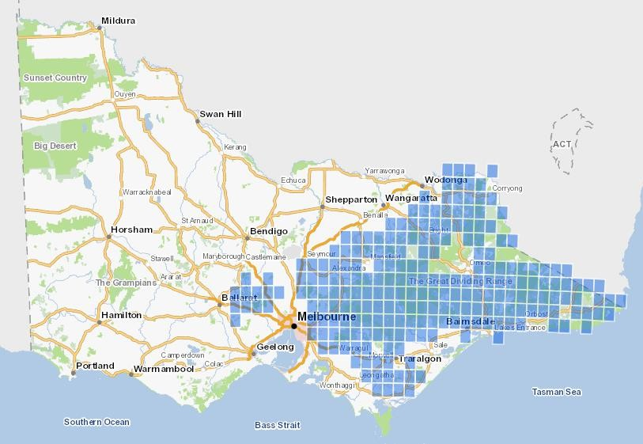In western Victoria, Greater Gliders are found as far west as Daylesford in the Wombat State Forest and surrounding forested areas. Greater Gliders are absent elsewhere in western Victoria, including several large areas of potentially suitable habitat such as the Otway Ranges and Grampians.
Figure 1: Distribution of the Greater Glider in Victoria (Victorian Biodiversity Atlas, 2017)

Habitat

Greater Gliders are forest dependent and prefer older tree age classes in moist forest types. They are obligate users of hollow-bearing trees for shelter and nesting, with each family group using multiple den trees within its home range (Lindenmayer et al. 2004). Greater Glider density varies proportionally to the availability of hollow-bearing trees and do not persist in areas of forest where such trees are absent.
Lindenmayer et al. (1990) found the abundance of Greater Gliders in the Victorian Central Highlands was positively correlated with forest age and the density of hollow-bearing trees. Incoll et al. (2001) also studied Greater Glider abundance in the same habitat type and found a positive correlation with overstorey basal area and old-growth patch size.
There is an inverse relationship between the habitat patch size and extinction risk. Population Viability Analysis (McCarthy and Lindenmayer 1999) suggests increased extinction risk in small patches of suitable habitat. Therefore, populations inhabiting small patches of otherwise suitable habitat are subject to heightened risks of extinction due to the generally low densities and rates of population increase, and the potential impacts of events such as bushfire.
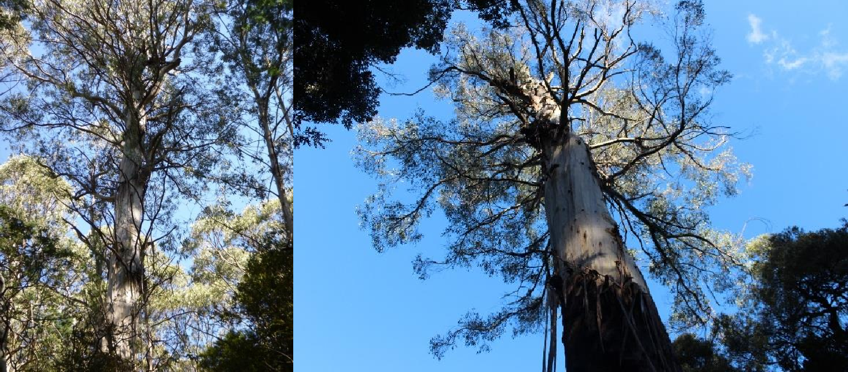

Life history and ecology
Based on data collected in NSW, Tyndale-Biscoe and Smith (1969a) reported that Greater Gliders reached maturity in their second year of life. They noted that 68% of mature females breed each year. A single young is produced each year, resulting in a very low reproductive output. Individuals are largely solitary except during the breeding season. Males occupy exclusive home ranges with little overlap, while the home ranges of females overlap significantly. Density estimates of 0.6 to 2.8 individuals per hectare have been recorded (Henry 1984; van der Ree et al., 2004). There is only limited information on current densities. Home range size varies with habitat quality, availability of suitable food trees and availability of tree hollows.
While evidence is lacking for Victoria, it appears that the Greater Glider has a low capacity for dispersal. Coupled with low reproductive output, this makes the Greater Glider more sensitive to elevated mortality and breeding failure and suggests it has a limited ability to recover from disturbance (Kavanagh and Wheeler 2004).
The diet of Greater Gliders consists almost entirely of eucalypt foliage (Foley and Hume 1987; Foley et al. 1990; and Cunningham et al. 2004), which also provides for approximately 60% of its water intake (Foley et al. 1990). Preferred species in Victoria include Mountain Ash (Eucalyptus regnans) in the Central Highlands; Cut-tail (Eucalyptus fastigata), Manna Gum (Eucalyptus viminalis), White Stringybark (Eucalyptus globoidea) and Narrow-leaved Peppermint (Eucalyptus radiata) in East Gippsland, and Narrow-leaved Peppermint and Mountain Gum (Eucalyptus dalrympleana) in north-east Victoria. Drought reduces the availability of young palatable leaves; it affects growth in eucalypts and thereby the availability of leaves for feeding.

Conservation status

National conservation status
The Greater Glider was listed as vulnerable under the Environment Protection and Biodiversity Conservation Act 1999 in May 2016 (see Department of the Environment and Energy 2016).

Victorian conservation status
The Greater Glider was listed as threatened under the Flora and Fauna Guarantee Act 1988 in June 2017.
In its final recommendation report (SAC 2017), the Flora and Fauna Guarantee Scientific Advisory Committee found that:
- the Greater Glider is in a demonstrable state of decline likely to lead to extinction;
- the Greater Glider is significantly prone to future threats that are likely to lead to extinction; and
- the threats are operating and are expected to continue to operate in the future at a level likely to lead to extinction.
There is evidence that the Greater Glider has declined in some parts of its range in Victoria, including in the Central Highlands and in East Gippsland. In the montane ash forests of the Victorian Central Highlands, Lindenmayer et al. (2011) reported a decline over a 12-year period in the proportion of 160 long-term monitoring sites known to be occupied by Greater Gliders, with annual decline of occupied sites averaging 8.8%. The observed period of decline was associated with a prolonged and severe drought in south eastern Australia (Dijk 2013).
Evidence has also been presented (Lucas Bluff unpubl.) that Greater Gliders have declined in East Gippsland: site-level occupancy rate has declined by ~50% in ~20 years and has declined further than the occupancy rate of other arboreal species, based on resampling of 49 sites across East Gippsland at which Greater Gliders had been recorded in the late 1980s or early 1990s.
Beyond Victoria, there is further evidence of rapid population decline at Booderee National Park on the south coast of New South Wales, where Lindenmayer et al. (2011) reported a decline over a five-year period based on repeated surveys at sites established in a range of habitat types and fire histories, to the point of Greater Gliders being absent from all monitoring sites.

Threats
The key threats to the Greater Glider can be summarised in terms of elevated mortality, habitat degradation and the risks associated with small, fragmented populations, including genetic decline. Factors contributing to elevated mortality and the loss of hollow-bearing trees include bushfire, planned burning, drought, timber harvesting and hyper-predation (SAC 2017). There is some evidence to indicate that climate change in the form of more extreme droughts and higher temperatures might result in a reduction in quality or availability of food. Increased morbidity or mortality might also be associated with heat stress. As populations decline and become more isolated, they are more prone to the effects of small population size and potentially genetic decline. This may result from habitat fragmentation due to land management practices or contraction of suitable habitat due to climate change. Fragmentation and isolation impact on the ability of Greater Gliders to recolonise suitable habitat and reduce genetic exchange between sub-populations.
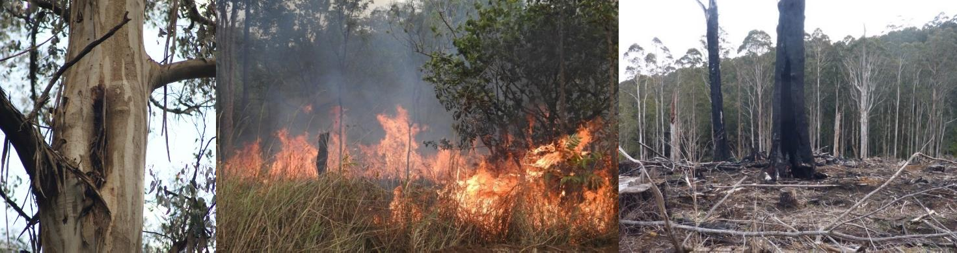

Social and economic issues

Timber supply
Native forest timber harvesting in the eastern and central parts of Victoria overlaps with the main distribution and habitat of the Greater Glider. Timber harvesting has the potential to affect Greater Glider populations through localised habitat modification, however, timber harvesting only occurs in a relatively small proportion of the total area of habitat occupied by Greater Gliders.

Bushfire risk
Fuel management practices across Victoria’s public and private lands aim to reduce the impact of bushfires to communities at risk and provide for the regeneration or preservation of forest assets including ecological and cultural values. This includes undertaking fuel management by planned burning, slashing and mulching. Forest Fire Management Victoria (FFMVic) further reduces risk on public land through early detection and rapid suppression of bushfires. Other works such as upgrading fire towers, building new bridges and improving roads make suppression more achievable and safer, helping to reduce the impact on community and the environment. These activities can require the removal of hazardous trees to ensure that staff can undertake bushfire management work safely. While these activities may have an impact on Greater Glider populations and their habitat, the protection of life and property is an overriding priority of the Victorian Government. Recognising that hazardous trees may also be important habitat for arboreal mammals, wherever possible FFMVic undertakes values checking before undertaking on-ground works to mitigate impacts to habitat.

Animal welfare
The management of public land, including timber harvesting and bushfire prevention and suppression, has the potential to result in injury and death to many animals each year. As a large and readily observable mammal, the impact of these activities on the Greater Glider arouses concern.

Existing conservation measures

Survey
Surveys, including general and targeted surveys, have been undertaken for the Greater Glider since the 1980s and include:
- Land Conservation Council area studies throughout Victoria in the 1980s;
- Surveys associated with comprehensive regional assessments (precursors to Victoria’s five Regional Forest Agreements);
- Pre-logging surveys undertaken for a wide range of forest blocks from mid-1980s to mid-1990s;
- Pre-harvest surveys undertaken by VicForests based on a risk-based approach to manage threatened flora and fauna species and communities, including Greater Gliders, that may be found in areas planned for timber harvesting;
- ARI surveys in the Central Highlands in 2012 investigating current status and impact of 2009 fires (Lumsden et al. 2013);
- Goulburn Broken Catchment Management Authority surveys undertaken in 2010/11 following the 2009 bushfires; these surveys targeted large forest owls but Greater Gliders would have been recorded;
- Arboreal mammal surveys undertaken in 2015 in East Gippsland to assess site occupancy at previously surveyed sites; and
- ARI targeted surveys undertaken in 2017 in the Strathbogie Ranges (Nelson et al. 2018) and Toolangi/Acheron area;
- Various community group surveys (e.g. Strathbogie Sustainable Forest Alliance 2017).
- ARI structured surveys in eastern Victoria undertaken in 2017 and 2018.

The Victorian Government has commenced a program of pre-harvest surveys (the Forest Protection Survey Program) designed to ensure that threatened species and communities are correctly identified and protected in accordance with the Code of Practice for Timber Production, 2014.
In addition, a complementary landscape scale survey program is underway as part of the modernisation of Victoria’s Regional Forest Agreements. The landscape scale survey program will improve the understanding of the distribution and resilience of threatened species and communities across the landscape, irrespective of tenure.
The data and information collected across both survey programs will inform and update our understanding of our threatened species and communities, their distributions and resilience to disturbance factors such as bushfire, climate change, predation and timber harvesting. The capture of this valuable data will lead to the development of improved conservation and protection measures across the landscape.

Modelling
DELWP’s Arthur Rylah Institute has developed a habitat distribution model for the Greater Glider as part of a broader project to develop models for Victorian species to support regulation, investment and public land management. An occupancy model was also developed for the Central Highlands (Lumsden et al. 2013).
Possingham et al. (1994) modelled the probability of persistence of the Greater Glider within the Ada Forest Block under scenarios relating to patches of old-growth forest and the impact of wildfire.
This modelling has assisted in informing habitat to be placed in protection areas for the Greater Glider.

Timber harvesting
At the time of listing (June 2017), approximately 26% of the area identified as likely habitat for the Greater Glider was protected in the formal parks and reserves system, with an additional 14% protected in the Special Protection Zone within State forest. Of the remaining area, approximately 43% fell in the General Management Zone or Special Management Zone of State forest, while 17% was other public land or private land.

In March 2018, the Victorian Government approved the reservation of approximately 2500 hectares of native forest, including substantial areas of old-growth forest, in the Kuark Forest in East Gippsland. At the same time, the Victorian Government announced that very large, living trees in excess of 2.5 metres diameter at breast height will be protected from timber harvesting throughout State forest.

Fire management
The primary objectives of DELWP’s fuel management program is to minimise the impact of major bushfires on human life and other values - including the environment, as well as maintaining or improving the resilience of natural ecosystems. DELWP’s fuel management processes are designed to consider forest values and how they can be protected through strategic planning and the way we operationally deliver any fuel management activities. Planning and delivery of this work is guided by expert knowledge and advice to ensure forests are managed for a diverse range of ecological, cultural and built values.
The Greater Glider is recognised as a threatened species in DELWP’s processes of strategic and operational bushfire management planning. In strategic bushfire management planning, DELWP will take account of Greater Glider habitat and colonies when designating different fire management zones in the landscape.
Operational planning includes additional checks of values that may be impacted by fuel management activities. Nominated burns are tested against known data surveys which encompass a range of information, to determine if they overlap habitat areas and ranges of vulnerable species. If a potential impact is flagged, biodiversity experts within DELWP recommend options to minimise impact. Examples of mitigation measures include:

- clearing fine fuels from around hollow-bearing habitat trees with rake hoes to ensure they do not burn;
- burning at a lower intensity;
- burning during particular seasons;
- undertaking mechanical treatment rather than planned burning; and
- avoiding using heavy machinery or chemicals in certain areas.

Hazardous tree management
In preparing planned burn sites, hazardous trees which have been identified as significant, such as scar trees or hollow-bearing habitat trees, are designated for protection and removal is avoided where possible.

Research
Many research projects and publications are relevant to the Greater Glider; the following is a selective summary. Research relating to the distribution, abundance and population trends of the Greater Glider include a review of the evidence for recent decline (Lindenmayer et al. 2011) and the resampling of survey sites in East Gippsland (Bluff in prep.).
Investigations into the biology of the Greater Glider include studies of population structure (Henry 1984, Tyndale-Biscoe and Smith 1969a) and studies of diet and metabolism (Foley et al. 1990, Jensen et al. 2015, Kavanagh and Lambert 1990). Home range estimates have been provided by Pope et al. (2005), Smith et al. (2007) and Kavanagh and Wheeler (2004). Rübsamen et al. (1984) studied the metabolic response of the Greater Glider to heat stress.
Habitat-related studies include the use of patches in fragmented habitat (Lindenmayer et al. 2005, Incoll et al. 2001). Research relating to the Greater Glider’s response to disturbance include, the effects of variable- intensity logging (Kavanagh 2000), persistence in areas affected by bushfire (Lindenmayer et al. 2011) and response to permanent habitat destruction (Tyndale-Biscoe and Smith 1969b). VicForests has undertaken planning for a study to assess survival and persistence of Greater Gliders under various harvesting intensities in mixed species forest.
DELWP is currently investigating the impact of fuel management on Greater Glider as part of its monitoring, evaluation and reporting program for bushfire risk management while loss of hollow-bearing trees resulting from planned burning has been assessed for sites in East Gippsland (Bluff 2016). Other studies relating to the impacts of bushfires include Berry et al. (2015) and Lindenmayer et al. (2016).
Studies relevant to the threat posed by predation include Kavanagh (1988), Pavey (1992), Bilney et al. (2006), Glen and Dickman (2005), Cook et al. 2006 and Belcher et al. (2007). Use of artificial nest boxes by Greater Gliders, among other species, was investigated by Menkhorst (1984) and Lindenmayer et al. (2003).

Conservation objectives, measures and intended management actions

In November 2019, the Victorian Government announced further measures which will support Greater Glider populations:
- The end of timber harvesting in old-growth forest immediately; and
- Phase-out of native forest timber harvesting by 2030.
In addition, this Action Statement identifies the following additional management actions to achieve the conservation objectives for the Greater Glider.

Long term objective | The long-term conservation objective is to ensure the Greater Glider can survive, flourish and retain its potential for evolutionary development in the wild.
Objectives of this Action Statement | - To address specific knowledge gaps in the biology and ecology of the Greater Glider to support ecologically sustainable management regimes  - To secure populations or habitat from potentially incompatible land use or catastrophic loss.

Intended Management Actions | Responsibility
Objective 1: To address specific knowledge gaps in the biology and ecology of the Greater Glider to support ecologically sustainable management regimes
- Develop and implement targeted research programs that:  - Determine the distribution, abundance and population genetics of Greater Gliders, and correlate this data with key habitat features (including hollow bearing trees, forest structure), fire history, timber harvesting and climate change impacts such as drought and heat;  - Based on the above analyses, develop occupancy models to inform the most effective ways to manage forest ecosystems. | DELWP
2. Develop and implement a focussed research program to assess the survival and persistence of Greater Gliders under various timber harvesting scenarios. This should include pre- and post-harvest assessments of Greater Glider distribution, abundance, population structure and movement patterns – and be able to quantify the specific benefits of different timber harvest strategies. | DELWP
- Develop and implement a focussed research program to:  - Correlate climate change impacts such as temperature and drought with Greater Glider population attributes;  - Determine the specific impacts of heat stress and foliage nutritional value, as affected by climate change impacts, on Greater Glider physiology and foraging; and  - Based on the above research, identify potential refuges for Greater Glider under different climate change scenarios. | DELWP
Objective 2: To secure populations or habitat from potentially incompatible land use or catastrophic loss
4. Immediately protect key areas of habitat across eastern Victoria. An indicative map of these areas is included at Attachment 1. When boundaries are finalised, an update to this action statement will be released that includes the final map. | DELWP
5. Retain at least 40% of the basal area of eucalypts across each timber harvesting coupe, prioritising live, hollow bearing trees, wherever a density of Greater Gliders equal to or greater than five individuals per spotlight kilometre (or equivalent measure) is identified. Note that this prescription replaces the existing requirement to establish a Special  Protection Zone in cases where greater than 10 individuals per spotlight kilometre (or | VicForests

Intended Management Actions | Responsibility
equivalent measure) are detected in the East Gippsland Forest Management Area.
6. Ensure that fire planning officers use the best available information in bushfire incident management, and that fire suppression actions such as construction of control lines and back-burning should avoid important populations and associated habitat. | DELWP
7. Determine the most appropriate fire management practices to ensure viable populations of Greater Glider and their habitat (including key features such as hollows in large old trees). This includes developing feasible, cost-effective measures to mitigate any significant impacts of planned burning on Greater Glider populations and their habitat. Incorporate these measures into strategic, tactical and operational fire management plans. | DELWP
8. Ensure the necessary information on distribution, abundance, habitat preferences and habitat management (including old growth forest) is collected to identify near- and longer- term importance of areas for a range of forest-dependent species, including the Greater Glider, and use this information to inform planning for any new park and/or reserve system to protect forest-dwelling species as part of the modernisation of Victoria’s Regional Forest Agreements. | DELWP

10 Greater Glider Action Statement

References

Belcher, C. A., J. L. Nelson, and J. P. Darrant. (2007) Diet of the tiger quoll (Dasyurus maculatus) in south-eastern Australia. Australian Journal of Zoology 55: 117-122.
Berry, L E., D A. Driscoll, S. C. Banks, and D. B. Lindenmayer. (2015) The use of topographic fire refuges by the greater glider (Petauroides volans) and the mountain brushtail possum (Trichosurus cunninghami) following a landscape-scale fire. Australian Mammalogy 37: 39-45.
Bilney, R. J., R. Cooke, and J. White. (2006) Change in the diet of sooty owls (Tyto tenebricosa) since European settlement: from terrestrial to arboreal prey and increased overlap with powerful owls. Wildlife Research 33: 17-24.
Bluff, L. (2016). Reducing the effect of planned burns on hollow-bearing trees. Department of Environment, Land, Water and Planning, 2016.
Cooke, R., R. Wallis, F. Hogan, J. White, and A. Webster. (2006) The diet of powerful owls (Ninox strenua) and prey availability in a continuum of habitats from disturbed urban fringe to protected forest environments in south-eastern Australia. Wildlife Research 33: 199-206.
Cunningham, R. B., M. L. Pope, and D. B. Lindenmayer. (2005) Patch use by the greater glider (Petauroides volans) in a fragmented forest ecosystem. III. Night-time use of trees. Wildlife Research 31: 579-585.
Department of the Environment and Energy (2016) Conservation advice. Petauroides volans Greater Glider. Department of Energy and Environment, Canberra. http://www.environment.gov.au/biodiversity/threatened/species/pubs/254- conservation-advice-05052016.pdf Accessed 3 July 2017.
DEPI (2014) Planning Standards for timber harvesting operations in Victoria’s State forests 2014. Department of Environment and Primary Industries, Melbourne.
Dijk, A. I.J.M., H. E. Beck, R. S. Crosbie, R. A.M. Jeu, Y-Y. Liu, G. M. Podger, B. Timbal, and N. R. Viney. (2013) The Millennium Drought in southeast Australia (2001–2009): Natural and human causes and implications for water resources, ecosystems, economy, and society. Water Resources Research 49: 1040-1057.
Foley, W. J., J. C. Kehl, K. A. Nagy, I. R. Kaplan, and A. C. Borsboom. (1990) Energy and water metabolism in free-living greater gliders, Petauroides volans. Australian Journal of Zoology 38: 1-9.
Glen, A. S., and C. R. Dickman. (2006) Diet of the spotted‐tailed quoll (Dasyurus maculatus) in eastern Australia: effects of season, sex and size. Journal of Zoology 269: 241-248.
Henry, S. R. (1984) Social organisation of the greater glider (Petauroides volans) in Victoria. In Possums and Gliders
(eds A. P. Smith & I. D. Hume), pp. 221-228. Surrey Beatty and Sons, Chipping Norton.
Incoll, R. D., R. H. Loyn, S. J. Ward, R. B. Cunningham, and C. F. Donnelly. (2001) The occurrence of gliding possums in old-growth forest patches of mountain ash (Eucalyptus regnans) in the Central Highlands of Victoria. Biological Conservation 98: 77-88.
Jensen, L.M., I.R. Wallis, and W.J. Foley. (2015) The relative concentrations of nutrients and toxins dictate feeding by a vertebrate browser, the greater glider Petauroides volans. PloS one 10: e0121584.
Kavanagh, R.P. (1988) The impact of predation by the powerful owl, Ninox strenua, on a population of the greater glider,
Petauroides volans. Austral Ecology 13: 445-450.
Kavanagh, R.P. (2000) Effects of variable-intensity logging and the influence of habitat variables on the distribution of the greater glider Petauroides volans in montane forest, south-eastern New South Wales. Pacific Conservation Biology 6:
18-30.
Kavanagh, R.P., and M. J. Lambert. (1990) Food selection by the greater glider, Petauroides volans: is foliar nitrogen a determinant of habitat quality? Australian Wildlife Research 17: 285-299.
Kavanagh, R. P., & Wheeler, R. J. (2004) Home range of the greater glider Petauroides volans in tall montane forest of south-eastern New South Wales, and changes following logging. In The Biology of Australian Possums and Gliders (eds
R. L. Goldingay & S. M. Jackson), pp. 413-425. Surrey Beatty and Sons, Sydney.
Lindenmayer, D. B., C. I. MacGregor, R. B. Cunningham, R. D. Incoll, Mason Crane, D. Rawlins, and D. R. Michael. (2003) The use of nest boxes by arboreal marsupials in the forests of the central highlands of Victoria. Wildlife Research 30: 259-264.
Lindenmayer, D. B., J. T. Wood, L. McBurney, C. MacGregor, K. Youngentob, and S. C. Banks. (2011) How to make a common species rare: a case against conservation complacency. Biological Conservation 144: 1663-1672.
Lindenmayer, D. B., M. L. Pope, and R. B. Cunningham. (2005) Patch use by the greater glider (Petauroides volans) in a fragmented forest ecosystem. II. Characteristics of den trees and preliminary data on den-use patterns. Wildlife Research 31: 569-577.
Lindenmayer, D. B., R. B. Cunningham, M. T. Tanton, A. P. Smith, and H. A. Nix. (1990) Habitat requirements of the mountain brushtail possum and the greater glider in the montane ash-type eucalypt forests of the central highlands of Victoria. Australian Wildlife Research 17: 467-478.
Lindenmayer, D. B., W. Blanchard, L. McBurney, D. Blair, S. C. Banks, D. Driscoll, A. L. Smith, and A. M. Gill. (2013) Fire severity and landscape context effects on arboreal marsupials. Biological Conservation 167: 137-148.

Lindenmayer, D.B., W. Blanchard, L. McBurney, D. Blair, S. Banks, G.E. Likens, J.F. Franklin, W.F. Laurance, J.A.R. Stein, and P. Gibbons. (2012) Interacting factors driving a major loss of large trees with cavities in a forest ecosystem. PLoS One 7: e41864.
Lindenmayer, D.B., R.B. Cunningham, and C.F. Donnelly. (1997) Decay and collapse of trees with hollows in eastern Australian forests: impacts on arboreal marsupials. Ecological Applications 7: 625-641.
Lindenmayer, D.B., R.J. Hobbs, G.E. Likens, C.J. Krebs, and S.C. Banks. (2011) Newly discovered landscape traps produce regime shifts in wet forests. Proceedings of the National Academy of Sciences 108: 15887-15891.
Lindenmayer, D.B., W. Blanchard, C. MacGregor, P. Barton, S.C. Banks, M. Crane, D. Michael (2016) Temporal trends in mammal responses to fire reveals the complex effects of fire regime attributes. Ecological Applications 26: 557-573.
Lumsden, L. F., J. L. Nelson, C. R. Todd, M. P. Scroggie, E. G. McNabb, T. A. Raadik, S. J. Smith (2013) A new strategic approach to biodiversity management–research component. Arthur Rylah Institute for Environmental Research. Unpublished client report for the Department of Environment and Primary Industries.
McCarthy, M.A., and D.B. Lindenmayer (1999) Conservation of the greater glider (Petauroides volans) in remnant native vegetation within exotic plantation forest. Animal Conservation 2: 203-209.
McCarthy, M.A., and D.B. Lindenmayer. (1999) Incorporating metapopulation dynamics of greater gliders into reserve design in disturbed landscapes. Ecology 80: 651-667.
McKay, G. M. (2008). Greater Glider Petauroides volans. In The Mammals of Australia. Third edition. (Eds S. Van Dyck & R. Strahan), pp. 240-242. Reed New Holland, Sydney.
Menkhorst, P. W. (1984) Use of nest boxes by forest vertebrates in Gippsland: acceptance, preference and demand. Wildlife Research 11: 255-264.
Nelson, J.L., Scroggie, M.P., Durkin, L.K., Cripps, J.K., Ramsey, D.S.L. and Lumsden, L.F. (2018). Estimating the density of the Greater Glider in the Strathbogie Ranges, North East Victoria, with an assessment of coupes scheduled for timber harvesting in 2018. Arthur Rylah Institute for Environmental Research Technical Report Series No. 293.
Pavey, C. R. (1992) Impact of powerful owl predation on a population of the greater glider: a response to Kavanagh (1988). Austral Ecology 17: 463-467.
Pope, M. L., D. B. Lindenmayer, and R. B. Cunningham. (2005) Patch use by the greater glider (Petauroides volans) in a fragmented forest ecosystem. I. Home range size and movements. Wildlife Research 31: 559-568.
Possingham, H. P., D. B. Lindenmayer, T. W. Norton, and I. Davies. (1994) Metapopulation viability analysis of the greater glider Petauroides volans in a wood production area. Biological Conservation 70: 227-236.
Rübsamen, K., I. D. Hume, W. J. Foley, and U. Rübsamen (1984) Implications of the large surface area to body mass ratio on the heat balance of the greater glider (Petauroides volans: Marsupialia). Journal of Comparative Physiology B: Biochemical, Systemic, and Environmental Physiology 154: 105-111.
Schirmer, J., Mylek, M., and Morison, J. (2013). Socio-economic characteristics of Victoria’s forestry industries, 2009- 2012. Department of Environment and Primary Industries.
Scientific Advisory Committee, Flora and Fauna Guarantee (2017) Final recommendation on a nomination for listing:
Petauroides volans subsp. volans Kerr 1792 – Greater Glider.
Smith, G.C., M. Mathieson, and L. Hogan. (2007) Home range and habitat use of a low-density population of greater gliders, Petauroides volans (Pseudocheiridae: Marsupialia), in a hollow-limiting environment. Wildlife Research 34: 472- 483.
Strathbogie Sustainable Forest Alliance (2017) May 2017 community spotlighting program. Blog post at : https://strathbogiesustainableforests.wordpress.com/2017/04/29/may-june-2017-community-spotlighting-program/ accessed 29 June 2017.
Tyndale-Biscoe, C. H., and R. F. C. Smith. (1969b) Studies on the marsupial glider, Schoinobates volans (Kerr): III. Response to habitat destruction. Journal of Animal Ecology 38: 651-659.
Tyndale-Biscoe, C.H. and Smith, R.F.C. (1969a). Studies on the marsupial glider, Schoinobates volans (Kerr): ii: Population structure and regulatory mechanisms. Journal of Animal Ecology 38: 637-650.
van der Ree, R., S. J. Ward, and K. Handasyde. (2004) Distribution and conservation status of possums and gliders in Victoria. Pages 91-110 in R. L. Goldingay and S. Jackson, editors. The biology of Australian possums and gliders. Surrey Beatty and Sons PTY, Chipping Norton, Australia.

Attachment 1: Immediate Protection Areas (Indicative)

Benalla
VICTORIA

Bright

Alexandra
Mansfield

Omeo

Healesville

Bairnsdale

Lakes Entrance
Orbost

Pakenham

Warragul

Leongatha

Traralgon Morwell

Sale
Legend
IPAs PARKS SPZ

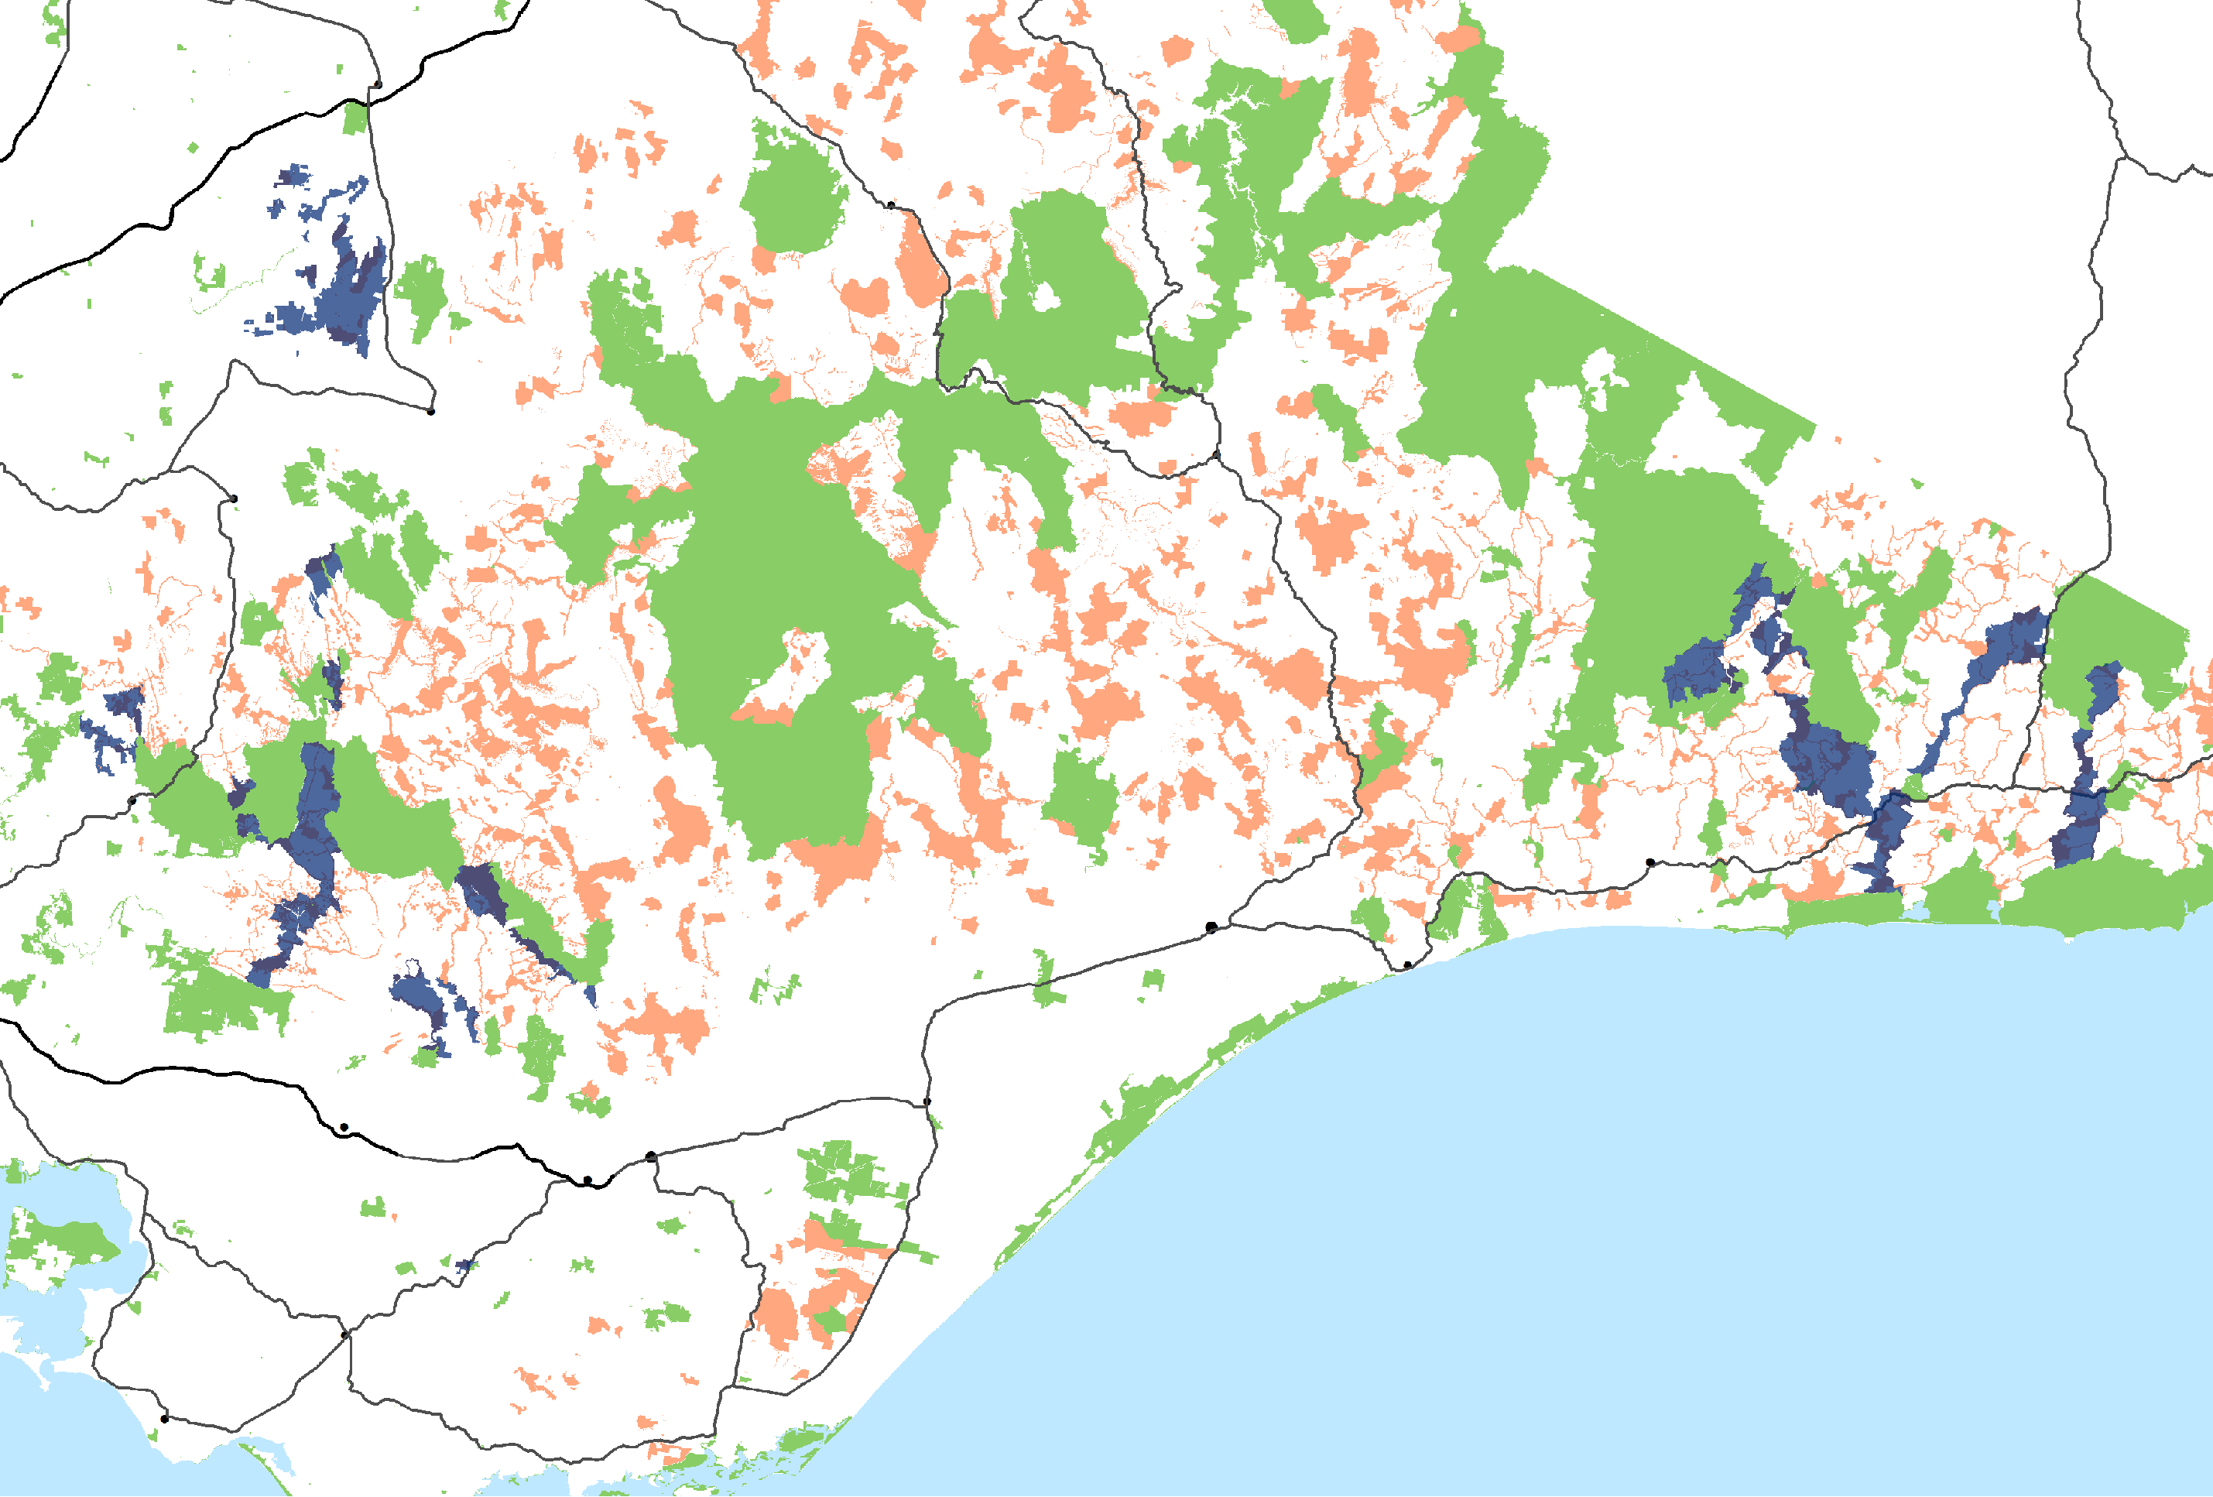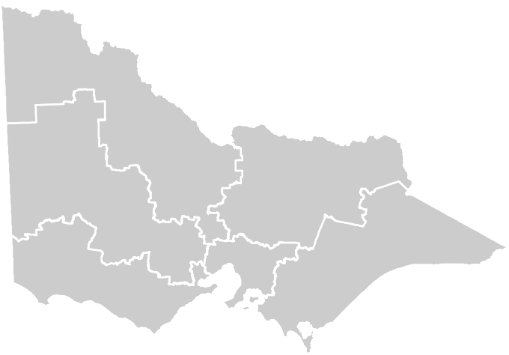Wonthaggi

NOTE: Boundaries may be subject to future amendments

Greater Glider Action Statement 13

delwp.vic.gov.au

