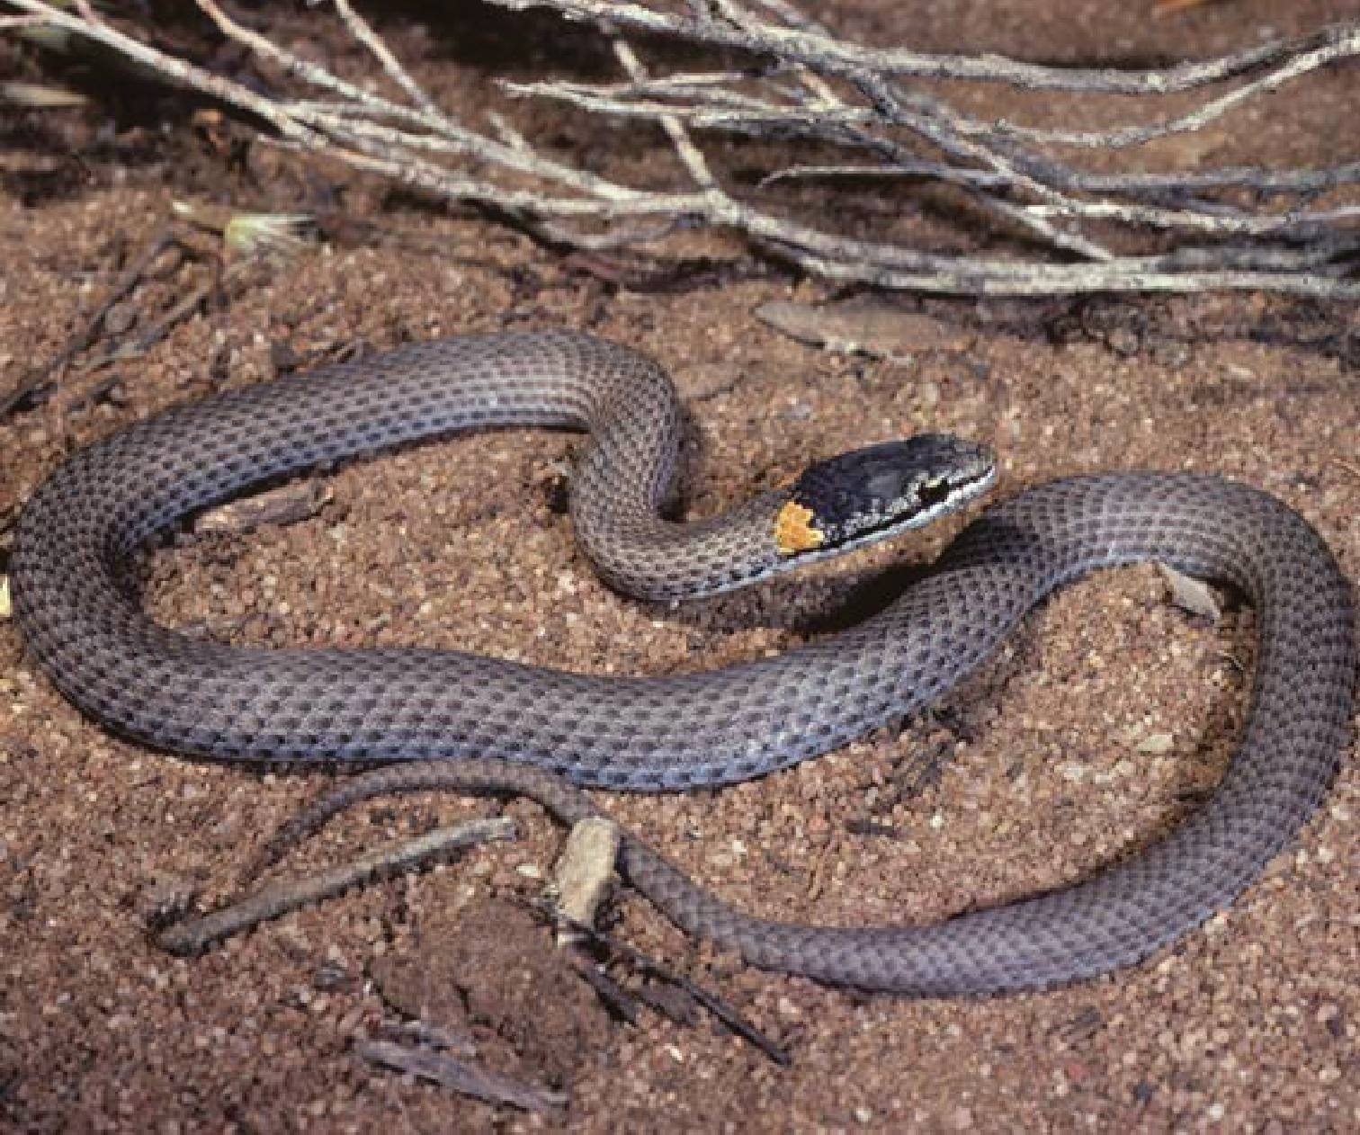Action statement No.263
Flora and Fauna Guarantee Act 1988

Masters’ Snake Drysdalia mastersii

© The State of Victoria Department of Environment, Land, Water and Planning 2015

This work is licensed under a Creative Commons Attribution 4.0 International licence. You are free to re-use the work under that licence,
on the condition that you credit the State of Victoria as author. The licence does not apply to any images, photographs or branding, including the Victorian Coat of Arms, the Victorian Government logo and the Department of Environment, Land, Water and Planning (DELWP) logo.
To view a copy of this licence, visit http://creativecommons.org/licenses/by/4.0/

Cover photo: Peter Robertson
Compiled by: Nick Clemann (Arthur Rylah Institute) and Peter Robertson (Wildlife Profiles Pty. Ltd.) ISBN: 978-1-74146-934-9 (pdf)

Disclaimer
This publication may be of assistance to you but the State of Victoria and its employees do not guarantee that the publication is without flaw of any kind or is wholly appropriate for your particular purposes and therefore disclaims all liability for any error, loss or other consequence which may arise from you relying on any information in this publication.

Accessibility
If you would like to receive this publication in an alternative format, please telephone the DELWP Customer Service Centre on 136 186, email customer.service@delwp.vic.gov.au, or via the National Relay Service on 133 677, email www.relayservice.com.au. This document is also available on the internet at www.delwp.vic.gov.au

Action Statement No. 263
Masters’Snake Drysdalia mastersii

Description
Masters’ Snake is a small grey-brown member of the family Elapidae (terrestrial, front-fanged venomous snake). A broken orange-yellow band or collar on the nape, and a lower number of subcaudal scales (ranging from 34 to 43 in Victoria (Coventry and Robertson 1991), although Cogger (2000) reports subcaudal scales in the range 40 to 55) distinguish
it from the congeneric and superficially similar White-lipped Snake D. coronoides (which has 38 to 67 subcaudal scales). These species’ ranges do not overlap. Masters’ Snake’s scales often have light lateral tips that produce a series of faint longitudinal striations (Cogger 2000). The head is darker than the body. Coventry and Robertson (1991) report a maximum length of less than 30 cm for Victorian specimens, whilst Wilson and Swan (2010) and Cogger (2000) report maximum lengths of 33 and 40 cm respectively. The largest specimen measured by Shine (1981) had a snout-vent length (SVL) of 25.3 cm. Size at birth is around 8 cm SVL (Shine 1981).

Distribution
In Victoria, Masters’ Snake is known only from the Big Desert (including Wyperfeld National Park) (Coventry and Robertson 1991, Coventry 1996a and b, Victorian Biodiversity Atlas 2015). More broadly, it occurs in semi-arid southern Australia, from near Esperance, Western Australia, to the Big Desert in Victoria. Earlier literature did not list Masters’ Snake amongst reptiles known from the Victorian Mallee (Rawlinson 1966). Gilmore and McVicar (1973) detailed the first two specimens from the collection of the (then) National Museum of Victoria.

Habitat
In Victoria, Masters’ Snake occurs in mallee and heath communities, usually in association with porcupine grass (Triodia scariosa) (Robertson et al. 1989, Coventry and Robertson 1991). Beyond Victoria, it has also been recorded in dense heath
on coastal dunes and limestones (Wilson and Swan 2010, P. Robertson pers. obs.).

Life History and Ecology
Masters’ Snake is diurnal and feeds on small lizards (Shine 1981, 1991). Coventry (1996b) recorded
the skinks Morethia obscura, Lerista bougainvillii
and Ctenotus robustus in the stomachs of Masters’
Snakes trapped in the Big Desert. It is viviparous, producing two to three young each year (mean 2.8, Shine 1981). Coventry (1996b) suggests that
mating occurs soon after females give birth, and that females are likely to store sperm over winter.

Conservation status

Victorian conservation status
Masters’ Snake (Drysdalia mastersii) has been listed as threatened under the Victorian Flora and Fauna Guarantee Act 1988.
Masters’ Snake (Drysdalia mastersii) has been listed as endangered in Victoria according to the Department of Environment, Land, Water and Planning (DELWP)’s Advisory List of Threatened
Vertebrate Fauna in Victoria - 2013 (DSE 2013).

Threats
Based on surveys using pitfall traps in the Big Desert in the late 1970s and early 1980s, Coventry (1996b) labelled Masters’ Snake “the most common elapid trapped or observed during the survey” (p. 115).
However, the species appears to have suffered a precipitous decline since that time. There was no pitfall trapping within the known Victorian range of Masters’ Snake between 1987 and 2002, but intensive trapping since 2002 in the parts of the Big Desert where Masters’ Snake was previously
recorded has failed to detect the species (Robertson et al. 2010; P. Robertson unpublished data). Only two records of the species were recorded on the Victorian Biodiversity Atlas in that period, in 1999 and 2007.

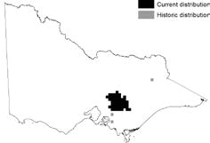
Distribution in Victoria (DELWP, 2015)

Unlike most small snakes that occur in far north- western Victoria, Masters’ Snake is not a burrowing species; instead it relies on live vegetation, and possibly ground debris and plant litter, for shelter from very high ground temperatures in summer and predators(P. Robertson pers. obs.). It is likely that long unburnt vegetation provides critical habitat and drought refuges, so loss of these shelter sites is likely to represent a major threat to this snake. In recent years much of the range of Masters’ Snake has been burnt by wildfire and planned burning. This is likely to have resulted in a severe reduction in available shelter for this species, with concomitant declines
in geographic range and numbers. It is likely that the ‘Millennium Drought’, which affected south-
eastern Australia between 1995 and 2009, adversely affected Masters’ Snake by increasing the severity of fires, and perhaps through less immediate effects on the snake’s habitat and prey.
Red Foxes Vulpes vulpes and Cats Felis catus are known predators of small reptiles (e.g., Read and Bowen 2001), but their specific impacts on Masters’ Snake have not been quantified. It is likely that these exotic predators take Masters’ Snake, and the snake is likely to be particularly vulnerable in areas where shelter is scarce, such as areas that have been burnt. The area in Victoria where Masters’ Snake occurs has been subject to intense wild dog control in recent years; it is plausible that a reduction in dogs may have resulted in greater numbers of foxes and cats in this area (i.e. ‘mesopredator release’ Ritchie and Johnson (2009)). The track network through
this landscape is likely to facilitate the movements of feral predators (Woinarski 1989). The impact of elevated predation rates due to exotic predators will be most devastating to populations of Masters’ Snakes that are already fragmented and/or small due to other pressures.

Standard threat Source of threat Explanation
Loss of important habitat features | Fire - bushfire Fire - frequency Fire - intensity | Fire removes habitat elements that are critical for the persistence of Masters’ Snake. Large, intense and frequent fires represent a threat to this species, removing their shelter from the effects of very high ground temperatures in summer and from predators.
Climate | Drought | Protracted drought predisposes the habitat of Masters’ Snake to fire (see above). Similarly, the effects of drought (and fire) may adversely affect the lizards that form the diet of Masters’ Snake.
 | Climate change | Like all reptiles, Masters’ Snake is ectothermic, and key physiological functions are affected by the thermal  environment. Consequently, a changing climate may affect these functions in ways that are not yet well understood.  A changing climate may also lead to changes in the frequency and intensity of fires, and changes to vegetation type and structure, and predator / prey relationships that adversely affect Masters’ Snake.
Predation | Animals - foxes Animals - cats | Predation rates of Masters’ Snake are elevated by exotic predators such as foxes and cats. This threat may be particularly devastating for populations that are small and/or fragmented due to other threats such as loss of habitat due to fire.

Important locations
Due to apparent declines and likely loss and degradation of habitat, all extant populations of Masters’ Snake are important for the persistence of the species in Victoria.
Catchment | Location name | Land manager | Bioregion
MALLEE | Big Desert | Parks Victoria | Lowan Mallee

Past management actions
No specific conservation management actions have been undertaken for the Masters’ Snake.
Action Result explanation
Conduct survey | Numerous fauna surveys have been conducted in the Big Desert, some (but not all) of which have resulted in records of Masters’ Snake (e.g., Mather 1979, Menkhorst 1982, Woinarski 1989, Robertson et al. 1989, Coventry 1996a and b, Robertson et al. 2010).

Conservation objectives

Long term objective
To ensure that the Masters’ Snake can survive, flourish and retain its potential for evolutionary development in the wild.

Objectives of this Action Statement
- To increase knowledge of biology, ecology or management requirements
- To maintain or improve condition of habitat
- To mitigate the impact of threatening processes affecting Masters’ Snake

Intended management actions
The actions in this action statement have been developed taking into consideration relevant social and economic matters, as required under the FFG Act.
These actions are designed to support the conservation, management or control of flora and fauna and the management of potentially threatening processes, which will assist in mitigating any impact of climate change on the Masters’ Snake, and will have no impact on greenhouse gas emissions.
The intended management actions listed below are further elaborated in DELWP’s Actions for Biodiversity Conservation (ABC) system. Detailed information about the actions and locations, including priorities, is held in this system and will be updated annually for land managers and other authorities.

Standard objective | Objective explanation
To increase knowledge of biology, ecology or  management requirements | Effective management of threatened species such as Masters’ Snake must be underpinned by robust knowledge of the biology, ecology and management requirements of the taxon. This objective seeks to source key information that will be used to inform the management of this species.
Standard action | Details | Responsible agents
Conduct survey to determine abundance / extent | The current geographic range of Masters’ Snake in Victoria, and the species’ relative abundance across this range, is not known. This action will clarify these parameters. Concurrent assessments  of habitat variables at survey sites can be collected during surveys in order to refine understanding of the species’ habitat preferences and the effects of changes to habitat. | DELWP, Parks Victoria
Conduct priority research projects as specified | Assess impacts on Masters’ Snake of wildfire and planned burning. | DELWP, Parks Victoria

Conduct priority research projects as specified | Undertake demographic and site occupancy monitoring of sufficient intensity and duration to understand population and occupancy trends, and the factors driving those trends. | DELWP

Standard objective | Objective explanation
To maintain or improve condition of habitat | Loss and degradation of habitat is considered the greatest immediate threat to the persistence of Masters’ Snake in Victoria. This objective seeks to ensure that existing habitat is maintained, and lost or degraded habitat is allowed to recover.
Standard action | Details | Responsible agents
Identify fire management priorities and develop detailed plan | Land managers should consult with relevant experts on the Masters’ Snake prior to conducting planned burns within the known or suspected range of the species. To facilitate this, contact details for relevant experts and information on the Masters’ Snake’s distribution and habitat preferences (including the post-fire age of vegetation) should be included in all relevant fire planning by DELWP and Parks Victoria.  Fuel reduction fires should be planned so as to maximise the amount of habitat that is in a state of stasis (see above), and to maximise a mosaic of age classes, whilst ensuring that suitably-aged stands of habitat are retained for Masters’ Snake. | DELWP, Parks Victoria
Protect habitat from fire | High quality, contiguous habitat is likely to be the most important factor in the persistence of Masters’ Snake. Maintenance of this habitat will  help the species cope with other pressures, such as predation, and will ensure that resources such as shelter and prey are available. Habitat that is most favourable for Masters’ Snake is likely to be present when the vegetation community is in a long post- fire state of ‘stasis’, which Cheal (2010) suggests occurs 24 to 60 years after fire in this region. It is vital that fires are not so large that they burn all or most habitat occupied by the species. Ensuring this will necessitate a mosaic pattern of burns such that large, connected tracts remain in the stasis age class. Suppression of wildfires within the known  or suspected range of Masters’ Snake should be a priority.  Where possible, bushfires should be suppressed in areas where Masters’ Snake is known to occur, or in habitat that is in a state of stasis. | DELWP Parks Victoria

Standard objective | Objective explanation
To mitigate the impact of threatening processes affecting Masters’ Snake | It is highly likely that Masters’ Snake has declined within Victoria due to the effects of threatening processes. This objective seeks to mitigate the impacts of these processes so that the species can recover.
Standard action | Details | Responsible agents
Control exotic predators | Rates of predation of Masters’ Snakes that are elevated by the presence of exotic predators such as foxes and cats represent a threat to this species, especially where habitat has been lost, degraded or fragmented. Systematic and sustained control of these predators is desirable. Predator control should be coordinated to ensure that dogs, cats and Foxes are controlled at the same time in order to avoid ‘mesopredator release’. Control programs for exotic predators (especially foxes and cats)  should be initiated or intensified within and around the Big Desert. | DELWP Parks Victoria
Monitor effectiveness of threat management activities | Establish a population monitoring program for Masters’ Snake to assess the effects of exotic predator control. The results of this monitoring would inform the predator control program in order to ensure that predator suppression was sufficient to allow recovery of Masters’ Snakes throughout the Big Desert. | DELWP

References
Cheal, D. 2010. Growth stages and tolerable fire intervals for Victoria’s native vegetation data sets. Fire and adaptive management report No. 84.
Department of Sustainability and Environment, East Melbourne.
Coventry, A. J. 1996a. Results of surveys of the herpetofauna of several areas in north-western Victoria. The Victorian Naturalist 113: 289-298.
Coventry, A. J. 1996b. The herpetofauna of the Chinaman Well area of the Big Desert, Victoria. Proceedings of the Royal Society of Victoria 108: 107-119.
Coventry, A. J. and Robertson, P. 1991. The Snakes
of Victoria – a Guide to their Identification. Department of Conservation and Environment, East Melbourne.
Cogger, H.G. 2000. Reptiles and Amphibians of Australia - 6th edition. Sydney, NSW: Reed New Holland.
Department of Environment, Land, Water and Planning (DELWP) 2015. Data Source: ‘Biodiversity Interactive Map’. Site version 3.2. Retrieved December 2015: http://mapshare2.dse.vic.gov.au/ MapShare2EXT/imf.jsp?site=bim
Department of Sustainability and Environment (DSE) 2013. Advisory List of Threatened Vertebrate Fauna in Victoria – 2013. Department of Sustainability and Environment, East Melbourne.
Gilmore, A. M. and McVicar, J. M. 1973. Report on the reptiles of the Victorian Mallee from the
collections and archives of the National Museum of Victoria. Land Conservation Council of Victoria.
Mather, P. B. 1979. An examination of the reptile fauna of Wyperfeld National Park using pitfall trapping. The Victorian Naturalist 96: 98-101.
Menkhorst, P. W. 1982. Pitfall trapping of reptiles in the Big Desert, Victoria. The Victorian Naturalist 99: 66-70.
Rawlinson, P. A. 1966. Reptiles of the Victorian Mallee. Proceedings of the Royal Society of Victoria 79: 605-619.
Read, J. & Bowen, Z. 2001 Population dynamics, diet and aspects of the biology of feral cats and foxes in arid South Australia. Wildlife Research, 28(2): 195-203.
Ritchie, E. G. and Johnson, C. N. 2009. Predator interactions, mesopredator release and biodiversity conservation. Ecology Letters 12: 982-
998.
Robertson, P., Bennett, A. F., Lumsden, L. F., Silveira,
C. E., Johnson. P. G. Yen, A.L., Milledge, G. A., Lillywhite, P. K. and Pribble, H. J. 1989. Fauna of the Mallee study area north-western Victoria. Arthur Rylah Institute for Environmental Research, Technical Report Series No. 87.

Robertson, P., Coventry, P., Gibbons, D., Silveira, C., Sluiter, I., Morgan, D. and Baumgartner, J.
2010. Examination of the responses of terrestrial vertebrates to the 2002 wildfire in the Big Desert. Interim report 2: Results from surveys in 1985-87, 2003-04 and 2009. Unpublished report to the Department of Sustainability and Environment. Wildlife Profiles Pty. Ltd., Melbourne.
Shine, R. 1981. Venomous snakes in cold climates: ecology of the Australian genus Drysdalia (Serpentes: Elapidae). Copeia 1981: 14-25.
Shine, R. 1991. Australian Snakes: a Natural History. Reed New Holland, Sydney.
Woinarski, J. C. Z. 1989. The vertebrate fauna of Broombush Melaleuca uncinata vegetation in north-western Victoria, with reference to the effects of Broombush harvesting. Australian Wildlife Research 16: 217-238.

www.delwp.vic.gov.au

