Introduction
Biodiversity Response Planning (BRP) is a long-term area-based planning approach to biodiversity conservation in Victoria. It is designed to strengthen alignment, engagement and participation between government, Traditional Owners, non-government agencies and the community.
DELWP Regional staff have been working with stakeholders on actions to conserve biodiversity in specific landscapes, informed by the best available science and local knowledge.
These Fact Sheets capture a point in time, reflecting data and knowledge available in 2020. They provide information for many (but not all) landscapes across Victoria, containing general information on the key values and threats in each area, as well as the priority cost-effective actions that provide the best protection of biodiversity. Fact Sheets are intended to provide useful biodiversity information for the community, non-government and government organisations during project planning and development.
Further information and the full list of Fact Sheets is available on the Department’s Environment website.

Landscape description
The Kara Kara - St Arnaud landscape is 67,300ha, with over half the area (60%) covered with native vegetation. Public land makes up 39% of the area and includes Kara Kara National Park (NP), Stuart Mill Nature Conservation Reserve, St Arnaud State Forest (north and south). Refer to the map at the end of this Fact Sheet.

Cultural importance
We recognise that the entire landscape has high cultural value for Traditional Owners. Landscapes identified as having “notable” cultural importance is based on the density of recorded cultural heritage sites and knowledge shared by Traditional Owners. We also recognise that there are locations important to Traditional Owners not within these landscapes.

Stakeholder interest
As part of the BRP process, in October 2020 stakeholders were asked to nominate focus landscapes and actions of interest. Northern Grampians Shire Council nominated Kara Kara - St Arnaud.
Possible future investment/project development in this landscape will be available to any interested stakeholders in addition to those who nominated this landscape.

0BEcological values identified by Traditional Owners, partners and community within this landscape
Revegetation of Djandak with:
- Buwatji (grasses used for grain)
- Witji (weaving grasses)
- Gatjawil Matorm (tuberous plants with scented flowers)
- Murnang (Yam Daisies) including Kangaroo grass, Lomandra and Dianella species, Chocolate Lily, Vanilla Lily, and Bulbine Lily
Forest and woodland thinning in Dja Dja Wurrung Parks (Kara Kara NP)
Nationally listed orchids
Kara Kara NP contains 12 fauna refuges covering 623ha
Wi (cultural fire) authorised and lead by Dja Dja Wurrung on Djandak (Country):
- Barkly - Kara Kara NP Blue Gum Tk
- Barkly - Kara Kara NP Teddington Rd
- Redbank - Richmond Tk
Largest relatively intact area of Box-Ironbark forest and woodland in Victoria. Greatest abundance of large old tree sites of any Box-Ironbark forest area in Victoria.
 | Habitat Distribution Models identify 16 species with more than 5% of their Victorian range in this landscape area | Traditional Owners, stakeholders and community groups identified the following species of interest within this landscape
 | 16 Plants, notably:  - Red-cross Spider-orchid (Caladenia cruciformis), rare with 65% of its Victorian range in area  - Stuart Mill Spider-orchid (Caladenia cretacea), endangered with 35% of its Victorian range in area  - Lowly Greenhood (Pterostylis despectans), endangered with 18% of its Victorian range in area | - Buloke  - Buloke Mistletoe  - Clover Glycine  - Green Leek-orchid  - McIvor Spider Orchid  - Stuart Mill Spider-orchid  - Red-cross Spider-orchid  - Brilliant Sun-orchid  - Lowly Greenhood  - Swamp Diuris  - Blue Mallee  - Goldfields Grevillea  - Grey Grass Tree
 | Mammals | - Greater Long-eared bats  - Squirrel Glider  - Brush-tailed Phascogale
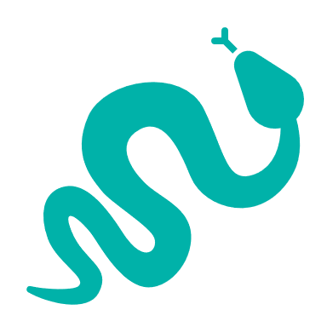 | Reptiles | - Lace Monitor
 | Birds | - Diamond Firetail  - Hooded Robin  - Bush Stone-Curlew  - Powerful Owl  - Barking Owl  - Speckled Warbler  - Swift Parrot  - Painted Honeyeater  - Regent Honeyeater  - Australasian Shoveler  - Hardhead  - Musk Duck  - Blue-billed Duck  - Square-tailed Kite
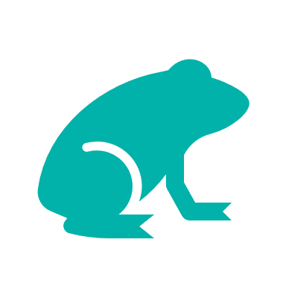 | Amphibians | - Bibron's Toadlet
Traditional Owners, stakeholders and community groups identified the following threats within this landscape
Exclusion of Dja Dja Wurrung leadership (governance)
Utilising past learnings and achievement to guide future effort – Dja Dja Wurrung participation in past and future biodiversity planning and delivery below the International Association of Public Participation (IAP2) level of ‘involve’ does not support Dja Dja Wurrung aspirations
Habitat loss and simplification
Inappropriate fire regimes
Interspecific competition and Introduced predators
Inappropriate fire regimes and overfishing
Climate change
Lack of listening, hearing and respect for Dja Dja Wurrung ability to talk to Country – not utilising Dja Dja Wurrung knowledge base tools and the bias toward western science decision support tools
Landscape fragmentation
Overgrazing by native and introduced species
Weed invasion
European farming techniques
Overabundance of native species like kangaroo

Strategic Management Prospects
Strategic Management Prospects (SMP) models biodiversity values such as species habitat distribution, landscape-scale threats and highlights the most cost-effective actions for specific locations. More information about SMP is available in NatureKit.

Additional threats
Threats identified (in addition to those modelled in SMP) through the consultation process were:
- alterations to hydrology
- land salinisation
- soil erosion
- habitat degradation due to extremes of climate and weather, and lack of regeneration in some vegetation classes
- recreational activities causing fragmentation
- loss of vegetation, and erosion
- legacy use of public land
- private land use impacting biodiversity
- inappropriate land use planning, inappropriate fire regimes (planned burning and bushfires)
Some individual threatened species may also require targeted intervention, beyond actions to manage landscape-scale threats, to improve their future prospects.

Which landscape-scale actions are most cost-effective in this landscape?
The coloured areas indicate where the identified landscape-scale actions and locations are most cost-effective and will maximise biodiversity benefit across Victoria for multiple species.
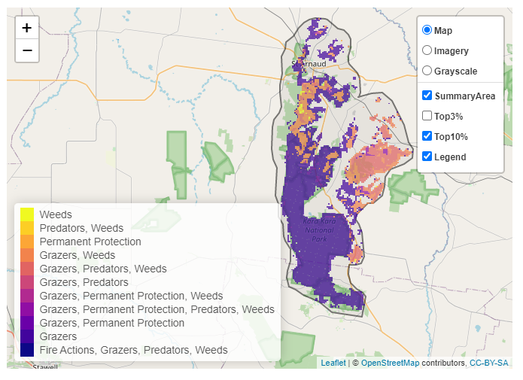
The SMP priority actions which rank among the top 10% for cost-effectiveness of that action across Victoria for much of the landscape are in order of the top 3 actions, see map and list below:
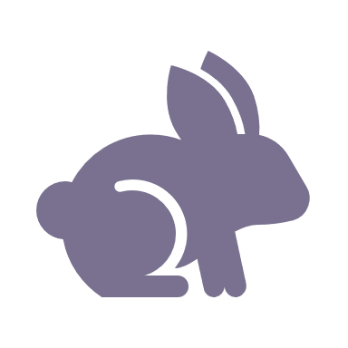 | Control rabbits 19,359ha
 | Control goats 18,924ha
 | Control pigs 12,216ha

Of the top 10% of cost-effective actions, controlling goats provides the most cost-effective biodiversity benefits when considering all flora and fauna.
From the nomination process the following additional actions were also suggested for this landscape:
- deer control
- fox control
- cat control
- revegetation
- overabundant kangaroos
- permanent protection
- monitoring and action planning
- cultural fire
- managing overall grazing impacts (including native, game, and domestic herbivores)
The most cost-effective action for flora and fauna
Plants, amphibians - Control rabbits
Mammals, birds, reptiles - Control goats
For a further in depth look into SMP for this landscape please refer to NatureKit.

