Background / preamble
The Wilsons Promontory landscape was recognised during the 2019/20 Gippsland Biodiversity Response Planning (BRP) process as a focus area for future collaborative biodiversity action and investment.
Under the Victorian government’s biodiversity plan, Biodiversity 2037: Protecting Victoria’s Biodiversity, the BRP process is a long-term area-based planning approach to biodiversity conservation in Victoria. It is designed to strengthen alignment, engagement and participation between government, Traditional Owners, non-government agencies and the community to benefit biodiversity by working together to identify, promote and tackle local biodiversity needs as part of an ongoing collective process.
In 2019/20, significant impacts from the bushfires in East Gippsland and COVID-19 on community, biodiversity stakeholders and agencies, and the environment, resulted in planned engagement with many local stakeholders in Gippsland about BRP being postponed to a future process. In the interim, a multi-agency Working Group of local staff in Gippsland came together to identify a series of potential strategic priority actions across the region, as well as 13 focus landscapes. Membership of this Working Group for Gippsland included staff from the Department of Environment, Land, Water and Planning (DELWP) coasts & marine policy and local forest, fire and biodiversity teams, East Gippsland and West Gippsland Catchment Management Authorities (EGCMA & WGCMA), Parks Victoria, Trust for Nature (TfN), the Bunurong Land Council Aboriginal Corporation (BLCAC) and the Gunaikurnai Land and Waters Aboriginal Corporation (GLaWAC).
As part of this process, the Gippsland BRP Working Group drew upon information available from the DELWP Strategic Management Prospects (SMP) tool as well as their own local knowledge to identify key biodiversity assets, threats and potential management actions across Gippsland. A subset of this information is presented in this Fact Sheet, reflecting a point in time assessment of some of the important biodiversity needs and landscapes for focus across the region.
These BRP Fact Sheets provide useful biodiversity information for the community, non-government and government organisations during project planning and development, including guidance for stakeholders interested to contribute towards some of the strategic priorities identified in these areas to date. Further information and the full list of Fact Sheets is available on the Department’s Environment website.

Landscape description
Landscape context: 48,278ha, 100% public land, 99% native vegetation cover
The southernmost point of the Australian mainland, this landscape is so named from its overlap with the iconic Wilsons Promontory National Park. Wilsons Promontory is a peninsula of land with a hilly central range and rugged coastline connected to the mainland by a sandy isthmus. This landscape is relatively remote and supports a wide diversity of vegetation types from Warm Temperate Rainforest and Wet Forest to coastal woodlands, heathlands and extensive coastal shrublands.

Biodiversity highlights and important places:
Many species occurring in this landscape are restricted and / or rare due to the Promontory’s effective isolation from the rest of mainland Victoria and the remote, hilly, high rainfall core of the promontory. The landscape supports largely intact terrestrial ecosystems surrounded by diverse marine habitat. Offshore islands support seal and seabird colonies and Parks Victoria have recently obtained funding to establish a predator-proof fence at the entry to the park across the Yanakie Isthmus.

Important vegetation communities in this landscape include:
*FFG listed | Cool Temperate Rainforest
**EPBC listed | Subtropical and Temperate Coastal Saltmarsh
*Flora and Fauna Guarantee Act 1988 (Victorian)
**Environment Protection and Biodiversity Conservation Act 1999 (Federal)

Cultural importance
We would like to acknowledge the traditional owners and custodians of Country across this landscape. We pay our respects to Country, and to First Nations Elders past and present whose knowledge and wisdom has ensured the continuation of culture and traditional practices. We are committed to genuinely partner, and meaningfully engage, with Victoria’s Traditional Owners and Aboriginal communities to support the protection of Country, the maintenance of spiritual and cultural practices and their broader aspirations into the 21st century and beyond in the spirit of self-determination.

The Bunurong Land Council Aboriginal Corporation (BLCAC) and Gunaikurnai Land and Waters Aboriginal Corporation (GLaWAC) are both ongoing members of the local Gippsland Biodiversity Response Planning Working Group.

Stakeholder and community interest
Local engagement for BRP in Gippsland in 2019/20 was postponed due to impacts from fire and COVID-19. If you would like to contribute local knowledge about this landscape in the future, find out more about BRP or add your name to the state-wide or Gippsland BRP stakeholder lists, you can find further information on the Department’s Environment webpage.

Species summary
An analysis of available Habitat Distribution Models* identified 52 species with more than 5% of their Victorian range falling within the Wilsons Promontory BRP landscape, including 23 threatened species and 5 EPBC listed species.
*Note: While version 2.0 of the SMP model utilises HDMs for ~3,200 terrestrial species in its analysis, these models currently exclude aquatic, invertebrate, marine and non-vascular plant species. These HDMs and SMP will continue to be improved upon with ongoing input from species experts and natural resource management practitioners.
Species class | Species with a high proportion of their Victorian distribution in this landscape | Other notable species identified during the BRP process
48 plants, incl. 19 threatened species (3 EPBC) | 6 species with greater than 45% of their Victorian range within this landscape, notably:  - Cherry Rice-flower Pimelea drupacea (FFG listed, vulnerable, restricted to Wilsons Promontory and Tasmania)  - Bass Guinea-flower Hibbertia hirticalyx (83% of Victorian range, restricted to Wilsons Promontory area and Tasmania)  - Island Celery Apium insulare (FFG listed, vulnerable, 80% of Victorian range)  - Coast Lily Bulbine crassa (73% of Victorian range, restricted to Wilsons Promontory area and Tasmania)  - Crimson Berry Leptecophylla juniperina subsp. oxycedrus (FFG listed, vulnerable, 50% of Victorian range, restricted to south Gippsland, Phillip Island and Tasmania)  Other notable species include:  - Coast Needlewood Hakea decurrens subsp. platytaenis (38% of Victorian range, one of only two known sites in Victoria)  - Promontory Peppermint Eucalyptus willisii s.s. (30% of Victorian range, core habitat for this species)  - Tasman Pomaderris Pomaderris apetala subsp. maritima (FFG listed, vulnerable, 27% of Victorian range, Victorian populations restricted to Wilsons Promontory and Corner Inlet)  - Shore Spleenwort Asplenium obtusatum subsp. northlandicum (FFG listed, vulnerable, 24% of Victorian range, found mostly on granite and basalt islands)  - Small Shade-nettle Australina pusilla subsp. pusilla (21% of Victorian range, core habitat for this species)  - Bassian Pomaderris Pomaderris oraria subsp. oraria (19% of Victorian range, restricted to south Gippsland and Tasmania)  - Brickmaker’s Sedge Gahnia grandis (FFG listed, vulnerable, 17% of Victorian range, one of only two known sites in Victoria)  - Prom Sheoak Allocasuarina media (16% of Victorian range, restricted to Victoria, restricted to south Gippsland and Wilsons Promontory)  - Rock Banksia Banksia saxicola (15% of Victorian range, restricted to Victoria, one of only two sites in Victoria)  - Eastern Spider-orchid Caladenia orientalis (EPBC listed, Endangered, 11% of Victorian range, restricted to south Gippsland)  - Swamp Greenhood Pterostylis tenuissima (EPBC listed, Vulnerable, 10% of Victorian distribution, core habitat in Gippsland)  - Oval Wedge-fern Lindsaea trichomanoides (FFG listed, endangered, 7% of Victorian range including core habitat – the only recent confirmed record for this species)  - Promontory Daisy-bush Olearia rugosa subsp. allenderae (FFG listed, vulnerable, 7% of Victorian range, restricted to Gippsland)  - Leafy Greenhood Pterostylis cucullata (EPBC listed, Vulnerable, 5% of Victorian range) | - Late Helmet-orchid Corybas sp. aff. diemenicus (Coastal) (FFG listed, endangered)
2 mammals, incl. 2 threatened species (2 EPBC) | Including:  - New Holland Mouse (EPBC listed, Vulnerable, 14% of Victorian range)  - Swamp Antechinus (EPBC listed, Vulnerable, 10% of Victorian range) | - Long-nosed Potoroo (EPBC listed, Vulnerable, 3% of Victorian range)
0 reptiles | No species with >5% of their Victorian range within this landscape | (Landscape supports many common reptile species)
2 birds, incl. 2 threatened species (0 EPBC) | Including:  - Ground Parrot (FFG listed, endangered, 20% of Victorian range)  - King Quail (FFG listed, endangered, 11% of Victorian range) | - Hooded Plover (EPBC listed, Vulnerable, 4% of Victorian range)  - White-bellied Sea-eagle (FFG listed, vulnerable, 1% of Victorian range)
0 frogs | No species with >5% of their Victorian range within this landscape | (Landscape supports many common frog species)
Other species raised by the Working Group (e.g. fish, invertebrates etc):
- Lilly Pilly Burrowing Crayfish (FFG listed, vulnerable, restricted to this landscape)
- South Gippsland Spiny Crayfish (FFG listed, endangered, restricted to south Gippsland area)
- Ancient Greenling Damselfly Hemiphlebia mirabilis (FFG listed, endangered, restricted to south-eastern Australia)
- Australian Mudfish (FFG listed, critically endangered, restricted to south-eastern Australia, mostly in Victoria)
- Caddisfly – Notoperata sparsa (FFG listed, vulnerable), Plectrotarsus gravenhorstii (FFG listed, vulnerable) and Westriplectes pedderensis (FFG listed, vulnerable)

Strategic Management Prospects
Strategic Management Prospects (SMP) models species distributions, habitat importance, landscape-scale threats, and management costs. It then compares and highlights those places with the greatest opportunities for cost-effective action state-wide. Learn more about this tool on the SMP webpage.

Which landscape-scale actions are most cost-effective in this landscape?
The maps and information below show those places and actions modelled by SMP to provide the best opportunities for cost-effective action to benefit biodiversity across the state. Coloured areas in the maps below indicate opportunities for highly cost-effective actions that provide significant benefits to biodiversity in those places. If undertaken across Victoria, these collective actions should provide the greatest potential benefit to biodiversity by focusing on undertaking landscape-scale actions in places where they will provide the greatest benefit for cost across all species.
Map a) shows actions in the top 3% cost-effectiveness areas, and Map b) shows actions in the top 10% cost-effective areas.
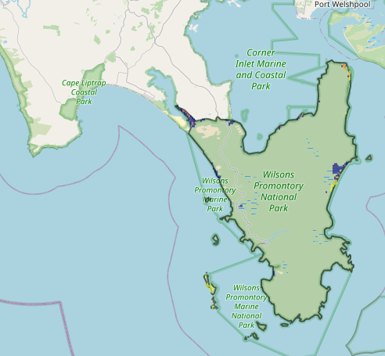
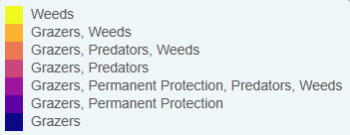
The following landscape-scale actions were ranked among the top 3% cost-effective opportunities for biodiversity action across the state by SMP:
Map a) – SMP top 3% cost-effective actions

Control deer 354ha
Control overabundant kangaroos 334ha
Control weeds 304ha
Control rabbits 172ha
Combined cat and fox control 96ha

The following landscape-scale actions were ranked among the top 10% cost-effective opportunities for biodiversity action across the state by SMP:
Control deer 41,148ha
Control weeds 22,746ha
Combined cat and fox control 21,313ha
Control cats 16,428ha
Control foxes 14,950ha
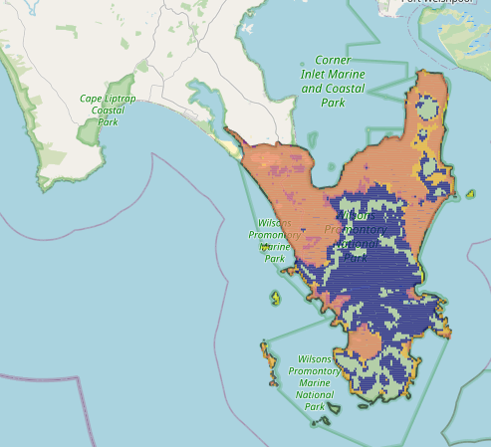
Map b) – SMP top 10% cost-effective actions

The most cost-effective actions for flora & fauna according to SMP
 | Plants – Control deer and Control weeds |  | Birds – Combined fox and cat control and Control deer
 | Mammals – Combined fox and cat control |  | Amphibians – Combined fox and cat control (particularly cats) and Control deer
 | Reptiles – Combined fox and cat control (particularly cats) and Control deer
For a further in depth look into SMP for this landscape please refer to NatureKit.

Additional threats raised by the Working Group
- Encroachment by native shrubs (e.g. Coastal tea tree across Yanakie Isthmus)

Highest priority strategic actions
With consideration of the information available in SMP and local knowledge of this landscape, the Gippsland BRP Working Group identified the following priority actions for future collaboration and investment in this landscape:
The highest priority actions for the Wilsons Promontory landscape include:
- Controlling deer (with aim of extirpation, particularly for Sambar Deer)
- Integrated predator control (including the maintenance of the existing fox and cat control programs across Yanakie Isthmus)
- Management of invasive native shrubs through ecological burning (particularly Coastal Tea-tree on Yanakie Isthmus)
- Targeted transformer weed control (including on offshore islands)
- Controlling rabbits
Other key actions highlighted by the Working Group include:
- Management of overabundant native grazers on Yanakie Isthmus (particularly kangaroos)

