What is NVIM?  NVIM stands for Native Vegetation Information Management and is a system to access Victoria’s native vegetation information.  The initial release will assist landholders in accessing information required to apply for a permit to remove native vegetation under Victoria’s permitted clearing regulations. The tool will generate a report that can be submitted with an application for a permit to remove native vegetation.  Accessing NVIM  NVIM is a web-based system available to the public –http://nvim.depi.vic.gov.au. The home page provides information about the system and tools available.  Search for Property  - Enter property address where you plan to remove, lop or destroy native vegetation in the Search bar  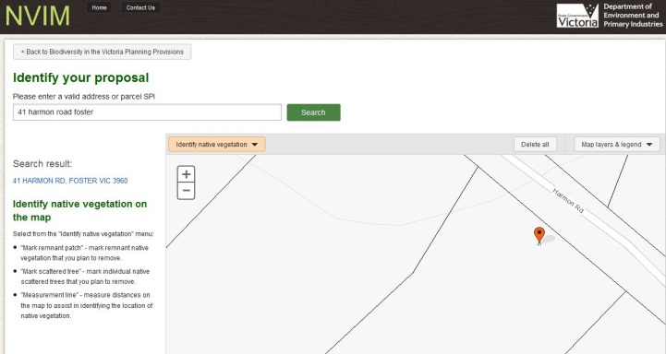  - Address will be displayed in information panel on the left and marked on map on the right  Select Different Layers  - Switch on or off different layers to change the map view prior to identifying the native vegetation  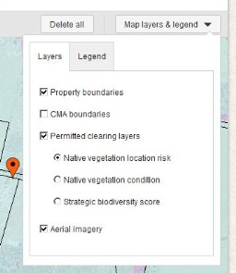  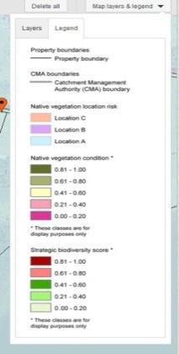  - Aerial imagery is available to assist in identifying native vegetation on property  - Use the legend to identify different vegetation types on the map  Risk-based Pathway  - The information on the Risk-based pathway details screen reflects the marked native vegetation on the previous Identify your proposal screen  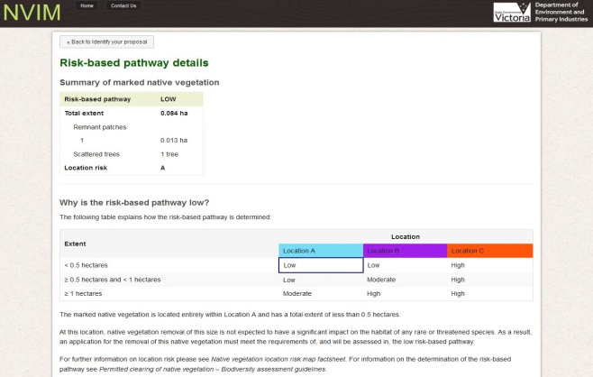  - The table will display how the risk-based pathway is determined and highlight the cell relevant to your application (low, moderate or high)  - Details on previous planning permits and next steps is available for your information  - If your application is within the low risk-based pathway select Calculate offset requirements  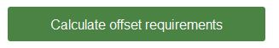  - NVIM does not currently calculate offset requirements for moderate or high risk-based pathway applications  - If your application is within moderate or high risk-based pathway select Download report  Offset Requirements  - The information on the Offset requirements screen is calculated based on the marked native vegetation on the Identify your proposal screen  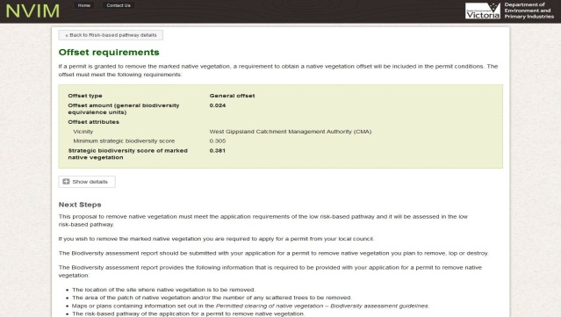 | Drawing Tools  - From the map toolbar select a drawing tool to identify native vegetation  - Mark the native vegetation that you plan to remove, lop or destroy  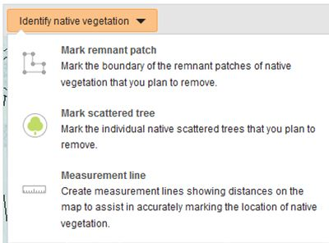  - Drawing tools available in NVIM include:  - Mark remnant patch by drawing a polygon  - Mark scattered trees by marking a point for each tree  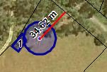  - Measuring tool can check distances to improve accuracy  - All native vegetation to be cleared should be identified  DRAWING TIPS  - Use the scroll bar on your mouse or the map controls to zoom in & out, pan on map to assist with drawing  - If patch is marked on top of another patch the polygons can be merged & calculations based on the combined area  - A tree cannot be marked on top of a remnant patch & vice versa as these reflect different native vegetation types  - If wanting to delete drawings, select ‘Delete all’ button from the map toolbar near layers/legend menu  - When marking native vegetation on roadside or public land an address may not be found  Information Panel  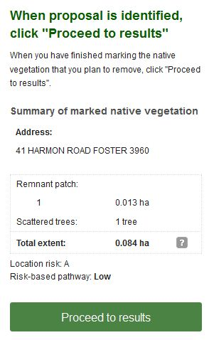  - The information panel contains important information including user instructions, the property address & a summary of the native vegetation marked on the map:  - Remnant patch shown with number and hectares (ha)  - Number of scattered trees shown  - Proceed to results to obtain details on risk-based pathway  Download and Submit Report  - Download your Biodiversity assessment report  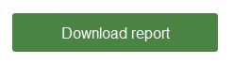  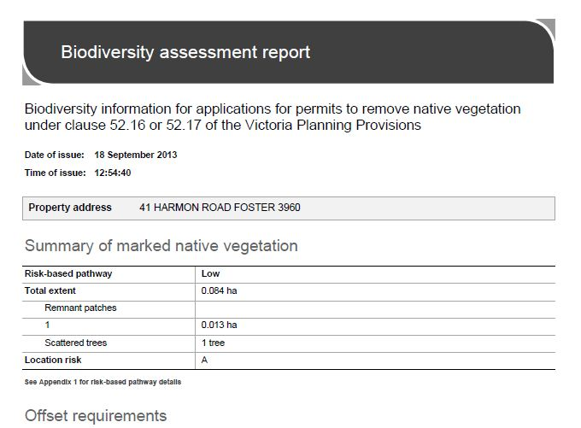  - Submit the Biodiversity assessment report to your local council with your permit application and all other application requirements  Points to Note  - NVIM can not calculate offset requirements for moderate or high risk- based pathway applications at this time  - No drawing is allowed in the Melbourne Strategic Assessment (MSA) area (included in the next release later 2013)  - If drawing is outside Victoria, calculations will return an exception value (-99)  - No information will be saved to NVIM in its current form however future releases will enable this functionality  - Some properties have multiple address listings, drawing on these properties will return multiple results in the information panel  - NVIM is not supported by Internet Explorer 8 or below. Please use Internet Explorer 9 or later, Chrome or Firefox  More Information  - Further information regarding the NVIM system, including video tutorial, is available on the DEPI website www.depi.vic.gov.au/nvim

