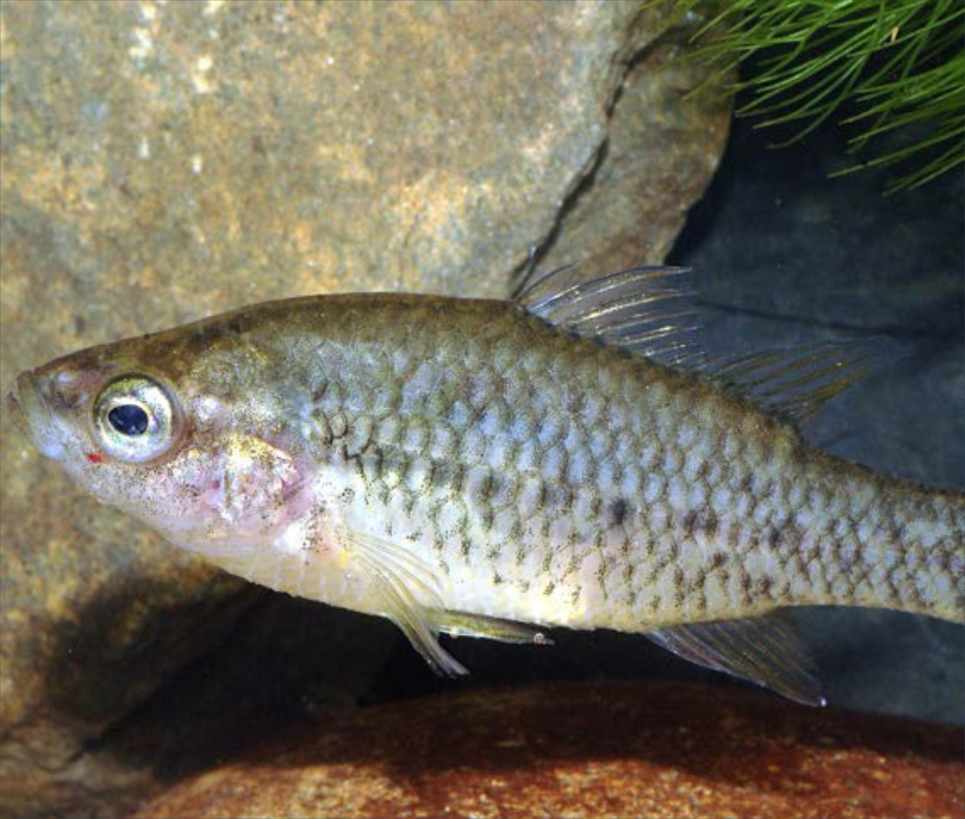Action statement No.134
Flora and Fauna Guarantee Act 1988

Yarra Pygmy Perch Nannoperca obscura

© The State of Victoria Department of Environment, Land, Water and Planning 2015

This work is licensed under a Creative Commons Attribution 4.0 International licence. You are free to re-use the work under that licence,
on the condition that you credit the State of Victoria as author. The licence does not apply to any images, photographs or branding, including the Victorian Coat of Arms, the Victorian Government logo and the Department of Environment, Land, Water and Planning (DELWP) logo.
To view a copy of this licence, visit http://creativecommons.org/licenses/by/4.0/

Cover photo: Tarmo Raadik Compiled by: Daniel Stoessel ISBN: 978-1-74146-670-6 (pdf)

Disclaimer
This publication may be of assistance to you but the State of Victoria and its employees do not guarantee that the publication is without flaw of any kind or is wholly appropriate for your particular purposes and therefore disclaims all liability for any error, loss or other consequence which may arise from you relying on any information in this publication.

Accessibility
If you would like to receive this publication in an alternative format, please telephone the DELWP Customer Service Centre on 136 186, email customer.service@delwp.vic.gov.au, or via the National Relay Service on 133 677, email www.relayservice.com.au. This document is also available on the internet at www.delwp.vic.gov.au

Action Statement No. 134
Yarra Pygmy Perch Nannoperca obscura

Description
The Yarra Pygmy Perch (Nannoperca obscura) is a small perch-like member of the family
Percichthyidae that attains a total length of 75 mm (Allen et al. 2002). It has an oblong, compressed body, a single deeply-notched dorsal fin and a lateral line that is divided into two parts. The dorsal head profile is relatively straight and the snout pointed.
The eye is of moderate size and is situated high
on the head, near the dorsal profile. The mouth is small (the maxilla and supplemental bones reaching back to the anterior border of the eye), terminal and oblique. The colour is generally olive-green above, greenish-brown laterally and yellowish- white underneath with several anteriorly pointing, chevron shaped markings on the posterior half of the body. The fins are normally clear to translucent fawn and may have dark margins. At the onset of spawning, the male’s pelvic fins become black, the leading edge of the anal fin darkens and the dorsal and anal fins intensify to a brownish-orange colour (McDowall 1980; Cadwallader & Backhouse 1983).
Unlike other members of the genus, the Yarra Pygmy Perch has a pre-orbital bone that is not completely covered by skin, exposing its serrated lower edge (Kuiter & Allen 1986).

Distribution
The Yarra Pygmy Perch was first described from the lower Yarra River at Melbourne (Klunzinger 1872). It is at present known from 42 locations, extending from Dandenong Creek in Victoria, to
Lake Alexandrina in South Australia (Hammer 2001; Saddlier et al. 2013). Despite the considerable range, populations are patchy and highly

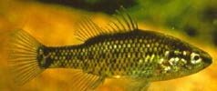

Yarra Pygmy Perch (DELWP)

fragmented and characterised by moderate levels of genetic differentiation between sites, implying poor dispersal ability (Hammer et al. 2010).
Four diagnosable linages have been defined as Evolutionary Significant Units based on genetic criteria: 1. Murray Darling Basin; 2. Glenelg River Basin, Millicent Coast and Mount Emu Creek; 3. Rivers including and immediately surrounding the Merri Catchment, and; 4. Eastern range populations (Hammer et al. 2010). As few populations in Victoria have been recently surveyed, current population status and trends are unknown (Saddlier et al.
2013). Population monitoring within an extremely restricted range of the species in South Australia during 1999, 2006 and 2008 suggested ongoing declines in the area of occupancy and relative abundance, corresponding to deterioration in spring-flow discharge and habitat (Hammer 2009).

Habitat
The Yarra Pygmy Perch typically occurs in slow- flowing or still waters that possess large amounts of aquatic vegetation (particularly emergent vegetation) such as lakes, ponds and slow-flowing rivers (Kuiter et al. 1996; Woodward & Malone
2002). Yarra Pygmy Perch are usually found in small groups and often co-occur with the southern pygmy perch (Nannoperca australis), although the former appears to prefer slightly stronger flows (Kuiter
et al. 1996). Where cohabitation occurs, Yarra Pygmy Perch are often restricted to shallow habitat adjacent to the stream margins due to competition with southern pygmy perch for habitat and space (Woodward and Malone 2002).

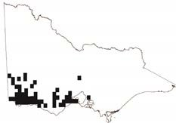
Yarra Pygmy Perch Distribution in Victoria (DELWP 2015)

Life History and Ecology
The Yarra Pygmy Perch is a demersal species that completes its entire life cycle in freshwater
(Cadwallader & Backhouse 1983). Little is known about the maximum age of individuals in a population, however, individuals of the species are assumed to be short lived (i.e. <5 yrs). Its diet consists primarily of insects, insect larvae and planktonic crustaceans (Allen 1989). Yarra Pygmy
Perch spawn during spring (September to October) at water temperatures of 16 – 24 ºC (Kuiter et al. 1996). Very little is known of the breeding biology
of this species, although it is assumed that breeding behaviour is similar to the closely related southern pygmy perch, which lays demersal, non-adhesive eggs over aquatic vegetation and the substrate
(Llewellyn 1974; Humphries 1995).

Conservation status

National conservation status
Nannoperca obscura is listed as vulnerable under the Commonwealth Environment Protection and Biodiversity Conservation Act 1999.

Victorian conservation status
Nannoperca obscura is listed as threatened under the Victorian Flora and Fauna Guarantee Act 1988 (FFG Act).
Nannoperca obscura is considered vulnerable in Victoria according the Department of Environment, Land, Water and Planning (DELWP)’s Advisory List of Threatened Vertebrate Fauna (DSE 2013).

Threats
The Yarra Pygmy Perch has declined in distribution and abundance since European settlement, with the most eastern populations in the lower Yarra River and Dandenong Creek now presumed
extinct (Saddlier & Hammer 2010). The majority of extant populations occur at sites that have little or no formal protection from threats, and those that do are exposed to broader threats
affecting freshwater habitats and catchments (e.g. extraction of groundwater) (Saddlier et al. 2013).
Remaining populations have almost certainly been substantially fragmented and depleted by habitat loss and modification, interactions with introduced species, drought impacts and altered hydrology (Wager & Jackson 1993; Kuiter et al. 1996; Saddlier et al. 2013). The likely short life, poor dispersal ability, and currently fragmented, patchy and variable nature of remaining habitat
makes the species extremely vulnerable to localised extinction. In addition, reduced flooding and loss
of habitat linkages greatly reduce the species ability to recolonise habitats. The major current and suspected threats are detailed as follows.

Standard threat | Source of threat Explanation
Habitat damage or loss | Water – level/ flow changes | Considerable areas of freshwater wetlands have/are being lost to agriculture, urban and industrial development through drainage and infilling.
 | Animal – domestic stock | Damage from unrestricted stock access has a major impact on shallow wetlands through disturbance, infilling and siltation, increased turbidity, and removal and destruction of instream and riparian habitat.
Surface water - quantity/regime | Water – level/ flow changes | Direct extraction of water for stock and agricultural practices  is a common problem. So too is damming of feeder tributaries for the same purpose. Resulting reduction of flows may impact not only the amount of water available (particularly during summer months), but may reduce the level of flushing flows that are required to clear sedimentation from the stream bed.
Competition | Animals – other species | The presence of eastern gambusia (Gambusia holbrooki) at a number of sites is of concern. Eastern gambusia are known to predate and be aggressive toward native species, to compete for food resources and habitat, and are implicated in the decline of more than 30 fish species worldwide, at least nine of which are found in Australia (Macdonald and Tonkin 2008).

Carnivory | Animals – other species | Predation by redfin perch (Perca fluviatilis) and brown trout (Salmo trutta) has been implicated as contributing to the decline of a number of native species.
Surface water - quality | Agricultural chemicals/ effluent | Agricultural run-off can directly affect water quality via increased input of sediment and contaminants such as pesticides and herbicides. It may also increase the risk of algal blooms through increased water nutrient levels and sedimentation.
 | Animals – domestic stock | Destruction of instream vegetation results in decreases in water quality through increased nutrient run-off,  sedimentation, summer water temperatures, a reduction in bank stability, and erosion and sedimentation.
 | Water - turbidity | Instability of steam banks and bed caused by unrestricted stock access has a direct effect on turbidity levels, particularly during rainfall events. Elevated turbidity levels have both short-term and long-term impacts upon habitat and breeding success of many species of freshwater fish species.

Important populations

Catchment Location name Land manager Bioregion
CORANGAMITE | Curdies River, Scotts Creek and tributaries | DELWP | Warrnambool Plain
 | Fitzroy River and Darlot Creek, Portland Coast | DELWP | Warrnambool Plain
 | Gnarkeet Creek | DELWP | Victorian Volcanic Plain
 | Hospital Swamp, Barwon River | DELWP | Otway Plain
 | Moorabool River | DELWP | Victorian Vocanic Plain
 | Pennyroyal Creek | DELWP | Otway Plain
 | Reedy Lake, Barwon River | DELWP | Otway Plain
 | Thompsons Creek | DELWP | Otway Plain
 | Waurn Ponds Creek, Barwon River | DELWP | Victorian Volcanic Plain
 | Woady Yallock River | DELWP | Victorian Volcanic Plain
GLENELG HOPKINS | Long Swamp | DELWP | Bridgewater
 | McRae Creek, Glenelg River | DELWP | Dundas Tablelands

GLENELG HOPKINS | Merino Creek, Glenelg River | DELWP | Dundas Tablelands
 | Miakite Creek, Glenelg River | DELWP | Dundas Tablelands
 | Mount Emu Creek, Hopkins River | DELWP | Victorian Volcanic Plain
 | Spring Creek and Merri River, Hopkins River | DELWP | Victorian Volcanic Plain
 | Wannon River | DELWP | Dundas Tablelands
PORT PHILLIP & WESTERNPORT | Deep Creek, Maribyrnong River | DELWP | Central Victorian Uplands
WIMMERA | Mosquito Creek, Millicent Coast | DELWP | Wimmera

Past management actions

Action Result explanation
Determine distribution and abundance | Distributional data for Victoria has been collected from ad hoc surveys, with the extent and abundance of many populations not being fully quantified (Saddlier et al. 2013).  In 2014 a population model was developed by DELWP for the Deep Creek population (Actions for Biodiversity Conservation, 2015).
Determine habitat characteristics and requirements | A study of the relationship between fish communities and condition of the Glenelg River between Rocklands Reservoir and Casterton undertaken in early 2000s (ARI 2003).
Threat identification | Threats to individual populations and recommended actions were identified in isolated studies of Waurn Ponds Creek (Close et al. 2002) and Thompsons Creek (Zampatti 2001, McKinnon and Ryan 2008).  In 2008 a number of sites on the Barwon River, Waurn Ponds, Pennyroyal Creek, Gnarkeet Chain of Ponds, Woady Yaloak River, Thompson Creek, Curdies River and Merrigig Creek were surveyed with the aim of determining the current state of the populations during a known drought period, documenting potential threats and identifying remedial actions  A study on the management of a range of threatened fish species (including Yarra Pygmy Perch) was conducted for the Curdies River, Sutherland Creek, Woady Yallock Creek, Thompsons Creek, Pennyroyal Creek, Waurn Ponds Creek and the Barwon River (Saddlier et al. 2009).
Recreational fish stocking | Decision made to not stock golden perch (Macquaria ambigua), outside the species natural range into catchments with pygmy perch populations present (Saddlier et al. 2013).

Protection and revegetation | In 2010/11 a large scale river restoration project was commenced by Glenelg Hopkins Catchment Management Authority in the upper Glenelg. This project encompassed several streams identified as important as Yarra Pygmy Perch sites. The project is part of the four year large scale river restoration project.  Habitat works, including fencing, revegetation and weed control have been undertaken along the Crawford River from the Crawford River Regional Park to the confluence of the Glenelg River with the aim to protect and reinstate Yarra and variegated pygmy perch habitat.  An extensive stretch of Deep Creek (Maribyrnong River) immediately downstream of Doggett’s Bridge on the Lancefield-Kilmore Road has been fenced off to stop cattle access.  Sections of Curdies River have been fenced under Landcare and Swamp Scrub projects.
Genetics investigation | Phylogeographic structure of Yarra Pygmy Perch investigated in 2010 (see Hammer et al. 2010).  Broader level systematics confirmed Yarra Pygmy Perch as a single well defined species (Unmack et al. 2011).  Fine-scale landscape genetics (gene flow) and individual genotyping (including paternity) have been initiated (Carvalho et al. 2011)  Investigation as to freshwater phylogeographic patterns in south-east Australian pygmy perches suggest hybridisation has historically occurred between Yarra Pygmy Perch and Southern Pygmy perch in at least one catchment (Unmack et al. 2013).
National Recovery Plan | A National Recovery Plan was developed for the species in 2010.

Conservation objectives

Long term objective
To ensure the Yarra Pygmy Perch can survive, flourish and retain its potential for evolutionary development in the wild.

Objectives of this Action Statement
- To increase knowledge of biology, ecology or management requirements
- To secure populations or habitat from potentially incompatible land use or catastrophic loss
- To increase the number of populations or individuals
- To increase community awareness and support

Intended management actions
The intended management actions listed below are further elaborated in DELWP’s Actions for Biodiversity Conservation (ABC) system. Detailed information about the actions and locations, including priorities, is held in this system and will be provided annually to land managers and other authorities.

Standard objective Objective explanation
To increase knowledge of biology, ecology or  management requirements | To increase knowledge of biology, ecology and management requirements to better achieve conservation goals

Standard action Details Responsible agents
Develop detailed population monitoring protocols | Develop standardised monitoring protocol. | DELWP
Conduct survey to confirm existing records | Conduct survey to confirm existing records and define current condition. | DELWP
Conduct survey to locate additional populations | Conduct surveys in areas not previously targeted to identify unknown populations of Yarra Pygmy Perch. | DELWP
Undertake detailed population monitoring and collect demographic information | Establish a network of monitoring sites.  Conduct population monitoring and determine population viability. | DELWP
Undertake genetic research | Determine implications of population partitioning. | DELWP
Identify core habitat | Investigate habitat requirements of life stages.  Develop and test a predictive habitat model. | DELWP
Conduct priority research projects as specified | Determine maximum water salinity and dissolved oxygen limits.  Determine specifics of negative interactions with introduced Eastern gambusia (Gambusia holbrooki) and Redfin perch (Perca fluviatilus).  Identify location and extent of potential drought refugia at sites which contain important populations.  Develop a broad-scale drought contingency plan. | DELWP

Standard objective | Objective explanation
To secure populations or habitat from potentially incompatible land use or catastrophic loss | Secure populations or habitat from potentially incompatible land use or catastrophic loss to improve conservation outcomes
Standard action | Details | Responsible agents
Assess threats | Identify current and potential threats to populations.  Prepare threat management approaches for all priority sites in consultation with all relevant stakeholders. | DELWP
Restore habitat | Prioritise the protection and restoration of habitat at sites supporting Yarra Pygmy Perch populations. | DELWP, CMAs,  Melbourne Water

Erect/maintain fence to exclude domestic stock | Fence waterways which contain Yarra Pygmy Perch populations to allow either natural regeneration or replanting of riparian zone. | DELWP, CMAs,  Melbourne Water
Liaise with private landholders | Protect populations on private land / waters by private-land management agreements, where possible.  Liaise with adjacent landholders to encourage protection and raise awareness of species requirements. | DELWP, CMAs
Negotiate a formal management agreement with a public authority | Protect populations on public land by negotiating agreements and land covenants. | DELWP, CMAs
Liaise with government agencies | Liaise with water management agencies to ensure Yarra Pygmy Perch are included in planning requirements for works and environmental flow management and regional waterway strategies. | DELWP
Control introduced animals | Apply agreed risk assessment protocols such as those under the Protocol for the Translocation of Fish in Victorian Inland Public Waters, to proposals to stock non-native or non-indigenous fish into waters supporting populations of Yarra Pygmy Perch. | DELWP
Determine environmental flow requirements and develop detailed plan | Investigate minimum water levels required to support self-sustaining Yarra Pygmy Perch populations. This data will be valuable in  determining flows necessary to maintain viable populations, and will be particularly important in determining the effects of climate change on populations. | DELWP, Melbourne Water
Salvage populations/ individuals | Where a population is under immediate threat of extinction, translocate a suitable number of individuals to either a site containing suitable habitat and water security in the wild, or to a captive breeding facility.  Once conditions improve, re-establish the population at site of origin. | DELWP

Standard objective | Objective explanation
To increase number of  populations or individuals | To increase number of Yarra Pygmy Perch populations
Standard action | Details | Responsible agents
Identify potential sites for reintroduction/translocation | Evaluate and select suitable translocation sites. | DELWP

Undertake captive breeding for reintroduction or enforcement | Investigate the feasibility of establishing captive breeding populations with a view to re-establishing populations in the wild from their most  appropriate genetic stock. | DELWP
Prepare a plan for reintroduction/ reinforcement/translocation | Prepare a translocation plan and protocols. | DELWP

Standard objective | Objective explanation
To increase community awareness and support | To increase community awareness and support of Yarra Pygmy Perch populations
Standard action | Details | Responsible agents
Develop, publish and distribute educational, technical or publicity material and/or displays | Provide information to land and water managers, stakeholders and the public. | DELWP, CMAs,  Melbourne Water
Involve community groups and volunteers in recovery activities. | Identify opportunities for community involvement in the conservation of the Yarra Pygmy Perch.  Advocate the species as an icon for communities. | DELWP, CMAs

References
Allen, G.R. 1989. Freshwater Fishes of Australia, TFH Publications, Sydney.
Allen, G.R., Midgley, S.H. & Allen, M. 2002. Field Guide to the freshwater fishes of Australia.
Western Australian Museum, Perth. 394 pp.
Arthur Rylah Institute (ARI) 2003. Glenelg River Salinity Trade-off Project: Glenelg River fish communities. Arthur Rylah Institute, Department of Sustainability and Environment, Melbourne.
Cadwallader, P. L. & Backhouse, G. 1983. A Guide to the Freshwater Fish of Victoria. Government Printer: Melbourne. 249 pp.
Carvalho, D. C., Rodrı´guez-Za´rate, C. J., Hammer,
M. P., and Beheregaray, L. B. 2011. Development of 21 microsatellite markers for the threatened Yarra Pygmy Perch (Nannoperca obscura) through 454 shot-gun pyrosequencing. Conservation Genetic Resources 3: 601–604.
Close, P., Webb, E. and Koster, W. 2002. Rehabilitation of Waurn Ponds Creek, Victoria, for Yarra Pygmy Perch (Nannoperca obscura) and other native freshwater fishes. Report
to the Corangamite Catchment Management Authority. Arthur Rylah Institute, Department of Sustainability and Environment, Melbourne.
Department of Environment, Land, Water and Planning (DELWP) 2015. Victorian Biodiversity Atlas, retrieved May 2015
http://mapshare2.dse.vic.gov.au/MapShare2EXT/ imf.jsp?site=bim
Department of Sustainability and Environment
(DSE) 2013. Advisory List of Threatened Vertebrate Fauna in Victoria - 2013. Department of Sustainability and Environment, Melbourne.
Hammer, M. 2001. Molecular systematics and conservation biology of the southern pygmy perch Nannoperca australis (Günther 1861) (Teleostei: Percichthyidae) in south-eastern Australia. B. Sc. (Honours) thesis. Adelaide University.
Hammer, M. 2009. Status assessment for nationally listed freshwater fishes of south-east South Australia during extreme drought, spring 2008.
Report to Department for Environment and Heritage, South Australian Government. Aquasave Consultants, Adelaide.
Hammer, M., Wedderburn, S., and van Weenan, J. 2009. Action Plan for South Australian Freshwater Fishes. Native Fish Australia, Adelaide.
Hammer, M., Unmack, P.J., Adams, M., Johnson,
J.B. & Walker, K.F. 2010. Phylogeographic structure in the threatened Yarra Pygmy Perch Nannoperca obscura (Teleosti: Percichthyidae) has major implications for declining populations. Conservation Genetics 11: 213–223.

Hammer, M. 2011. Update on the status and recovery efforts for Yarra Pygmy Perch in south east South Australia. Report to Department
of Environment and Natural Resources, South Australia Government. Aquasave Consultants, Adelaide.
Humphries, P. 1995. Life history, food and habitat of southern pygmy perch, Nannoperca australis, in the Macquarie River, Tasmania. Marine and Freshwater Research 46: 1159–1169.
Jones, M., Tinkler, P., Lindeman, M., Hackett, G. and Pickworth, A. 2008. Threats, distribution and
abundance of Yarra Pygmy Perch in Victoria during a drought period. A report for the Department
of Sustainability, Arthur Rylah Institute for Environmental Research, Department of Sustainability and Environment, Melbourne
Klunzinger, C.B. 1872. Zur Fische-fauna von Sud Australien. Archiv Naturgeschichte 38 (1):17–47.
Kuiter, R.H, Humphries P.A. & Arthington, A.H. 1996. Family Nannopercidae – Pigmy Perches. Pp 168-
175. In McDowall, R. (ed.) Freshwater Fishes of South-Eastern Australia (Revised edition). Reed Books, Sydney.
Kuiter, R.H. & Allen, G.R. 1986. A synopsis of the Australian pigmy perches (Percichthidae), with the description of a new species. Revue Français d’Aquariologie 12: 109–116.
Llewwllyn, L.C. 1974. Spawning, development and distribution of southern pygmy perch Nannoperca australis australis Günther from inland waters in eastern Australia. Australian Journal of Marine and Freshwater Research 25: 121–149.
McDowall, R.M. 1980. Freshwater Fishes in South- Eastern Australia. Reed, Sydney. 208 pp.
McKinnon, L. & Ryan, T. 2008. Assessment of Yarra Pygmy Perch and other fish species in Thompsons Creek. Prepared for the Corangamite Catchment Management Authority. Environous, Melbourne.
Saddlier, S., Ryan, T. & Wooley, J. 2009. Corangamite CMA – Significant fish species protection under dry inflow conditions. Arthur Rylah Institute
for Environmental Research Technical Report Series No. 198. Department of Sustainability and Environment, Melbourne.
Saddlier, S. & Hammer, M. 2010. National Recovery Plan for the Yarra Pygmy Perch Nannoperca obscura. Department of Sustainability and Environment, Melbourne.
Saddlier, S. Koehn, J.D. & Hammer, M.P. 2013. Let’s not forget the small fishes – conservation of two threatened species of pygmy perch in south-eastern Australia. Marine and Freshwater Research 64: 874–886.

Unmack, P. J., Hammer, M., Adams, M., and Dowling, T. E. 2011. A phylogenetic analysis of pygmy perches (Teleostei: Percichthyidae) with an assessment of the major historical influences on aquatic biogeography in southern Australia. Systematic Biology 60: 797–812.
Unmack, P.J., Hammer, M., Adams, M.,
Johnson, J.B. and Dowling, T.E. 2013. The
role of continental shelf width in determining freshwater phylogeographic patterns in south- eastern Australian pygmy perches (Teleostei: Percichthyidae). Molecular Ecology 22: 1683–
1699.
Wager, R. & Jackson, P. 1993. The Action Plan for Australian Freshwater Fishes. Australian Nature Conservation Agency, Endangered Species Program. Project No. 147. Canberra.
Woodward, G.M.A. & Malone, B.S. 2002. Patterns of abundance and habitat use by Nannoperca obscura (Yarra Pygmy Perch) and Nannoperca australis (southern pygmy perch). Proceedings of the Royal Society of Victoria 114: 61–72.
Zampatti, B.P. 2001. The distribution of Yarra Pygmy Perch in the Thomson Creek Catchment and preliminary assessment of a rock ramp fishway.
Unpublished client report for the Corangamite Catchment Management Authority, Arthur Rylah Institute for Environmental Research, Department of Sustainability and Environment, Melbourne.

www.delwp.vic.gov.au

