Background / preamble
The Bunurong Coast landscape was recognised during the 2019/20 Gippsland Biodiversity Response Planning (BRP) process as a focus area for future collaborative biodiversity action and investment.
Under the Victorian Government’s Biodiversity 2037: Protecting Victoria’s Biodiversity plan, the BRP process is a long-term area-based planning approach to biodiversity conservation in Victoria. It is designed to strengthen alignment, engagement and participation between government, Traditional Owners, non-government agencies and the community to benefit biodiversity by working together to identify, promote and tackle local biodiversity needs as part of an ongoing collective process.
In 2019/20, significant impacts from the bushfires in East Gippsland and coronavirus (COVID-19) on community, biodiversity stakeholders and agencies, and the environment, resulted in planned engagement with many local stakeholders in Gippsland about BRP being postponed to a future process. In the interim, a multi-agency working group of local staff in Gippsland came together to identify a series of potential strategic priority actions across the region, as well as 13 focus landscapes. Membership of this working group for Gippsland included staff from the Department of Environment, Land, Water and Planning (DELWP) coasts & marine policy and local forest, fire and biodiversity teams, East Gippsland and West Gippsland Catchment Management Authorities (EGCMA & WGCMA), Parks Victoria, Trust for Nature (TfN), the Bunurong Land Council Aboriginal Corporation (BLCAC) and the Gunaikurnai Land and Waters Aboriginal Corporation (GLaWAC).
As part of this process, the Gippsland BRP working group drew upon information available from the DELWP Strategic Management Prospects (SMP) tool as well as their own local knowledge to identify key biodiversity assets, threats and potential management actions across Gippsland. A subset of this information is presented in this Fact Sheet, reflecting a point in time assessment of some of the important biodiversity needs and landscapes for focus across the region.
These BRP Fact Sheets provide useful biodiversity information for the community, non-government and government organisations during project planning and development, including guidance for stakeholders interested to contribute towards some of the strategic priorities identified in these areas to date. Further information and the full list of Fact Sheets is available on the Department’s Environment website.

Landscape description
Landscape context: 86,827ha, 15% public land, 24% native vegetation cover
The Bunurong Coast landscape is dominated by coastal plain with lower rolling hills of the Strzelecki Ranges. A rugged coastline with prominent headlands and protected inlets. The native vegetation is largely cleared for farmland, but substantial areas remain, mostly near the headlands and along the coast, including Cape Liptrap and near Wonthaggi. Features include Shallow Inlet, Waratah Bay and Andersons Inlet. Embedded towns include Wonthaggi, Inverloch, Fish Creek and Walkerville. This landscape includes the lower reaches of the Tarwin and Powlett Rivers.

Biodiversity highlights and important places:
Inlets and estuaries important for waterbirds and migratory waders, including the Shallow Inlet East Asian-Australasian shorebird flyway site. Coastal and inland reserves including the Wonthaggi Heathlands Nature Conservation Reserve, and Cape Liptrap Coastal Park, which support an array of diverse native flora and fauna, including threatened species such as Eastern Spider-orchid, Powerful Owl and Hooded Plover.

Important vegetation communities in this landscape include:
*FFG listed | Coastal Moonah Woodland
**EPBC listed | Subtropical and Temperate Coastal Saltmarsh
*Flora and Fauna Guarantee Act 1988 (Victorian)
**Environment Protection and Biodiversity Conservation Act 1999 (Federal)

Cultural importance
We would like to acknowledge the Traditional Owners and custodians of Country across this landscape, including the Bunurong people. We pay our respects to Country, and to Elders past and present whose knowledge and wisdom has ensured the continuation of culture and traditional practices. We are committed to genuinely partner, and meaningfully engage, with Victoria’s Traditional Owners and Aboriginal communities to support the protection of Country, the maintenance of spiritual and cultural practices and their broader aspirations into the 21st century and beyond in the spirit of self-determination.
Bunurong Land Council Aboriginal Corporation (BLCAC) are the appointed Registered Aboriginal Party (RAP) west of the Tarwin River (including Anderson’s Inlet). BLCAC are an ongoing member of the local Gippsland Biodiversity Response Planning working group.

Stakeholder and community interest
Local engagement for BRP in Gippsland in 2019/20 was postponed due to impacts from fire and coronavirus (COVID-19). If you would like to contribute local knowledge about this landscape in the future, find out more about BRP or add your name to the state-wide or Gippsland BRP stakeholder lists, you can find further information on the Department’s Environment website.

Species summary
An analysis of available Habitat Distribution Models* identified 64 species with more than 5% of their Victorian range falling within the Bunurong Coast BRP landscape, including 14 threatened species and 4 EPBC listed species.
*Note: While version 2.0 of the SMP model utilises HDMs for ~3,200 terrestrial species in its analysis, these models currently exclude aquatic, invertebrate, marine and non-vascular plant species. These HDMs and SMP will continue to be improved upon with ongoing input from species experts and natural resource management practitioners.
Species class | Species with a high proportion of their Victorian distribution in this landscape | Other notable species identified during the BRP process
58 plants, incl. 11 threatened species (2 EPBC) | 6 species with greater than 20% of their Victorian range falling within this landscape, notably:  - Prom Sheoak Allocasuarina media (34% of Victorian range, restricted to south Gippsland and Wilsons Promontory)  - Eastern Spider-orchid Caladenia orientalis (EPBC listed, Endangered, 33% of Victorian distribution, restricted to area between Grantville and Yarram)  - Bassian Pomaderris Pomaderris oraria subsp. oraria (32% of Victorian range)  - Coast Ballart Exocarpus syrticola (23% of Victorian range)  - Coast Wirilda Acacia uncifolia (23% of Victorian range)  - Short Water-starwort Callitriche brachycarpa (FFG listed, vulnerable, 20% of Victorian range)  Other notable species include:  - Silver Everlasting Argentipallium dealbatum (18% of Victorian range, occurs only in far south-west Victoria, south Gippsland and Tasmania)  - Crimson Berry Leptcophylla juniperina subsp. oxycedrus (FFG listed, vulnerable, 17% of Victorian range, restricted to south Gippsland, Phillip Island and Tasmania)  - Promontory Peppermint Eucalyptus willisii s.s. (17% of Victorian range, core habitat for this species)  - Bass Guinea-flower Hibbertia hirticalyx (15% of Victorian range, restricted to Wilsons Promontory area and Tasmania)  - Coast Lily Bulbine crassa (8% of Victorian range, restricted to Wilsons Promontory area and Tasmania)  - Bog Gum Eucalyptus kitsoniana (8% of Victorian range, restricted to Victoria)  - Dense Leek-orchid Prasophyllum spicatum (EPBC listed, Vulnerable, 7% of Victorian range) | - None raised
2 mammals, incl. 2 threatened species (2 EPBC) | Including:  - New Holland Mouse (EPBC listed, Vulnerable, 9% of Victorian range)  - Swamp Antechinus (EPBC listed, Vulnerable, 9% of Victorian range) | - None raised
2 reptiles, incl. 0 threatened species (0 EPBC) | Including:  - Four-toed Skink (7% of Victorian range)  - Metallic Skink (6% of Victorian range) | - None raised
2 birds, incl. 1 threatened species (0 EPBC) | Including:  - King Quail (FFG listed, endangered, 21% of Victorian range)  - Sanderling (6% of Victorian range) | - Hooded Plover (EPBC listed, 4% of Victorian range)  - Pacific Golden Plover (FFG listed, vulnerable, 4% of Victorian range)  - Common Greenshank (FFG listed, vulnerable, 2% of Victorian range)  - Curlew Sandpiper (EPBC listed, Critically Endangered, 1% of Victorian range)  - White-bellied Sea-eagle (FFG listed, vulnerable, 1% of Victorian range)  - Eastern Great Egret (FFG listed, vulnerable, 0.6% of Victorian range)  - Australasian Shoveler (FFG listed, vulnerable, 0.5% of Victorian range)
0 frogs | No species with more than 5% of their Victorian range within this landscape. | Landscape supports many common frog species.  Growling Grass Frog also present (EPBC listed, Vulnerable, 0.5% of Victorian range)
Other species raised by the working group (e.g. fish, invertebrates etc):
South Gippsland Burrowing Crayfish (FFG listed, endangered, restricted to south Gippsland area)

Strategic Management Prospects
Strategic Management Prospects (SMP) models species distributions, habitat importance, landscape-scale threats, and management costs. It then compares and highlights those places with the greatest opportunities for cost-effective action state-wide. Learn more about this tool on the SMP webpage.

Which landscape-scale actions are most cost-effective in this landscape?
The maps and information below show those places and actions modelled by SMP to provide the best opportunities for cost-effective action to benefit biodiversity across the state. Coloured areas in the maps below indicate opportunities for highly cost-effective actions that provide significant benefits to biodiversity in those places. If undertaken across Victoria, these collective actions should provide the greatest potential benefit to biodiversity by focusing on undertaking landscape-scale actions in places where they will provide the greatest benefit for cost across all species.
Map a) shows actions in the top 3% cost-effectiveness areas, and Map b) shows actions in the top 10% cost-effective areas.
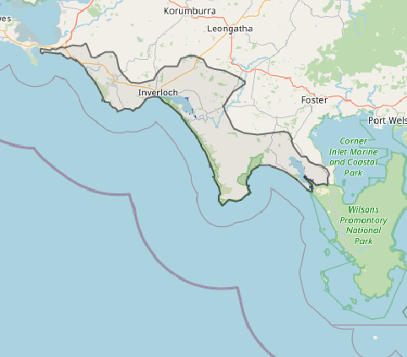
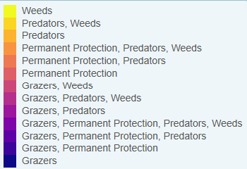
Map a) – SMP top 3% cost-effective actions
The following landscape-scale actions were ranked among the top 3% cost-effective opportunities for biodiversity action across the state by SMP:
Control overabundant kangaroos 218ha
Control rabbits 117ha
Permanent protection 61ha
Control deer 46ha
Combined cat and fox control 35ha

The following landscape-scale actions were ranked among the top 10% cost-effective opportunities for biodiversity action across the state by SMP:
Control rabbits 35,620ha
Control weeds 14,388ha
Control overabundant kangaroos 12,565ha
Combined cat and fox control 6,465ha
Control foxes 5,721ha

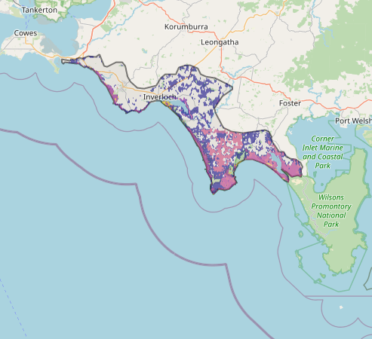
Map b) – SMP top 10% cost-effective actions

The most cost-effective actions for flora & fauna according to SMP
 | Plants – Control Rabbits and Control weeds |  | Birds – Combined fox and cat control
 | Mammals – Combined fox and cat control |  | Amphibians – Control rabbits and Combined fox and cat control
 | Reptiles – Combined fox and cat control
For a further in depth look into SMP for this landscape please refer to NatureKit.

Additional threats raised by the working group
- Encroachment by native shrubs (e.g. Coastal tea tree in Wonthaggi heathlands).

Highest priority strategic actions
With consideration of the information available in SMP and local knowledge of this landscape, the Gippsland BRP working group identified the following priority actions for future collaboration and investment in this landscape:
The highest priority actions for the Bunurong Coast landscape include:
 | - Protection of coastal, wetland and riparian vegetation (including through permanent protection)
 | - Controlling rabbits
 | - Revegetation of coastal, wetland and riparian vegetation
 | - Integrated predator control, particularly along the coastal wildlife corridors
 | - Control transformer weeds and invasive native shrubs (e.g. Coast tea-tree in the Wonthaggi heathlands), including use of appropriate ecological burning
Other key actions highlighted by the working group include:
- | - None raised

