
Painted Honeyeater
Grantiella picta
Action Statement

Flora and Fauna Guarantee Act 1988No. 193

Flora and Fauna Guarantee Act 1988 No. ###

Description and distribution
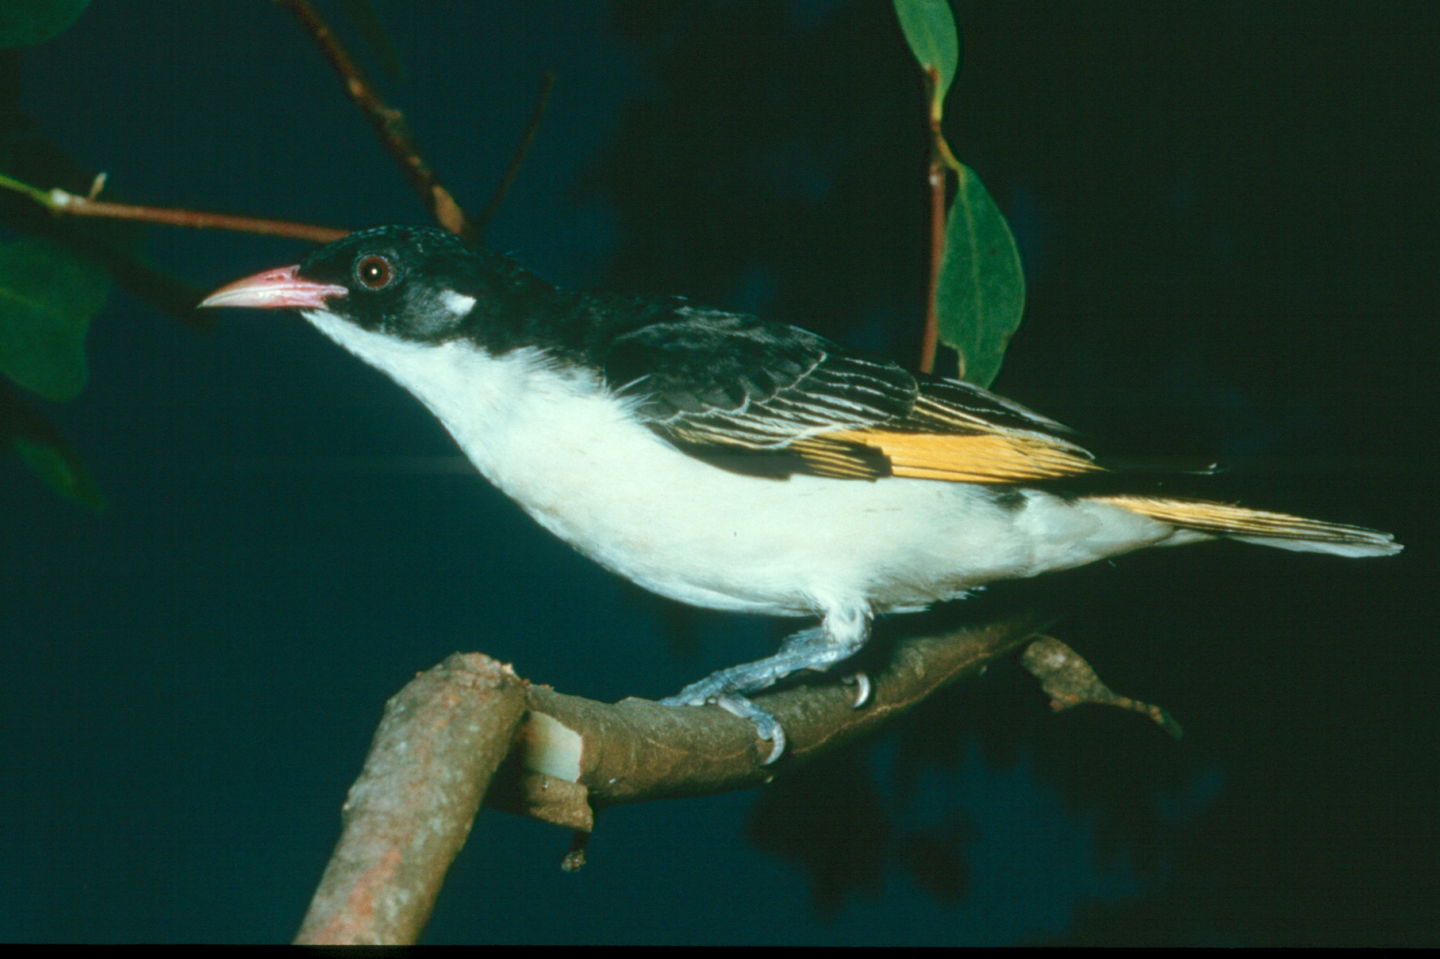
The endemic Painted Honeyeater Grantiella picta is a small, rare, specialised, migratory honeyeater with a conspicuous far-carrying call and a spectacular territorial display song-and-flight. The male has striking black, white and yellow plumage, with a contrasting pink bill and white ear tuft, whereas the female is duller with greyer upper parts and plainer flanks (Pizzey & Knight 1999).
The Painted Honeyeater occurs in the eastern half of Australia, from the eastern Northern Territory, through Queensland, New South Wales and Victoria to south-eastern South Australia. It occurs predominantly on the inland side of the Great Dividing Range but avoids arid areas (Blakers et al. 1984). In Victoria, it now mainly occurs in the Northern Inland Slopes and Goldfields Bioregions, but may also occur in the Central Victorian Uplands, Highlands Southern Fall and Murray Fans bioregions (DSE 2004). Victorian localities favoured by the Painted Honeyeater include Chiltern–Mt Pilot National Park, Warby Range State Park, Heathcote-Graytown National Park, Whroo Nature Conservation Reserve, Greater Bendigo National Park and Clunes State Forest (DSE 2004).
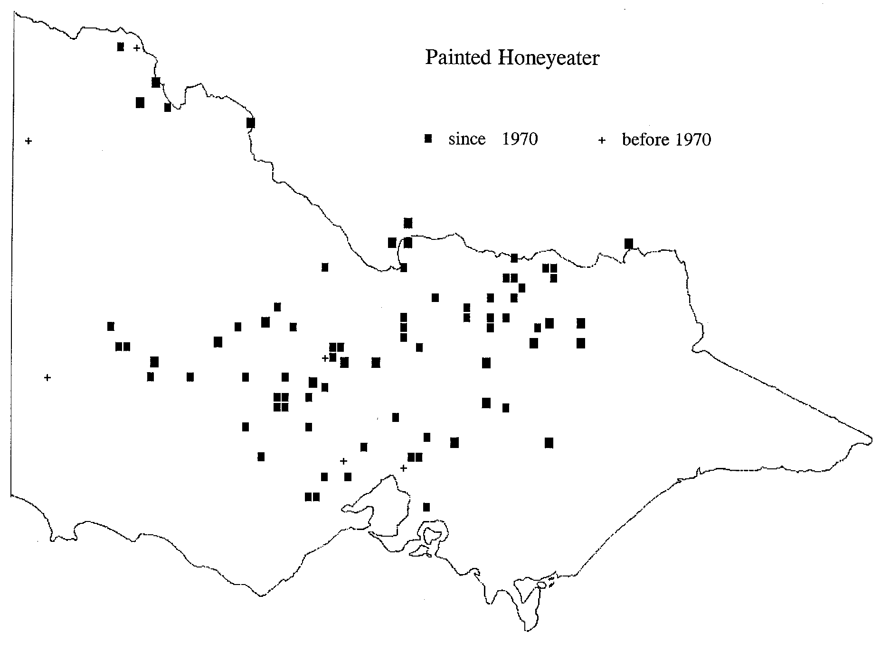
Painted Honeyeater Grantiella picta
(Photo: DSE/McCann)
Habitat
In Victoria, the Painted Honeyeater inhabits dry open-forest and woodland where mistletoe from the genus Amyema is common. It is most common in Box-Ironbark communities but also utilises Broad-leaved Peppermint-Red Stringybark, Box-Buloke, and Black Box open-forests and/or woodlands on the inland side of the Great Dividing Range (Emison et al. 1987). Red Ironbark-Red Box open-forests on the coastal side of the Great Dividing Range are also occasionally utilised (Emison et al. 1987). It may also inhabit open stands of old eucalypts, often in farmland, that are infested with mistletoe Amyema spp. Nests are generally built in mistletoes inIt will also inhabit open stands of old eucalypts, often in farmland, stands of old eucalypts, often in farmland, that are infested with mistletoe Amyema spp. Nests are generally built in mistletoes in tree canopies (Emison et al. 1987), however, in the Edenhope area, nests were built in the hanging branches of healthy stringybarks and, exceptionally, in mistletoe (Hindwood 1935).

Distribution in Victoria [source: DSE 2004]
Life history and ecology
The life history of the Painted Honeyeater is strongly linked with Amyema mistletoes that grow on eucalypts and acacias. Mistletoe berries form the bulk of its diet and consequently the Painted Honeyeater is an important disseminator of mistletoe seeds, and it often nests in mistletoe clumps. Therefore, its movements are correlated with the flowering and fruiting of mistletoes at different localities (Blakers et al. 1984, Reid 1986). In Victoria, the Drooping Mistletoe A. pendulum and the Box Mistletoe A. miquelli appear to be the most important mistletoe species for the Painted Honeyeater (Emison et al. 1987). Painted Honeyeaters also eat nectar from mistletoes and other plants, and invertebrates including those attracted to blossom (Eddy 1961, Reid 1986, Oliver et al.1998).
The Painted Honeyeater is a migrant to Victoria, arriving in October, breeding, then departing in March-April. It spends the non-breeding season in the semi-arid woodlands of inland and northern Australia where little is known of its ecology. Numbers arriving in Victoria may vary markedly between years.
Conservation status
National conservation status
The Painted Honeyeater has not been listed as a threatened species under the Commonwealth Environment Protection and Biodiversity Conservation Act 1999.
Victorian conservation status
The Painted Honeyeater has been listed as threatened under the Flora and Fauna Guarantee Act 1988.
The Painted Honeyeater has been assessed as ‘vulnerable’ in Victoria (DSE 2003).
Decline and threats
The Painted Honeyeater has declined in some parts of Victoria. For example, in the Edenhope area, it appeared annually from 1916 to 1926 and bred successfully; then re-appeared in 1927 but apparently did not breed due to a paucity of mistletoe (Hindwood 1935). It then failed to return in subsequent years even though the former nesting area was once again infested with mistletoe (Hindwood 1935). It has not been recorded in that area since 1927 (DSE 2004).
In the Bendigo area, the Painted Honeyeater was an annual visitor until the mid 1950s, when outbreaks of a cup moth, Doratifera sp., in the local forests resulted in defoliated eucalypts, particularly Red Ironbark, and the widespread death of mistletoes (Eddy 1961). Since then, the Painted Honeyeater has continued to decline in abundance in the Bendigo area (Bird Observers Group 1976), but some individuals still visit despite the continuing annual spring defoliation of eucalypts by cup moth larvae (Brindley 1991).
Clearance and fragmentation of habitat for agricultural purposes, and the lack of regeneration due to continued grazing of remnant habitats by sheep and rabbits, are likely to be threats (Garnett and Crowley 2000). The historic decline of mistletoe in timber-production forests (Robinson 1994) and continuing loss of old, mistletoe-bearing trees on farmland may have also contributed to the Painted Honeyeater’s decline.
Existing conservation measures
- High quality habitat is reserved in Victoria’s conservation reserve system, for example at Chiltern-Mt Pilot National Park, Warby Range State Park, Heathcote-Graytown National Park, and Whroo Nature Conservation Reserve.
- Victoria’s Native Vegetation Management Framework provides the strategic basis and guidance for the protection and enhancement of native vegetation remnants on private land;
- The implementation of Biodiversity Action Plans in relevant bioregions will benefit the Painted Honeyeater through the protection, enhancement and linking of forest and woodland remnants.
- Landcare groups continue to plant large numbers of local tree species in areas that have been partly or wholly cleared (e.g. the Lurg Regent Honeyeater Project);
- A research plan has been compiled for the Painted Honeyeater and other threatened woodland birds of south-eastern Australia (Robinson 1994).
Conservation objectives
Long term objective
To ensure that the Painted Honeyeater can survive, flourish and retain its potential for evolutionary development in the wild.
Objectives of this Action Statement
- To raise public awareness of the habitat requirements and plight of the Painted Honeyeater;
- To document all important breeding and foraging sites of the Painted Honeyeater in Victoria;
- To determine which of those sites are currently inadequately managed, and to initiate actions to overcome these shortcomings;
- To ensure that the population size of the Painted Honeyeater in Victoria is regularly monitored;
- To encourage studies that will identify the threatening processes that have led to the decline of the Painted Honeyeater and factors preventing population growth.
Intended management actions
Survey and monitoring
- Collate information on the distribution of the Painted Honeyeater and plan a survey and subsequent regular counts. The counts will utilise interested members from stakeholder groups such as Birds Australia, the Threatened Species Network, and other community groups such as Landcare.
Responsibility: DSE (Biodiversity and Natural Resources Division)
- Undertake survey and subsequent regular counts.
Responsibility: DSE (Biodiversity and Natural Resources Division, Regions)
- Assess habitat condition and threats operating at each key Painted Honeyeater locality.
Responsibility: DSE (Regions)
Extension and management
- Distribute the Action Statement to relevant groups and individuals throughout the present and former range of the Painted Honeyeater and encourage all parties to report observations to the Atlas of Victorian Wildlife (DSE 2004).
Responsibility: DSE (Biodiversity and Natural Resources Division)
- Develop regional guidelines and prescriptions to protect favoured sites and to ensure that mistletoes are not systematically eliminated from those and other potential sites
Responsibility: DSE (Regions)
Research
- Encourage universities to conduct research that will include an examination of the critical habitat needs and foraging ecology of the Painted Honeyeater; an assessment of the impacts of inter-specific competition and land management practices on its decline; and measurement of its annual breeding success.
Responsibility: DSE (Biodiversity and Natural Resources Division)
References
Bird Observers Group (1976) The birds of the Bendigo district. Australian Bird Watcher 6: 186-208.
Blakers, M., Davies, S.J.J.F. & Reilly, P.N. (1984) The Atlas of Australian birds. Melbourne University Press, Melbourne.
Brindley, A. (1991) Birds of the Bendigo District. Bendigo Field Naturalists Club, Bendigo.
DSE (2003) Advisory List of Threatened Vertebrate Fauna in Victoria - 2003. Biodiversity & Natural Resources Division, Department of Sustainability and Environment: Melbourne.
DSE (2004) Atlas of Victorian Wildlife (electronic fauna database). Department of Sustainability and Environment: Melbourne.
Eddy, R.J. (1961) Twenty years of Painted Honeyeaters. Australian Bird Watcher 1: 122-128.
Emison, W.B., Beardsell, C.M., Norman, F.I. & Loyn, R.H. (1987) Atlas of Victorian Birds. Department of Conservation, Forests and Lands and RAOU, Melbourne.
Garnett, S.T. & Crowley, G. M. (2000) The Action Plan for Australian Birds. Birds Australia & Environment Australia: Canberra.
Hindwood, K.A. (1935) The Painted Honeyeater. Emu 34: 149-157.
Pizzey, G. & Knight, F. (1999) The Graham Pizzey and Frank Knight Field Guide to the Birds of Australia. Harper Collins Publishers, Sydney.
Reid, N. (1986) Pollination and seed dispersal of mistletoes (Loranthaceae) by birds in southern Australia. Pp. 64-84 In The Dynamic Partnership: Birds and Plants in Southern Australia. (eds) H. Ford and D. C. Paton. The Flora and Fauna of South Australia Handbooks Committee, Adelaide.
Robinson, D. (1994) Research plan for threatened woodland birds of southeastern Australia. Arthur Rylah Institute for Environmental Research Technical Report Series 133.

Compiled by Charles Silveira (consultant) and Peter Menkhorst, Biodiversity and Natural Resources Division, Department of Sustainability and Environment.
Further information can be obtained from Department of Sustainability and Environment Customer Service Centre on 136 186.
Flora and Fauna Guarantee Action Statements are available from the Department of Sustainability and Environment website: http://www.dse.vic.gov.au
This Action Statement has been prepared under section 19 of the Flora and Fauna Guarantee Act 1988 under delegation from Professor Lyndsay Neilson, Secretary, Department of Sustainability and Environment, September 2003.
© The State of Victoria, Department of Sustainability and Environment, 2003
Published by the Department of Sustainability and Environment, Victoria. 8 Nicholson Street, East Melbourne, Victoria 3002 Australia
This publication may be of assistance to you but the State of Victoria and its employees do not guarantee that the publication is without flaw of any kind or is wholly appropriate for your particular purposes and therefore disclaims all liability for any error, loss or other consequence which may arise from you relying on any information in this publication.
ISSN 1448-9902

