Salt-lake Tussock-grass
Poa sallacustris
Action Statement

Flora and Fauna Guarantee Act 1988 No. 226

This Action Statement is based on a draft Recovery Plan prepared for this species by DSE under contract to the Australian Government Department of the Environment, Water, Heritage and the Arts.

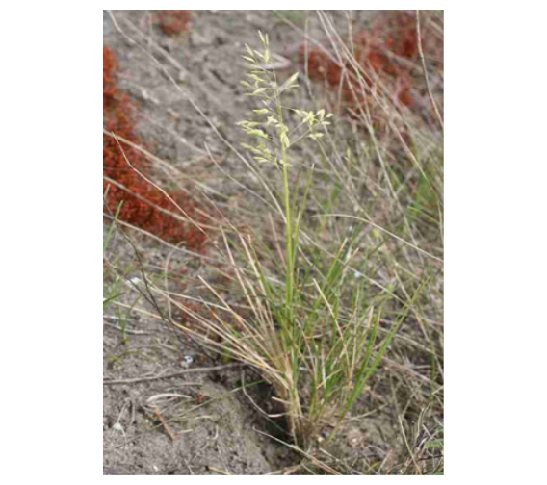
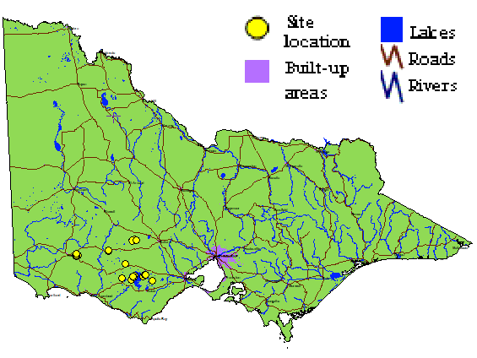
Description
Salt-lake Tussock-grass
(Photo: Pritchard)
Distribution in Victoria
(Flora Information System DSE 2007)

Salt-lake Tussock-grass (Poa sallacustris) is a perennial, rhizomatous grass, which reaches 30 cm in height when flowering from September through to December (Walsh 1991). The leaf blades are firm, smooth, glabrous, and loosely to closely folded, to 12 cm long. They extend from a sheath which is entire toward its base (Walsh 1991). A 1-2 mm, thinly membranous, acute to rounded ligule arises from the top of the sheath (Walsh & Entwisle 1994). The inflorescence consists of four to six flowered spikelets. Each flower has two bracts: the upper lemma and the lower palea. The lemmas are three-nerved and hairy along the midrib in the lower half; there may also be hairs along the lateral nerves near the base (Walsh & Entwisle 1994). The palea has few or no hairs at its base.

Distribution
Salt-lake Tussock-grass is apparently endemic to Victoria, where it occurs at the margins of brackish and salt lakes in the western district between Colac and Hamilton (Walsh 1991). Notable populations occur at Lakes Corangamite and Terangpom near Cressy, Lake Goldsmith south of Beaufort, Black Lake near Skipton, and Lake Linlithgow near Hamilton (Walsh & Entwisle 1994).

Abundance

The total area known to be covered by Salt-lake Tussock-grass is approximately 800m². These plants occur in nine populations. The extent of the range and abundance of Salt-lake Tussock-grass prior to European settlement is unknown.

Important populations
Important populations necessary to the long term survival and recovery of Salt-lake Tussock-grass occur in the following locations:
Site | Details
Lake Goldsmith Wildlife Reserve  (managed by Parks Victoria) | Lake Goldsmith (two populations) -  high abundances and more likely to be found with further searches
Lake Corangamite Lake Reserve  (managed by Parks Victoria) | Lake Corangamite -  currently viable population
Lake Terangpom Wildlife Reserve  (managed by Parks Victoria) | Lake Terangpom -  currently viable population
Private Land | Lake Linlithgow (including nearby Krause Swamp) -  currently viable population

Habitat
Populations of Salt-lake Tussock-grass occur in grassland/herbfield on flat to slightly sloping topography at the verges of slightly-to-strongly saline lakes (Walsh 1991). Associated species include Variable Willow-herb (Epilobium billardierianum), Nodding Club-sedge (Isolepis cernua), Australian Lilaeopsis (Lilaeopsis polyantha), Toowoomba Canary-grass (Phalaris aquatica), Buck’s Horn Plantain (Plantago coronopus), Salt Pratia (Lobelia irrigua), Lesser River Buttercup (Ranunculus diminutus), Small River Buttercup (R. amphitrichus), Common Bog-sedge (Schoenus apogon), Shiny Bog-sedge (S. nitens), Shiny Swamp-mat (Selliera radicans) and Narrow-leaf Wilsonia (Wilsonia backhousei). Soils tend to be sticky grey to black clays on a basalt substrate. At the Lake Terangpom population, the soils are sandy clays with tuff and ironstone nodules. At the Lake Corangamite population, the soils comprise partly decomposed Coxiella striata (a small aquatic snail) shellbeds.

Life history and ecology
Most populations of Salt-lake Tussock-grass are degraded by agriculture and have weed problems. Known populations are inadequately reserved. Several populations occur on private land (probably more than are currently known), and no populations are managed for conservation.
This species appears to occupy a very narrow physical and chemical niche, always around saline lakes where the ground-water is close to the surface and only mildly saline. The species is commonly associated with the rhizomatous Shiny Bog-sedge (Schoenus nitens). In nearly all cases, Salt-lake Tussock-grass occurs adjacent to a dense front of Phalaris, which at least currently seems unable to expand into the slightly more saline sites occupied by Salt-lake Tussock-grass. In the future, strains of Phalaris may be developed, or develop in situ that have the capacity to invade wetter sites. Tall Wheat Grass (Lophopyrum elongatum) is locally common and increasing in abundance in Salt-lake Tussock-grass areas, but is currently not so dense as to cause particular problems. Continued expansion of this grass at the current rate would lead to it becoming a major threat to Salt-lake Tussock-grass.

Conservation status

National conservation status
Salt-lake Tussock-grass is listed as vulnerable under the Commonwealth Environment Protection and Biodiversity Conservation Act 1999.

Victorian conservation status
Salt-lake Tussock-grass has been listed as threatened under the Victorian Flora and Fauna Guarantee Act 1988.
It is considered vulnerable in Victoria according to DSE’s Advisory List of Rare or Threatened Plants in Victoria – 2005 (DSE 2005).

Potentially threatening processes

Weed invasion
Notable weeds at or near populations include Toowoomba Canary Grass (Phalaris aquatica) and Tall Wheat-grass (Lophopyrum elongatum). A range of other pasture and annual weedy grasses threatens populations.

Grazing
Most sites are grazed by cattle or sheep.

Reservation status
No populations are formally conserved or are managed for conservation of this species.

Tree Planting
Further well-intentioned efforts to ‘revegetate’ lake margins pose a potential threat to available habitat.

Conversion to cropping
Conversion to cropping is a major threat across south-western Victoria, and modification of sites adjoining lake systems may lead to altered hydrology and/or chemical status of the substrate.

Previous management action
- Habitat of Salt-lake Tussock-grass has been assessed and described, and relevant environmental information has been collected.
- Potential habitat for Salt-lake Tussock-grass has been identified and surveyed.
- Seed has been collected for storage and tested for viability.
- A database is maintained including records of provenance, plant numbers and cultivation techniques and other relevant information.
- Seed germination trials have been undertaken at the Royal Botanic Gardens.
- Weed control has been undertaken.
- Regional recovery team has been established.

Long term objective
To ensure that the Salt-lake Tussock-grass can survive, flourish and retain its potential for evolutionary development in the wild.
Specific objectives, actions and targets
The intended management actions listed below are further elaborated in DSE’s Actions for Biodiversity Conservation (ABC) system. Detailed information about the actions and locations, including priorities, is held in this system and will be provided annually to land managers and other authorities.
- To increase knowledge of biology, ecology and management requirements
Action | Targets | Responsible
- Acquire baseline population data. Conduct detailed field and desk top surveys including identification of the area and extent of the population; estimates of the number, size and structure of the population; and inference or estimation of population change. | - Updated records on all state databases (Flora Information System, VROTPop and Herbarium).  - Populations accurately mapped. | DSE
- Assess habitat characteristics and/or condition. Accurately survey known habitat, and collect and analyse floristic and environmental information relevant to community ecology and condition. | - Ecological requirements identified for the completion of essential life history stages, recruitment and dispersal.  - Core habitat mapped. | DSE
- Conduct survey to locate suitable habitat. Identify and survey potential / historical habitat, using ecological and bioclimatic information that may indicate habitat preference. | - Predictive model for potential habitat developed and tested. | DSE
- Identify disturbance regimes to maintain habitat or promote regeneration and recruitment. | - Identify the existing flooding, burning or grazing regimes that maintain populations at Lake Goldsmith, Lake Corangamite and Lake Terangpom sites. | DSE
- Undertake research to identify key biological functions. Evaluate current reproductive / regenerative status, seed bank status and longevity, fecundity, and recruitment levels. Determine seed germination requirements by conducting laboratory and field trials aimed to identify key stimuli and determine stimuli for vegetative regeneration. | - Seed bank/regenerative potential quantified for target populations.  - Stimuli for recruitment/regeneration identified.  - Management strategies identified to maintain, enhance or restore regenerative processes fundamental to reproduction and survival. | DSE  Royal Botanic Gardens
- Analyse population trends. Measure population trends and responses against recovery actions by collecting demographic information including recruitment and mortality, timing of life history stages and morphological data. Collate, analyse and report on census data and compare with management histories. | - Techniques for monitoring developed and implemented.  - Census data for target populations collected.  - Population growth rates determined.  - Population Viability Analysis completed for targeted populations. | DSE
- To secure populations or habitat from potentially incompatible land use or catastrophic loss.
Action | Targets | Responsible
- Develop, provide input to or implement park, reserve or land management plan. | - Actions to conserve Salt-lake Tussock-grass incorporated into management plans for Lake Goldsmith, Lake Corangamite and Lake Terangpom sites. | DSE,  Parks Victoria
- Negotiate a cooperative management agreement with a private landholder. | - All private landholders with key populations or land incorporating suitable habitat approached and invited to enter into voluntary conservation agreements or requested for permission to survey for new populations. | DSE
- Erect/maintain signs to restrict or discourage access. Control accidental destruction by installing appropriate signage. | - Measurable seedling recruitment / vegetative regeneration and a measurable reduction in plant mortality at Lake Goldsmith, Lake Corangamite and Lake Terangpom sites. | DSE,  Parks Victoria
- Establish cultivated plants ex situ to safeguard from the unforeseen destruction of the wild population. | - Development of effective propagation and cultivation techniques.  - At least 25 mature plants derived from representative populations in cultivation. | DSE,  Royal Botanic Gardens
- Liaise with private landholders. Ensure that information and advice about the recovery of Salt-lake Tussock-grass has been provided to private land managers and landholders. | - All relevant private land managers are aware of the species and its management needs. | DSE
- Liaise with government agencies. Ensure that information and advice about the recovery of Salt-lake Tussock-grass has been provided to public land managers, local government authorities and Catchment Management Authorities | - All relevant authorities and public land managers are aware of the species and its management needs. | DSE
- To improve the condition of habitat
Action | Targets | Responsible
- Manage environmental weeds. Control threats from pest plants, using careful application of herbicide or hand removal of weeds. | - Measurable seedling recruitment / vegetative regeneration and a measurable reduction in plant mortality at Lake Goldsmith, Lake Corangamite and Lake Terangpom sites. | DSE,  Parks Victoria
- To increase the number of populations or individuals
Action | Targets | Responsible
- Store reproductive material. Establish a seed bank. | - Long-term storage facility identified.  - Seed from target populations in storage. | DSE,  Royal Botanic Gardens
- Determine seed viability. | - Seed viability determined. | Royal Botanic Gardens
- To increase community awareness and support
Action | Targets | Responsible
- Involve community groups and volunteers in recovery activities. | - Opportunities for involvement identified, promoted and supported. | DSE

References
DSE (2005) Advisory List of Rare or Threatened Plants in Victoria – 2005. Department of Sustainability and Environment, East Melbourne, Victoria.
Walsh, N.G. (1991) New taxa in Victorian Tussock-grassceae, Muelleria 7(3), 379-387.
Walsh, N.G. & Entwisle, T.J. (1994) Flora of Victoria. Volume 2: Ferns and Allied Plants, conifers and Monocotyledons, Inkata Press, Melbourne.

This Action Statement has been prepared under section 19 of the Flora and Fauna Guarantee Act 1988 under delegation from Mr Peter Harris, Secretary, Department of Sustainability and Environment, July 2008.
Published by the Victorian Government Department of Sustainability and Environment
Melbourne, July 2008
© The State of Victoria Department of Sustainability and Environment 2008
This publication is copyright. No part may be reproduced by any process except in accordance with the provisions of the Copyright Act 1968.
Authorised by the Victorian Government, 8 Nicholson Street, East Melbourne.
ISSN 1448-9902
For more information contact the DSE Customer Service Centre 136 186

Disclaimer
This publication may be of assistance to you but the State of Victoria and its employees do not guarantee that the publication is without flaw of any kind or is wholly appropriate for your particular purposes and therefore disclaims all liability for any error, loss or other consequence which may arise from you relying on any information in this publication.
Accessibility
If you would like to receive this publication in an accessible format, such as large print or audio, please telephone 136 186, 1800 122 969 (TTY), or email customer.service@dse.vic.gov.au
This document is also available in PDF format on the Internet at www.dse.vic.gov.au

