Introduction
Biodiversity Response Planning (BRP) is a long-term area-based planning approach to biodiversity conservation in Victoria. It is designed to strengthen alignment, engagement and participation between government, Traditional Owners, non-government agencies and the community.
DELWP Regional staff have been working with stakeholders on actions to conserve biodiversity in specific landscapes, informed by the best available science and local knowledge.
These Fact Sheets capture a point in time, reflecting data and knowledge available in 2020. They provide information for many (but not all) landscapes across Victoria, containing general information on the key values and threats in each area, as well as the priority cost-effective actions that provide the best protection of biodiversity. Fact Sheets are intended to provide useful biodiversity information for the community, non-government and government organisations during project planning and development.
Further information and the full list of Fact Sheets is available on the Department’s Environment website.

Landscape description
The Upper Mitta Mitta Dartmouth focus landscape is 132,173ha in size, of which 78% is covered in native vegetation. Public land makes up 99% of the area and includes a large portion of Alpine National Park. Approximately 60% of this landscape was impacted by bushfire in 2019/2020. For area context, refer to the map at the end of this Fact Sheet.
The Greater Alpine National Parks Management Plan provides further information relating to biodiversity values, threats and management issues in this landscape.

Cultural importance
We recognise that the entire landscape has high cultural value for Traditional Owners. Landscapes identified as having “notable” cultural importance are based on the density of recorded cultural heritage sites and knowledge shared by Traditional Owners. We also recognise that there are locations important to Traditional Owners not located within these focus landscapes.

Stakeholder interest
As part of the BRP process, in October 2020 stakeholders were asked to nominate focus landscapes, values, threats and potential biodiversity actions. Representatives from DELWP, Parks Victoria, Trust for Nature, Goulburn Broken Catchment Management Authority, North East Catchment Management Authority, Taungurung Land and Waters Council, Yorta Yorta Nation Aboriginal Corporation, and the Alpine Resorts agreed on the boundaries and key aspects of this landscape.
Possible future investment/project development in this landscape will be available to any interested stakeholders in addition to those who nominated this landscape.

Habitat Distribution Models identified 163 species with more than 5% of their Victorian range in this landscape area
- Kosciuszko Grevillea (Grevillea victoriae subsp. nivalis), Endangered, 21% Victorian range in area
- Ridge Flannel-flower (Actinotus forsythii), Vulnerable, 25% Victorian range in area
- Lemon-scented Ziera (Zieria citriodora), Vulnerable, 25% Victorian range in area
- Tailed Eyebright (Euphrasia caudata) Rare, 23% Victorian range in area
- Broad-toothed Rat (Mastacomys fuscus mordicus), Endangered, 6% Victorian range in area
Traditional Owners and other stakeholders identified additional species of interest: Eastern Wallaroo, Smoky Mouse, Greater Glider
- Red-throated Skink (Acritoscinus platynotus) 6% Victorian range in area
Traditional Owners and other stakeholders identified an additional species of interest: Alpine Water Skink
- Bar-shouldered Dove (Geopelia humeralis) 8% Victorian range in area
- Spotted Tree Frog (Litoria spenceri) Critically Endangered, 7% Victorian range in area.
Traditional Owners and other stakeholders identified additional species of interest: Smooth Toadlet, Alpine Tree Frog

Strategic Management Prospects
Strategic Management Prospects (SMP) models biodiversity values such as species habitat distribution, landscape-scale threats and highlights the most cost-effective actions for specific locations. More information about SMP is available in NatureKit.

Additional threats
Threats identified through the consultation process (in addition to those modelled in SMP) are:
- Weeds: these can have a negative impact on the biodiversity values and through competition with native vegetation can alter natural ecosystems. Invasive woody weeds such as Broom and Willows are a priority as they infest sensitive areas such as peatlands which provide habitat for rare and threatened species.
- The habitat of endangered species such as the Spotted Tree Frog (and other amphibians) is impacted by horses, deer, pigs and other hard-hooved animals which favour moist areas to graze, wallow and drink. The continued eradication of feral species is considered a high priority for ongoing habitat protection.
- Stock grazing along the riparian corridor is a continuing threat and uncontrolled access along water frontages impacts the landscape through overgrazing, pugging, and compaction. This activity leads to erosion, spread of weeds and competition with native fauna species. Uncontrolled grazing disables natural regeneration and with the lack of native species recruitment, vegetation communities and their associated habitat are severely impacted and lost.
- Recreational use (overuse, off-road/track and illegal activities) is considered a threat to this landscape.

Which landscape-scale actions are most cost-effective in this landscape?
Some areas of this landscape of interest (coloured areas on the map) have highly cost-effective actions which provide significant benefit for biodiversity conservation.
The SMP priority action which ranks among the top 3% for cost-effectiveness of that action across the state for much of the area (>1,000ha) is to control horses. The other top 10% actions are:
Control pigs 42,393ha
Control horses 41,264ha
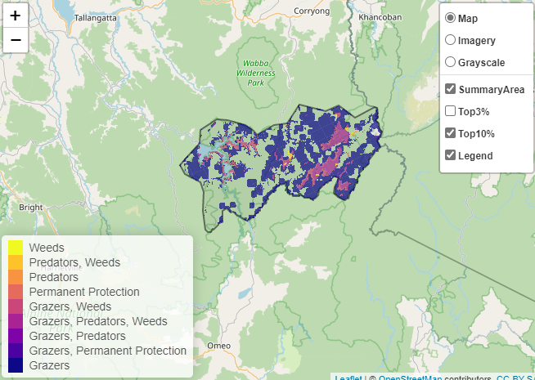

Of the top 10% of cost-effective actions, controlling pigs and horses provide the most cost-effective biodiversity benefits when considering all flora and fauna.
From the landscape nomination process, the following additional conservation actions were suggested:
- feral animal (herbivore) control for benefit of Spotted Tree Frog, and other native fauna and flora
- weed control, with emphasis on woody weeds to reduce infestations in sensitive areas
- fencing of waterways to control stock access and reduce the impact from erosion, sedimentation and pathogens entering waterways
- minimising impact from recreational activities through education, providing/maintaining recreation infrastructure, and follow-up visitor compliance and monitoring were identified as best practice to mitigate the impacts
Further recommended activities may be identified in consultation with partners.

The most cost-effective action for flora and fauna in this focus landscape
Plants – Control horses
Birds, Mammals, Reptiles – Control pigs
Amphibians – Control deer

For a further in depth look into SMP for this landscape please refer to NatureKit.

