Introduction
Biodiversity Response Planning (BRP) is a long-term area-based planning approach to biodiversity conservation in Victoria. It is designed to strengthen alignment, engagement and participation between government, Traditional Owners, non-government agencies and the community.
DELWP Regional staff have been working with stakeholders on actions to conserve biodiversity in specific landscapes, informed by the best available science and local knowledge.
These Fact Sheets capture a point in time, reflecting data and knowledge available in 2020. They provide information for many (but not all) landscapes across Victoria, containing general information on the key values and threats in each area, as well as the priority cost-effective actions that provide the best protection of biodiversity. Fact Sheets are intended to provide useful biodiversity information for the community, non-government and government organisations during project planning and development.
Further information and the full list of Fact Sheets is available on the Department’s Environment website.

Landscape description
The Murray River East of Barmah focus landscape is 54,483ha in size with 32% cover of native vegetation. Public land makes up 25% of the area which extends from the eastern edge of Barmah State Forest upstream along the Murray River to Albury/Wodonga. The public lands include Barmah National Park and the proposed Murray River Park. For area context, refer to the map at the end of this factsheet.
The focus landscape covers land and waterways with are of significant interest to the Yorta Yorta Nation, Goulburn Broken Catchment Management Authority, Parks Victoria and DELWP. Parks Victoria through collaboration with Yorta Yorta Traditional Owner Board have developed a Joint Management Plan which covers part of the focus landscape. Parks Victoria’s River Red Gum Parks Management Plan also covers part of the area.

Cultural importance
We recognise that the entire landscape has high cultural value for Traditional Owners. Landscapes identified as having “notable” cultural importance are based on the density of recorded cultural heritage sites and knowledge shared by Traditional Owners. We also recognise that there are locations important to Traditional Owners not within these landscapes of interest. This landscape includes Country of the Yorta Yorta People.

Stakeholder interest
As part of the BRP process, in October 2020 stakeholders were asked to nominate focus landscapes, values, threats and potential biodiversity actions. Representatives from DELWP, Parks Victoria, Trust for Nature, Goulburn Broken Catchment Management Authority, North East Catchment Management Authority, Taungurung Land and Waters Council, Yorta Yorta Nation Aboriginal Corporation, and the Alpine Resorts agreed on the boundaries and key aspects of this landscape.
Possible future investment/project development in this landscape will be available to any interested stakeholders in addition to those who nominated this landscape.

Habitat Distribution Models identified 12 species with more than 5% of their Victorian range in this landscape area
9 Plant species, including:
- Winter Apple (Eremophila debilis) Endangered,17% Victorian range in area
- Water Shield (Brasenia schreberi), Vulnerable, 17% Victorian range in area
- Coolibah Grass (Panicum queenslandicum) Endangered, 15% Victorian range in area
- Hornwort (Ceratophyllum demersum), Poorly known,10% Victorian range in area
In addition to species noted above, Traditional Owners and other stakeholders identified the following species and communities of interest: Ramsar wetlands, River Red Gum wetlands and woodlands, River Swamp Wallaby-grass
 | Notable mammal species found in this landscape: Squirrel Glider, Water Rat, Grey-headed Flying Fox
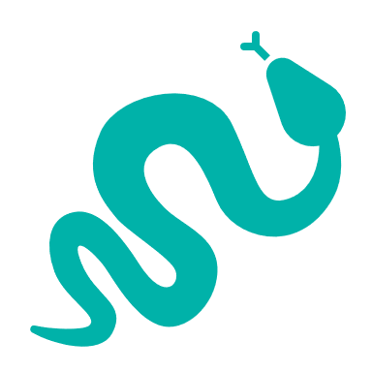 | Notable reptile species found in this landscape: Eastern Snake-necked Turtle, Woodland Blind Snake, Carpet Python
2 Bird species:
- Bar-shouldered Dove (Geopelia humeralis), 12% Victorian range in area
- Superb Parrot (Polytelis swainsonii) Endangered, 8% Victorian range in area
In addition to species noted above, Traditional Owners and other stakeholders identified the following species of interest: Azure Kingfisher, Australian Painted Snipe, White-bellied Sea Eagle, Australasian Bittern
1 Amphibian species:
- Rugose Toadlet (Uperoleia rugosa) Endangered, 6% Victorian range in area
In addition to species noted above, Traditional Owners and other stakeholders identified the Giant Bullfrog as a species of interest

Strategic Management Prospects
Strategic Management Prospects (SMP) models biodiversity values such as species habitat distribution, landscape-scale threats and highlights the most cost-effective actions for specific locations. More information about SMP is available in NatureKit.

Additional threats
Threats identified through the consultation process (in addition to those modelled in SMP) are:
- Stock grazing along the riparian corridor is a continuing threat to these sensitive areas. Uncontrolled access along the water frontages impacts the landscape through overgrazing, pugging, and compaction. This activity leads to erosion, spread of weeds and competition with native fauna species. Uncontrolled grazing disables natural regeneration and with the lack of native species recruitment, vegetation communities are severely impacted and lost.
- Woody weeds are also a threat with invasive species such as Willow, Box elder and Ash species readily taking over some areas.
- Tourism and recreational activities (camping, boating, firewood collection) are impacting the riparian areas. Camping within proximity to the waterway has seen areas devoid of vegetation, heavily compacted and adding pressure to already erodible sites. The activities have also resulted in rubbish dumping, toileting near the waterway, removal of wood (dead, alive, standing and fallen) and off-road driving.
- Fox predation on turtle eggs, and aquatic pest species such as Carp are also considered key threats.

Which landscape-scale actions are most cost-effective in this landscape?
Some areas of this focus landscape have highly cost-effective actions which provide significant benefit for biodiversity conservation. The SMP priority action which ranks among the top 3% for cost-effectiveness of that action across the state for much of the area (>1,000ha) is to Control horses. The top 10% actions are:
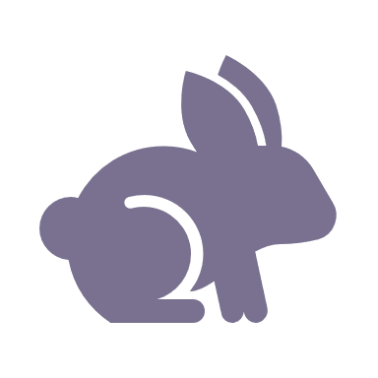 | Control rabbits 30,436ha
 | Control weeds 28,790ha

Of the top 10% of cost-effective actions, control rabbits and weeds provide the most cost-effective biodiversity benefits when considering all flora and fauna.

The SMP map for this focus landscape is currently not available – please contact the regional Natural Environment Programs team for further information.

Biodiversity management activities identified (in addition to those modelled in SMP) through the consultation process are:
- stock exclusion and revegetation of riparian areas through the continuation of existing programs
- wider community education programs and compliance to address the recreational activities occurring along waterways that are causing environmental damage
- the continuation of pest management for the control of introduced invasive species with emphasis on foxes, carp and weeds
- secure and protect habitat for threatened species and continue monitoring activities to determine control programs for threats

The most cost-effective action for flora and fauna
Plants - Control weeds
Birds, Amphibians, Mammals, Reptiles - Combined cat and fox control

For a further in depth look into SMP for this landscape please refer to NatureKit.

