Introduction
Biodiversity Response Planning (BRP) is a long-term area-based planning approach to biodiversity conservation in Victoria. It is designed to strengthen alignment, engagement and participation between government, Traditional Owners, non-government agencies and the community.
DELWP Regional staff have been working with stakeholders on actions to conserve biodiversity in specific landscapes, informed by the best available science and local knowledge.
These Fact Sheets capture a point in time, reflecting data and knowledge available in 2020. They provide information for many (but not all) landscapes across Victoria, containing general information on the key values and threats in each area, as well as the priority cost-effective actions that provide the best protection of biodiversity. Fact Sheets are intended to provide useful biodiversity information for the community, non-government and government organisations during project planning and development.
Further information and the full list of Fact Sheets is available on the Department’s Environment website.

Landscape description
The Murray River west of Barmah focus landscape is 12,766ha in size with approximately 53% covered by native vegetation. Public land makes up 42% of the area which extends downstream along the Murray River from Barmah in the east through to Echuca in the west. The public lands include Barmah National Park, Lower Goulburn National Park and Murray Valley Regional Park. For area context, refer to the map at the end of this factsheet.
The focus landscape covers land and waterways which are of interest to the Yorta Yorta Nation, Goulburn Broken Catchment Management Authority, Parks Victoria and DELWP. Parks Victoria through collaboration with Yorta Yorta Traditional Owner Board have developed a Joint Management Plan for Barmah National Park which covers part of the focus landscape.
Possible future investment/project development in this landscape will be available to any interested stakeholders in addition to those who nominated this landscape

Cultural importance
We recognise that the entire landscape has high cultural value for Traditional Owners. Landscapes identified as having “notable” cultural importance are based on the density of recorded cultural heritage sites and knowledge shared by Traditional Owners. We also recognise that there are locations important to Traditional Owners not within these landscapes of interest. This landscape includes Country of the Yorta Yorta People.

Stakeholder interest
As part of the BRP process, in October 2020 stakeholders were asked to nominate focus landscapes, values, threats and potential biodiversity actions. Representatives from DELWP, Parks Victoria, Trust for Nature, Goulburn Broken Catchment Management Authority, North East Catchment Management Authority, Taungurung Land and Waters Council, Yorta Yorta Nation Aboriginal Corporation, and the Alpine Resorts agreed on the boundaries and key aspects of this landscape.

Habitat Distribution Models identified 1 species with more than 5% of their Victorian range in this landscape area
1 plant species with more than 5% of their Victorian range in this landscape area:
- Wavy Marshwort (Nympoides crenata) Vulnerable, 6% Victorian range in area
In addition, Traditional Owners and other stakeholder identified the following important species and communities: Ramsar wetlands, River Red Gum wetlands and woodlands, River Swamp Wallaby-grass
Notable species found in this landscape: Squirrel Glider
Notable species found in this landscape: Eastern Snake-necked Turtle
Notable species found in this landscape: Superb Parrot, Azure Kingfisher, Australasian Bittern, White-bellied Sea Eagle

Strategic Management Prospects
Strategic Management Prospects (SMP) models biodiversity values such as species habitat distribution, landscape-scale threats and highlights the most cost-effective actions for specific locations. More information about SMP is available in NatureKit.

Additional threats
Threats identified through the consultation process (in addition to those modelled in SMP) are:
- Grazing animals (predominantly feral species) along the riparian corridor is a continuing threat to these sensitive areas. This activity leads to erosion, spread of weeds and competition with native fauna species. Uncontrolled grazing disables natural regeneration and with the lack of native species recruitment, vegetation communities are severely impacted and lost.
- Weeds and introduced invasive pest animals are a continuing threat in this landscape and ongoing removal is required.
- Aquatic species such as carp are an historic and ongoing threat to water quality and native species populations (fish and amphibians).
- Tourism and recreational activities (legal and illegal), including camping, boating, firewood collection and off-road driving are impacting the riparian areas.
- Camping within proximity to the waterway has seen areas devoid of vegetation, heavily compacted and adding pressure to already erodible sites.
- Removal of wood (dead, alive, standing and fallen) for firewood impacts many ground and arboreal species which use trees/timber as habitat.
- Change to natural water regimes (frequency, timing, duration, depth, variability and extent of flooding) also pose a threat.

Which landscape-scale actions are most cost-effective in this landscape?
Some areas of this landscape of interest (coloured areas on the map below) have highly cost-effective actions which provide significant benefit for biodiversity conservation.

The SMP priority action which ranks among the top 3% for cost-effectiveness of that action across the state for much of the area (>1,000ha) is to Control horses. The other top 10% actions are:
Control pigs 7,897ha
Control rabbits 6,070ha

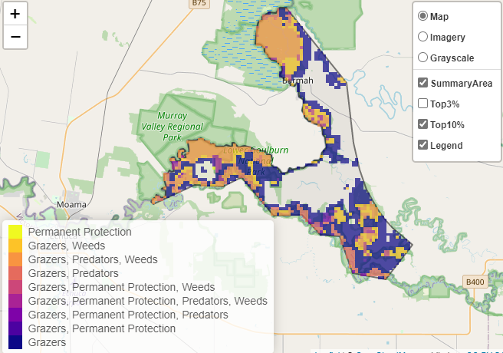
Of the top 10% of cost-effective actions, controlling pigs and rabbits provides the most cost-effective biodiversity benefits when considering all flora and fauna.

Biodiversity management activities identified through the consultation process (in addition to those modelled in SMP) are:
- The continuation of pest management for the control of introduced invasive species with emphasis on foxes, horses, deer, pigs, carp and weeds.
- Wider community education programs and compliance is required to address the recreational activities occurring along waterways that area causing environmental damage.
- Secure and protect habitat for threatened species and continue monitoring activities to determine control programs for threats.

The most cost-effective action for flora and fauna
Plants, Amphibians - Control pigs
Mammals, Birds, Reptiles - Combined cat and fox control

For a further in depth look into SMP for this landscape please refer to NatureKit.

