Introduction
Biodiversity Response Planning (BRP) is a long-term area-based planning approach to biodiversity conservation in Victoria. It is designed to strengthen alignment, engagement and participation between government, Traditional Owners, non-government agencies and the community.
DELWP Regional staff have been working with stakeholders on actions to conserve biodiversity in specific landscapes, informed by the best available science and local knowledge.
These Fact Sheets capture a point in time, reflecting data and knowledge available in 2020. They provide information for many (but not all) landscapes across Victoria, containing general information on the key values and threats in each area, as well as the priority cost-effective actions that provide the best protection of biodiversity. Fact Sheets are intended to provide useful biodiversity information for the community, non-government and government organisations during project planning and development.
Further information and the full list of Fact Sheets is available on the Department’s Environment website.

Landscape description
The Wabba Wilderness focus landscape is 26,551ha in size, with over 81% covered by native vegetation. The whole area is public land, known as the Wabba Wilderness Park. Approximately 99% of the Wabba Wilderness landscape was impacted by bushfire in 2019/2020. For area context, refer to the map at the end of this Fact Sheet. The area is managed by Parks Victoria.

Cultural importance
We recognise that the entire landscape has high cultural value for Traditional Owners. Landscapes identified as having “notable” cultural importance are based on the density of recorded cultural heritage sites and knowledge shared by Traditional Owners. We also recognise that there are locations important to Traditional Owners not within these focus landscapes.

Stakeholder interest
As part of the BRP process, in October 2020 stakeholders were asked to nominate focus landscapes, values, threats and potential biodiversity actions. Representatives from DELWP, Parks Victoria, Trust for Nature, Goulburn Broken Catchment Management Authority, North East Catchment Management Authority, Taungurung Land and Waters Council, Yorta Yorta Nation Aboriginal Corporation, and the Alpine Resorts agreed on the boundaries and key aspects of this landscape.
Possible future investment/project development in this landscape will be available to any interested stakeholders in addition to those who nominated this landscape.

Habitat Distribution Models identified 159 species with more than 5% of their Victorian range in this landscape area
159 Plant species, including:
- Summer Leek-orchid (Prasophyllum uvidulum), Endangered, 26% Victorian range in area
- Snow-gum Flax-lily (Dianella sp. aff. revoluta (Cobberas), conservation status is poorly known, 26% Victorian range in area
- Elegant Cassinia (Cassinia venusta), Rare, 12% Victorian range in area
- Bristly Bush-pea (Pultenaea acerosa), Vulnerable, 11% Victorian range in area
- Sharp Mountain Tussock-grass (Poa labillardierei var. acris), Vulnerable, 11% Victorian range in area
Traditional Owners and other stakeholders also identified the following species of interest: Baw Baw Violet, Purple Eyebright
Traditional Owners and other stakeholders also identified the following species of interest: Greater Glider
Traditional Owners and other stakeholders also identified the following species of interest: Powerful Owl, Sooty Owl
Traditional Owners and other stakeholders also identified the following species of interest: Booroolong Tree Frog and Spotted Tree Frog (both critically endangered) which have been identified in close proximity to this landscape

Strategic Management Prospects
Strategic Management Prospects (SMP) models biodiversity values such as species habitat distribution, landscape-scale threats and highlights the most cost-effective actions for specific locations. More information about SMP is available in NatureKit.

Additional threats
Threats identified through the consultation process (in addition to those modelled in SMP) are:
- Weeds – these can have a negative impact on the biodiversity values and, through competition with native vegetation, can alter natural ecosystems. The emergence of weeds after fires is considered a threat to biodiversity and control in this area is a priority.
- Endangered species such as the Summer Leek-orchid require specific habitat which is susceptible to impacts from weeds.
- Deer are present in this landscape and, along with other pest species, impact the habitat for native flora and fauna species. Continued monitoring and control programs are a priority for this landscape.

Which landscape-scale actions are most cost-effective in this landscape?
Some areas of this landscape of interest (coloured areas on the map – see next page) have highly cost-effective actions which provide significant benefit for biodiversity conservation.
The SMP priority action which ranks among the top 3% for cost-effectiveness of that action across the state for much of the area (>1,000ha) is to Control pigs. The other top 10% actions are:
Control pigs 23,981ha
Control deer 13,841ha

Of the top 10% of cost-effective actions, controlling pigs and deer provides the most cost-effective biodiversity benefits when considering all flora and fauna.

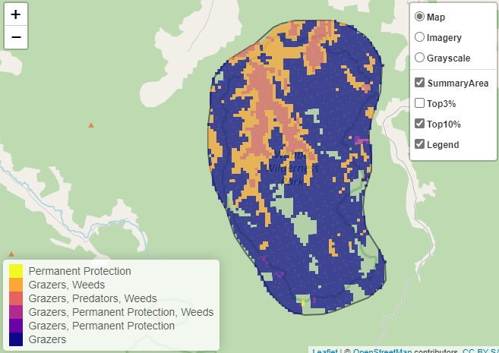

The nomination process identified the following additional biodiversity management actions for this focus landscape:
- habitat protection activities (feral animal control) to benefit of Spotted Tree Frog, and other native fauna and flora
- weed control with emphasis on woody weeds to reduce infestations in sensitive areas
- fencing of waterways to control stock access, reduce erosion, sedimentation and reduce pathogens entering the waterway
- minimising impact from recreational activities through education, providing/maintaining recreational infrastructure, and undertaking visitor compliance and monitoring is identified as best practice to mitigate the impacts

Further recommended activities may be identified in consultation with partners.

The most cost-effective actions for flora and fauna
Plants, Birds, Mammals, Reptiles – Control pigs
Amphibians – Control deer

For a further in-depth look at SMP results for this landscape please refer to NatureKit.

