Introduction
Biodiversity Response Planning (BRP) is a long-term area-based planning approach to biodiversity conservation in Victoria. It is designed to strengthen alignment, engagement and participation between government, Traditional Owners, non-government agencies and the community.
DELWP Regional staff have been working with stakeholders on actions to conserve biodiversity in specific landscapes, informed by the best available science and local knowledge.
These Fact Sheets capture a point in time, reflecting data and knowledge available in 2020. They provide information for many (but not all) landscapes across Victoria, containing general information on the key values and threats in each area, as well as the priority cost-effective actions that provide the best protection of biodiversity. Fact Sheets are intended to provide useful biodiversity information for the community, non-government and government organisations during project planning and development.
Further information and the full list of Fact Sheets is available on the Department’s Environment website.

Landscape description
The Warbys focus landscape is 36,629ha in size with over 53% covered by native vegetation. Warby – Ovens National Park makes up 41% of the area and is managed by Parks Victoria. The River Red Gum Parks Management Plan 2018 provides details on the management of the focus landscape.
For area context, refer to the map at the end of this Fact Sheet.

Cultural importance
We recognise that the entire landscape has high cultural value for Traditional Owners. Landscapes identified as having “notable” cultural importance are based on the density of recorded cultural heritage sites and knowledge held and shared by Traditional Owners. We also recognise that there are locations important to Traditional Owners not within these focus landscapes. This landscape includes Country of the Yorta Yorta People.

Stakeholder interest
As part of the BRP process, in October 2020 stakeholders were asked to nominate focus landscapes, values, threats and potential biodiversity actions. Representatives from DELWP, Parks Victoria, Trust for Nature, Goulburn Broken Catchment Management Authority, North East Catchment Management Authority, Taungurung Land and Waters Council, Yorta Yorta Nation Aboriginal Corporation, and the Alpine Resorts agreed on the boundaries and key aspects of this landscape.
Possible future investment/project development in this landscape will be available to any interested stakeholders in addition to those who nominated this landscape.

Habitat Distribution Models identified 17 species with more than 5% of their Victorian range in this landscape area
16 Plant species, notably:
- Common Fringe-sedge (Fimbristylis dichotoma) Vulnerable, 27% Victorian range in area
- Foot Triggerplant (Stylidium ecorne) Poorly known, 16% Victorian range in area
- Spur-wing Wattle (Acacia triptera) Rare, 16% Victorian range in area
- Warby Range Swamp-gum (Eucalyptus cadens) Vulnerable, 11% Victorian range in area
- Currawang (Acacia doratoxylon) Rare, 10% Victorian range in area
- Winter Apple (Eremophila debilis) Endangered, 8% Victorian range in area
Other species of interest identified by Traditional Owners and other stakeholders include: Austral Grass-tree, Leek Orchids
Other species of interest identified by Traditional Owners and other stakeholders include: Squirrel Glider, Brush-tailed Phascogale, Feathertail Glider
Other species of interest identified by Traditional Owners and other stakeholders include: Dwyers Snake, Carpet Python, Lace Monitor
Other species of interest identified by Traditional Owners and other stakeholders include: Turquoise Parrot, Regent Honeyeater (Critically Endangered), Superb Parrot, Barking Owl
- Rugose Toadlet (Uperoleia rugosa) Endangered, 6% Victorian range in area
Other species of interest identified by Traditional Owners and other stakeholders include: Giant Bullfrog (Critically Endangered)

Strategic Management Prospects
Strategic Management Prospects (SMP) models biodiversity values such as species habitat distribution, landscape-scale threats and highlights the most cost-effective actions for specific locations. More information about SMP is available in NatureKit.

Additional threats
Threats identified through the consultation process (in addition to those modelled in SMP) are:
- establishment of pest animals (rabbits, foxes, deer, goats)
- climate change
- recreational activities
- inappropriate fire regimes
Weeds are a significant management issue in the landscape, due to the extensive interface with private land and invasive grasses spread and colonise other areas quickly. As this focus landscape contains a wide range of vegetation communities, weeds of varying forms have been able to establish (e.g. Willows, Prickly Pear, Bridal Creeper, Chilean Needle Grass).

Which landscape-scale actions are most cost-effective in this landscape?
Some areas of this landscape of interest (coloured areas on the map below) have highly cost-effective actions which provide significant benefit for biodiversity conservation.
The SMP priority action which ranks among the top 3% for cost-effectiveness of that action across the state for much of the area (>1,000ha) is to Control pigs.
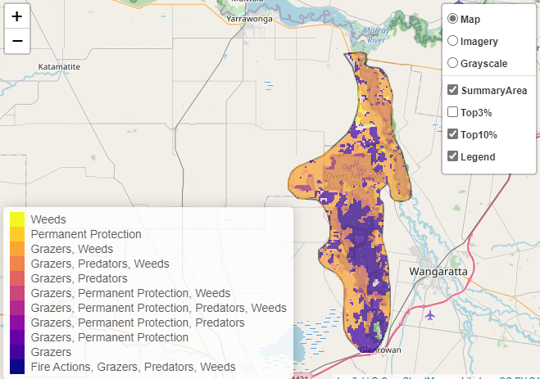
The other top 10% actions are:

Control rabbits 32,516ha
Control weeds 21,566ha
Of the top 10% of cost-effective actions, controlling rabbits and weeds provide the most cost-effective biodiversity benefits when considering the conservation of all flora and fauna.

From the landscape nomination process, the following additional actions were suggested:
- feral animal control to reduce impact on threatened species and general habitat health
- continuation of weed control programs for existing weed infestations and monitor for new infestations to ensure rapid response in treatment and eradication
- minimising impact from recreational activities in the National Park, and monitoring use and condition of infrastructure and facilities

Further recommended activities may be identified in consultation with partners.

The most cost-effective actions for flora and fauna
Plants - Control rabbits
Birds, Mammals, Amphibians, Reptiles - Combined cat and fox control

For a further in depth look into SMP for this landscape please refer to NatureKit.
