Introduction
Biodiversity Response Planning (BRP) is a long-term area-based planning approach to biodiversity conservation in Victoria. It is designed to strengthen alignment, engagement and participation between government, Traditional Owners, non-government agencies and the community.
DELWP Regional staff have been working with stakeholders on actions to conserve biodiversity in specific landscapes, informed by the best available science and local knowledge.
These Fact Sheets capture a point in time, reflecting data and knowledge available in 2020. They provide information for many (but not all) landscapes across Victoria, containing general information on the key values and threats in each area, as well as the priority cost-effective actions that provide the best protection of biodiversity. Fact Sheets are intended to provide useful biodiversity information for the community, non-government and government organisations during project planning and development.
Further information and the full list of Fact Sheets is available on the Department’s Environment website.

Landscape description
The Mount Hotham, Falls Creek and Bogong High Plains alpine area is 122,033ha of which 98% is public land and includes part of the Alpine National Park. Just over 80% of the area is covered with native vegetation. For area context, refer to the map at the end of this factsheet.

Cultural importance
We recognise that this entire landscape has high cultural value for Traditional Owners. Landscapes identified as having “notable” cultural importance is based on the density of recorded cultural heritage sites and knowledge shared by Traditional Owners. This landscape includes Country of the Taungurung People.

Stakeholder interest
As part of the BRP process, in October 2020 stakeholders were asked to nominate focus landscapes, values, threats and potential biodiversity actions. DELWP, Parks Victoria, Trust for Nature, Goulburn Broken Catchment Management Authority, North East Catchment Management Authority, Taungurung Land and Waters Council, Yorta Yorta Nation Aboriginal Corporation, and the Alpine Resorts agreed on the boundaries and key aspects of this landscape.
The representative stakeholders for this landscape are, Parks Victoria, Alpine Resorts and Taunguarung Land and Waters Council. The Greater Alpine Parks Management Plan provides details on the management of the areas within the Alpine National Park.

Habitat Distribution Models identify 274 species with more than 5% of their Victorian range in this landscape area
264 Plant species, including:
- Snow-wort (Abrotanella nivigena) Vulnerable, 100% Victorian range in area
- Reddish Bog-heath (Epacris glacialis) Rare, 100% Victorian range in area
- Allied Bent-grass (Deyeuxia affinis) Endangered, 100% Victorian range in area
- Bogong Sallee (Eucalyptus pauciflora subsp. hedraia) Rare, 100% Victorian range in area
Vegetation communities identified as important by Traditional Owners and stakeholders include: Alpine bogs, peatlands, grasslands and heathlands
2 Mammal species:
- Mountain Pygmy-possum (Burramys parvus) Critically Endangered, 99% Victorian range in area
- Broad-toothed Rat (Mastacomys fuscus mordicus) Endangered, 14% Victorian range in area
Other species identified as important by Traditional Owners and stakeholders include Long-footed Potoroo, Smoky Mouse and Spot-tailed Quoll
6 Reptile species:
- Guthega Skink (Liopholis Guthega) Critically Endangered, 100% Victorian range in area
- Alpine She-oak Skink (Cyclodomorphus praealtus) Critically Endangered, 78% Victorian range in area
- Alpine Water Skink (Eulamprus kosciuskoi), Critically Endangered, 61% Victorian range in area
- Alpine Bog Skink (Pseudemoia cryodroma) Endangered, 50% Victorian range in area
- Mountain Skink (Liopholis montana) Data deficient, estimated 32% Victorian range in area
Other species identified as important by Traditional Owners and stakeholders include Grass Skink
2 Amphibian species:
- Alpine Tree Frog (Litoria verreauxii alpine) Critically endangered, 49% Victorian range in area
- Spotted Tree Frog (Litoria spenceri) Critically Endangered, 8% Victorian range in area

Strategic Management Prospects
Strategic Management Prospects (SMP) models biodiversity values such as species habitat distribution, landscape-scale threats and highlights the most cost-effective actions for specific locations. More information about SMP is available in NatureKit.

Additional threats
Threats identified (in addition to those modelled in SMP) through the consultation process were:
- habitat loss through development (roads, buildings, infrastructure)
- predatory animals such as foxes and cats (effective management of these species is required, although cost-effective around resort areas it can be quite difficult and costly in the broader landscape)
- grazing of hard-hooved animals (deer, feral horses, cattle) degrades the habitat of aquatic species including endangered frogs
- weeds have the ability to spread from modified areas into the adjoining landscapes
Pest management is considered a high priority along with investment in monitoring activities to determine impact, scale and best management programs.
A predator monitoring program is required to support Long-footed Potoroo conservation efforts.
Tourism and recreation activities which attract hundreds of thousands of visitors each year to alpine areas can have huge impacts on the environment not only from the recreational use but also from the generation of waste (rubbish and wastewater).
Continuation of sustainability projects in Alpine Resorts for overall biodiversity benefit is strongly encouraged, including the reduction of impacts from resort operations, waste and emissions. Investment in education and behaviour change (signage, engagement with locals and tourists and encouraging citizen science) is required across all landscapes.

Which landscape-scale actions are most cost-effective in this landscape?
The coloured areas indicate where the identified landscape-scale actions and locations are most cost-effective and will maximise biodiversity benefit across Victoria for multiple species.
The SMP priority action which ranks among the top 3% for cost-effectiveness of that action across the state for much of the area (>1,000ha) is to control horses.
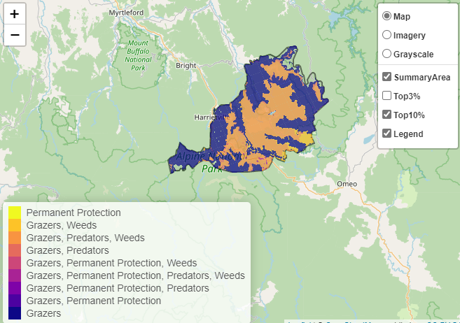
Of the top 10% of cost-effective actions, controlling horses and deer provide the most cost-effective biodiversity benefits when considering all flora & fauna.
Control horses 99,139ha
Control deer 68,906ha

Biodiversity activities identified (in addition to those modelled in SMP) through the consultation process were:
- Habitat and ecological community improvement works (expanding habitat for species i.e. Mountain Pygmy-possum, revegetation with food plants and connectivity areas)
- increasing awareness of threats such as rat poison in buildings
- restoring boulder field habitat
- restoring Alpine Peatland Bogs which have been historically impacted

Some species have Action Plans including: Spotted Tree Frog, Guthega Skink, She-oak Skink and Alpine Tree Frog (at Mt Hotham). However, there is limited data on some species and special data analysis is required (special needs analysis for populations, based on SMP modelling).

The most cost-effective actions for flora and fauna
Plants – control total grazing pressure
Birds, Mammals, Amphibians, Reptiles – combined cat and fox control

For a further in depth look into SMP for this landscape, please refer to NatureKit.

