Introduction
Biodiversity Response Planning (BRP) is a long-term area-based planning approach to biodiversity conservation in Victoria. It is designed to strengthen alignment, engagement and participation between government, Traditional Owners, non-government agencies and the community.
DELWP Regional staff have been working with stakeholders on actions to conserve biodiversity in specific landscapes, informed by the best available science and local knowledge.
These Fact Sheets capture a point in time, reflecting data and knowledge available in 2020. They provide information for many (but not all) landscapes across Victoria, containing general information on the key values and threats in each area, as well as the priority cost-effective actions that provide the best protection of biodiversity. Fact Sheets are intended to provide useful biodiversity information for the community, non-government and government organisations during project planning and development.
Further information and the full list of Fact Sheets is available on the Department’s Environment website.

Landscape description
The Ovens River and Buffalo River focus landscape is 120,423ha with approximately 55% of the area covered in native vegetation. Public land makes up 45% of the area and includes the part of the Mount Buffalo National Park. Approximately 20% of the landscape area was impacted by bushfire in 2020. For area context, refer to the map at the end of this Fact Sheet.
The focus area covers waterways of significant interest to the North East Catchment Management Authority, Taungurung Land and Waters Council and DELWP.

Cultural importance
We recognise that the entire landscape has high cultural value for Traditional Owners. Landscapes identified as having “notable” cultural importance is based on the density of recorded cultural heritage sites and knowledge shared by Traditional Owners. We also recognise that there are locations important to Traditional Owners not within these landscapes of interest. This landscape includes Country of the Taungurung People.

Stakeholder interest
As part of the BRP process, in October 2020 stakeholders were asked to nominate focus landscapes, values, threats and potential biodiversity actions. Representatives from DELWP, Parks Victoria, Trust for Nature, Goulburn Broken Catchment Management Authority, North East Catchment Management Authority, Taungurung Land and Waters Council, Yorta Yorta Nation Aboriginal Corporation, and the Alpine Resorts agreed on the boundaries and key aspects of this landscape.
Possible future investment/project development in this landscape will be available to any interested stakeholders in addition to those who nominated this landscape.

Strategic Management Prospects
Strategic Management Prospects (SMP) models biodiversity values such as species habitat distribution, landscape-scale threats and highlights the most cost-effective actions for specific locations. More information about SMP is available in NatureKit.
* Please note that the SMP analysis was completed for a similar polygon, which was used as a base for discussion, but the data summary included here is not considered complete. Due to last minute boundary changes, the SMP modelled output is only an estimate. A further update will be provided as soon as possible – please contact the regional Natural Environment Programs team for updated biodiversity information.

Habitat Distribution Models identified 11 species with more than 5% of their Victorian range in part of this landscape area*
Species of interest include:
- Fern-leaf Baeckea (Sannantha crenulata) Vulnerable, 15% Victorian range in area
- White-budded Red-gum (Eucalyptus blakelyi var. irrorata), Endangered, 13% Victorian range in area
- Buffalo Sallee (Eucalyptus mitchelliana) Rare, 54% Victorian range in area
- Granite Rustyhood (Pterostylis sp. aff. boormanii (Beechworth) Endangered, 8% Victorian range in area
Species of interest identified by Traditional Owners and other stakeholders include: Platypus
Species of interest identified by Traditional Owners and other stakeholders include; Brown Treecreeper, Azure Kingfisher, Egrets, Herons, Sea-eagle, forest-woodland birds (Robins, Whistlers, Warblers, Flycatchers), Dollarbird, Freckled Duck, Musk Duck, Hardhead

Additional threats
Threats identified through the consultation process (in addition to those modelled in SMP) are:
- Pest herbivore species, including a small population of Red Deer located near Harrietville which could be targeted for control with a good probability of eradication. Deer are prevalent in surrounding areas and can move along the waterways into new areas.
- Aquatic threats such as loss of habitat, erosion and invasive pest species such as Carp result in a loss of aquatic biodiversity. The continuation of habitat enhancement (instream and on-ground) as well as control of pest species (Carp) are considered important works in this landscape.
- Uncontrolled stock access to waterways and management of water frontages is also a key threat for riparian lands. These activities cause erosion, spread of weeds, allow pathogens to enter waterways, disable natural regeneration through lack of native species recruitment which results in vegetation communities that are severely impacted and lost.
- The loss of paddock trees in the wider landscape and fragmentation of vegetation is also a concern.

Which landscape-scale actions are most cost-effective in this landscape?
Some areas of this landscape of interest (coloured areas on the map) have highly cost-effective actions which provide significant benefit for biodiversity conservation.
The SMP priority action which rank among the top 3% for cost-effectiveness of that action across the state for much of the area (>1,000ha) is Controlling horses. The top 10% actions are:
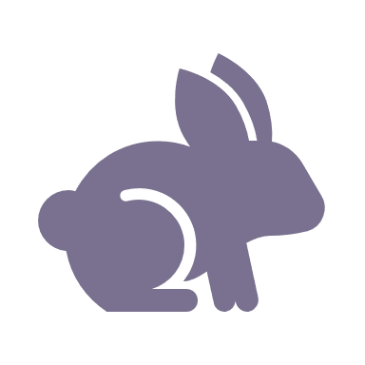 | Control rabbits 30,335ha
 | Control pigs 25,464ha
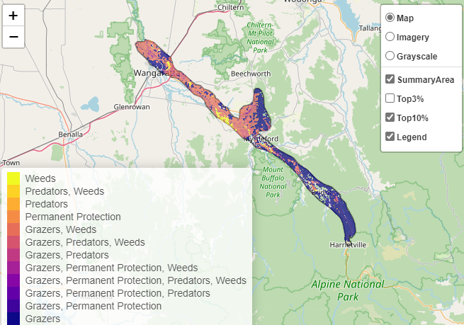

Of the top 10% of cost-effective actions, controlling rabbits and pigs provides the most cost-effective biodiversity benefits when considering all flora and fauna.

Biodiversity management activities identified (in addition to those modelled in SMP) through the consultation process are:
- deer control
- enhancement of riparian areas
- providing habitat connectivity
- improving aquatic biodiversity through weed control, erosion control and instream habitat

Additional recommended activities may be identified in consultation with partners.

The most cost-effective action for all flora and fauna
 | Plants, Birds, Amphibians – Control rabbits
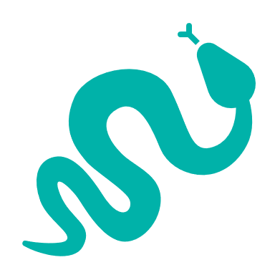 | Mammals, Reptiles – Control pigs

For a further in depth look into SMP for this landscape please refer to NatureKit.

