Introduction
Biodiversity Response Planning (BRP) is a long-term area-based planning approach to biodiversity conservation in Victoria. It is designed to strengthen alignment, engagement and participation between government, Traditional Owners, non-government agencies and the community.
DELWP Regional staff have been working with stakeholders on actions to conserve biodiversity in specific landscapes, informed by the best available science and local knowledge.
These Fact Sheets capture a point in time, reflecting data and knowledge available in 2020. They provide information for many (but not all) landscapes across Victoria, containing general information on the key values and threats in each area, as well as the priority cost-effective actions that provide the best protection of biodiversity. Fact Sheets are intended to provide useful biodiversity information for the community, non-government and government organisations during project planning and development.
Further information and the full list of Fact Sheets is available on the Department’s Environment website.

Landscape description
The Mt Buller and Mt Stirling focus landscape is 102,138ha with over 80% of the area covered in native vegetation. Public land makes up 100% of this landscape which includes part of Alpine National Park, Howqua Hills Historic Area and Mt Buller Resort. For area context, refer to the map at the end of this Fact Sheet.

Stakeholder involvement
As part of the Biodiversity Response Planning process, in October 2020 stakeholders were asked to nominate focus landscapes and actions of interest. DELWP, Parks Victoria, Trust for Nature, Goulburn Broken Catchment Management Authority, North East Catchment Management Authority, Taungurung Land and Waters Council, Yorta Yorta Nation Aboriginal Corporation and Alpine Resorts agreed on the nominated area.
As the focus area covers both National Park and Alpine Resort land, Parks Victoria and the respective Alpine Resorts are the representative stakeholders for this landscape. Further information regarding management of National Parks can be found in the Greater Alpine National Parks Management Plan.
Possible future investment/project development in this landscape will be available to any interested stakeholders in addition to those who nominated this landscape.

Cultural importance
We recognise that the entire landscape has high cultural value for Traditional Owners. Landscapes identified as having “notable” cultural importance are based on the density of recorded cultural heritage sites and knowledge shared by Traditional Owners. We also recognise that there are other locations important to Traditional Owners that are not within these focus landscapes. This focus landscape includes Country of the Taungurung People.

Habitat Distribution Models identify 194 species with more than 5% of their Victorian range in this landscape
187 plant species including:
- Purple Eyebright (Euphrasia collina subsp. speciosa), Presumed Extinct, 41% Victorian range in area
- Snowy Colobanth (Colobanthus curtisiae), Vulnerable, 34% Victorian range in area,
- Hairy Eyebright (Euphrasia lasianthera), Rare, 32% Victorian range in area
- Mountain Water-fern (Blechnum vulcanicum) Vulnerable, 29% Victorian range in area
- Bog Willow-herb (Epilobium brunnescens subsp. beaugleholei), Endangered, 24% Victorian range in area
2 Mammal species:
- Broad-toothed Rat (Mastacomys fuscus mordicus), Endangered, 6% Victorian range in area
- Smoky Mouse (Pseudomys fumeus) Endangered, 6% Victorian range in area
Other species of interest identified by Traditional Owners and stakeholders include: Eastern Pygmy-possum, Long-footed Potoroo, Greater Glider, Spot-tailed Quoll, Mountain Pygmy-possum
2 Reptile species:
- Mountain Skink (Liopholis montana), data deficient, 21% Victorian range in area
- Alpine Bog Skink (Pseudemoia cryodroma), Endangered, 9% Victorian range in area
Other species of interest identified by Traditional Owners and stakeholders include Alpine She-oak Skink, Highlands Copperhead, Mountain Dragon
No bird species with more than 5% of their Victorian range identified in the Habitat Distribution Models at this stage
Other species of interest identified by Traditional Owners and stakeholders include Sooty Owl, White-throated Needletail
2 Amphibian species:
- Alpine Tree Frog (Litoria verreauxii alpina), Critically Endangered, 10% Victorian range in area
- Spotted Tree Frog (Litoria spenceri), Critically Endangered, 8% Victorian range in area
Other species of interest identified by Traditional Owners and stakeholders include Plains Brown Tree Frog, Dendys Toadlet

Strategic Management Prospects
Strategic Management Prospects (SMP) models biodiversity values such as species habitat distribution, landscape-scale threats and highlights the most cost-effective actions for specific locations. More information about SMP is available in NatureKit.

Additional threats
Threats identified (in addition to those modelled in SMP) through the consultation process are habitat loss and associated impacts, and predatory animals such as foxes and cats. Effective management of these feral animals is required, especially to protect small and medium-sized native animals. Predator control can be cost effective around resorts; however, it can be quite difficult and costly in the broader landscape which is the source of these predators.
Grazing of hard-hooved animals, including cattle, degrades the habitat of aquatic species including endangered frogs. Pest animal management is considered a high priority along with investment in monitoring activities to determine impact, scale and best long-term pest management programs.
Weeds are a key threat in this area. Invasive plants can move from modified, impacted areas into the adjoining natural landscapes, notably Hawkweed which has been subject to extensive monitoring and control.
Tourism and recreation activities attract hundreds of thousands of visitors each year to alpine areas and can create significant impacts on the environment, not only from direct recreational use and disturbance but also with the generation of waste (rubbish and wastewater).

Which landscape-scale actions are most cost-effective in this landscape?
Some areas of this focus landscape (coloured areas on the map) have highly cost-effective actions which provide significant benefit for biodiversity conservation.
The Strategic Management Prospects priority action which ranks among the top 3% for cost-effectiveness of that action across the state for much of the landscape (>1,000ha) is to Control horses.
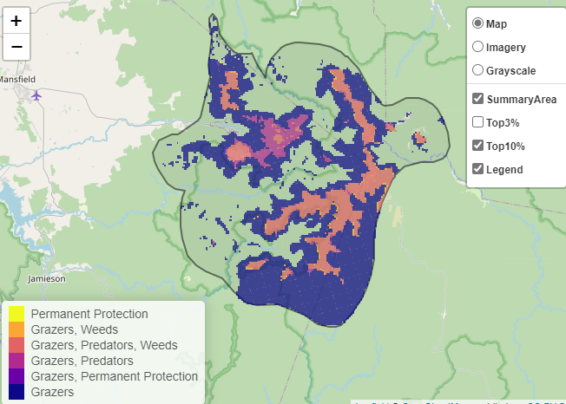
The top 10% cost-effective actions are in order:
Control horses 52,594ha

Control deer 26,214ha

Of the top 10% of cost-effective actions, controlling horses and deer provide the most cost-effective biodiversity benefits when considering the conservation of all flora and fauna.
Biodiversity activities (in addition to those modelled in SMP) identified through the consultation process were:
- Habitat and ecological community improvement works (expanding habitat for species such as Mountain Pygmy-possum) through works such as revegetation with food plants and creating connectivity between areas
- Raising awareness of reducing threats, such as use of rat poison in buildings
- Boulder field restoration
- Alpine Peatland Bog restoration
- Threatened species monitoring for Barred Galaxia, Mountain Pygmy-possum and Bogong Moth
- Predator monitoring program required to support Long-footed Potoroo protection
- ‘Special needs’ species where a lot of work is being focused (expanding predator control, understanding interactions with logging and fire)
- Management of cattle grazing
- Continuation and expansion of pest control programs for cats, foxes and deer
- Long-term planning and continuation of ongoing weed control across the landscape
- Identifying and continuing sustainability projects in resorts for overall biodiversity benefit, by reducing impacts of operations, waste and emissions
- Investment in education (signage, engagement with schools and encouraging citizen science) across all landscapes
- Engagement and research partnerships to understand the effects of climate change on biodiversity

The most cost-effective actions for flora & fauna
Plants - Control total grazing pressure
Birds, Mammals, Reptiles - Control horses
Amphibians - Combined cat and fox control

For a further in-depth look into SMP for this landscape, please refer to NatureKit.

