Introduction
Biodiversity Response Planning (BRP) is a long-term area-based planning approach to biodiversity conservation in Victoria. It is designed to strengthen alignment, engagement and participation between government, Traditional Owners, non-government agencies and the community.
DELWP Regional staff have been working with stakeholders on actions to conserve biodiversity in specific landscapes, informed by the best available science and local knowledge.
These Fact Sheets capture a point in time, reflecting data and knowledge available in 2020. They provide information for many (but not all) landscapes across Victoria, containing general information on the key values and threats in each area, as well as the priority cost-effective actions that provide the best protection of biodiversity. Fact Sheets are intended to provide useful biodiversity information for the community, non-government and government organisations during project planning and development.
Further information and the full list of Fact Sheets is available on the Department’s Environment website.

Landscape description
The Mount Buffalo focus landscape is 33,461ha with 76% of the area covered in native vegetation. Public land makes up 86% of this landscape and includes the Mount Buffalo National Park. Approximately 30% of the landscape area was impacted by bushfire in 2020. For area context, refer to the map at the end of this Fact Sheet.

Cultural importance
We recognise that the entire landscape has high cultural value for Traditional Owners. Landscapes identified as having “notable” cultural importance is based on the density of recorded cultural heritage sites and knowledge shared by Traditional Owners. We also recognise that there are locations important to Traditional Owners not within this focus landscape. This landscape includes Country of the Taungurung People.

Stakeholder interest
As part of the Biodiversity Response Planning process, in October 2020 stakeholders were asked to nominate focus landscapes and actions of interest. DELWP, Parks Victoria, Trust for Nature, Goulburn Broken Catchment Management Authority, North East Catchment Management Authority, Taungurung Land and Waters Council, Yorta Yorta Nation Aboriginal Corporation and Alpine Resorts agreed on the nominated area.
The representative stakeholders for this landscape are Parks Victoria and Taunguarung Land and Waters Council. The Greater Alpine Parks Management Plan provides details on the management of the Mount Buffalo National Park area.

Habitat Distribution Models identified 26 species with more than 5% of their Victorian range in this landscape area
26 Plant species, including:
- Buffalo Mint-bush (Prostanthera monticola) Rare, 99% Victorian range in area,
- Buffalo Sallow-wattle (Acacia phlebophylla), Rare, 84% Victorian range in area,
- Buffalo Sallee (Eucalyptus mitchelliana) Rare, 54% Victorian range in area
Notable species with less than 5% Victorian range in area include: Broad-toothed Rat, Long-footed Potoroo, Greater Gliders
Notable species with less than 5% Victorian range in area include: Alpine Bog Skink
Notable species with less than 5% Victorian range in area include: Spotted Tree Frog (Critically Endangered)

Strategic Management Prospects
Strategic Management Prospects (SMP) models biodiversity values such as species habitat distribution, landscape-scale threats and highlights the most cost-effective actions for specific locations. More information about SMP is available in NatureKit.

Additional threats
Threats in addition to those modelled in SMP which were identified through the consultation process are:
- Grazers/pest species: deer are present in this landscape and impact the environment by browsing, rubbing, pugging and wallowing. Although found on the Plateau area, most of the deer occupation is within the foothills and predominantly populated by females and younger males, this is due to recreational hunters targeting the larger males.
- Foxes have been identified in the area and although generally a priority to control, this can be problematic due to risk to off-target species (dingoes).
- Rabbits, cats and pigs have not been identified as a major threat and therefore not a high priority for control.
- Weeds are the highest priority for control as they can alter landscapes and affect biodiversity values. Weeds emerging post-bushfire are also of concern. Transformative weed species and feral grasses currently found in the modified areas pose a significant threat. Controlling these species before they spread into the surrounding landscape is of high importance.
- Promoting and implementing environmentally sustainable projects in mountain resorts for overall biodiversity benefit (such as reducing impacts of resort operations, waste and emissions).
- Investment in education is required across all landscapes for threat control.

In addition, threatened species predator monitoring and control is recommended along with monitoring for pigs and deer. This would be beneficial to ensure control programs can be implemented to target these species before they emerge on the plateau.

Which landscape-scale actions are most cost-effective in this landscape?
Some areas of this focus landscape (coloured areas on the map) have highly cost-effective actions which provide significant benefit for biodiversity conservation. The SMP priority action which ranks among the top 3% for cost-effectiveness of that action across the state for much of the area (>1,000ha) is to control pigs.
Of the top 10% of cost-effective actions, controlling pigs and deer provide the most cost-effective biodiversity benefits when considering all flora and fauna.
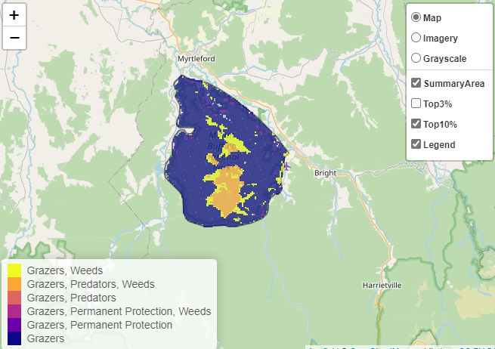

Control pigs 32,122ha

Control deer 16,311ha

The most cost-effective actions for flora and fauna
Plants - Control weeds
Birds, Amphibians - Combined cat and fox control
Mammals, Reptiles - Control cats, foxes and pigs

For a further in depth look into SMP for this landscape please refer to NatureKit.

